MINI PROJECT REPORT · TELEMATICS

Driver Behaviour Analysis and Safety Scoring
Implementing the UAH-DriveSet paper and extending it into a driver safety score for insurance
Submitted by
Kshitij Verma (24UCC202)
Lakshya Chandak (24UCC205)
Paper implemented
E. Romera, L. M. Bergasa and R. Arroyo, “Need Data for Driver Behaviour Analysis? Presenting the Public UAH-DriveSet”, IEEE International Conference on Intelligent Transportation Systems (ITSC), 2016.
November 2026

Abstract
Insurance companies want to price car insurance by how people actually drive, not just by their age or car. Phones already carry the sensors needed to measure driving. In this project we implemented the UAH-DriveSet paper, which recorded 40 trips by 6 drivers acting out three styles (normal, drowsy and aggressive) using a phone app called DriveSafe.
Starting from the raw phone data, we built our own detectors for hard braking, hard acceleration, sharp turns, speeding, tailgating, lane drifting and weaving. We turned these into scores out of 100 that stay within about 5 points of the original app. Using only our own numbers, a simple two-rule classifier recognised the driving style of 39 out of 40 trips for drivers it had never seen (97.5%), compared with 36 out of 40 (90%) for the original app.
Finally, we extended the work into a 300–900 driver safety score, similar to a CIBIL credit score. Every normal trip scored higher than every drowsy or aggressive trip, and every score comes with clear reasons, which makes it suitable for usage-based insurance.
Contents
Abstract 2
1. Introduction 3
2. The Dataset 3
3. Step 1: Exploring the Data 4
4. Step 2: Detecting Harsh Events 5
5. Step 3: Speeding, Tailgating, Drifting and Weaving 7
6. Step 4: Scores out of 100 8
7. Step 5: Predicting the Driving Style 9
8. Step 6: Driver Safety Score (Our Extension) 11
9. Summary of Results 12
10. Limitations 12
11. Conclusion and Future Work 12
References 13
Appendix: Project Files 13

1. Introduction
Most road accidents are caused by driver behaviour: speeding, following too closely, braking late or driving while tired. Telematics is the use of sensors (GPS, motion sensors, cameras) to measure this behaviour. A smartphone has all of these sensors, so it can act as a low-cost “black box” for a car.
Our faculty asked us to implement the UAH-DriveSet paper. The paper does two things: it shares a public dataset of real driving, and it shows how the DriveSafe app turns phone data into driving scores. Our aims were:
- Implement the paper: rebuild the app’s pipeline ourselves from the raw sensor data.
- Check our work: compare every result with the app’s own output, and test on drivers we never tuned on.
- Extend it: turn the result into a driver safety score (300–900) that an insurance company could use.
We did the work in six steps, one Jupyter notebook each:
Step | What we did | Result
1 | Loaded and explored the dataset | Understood the data; app baseline = 90%
2 | Detected hard braking, acceleration and turns | Braking matches the app (F1 = 0.81)
3 | Measured speeding, tailgating, drifting, weaving | Agree closely with the app (up to 0.97)
4 | Turned everything into scores out of 100 | Within ~5 points of the app
5 | Predicted normal / drowsy / aggressive | 39/40 correct (app: 36/40)
6 | Built a 300–900 driver safety score | Safe and risky trips fully separated

2. The Dataset
The UAH-DriveSet was recorded by the University of Alcalá (Spain). A phone running the DriveSafe app was mounted on the windshield while each driver drove fixed routes and acted out a driving style.
Item | Details
Drivers | 6 drivers (D1 to D6), each with their own car
Trips | 40 trips, about 500 minutes in total
Driving styles | 17 normal, 11 aggressive, 12 drowsy (the true label is in the folder name)
Roads | 18 motorway trips, 22 secondary road trips
License | CC BY-NC 4.0: research and education only

Each trip folder contains plain text files with no headings, only columns of numbers. The ones we used:
File | Recorded by | What it contains | Used for
RAW_ACCELEROMETERS | Motion sensor | Forward, sideways and vertical push, 10 times a second | Hard brakes, accelerations, turns
RAW_GPS | GPS | Speed and position, once a second | Speeding, speed checks
PROC_OPENSTREETMAP_DATA | Online map | Speed limit of the current road | Speeding
PROC_VEHICLE_DETECTION | Camera | Distance to the car in front | Tailgating
PROC_LANE_DETECTION | Camera | Car’s position inside its lane | Drifting, weaving
EVENTS_INERTIAL | App | Hard brakes, accelerations and turns found by the app | Comparing with our detector
SEMANTIC_FINAL | App | App’s final scores and style guess for the trip | Comparing scores and accuracy

We wrote a small Python reader (uah_driveset.py) that loads every file into a table with proper column names, so the rest of the project could work with clean data.

3. Step 1: Exploring the Data
Goal | Understand what the data looks like and check that the three driving styles really look different.
What we achieved | A working data loader, a clear picture of how each style shows up in the sensors, and the score to beat: the app guesses the style correctly for 36 of 40 trips (90%).

We compared one driver (D1) on the same road in all three styles. Aggressive driving was faster and full of sudden spikes in the motion sensor. Drowsy driving wandered more inside the lane, and it even had the hardest brake in the dataset (−0.57 g), like a tired driver reacting late. Normal driving was smooth.
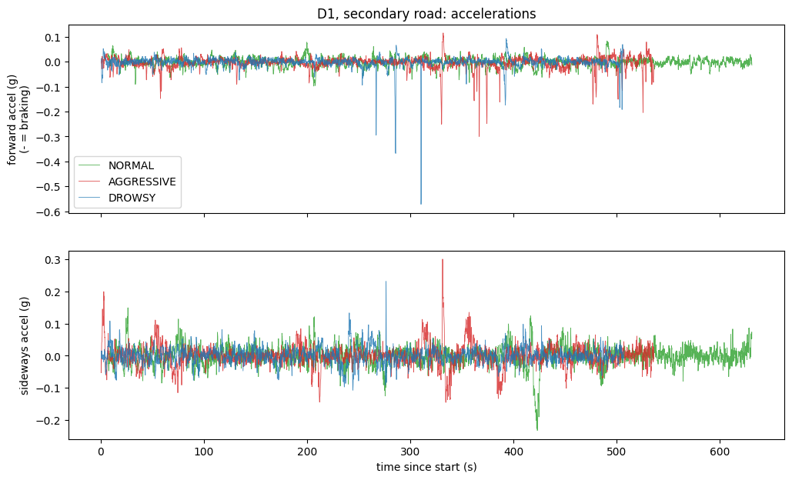
Figure 1: Motion sensor for driver D1 on the same road. Top: forward/back push (below zero = braking). Bottom: sideways push (turning). Aggressive driving (red) has many sharp spikes.
The dataset does not say which sensor axis is which. By checking the moments when the app reported braking and turning, we found that the Z column is forward/back and the Y column is sideways. This was needed for every later step.

4. Step 2: Detecting Harsh Events
Goal | Find hard braking, hard acceleration and sharp turns ourselves from the raw motion sensor, instead of relying on the app’s list.
What we achieved | A simple detector whose braking events match the app’s with F1 = 0.81 on new drivers, and whose per-trip event counts follow the app’s very closely (correlation 0.94).

How the detector works
The detector follows a few simple rules, like a speed camera for pushes:
- If the push goes past a threshold line, a harsh event has started; when it drops back, the event ends.
- Two pushes less than 1 second apart (3 seconds for acceleration and turns) count as one event.
- The strongest point of the push decides the level: low, medium or high.
- Anything below 5 km/h is ignored, so a parked car never triggers an event.
Event | Signal | Threshold | Medium / High from
Hard braking | forward push, negative | 0.12 g | 0.20 g / 0.35 g
Hard acceleration | forward push, positive | 0.09 g | 0.13 g / 0.20 g
Sharp turn | sideways push, either side | 0.12 g | 0.17 g / 0.30 g

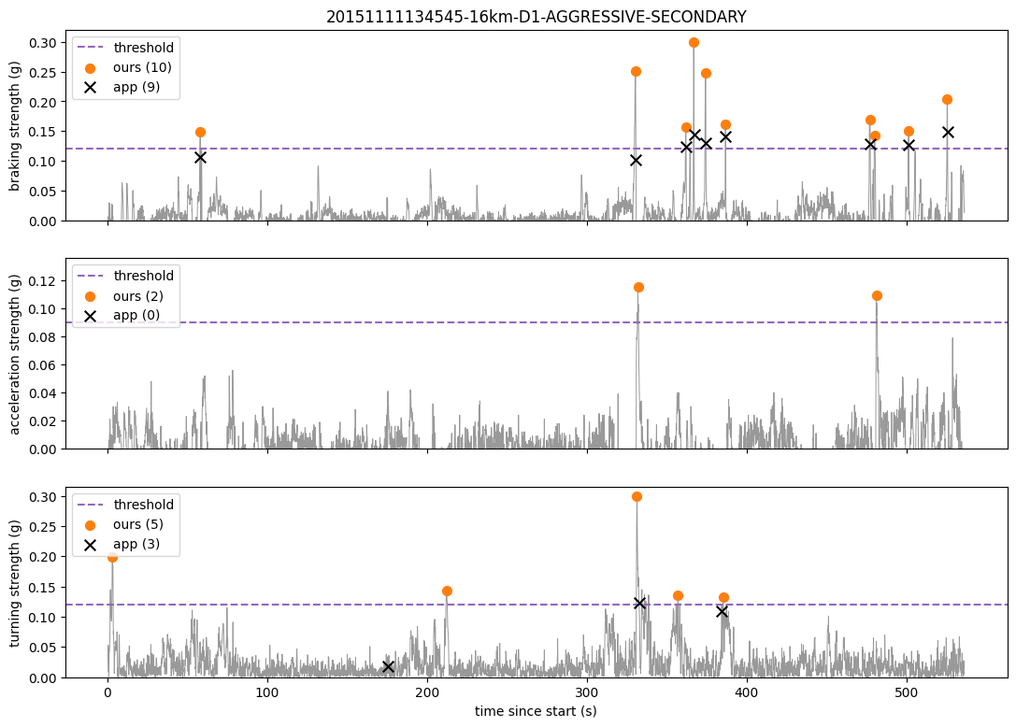
Figure 2: Our detector on one aggressive trip. Grey: sensor signal. Dashed: threshold. Orange dots: events we found. Black crosses: events the app found.

Choosing the thresholds fairly
We tried many threshold values on drivers D1–D3 and kept the one that made the fewest mistakes (false alarms plus missed events) compared with the app. A low line gives many false alarms; a high line misses real brakes. Drivers D4–D6 were kept aside as a fair test.
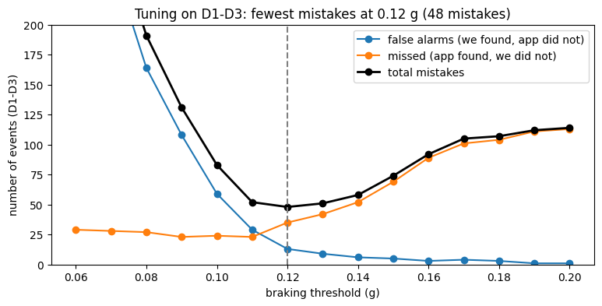
Figure 3: Choosing the braking threshold on drivers D1–D3. Total mistakes are lowest at 0.12 g.

Results on new drivers (D4–D6)
Precision tells us how many of our events are real; recall tells us how many of the app’s events we caught; F1 combines both (1.0 is perfect).
Event | Precision | Recall | F1 | Same severity level
Braking | 0.90 | 0.74 | 0.81 | 99%
Acceleration | 0.78 | 0.46 | 0.58 | 89%
Turning | 0.46 | 0.45 | 0.45 | 76%

Braking matches the app very well. Turning matches least because the app uses extra rules that the paper does not describe (for example, it never reported a turn below about 50 km/h). For judging a driver, the total per trip matters more than each single event, and there our counts follow the app’s closely.
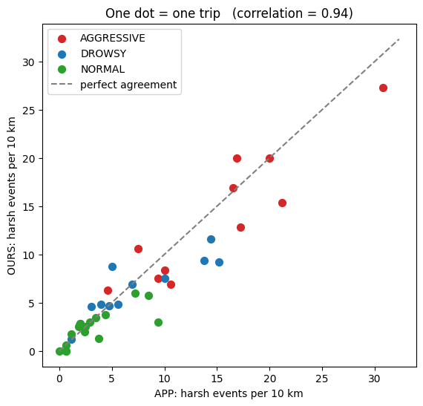
Figure 4: Harsh events per 10 km for every trip: ours against the app’s (correlation 0.94). Aggressive trips (red) have about six times more events than normal ones.

5. Step 3: Speeding, Tailgating, Drifting and Weaving
Goal | Measure the other risky behaviours from the paper using the GPS, the map and the camera, so that drowsy driving can be detected too.
What we achieved | Four new measures that agree strongly with the app and clearly separate the styles: speeding and tailgating point to aggressive drivers, drifting and weaving point to drowsy drivers.

Step 2 catches aggressive driving well, but drowsy drivers rarely brake hard; they wander in their lane. So we added four measures, each chosen by trying a few sensible values and keeping the one that agreed best with the app:
Behaviour | Our rule | Normal | Drowsy | Aggressive | Agreement with app
Speeding | % of time >10% over the speed limit | 5% | 6% | 30% | 0.86
Tailgating | % of time <0.5 s behind the car ahead | 1% | 1% | 21% | 0.97
Drifting | % of time >0.5 m from lane centre | 8% | 38% | 13% | 0.88
Weaving | drift >0.6 m then correct, per minute | 1.5 | 3.9 | 2.4 | 0.69

For tailgating we used time instead of distance: 20 metres is fine in a traffic jam but dangerous at 100 km/h, so we divide the distance by our speed. We also found that “weaving” in the app means zig-zagging inside the lane, not changing lanes; lane changes turned out to be equally common in all three styles. (Agreement values are correlations with the app’s scores, shown without the minus sign, which only appears because the app counts safety while we count risk.)
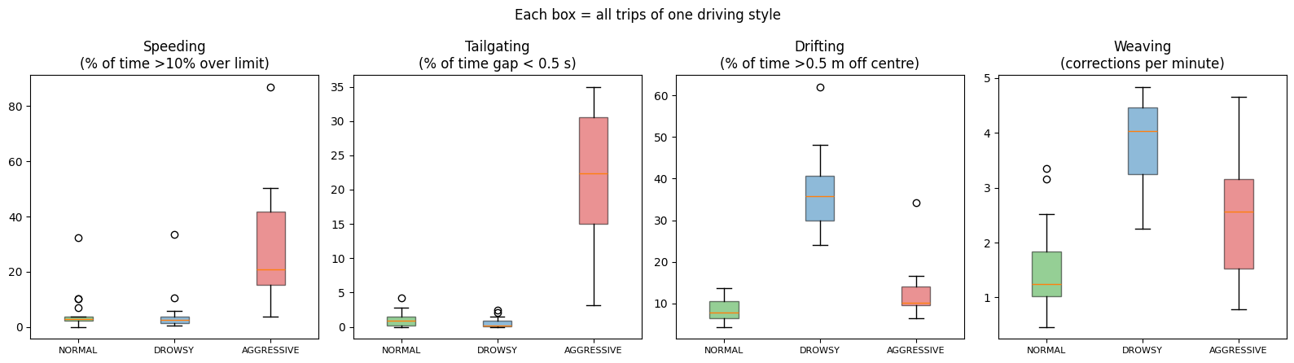
Figure 5: Each box shows all trips of one style. Speeding and tailgating are high for aggressive trips; drifting and weaving are high for drowsy trips.

6. Step 4: Scores out of 100
Goal | Put the seven different risk numbers on one common scale, a score out of 100, like the app’s report card.
What we achieved | Seven behaviour scores and an overall trip score. For new drivers, our overall score is on average only 4.8 points away from the app’s.

The seven risk numbers are in different units (events per 10 km, % of time, per minute), so they cannot be compared directly. We used one simple formula for every behaviour:
- Allowance: a little risk is forgiven; up to this amount the score stays at 100.
- Halving step: every extra step of risk above the allowance cuts the score in half.
For braking, the allowance is 2.5 weighted brakes per 10 km and the halving step is 3.1. A trip with 5.6 brakes per 10 km scores 50, one with 8.7 scores 25, and so on. Medium and high events count double. The two settings for each behaviour were found by trying about 2,000 combinations on drivers D1–D3 and keeping the one closest to the app’s scores.
The overall score of a trip is the plain average of its seven scores, exactly as the app does it.
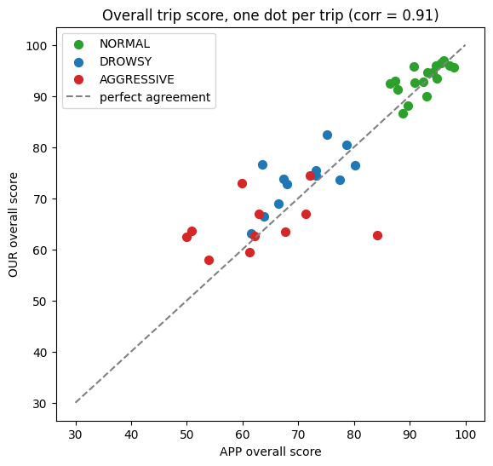
Figure 6: Overall score of every trip: ours against the app’s. The dots lie close to the line of perfect agreement.
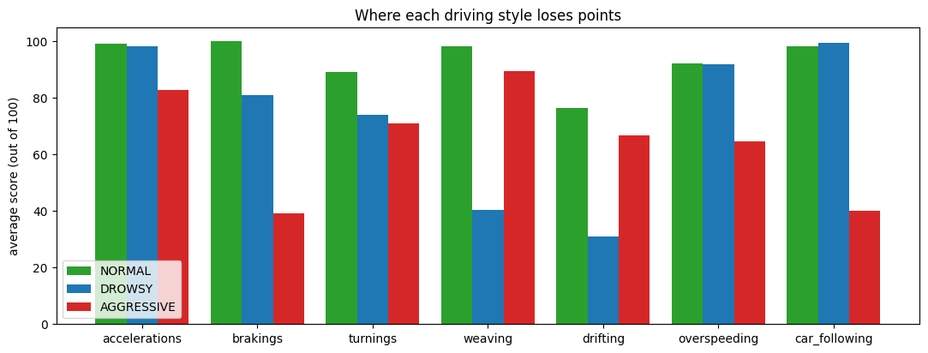
Figure 7: Average scores by style. Drowsy driving loses points on weaving and drifting; aggressive driving loses points on braking, speeding and car-following.

7. Step 5: Predicting the Driving Style
Goal | Using only our own numbers, tell whether a trip was normal, drowsy or aggressive, and beat the app’s 90%.
What we achieved | A simple, explainable rule that is right for 39 of 40 trips (97.5%) on drivers it had never seen. Machine-learning models confirmed the result.

From the Step 4 scores we made two risk numbers per trip: aggressive risk (points lost on braking, acceleration, turning, speeding and tailgating) and drowsy risk (points lost on weaving and drifting). On a chart, the three styles form three separate groups, so two questions are enough:
- Is aggressive risk above 26.3? Then the trip is aggressive.
- Otherwise, is drowsy risk above 30.9? Then it is drowsy. Otherwise it is normal.
Each line sits halfway in the gap between the groups it separates.
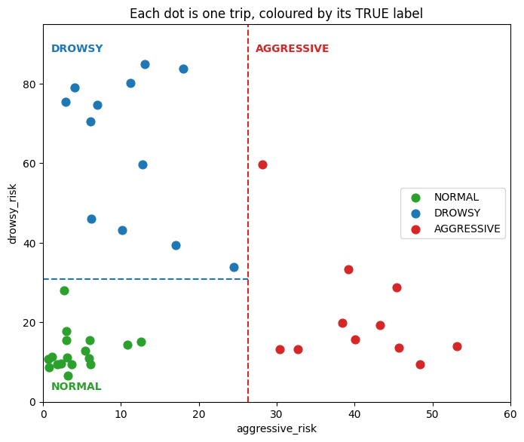
Figure 8: Every trip placed by its two risk numbers, coloured by its true style. The dashed lines are the rule.
To test fairly, we used “leave one driver out”: learn from 5 drivers, predict the 6th, and repeat for every driver. Every prediction is therefore about a driver the method has never seen.
Method | Correct | Accuracy
App (DriveSafe), the paper’s baseline | 36 / 40 | 90.0%
Our two-rule method | 39 / 40 | 97.5%
Decision tree (2 levels) | 37 / 40 | 92.5%
Logistic regression | 40 / 40 | 100%
Random forest | 40 / 40 | 100%

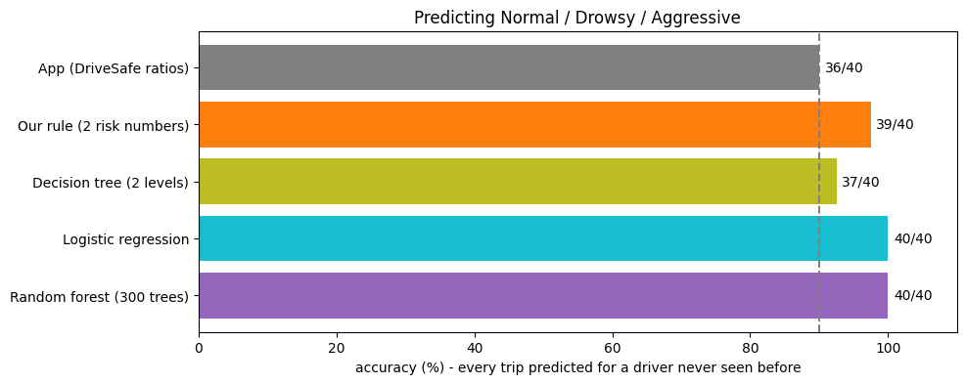
Figure 9: Accuracy of each method on unseen drivers. The dashed line is the app’s 90%.
The app mistook three aggressive trips and one drowsy trip for normal driving; our rule got all four right. Its only mistake was a drowsy trip with the hardest brake in the dataset, which looked aggressive to the sensors.
Random forest scored one trip higher, but with only 40 trips one trip is not real proof that it is better. We present the simple rule as our main method because it has only two numbers to learn, is much less likely to memorise the data, and every decision can be explained to a customer. That matters for insurance.

8. Step 6: Driver Safety Score (Our Extension)
Goal | Turn the work into a single, easy-to-understand driver safety score from 300 to 900, like a CIBIL credit score, that an insurance company could use to set premiums.
What we achieved | An explainable safety score in which every normal trip scores higher than every drowsy or aggressive trip, with clear bands and reasons for each score.

We stretched the Step 4 overall score onto a 300–900 scale: safety score = 300 + 12 × (overall score − 50). A perfect trip gets 900; an overall score of 50 or less gets 300. The score is then placed in a band:
Safety score | Band | Example premium change | Normal trips | Drowsy trips | Aggressive trips
750 – 900 | Excellent | −20% | 16 | 0 | 0
650 – 749 | Good | −10% | 1 | 2 | 0
550 – 649 | Average | no change | 0 | 7 | 2
300 – 549 | Risky | +25% | 0 | 3 | 9

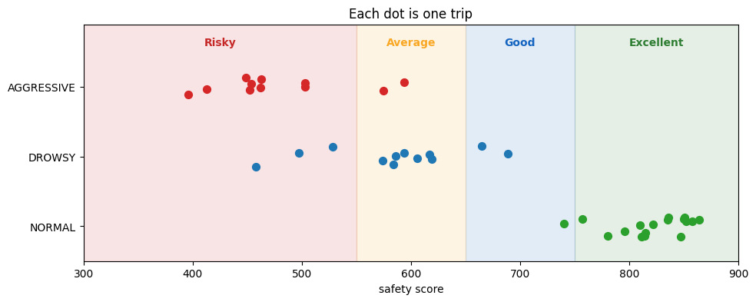
Figure 10: Safety score of every trip. The lowest normal trip (740) is still above the highest drowsy or aggressive trip (689).
Because the overall score is an average of seven scores, we can tell each driver exactly where they lost points. For example, one aggressive trip lost 130 points to tailgating and 113 points to hard braking, ending at 413 (Risky). A driver can see what to improve.
A driver’s score is the distance-weighted average of their trips. All six drivers scored 773–853 when driving normally and only 407–538 when driving aggressively. With a ₹10,000 base premium, the same person would pay ₹8,000 driving normally and ₹12,500 driving aggressively.
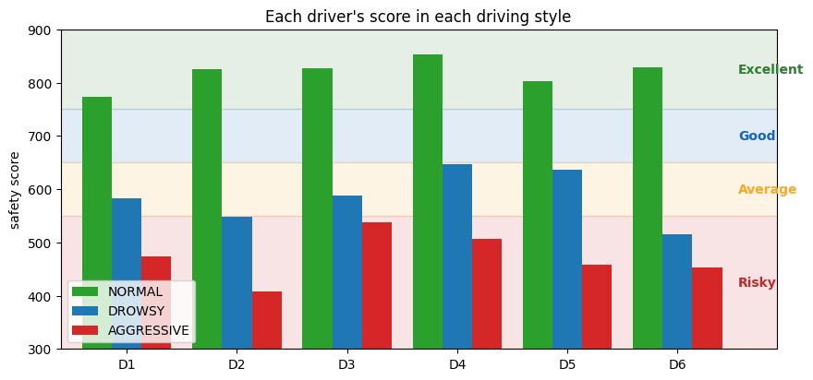
Figure 11: Each driver’s safety score in each driving style. Normal driving is Excellent for every driver.

9. Summary of Results
What we measured | Result
Braking events vs the app (new drivers) | F1 = 0.81, same severity 99% of the time
Harsh events per trip vs the app | Correlation 0.94
Tailgating / drifting / speeding vs the app | Correlation 0.97 / 0.88 / 0.86
Overall trip score vs the app (new drivers) | Average gap 4.8 points out of 100
Driving style prediction (unseen drivers) | 39/40 with our rule (app: 36/40)
Safety score | Every normal trip above every drowsy or aggressive trip

10. Limitations
- Small dataset: 40 trips from 6 drivers. Very high accuracy here does not guarantee the same on thousands of drivers.
- Acted behaviour: the drivers performed the styles on purpose, so real behaviour is likely less extreme.
- Compared with the app, not the truth: for events and scores, the app was our reference, and it can be wrong too.
- Example bands: the safety bands and premium changes are illustrative; an insurer would set them from claims data.
- Missing context: night driving, weather and traffic are not in the score yet.

11. Conclusion and Future Work
We implemented the UAH-DriveSet paper from the raw phone data upwards. Our own detectors and scores closely reproduce the original DriveSafe app, and using only our own numbers we recognised the driving style better than the app did (97.5% against 90%). We then extended the work into an explainable 300–900 safety score that clearly separates safe from risky driving and tells the driver why they got their score.
Possible next steps:
- Collect more drivers and real (not acted) trips, and check the score against real insurance claims.
- Add time of day, weather and road type to the score.
- Build a small app or dashboard that shows drivers their score and tips after each trip.

References
[1] E. Romera, L. M. Bergasa and R. Arroyo, “Need Data for Driver Behaviour Analysis? Presenting the Public UAH-DriveSet”, IEEE 19th International Conference on Intelligent Transportation Systems (ITSC), 2016.
[2] UAH-DriveSet website: http://www.robesafe.uah.es/personal/eduardo.romera/uah-driveset/

Appendix: Project Files
Notebook | Contents
01_explore_data.ipynb | Loading the data, comparing styles, app baseline
02_event_detection.ipynb | Harsh event detector, threshold tuning, comparison with the app
03_behaviour_features.ipynb | Speeding, tailgating, drifting and weaving
04_scores.ipynb | Scores out of 100 and the overall trip score
05_classification.ipynb | Predicting normal / drowsy / aggressive
06_safety_score.ipynb | The 300–900 driver safety score

Supporting Python files: uah_driveset.py (data loader), event_detection.py, behaviour_features.py, scoring.py, classifier.py and safety_score.py. The dataset itself is not included because of its size and license; it can be downloaded from the website above.

