

**ASSIGNMENT**

**ON**

**“Engineering Innovations in Ophthalmology: Advancements and Applications for Retinitis Pigmentosa”**  
**BY**

|  |
| --- |
| **KSHAMA.S** |
| **4SF22CS097**  **SECTION:4C** |

In the partial fulfilment of the requirement for IV sem. B.E. (CSE)

**BIOLOGY FOR ENGINEERS**

**BS422T8X**  
  
Under the guidance of

**Ms. Madhura**

Assistant Professor

Department of Basic Science

**PAGE INDEX**

**Chapter No Topic Page No.**

**1 Introduction 3**

**2 Mechanism 4**

**3 Applications 8**

**4 Future Directions 9**

**5 Conclusion and Reference 9**

**INTRODUCTION:**

The interdisciplinary field of "Biology for Engineers" integrates biological science with engineering principles to innovate solutions for medical and biological challenges. Engineers equipped with a deep understanding of biological systems can develop advanced technologies for healthcare, environmental sustainability, and bioprocessing. Key areas include biomechanics, biomaterials, biosensors, and medical devices.

Engineers working in the field of biology need a thorough understanding of biological systems and processes to effectively design and develop solutions that can interact with or mimic natural biological functions. This understanding allows them to address complex problems in medical diagnostics, treatment, and disease prevention. The application of engineering principles in biology ranges from the development of sophisticated medical devices and diagnostic tools to the creation of innovative therapies and regenerative medicine.

**Introduction to Ophthalmology:**

Ophthalmology is the branch of medicine and surgery that deals with the diagnosis and treatment of eye disorders. Engineers working in ophthalmology apply their skills to develop technologies that improve vision care and treatment. This includes designing surgical instruments, developing advanced imaging techniques, and creating devices that can restore or enhance vision.

The human eye is a complex organ with multiple components that work together to provide vision. Understanding the anatomy and physiology of the eye is essential for engineers working in this field. Key components of the eye include the cornea, lens, retina, optic nerve, and vitreous humor. Each of these components plays a critical role in the process of vision, and any dysfunction can lead to vision impairment or blindness.

**Introduction to Retinitis Pigmentosa (RP):**

Retinitis Pigmentosa (RP) is a group of inherited retinal dystrophies characterized by progressive photoreceptor degeneration, leading to significant vision loss and, ultimately, blindness. This genetic disorder affects approximately 1 in 4,000 people worldwide and poses significant challenges due to its complex genetic and cellular mechanisms.

RP primarily targets the rod photoreceptors responsible for night vision and peripheral vision. As the disease progresses, cone photoreceptors, which handle central and color vision, also deteriorate. The progressive nature of RP makes early diagnosis and intervention critical for managing the disease and preserving vision for as long as possible.

RP is a prime example of how engineering can intersect with biology to provide innovative solutions for medical challenges. Engineers contribute to the understanding and treatment of RP through the development of retinal implants, gene therapies, and advanced imaging techniques. These technologies aim to slow the progression of the disease, restore partial vision, and improve the quality of life for patients.

The involvement of engineers in addressing RP is pivotal. Through the application of engineering principles, innovative diagnostic tools, therapeutic devices, and treatment strategies can be developed to combat this debilitating condition.

**Mechanism of Retinitis Pigmentosa (RP)**

**Genetic Basis**

Retinitis Pigmentosa (RP) is caused by mutations in a variety of genes that are critical for the normal functioning of photoreceptors in the retina. More than 60 genes have been implicated in RP, with each mutation leading to the production of defective proteins that disrupt photoreceptor cell function. The inheritance patterns of RP can be autosomal dominant, autosomal recessive, or X-linked, with varying degrees of severity and age of onset.

**Key Genes Involved:**

1. **RHO (Rhodopsin):**
   * **Function:** Rhodopsin is a light-sensitive receptor protein involved in the phototransduction pathway of rod cells.
   * **Mutations:** Mutations in the RHO gene are a common cause of autosomal dominant RP, leading to protein misfolding and rod cell death.

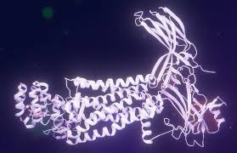

**Fig 1: RHO gene**

1. **USH2A (Usher Syndrome 2A):**
   * **Function:** The USH2A gene encodes a protein critical for the maintenance of photoreceptors and the inner ear.
   * **Mutations:** Mutations cause Usher syndrome, which includes RP and hearing loss.

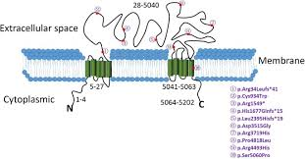

**Fig 2: USH2A gene**

1. **RPGR (Retinitis Pigmentosa GTPase Regulator):**
   * **Function:** RPGR is involved in the transport of proteins in photoreceptor cells.
   * **Mutations:** X-linked RP is often associated with mutations in this gene, predominantly affecting males.

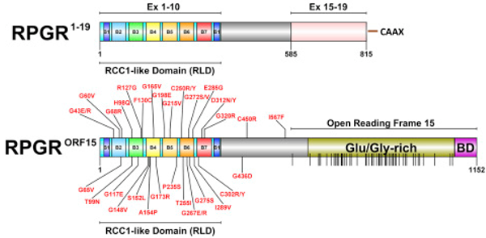

**Fig 3: RPGR gene**

1. **PDE6B (Phosphodiesterase 6B):**
   * **Function:** This gene encodes a subunit of the rod photoreceptor cGMP-specific phosphodiesterase.
   * **Mutations:** Mutations lead to autosomal recessive RP, affecting the phototransduction cascade.

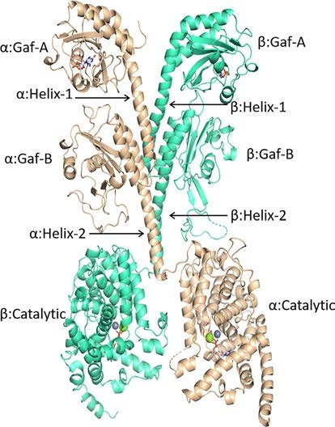

**Fig 4: PDE6B gene**

1. **PRPF31 (Pre-mRNA Processing Factor 31):**
   * **Function:** PRPF31 is involved in the splicing of pre-mRNA, which is critical for photoreceptor cell function.
   * **Mutations:** Mutations can cause autosomal dominant RP with variable expressivity.

**Pathophysiology**

The pathological process of RP involves the progressive degeneration of photoreceptors, starting with rods and followed by cones. This degeneration is influenced by various cellular mechanisms, including apoptosis, oxidative stress, and the accumulation of toxic byproducts.

**Photoreceptor Degeneration**

1. **Rod Photoreceptors:**
   * **Initial Impact:** Rod cells, responsible for night and peripheral vision, are typically the first to be affected. Early symptoms include night blindness (nyctalopia) and loss of peripheral vision.
   * **Progression:** As rod cells die, patients experience "tunnel vision," where only central vision remains intact.
2. **Cone Photoreceptors:**
   * **Subsequent Impact:** With the progression of RP, cone cells, responsible for color and central vision, begin to deteriorate.
   * **Result:** This leads to loss of central vision and difficulties with tasks requiring detailed vision, such as reading and recognizing faces.

**Retinal Remodeling**

As photoreceptors degenerate, the retina undergoes significant structural and functional changes:

1. **Microglial Activation:**
   * **Role:** Microglial cells, the resident immune cells of the retina, become activated in response to photoreceptor cell death.
   * **Impact:** This activation leads to inflammation and can further exacerbate retinal degeneration.
2. **Müller Cell Gliosis:**
   * **Role:** Müller cells, which provide structural and metabolic support to the retina, undergo reactive gliosis in response to retinal injury.
   * **Impact:** Gliosis disrupts normal retinal architecture and function, contributing to vision loss.
3. **Formation of Retinal Cysts:**
   * **Occurrence:** Cystic changes in the retina, particularly in the macula, can occur as a result of the degenerative process.
   * **Effect:** These cysts can lead to further vision impairment and complicate the clinical management of RP.

**Cellular Mechanisms**

Several cellular processes are implicated in the degeneration of photoreceptors in RP:

1. **Apoptosis:**
   * **Process:** Apoptosis, or programmed cell death, is a primary mechanism of photoreceptor loss in RP.
   * **Trigger:** Genetic mutations lead to cellular stress and activation of apoptotic pathways.
2. **Oxidative Stress:**
   * **Cause:** Increased oxidative stress results from the imbalance between the production of reactive oxygen species (ROS) and the retina's ability to detoxify these reactive intermediates.
   * **Consequence:** Oxidative damage to cellular components, including DNA, proteins, and lipids, accelerates photoreceptor death.
3. **Accumulation of Toxic Byproducts:**
   * **Issue:** Defective photoreceptors accumulate toxic byproducts, such as misfolded proteins and lipid peroxidation products.
   * **Result:** These byproducts disrupt cellular homeostasis and promote further degeneration.

**Visual Representation:**

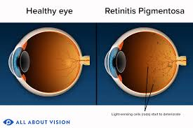

**Fig 5: Normal Retina vs. RP-Affected Retina**

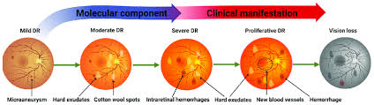

**Fig 6: Propagation of vision loss**

By understanding these genetic and cellular mechanisms, engineers and medical researchers can develop targeted interventions to slow the progression of RP, preserve remaining vision, and potentially restore lost vision through innovative treatments and technologies.

**Applications**

**Retinal Implants:**

* **Design and Development:** Retinal implants, such as the Argus II, consist of a microelectrode array that is surgically placed on the retina. These implants electrically stimulate the remaining retinal cells to restore partial vision.
* **Materials Science:** Biocompatible materials are essential for retinal implants to prevent adverse immune responses and ensure longevity and functionality within the eye.
* **Microelectronics:** Advancements in microelectronics have enabled the creation of compact and energy-efficient devices that process visual information and stimulate the retina.

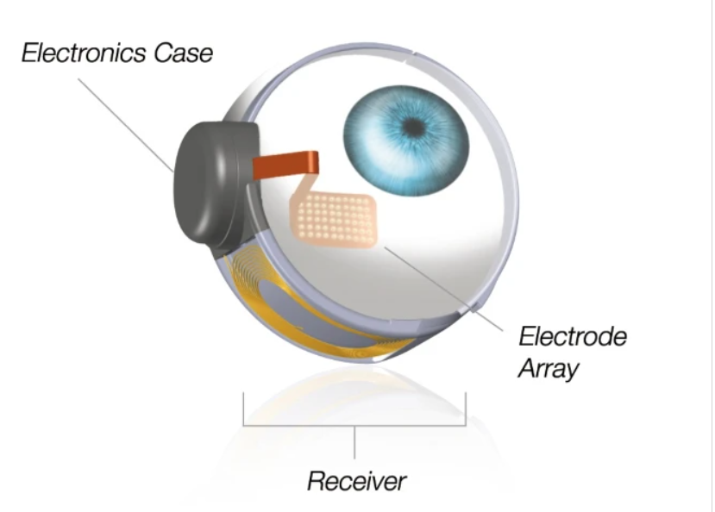

**Fig 7: Retinal Implants**

**Gene Therapy:**

* **Vectors:** Engineers develop viral vectors that deliver healthy copies of defective genes to retinal cells. This approach aims to correct genetic defects at the molecular level.
* **Delivery Systems:** Micro-needles and other precision delivery mechanisms are designed to administer gene therapy directly to the retina, ensuring targeted and efficient treatment.

**Optogenetics:**

* **Photosensitive Proteins:** By engineering retinal cells to express photosensitive proteins, optogenetics allows for the restoration of light sensitivity in degenerating retinas.
* **Light Delivery Systems:** External devices are developed to provide controlled light stimuli, activating the photosensitive proteins and enabling visual perception.

**Biomedical Imaging:**

* **Advanced Imaging Techniques:** Optical Coherence Tomography (OCT) and other imaging modalities are used to monitor disease progression and assess treatment efficacy.
* **Image Processing Algorithms:** Sophisticated algorithms enhance image quality and extract valuable data from retinal scans, aiding in diagnosis and monitoring.

**Drug Delivery Systems**

* **Nanoparticles:** Nanoparticles are engineered to deliver therapeutic agents directly to retinal cells, improving drug efficacy and minimizing side effects.
* **Sustained Release Systems:** Devices and formulations that provide controlled release of drugs over extended periods are developed to ensure consistent therapeutic effects.

**Future Directions**

* **Personalized Medicine:** Advancements in genetic screening and bioinformatics will enable personalized treatment plans tailored to individual genetic profiles, enhancing treatment efficacy.
* **Advanced Prosthetics:** Development of more sophisticated retinal implants with higher resolution and better biocompatibility will improve visual outcomes for RP patients.
* **Regenerative Medicine:** Stem cell therapy and tissue engineering hold promise for regenerating damaged retinal tissue and restoring vision in RP patients.
* **Enhanced Gene Editing:** CRISPR and other gene-editing technologies will offer more precise and efficient methods for correcting genetic defects responsible for RP.

**Conclusion**

Retinitis Pigmentosa presents significant challenges due to its genetic complexity and progressive nature. However, interdisciplinary approaches combining biology and engineering offer promising solutions for diagnosis, treatment, and management. Continued research and development in retinal implants, gene therapy, optogenetics, imaging techniques, and drug delivery systems are essential for improving the quality of life for individuals affected by RP.

**References**

1. Daiger, S. P., et al. (2013). "Retinitis Pigmentosa Overview." GeneReviews.
2. Chuang, A. T., et al. (2014). "Retinal Prosthetic Devices." Graefe's Archive for Clinical and Experimental Ophthalmology.
3. Bainbridge, J. W. B., et al. (2008). "Effect of Gene Therapy on Visual Function in Leber's Congenital Amaurosis." New England Journal of Medicine.