Task1: Name: Adding a new product.

Related use cases:

1)

|  |  |
| --- | --- |
| Actor | System |
|  |  |
| Input data then click button “Add product”  Add product screen with input data | Hide “Add Product” screen and display successful message. |
| Click “OK” | Display Main Screen |

Add new customer

Customer**(customerId**, Name, Phone, Address)

|  |  |
| --- | --- |
| Actor | System |
|  | Add Customer |
| Input the customer data, then click “Add customer” |  |
| Click ok | Display main screen |

Add a new purchase

Purchased(**PurchaseId**, *CustomerID, ProductID*, Quantity, Price, TotalTax, TotalCost)

|  |  |
| --- | --- |
| Actor | System |
|  |  |
| A purchase can be recorded after fetching the purchase /order details |  |
|  | The purchase is recorded successfully. |
| Click Ok | Display main screen. |

2) ER DIAGRAM

ER diagram for the online store management system

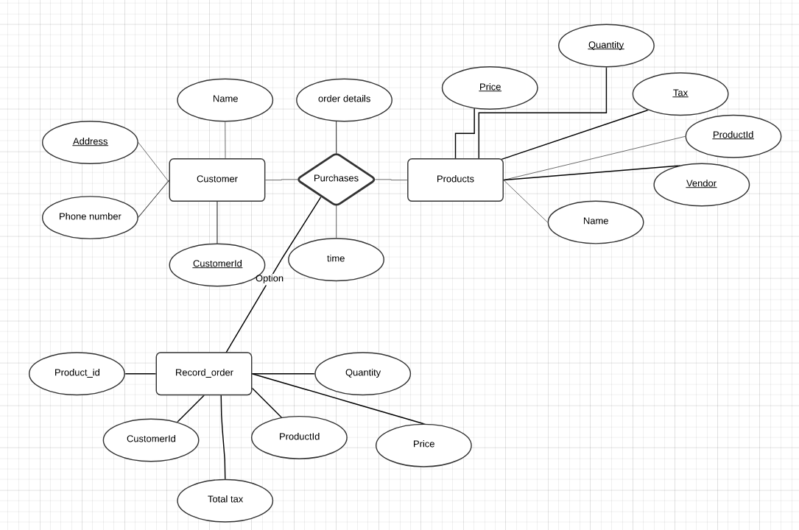

3)

Database for all the use cases

Customer**(customerId**, Name, Phone, Address)=> required to add a customer

Products(**ProductID**, Name, price, Quantity, Vendor, TaxRate) => required to add a product.

Orders(**OrderId**, *CustomerID, ProductID*, Quantity, Price, TotalTax, TotalCost) => required to record a purchase

4 and 5

Have attached the DB files for question 4 and 5.