# Report for Assignment 1 resit

## Project chosen

Name: CodiumAI Cover-Agent

URL: https://github.com/Codium-ai/cover-agent

Number of lines of code and the tool used to count it: cloc tool
9563 lines in total(4191 of it is HTML, 1950 of it is Python. Rest are miscellaneous languages)

Programming language: Mainly Python & HTML

## Coverage measurement with existing tool

Poetry & pytest using the command: poetry run pytest --cov=cover_agent --cov-report=term-missing --cov-report=html
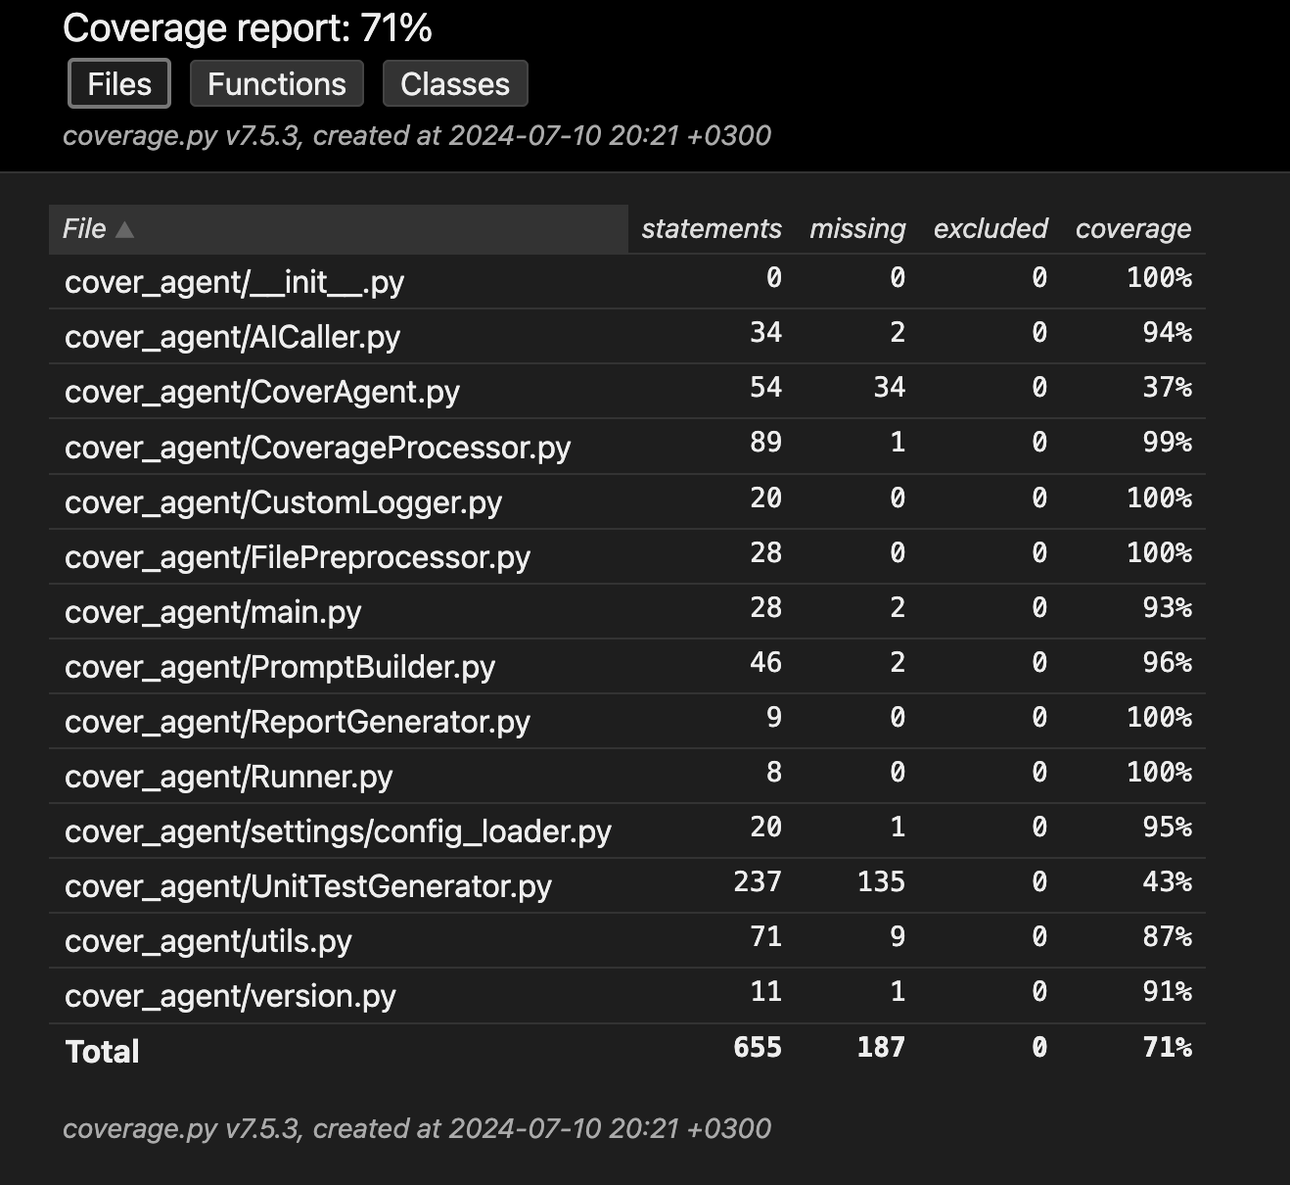

## Coverage improvement

### Individual tests

CoverAgent.__init__ Function:

commit link: https://github.com/Codium-ai/cover-agent/commit/922a51d7ad952eb2f21b7ec33383c83a909c11bd

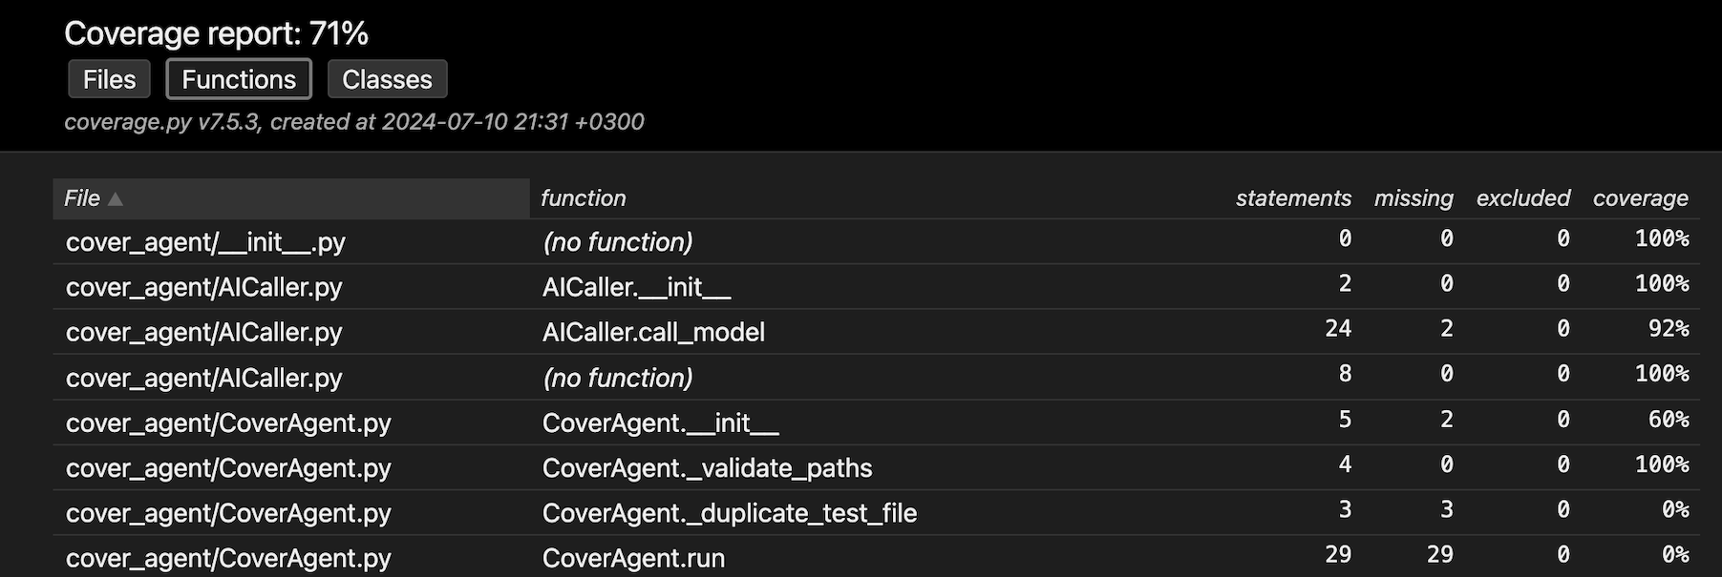
Old:

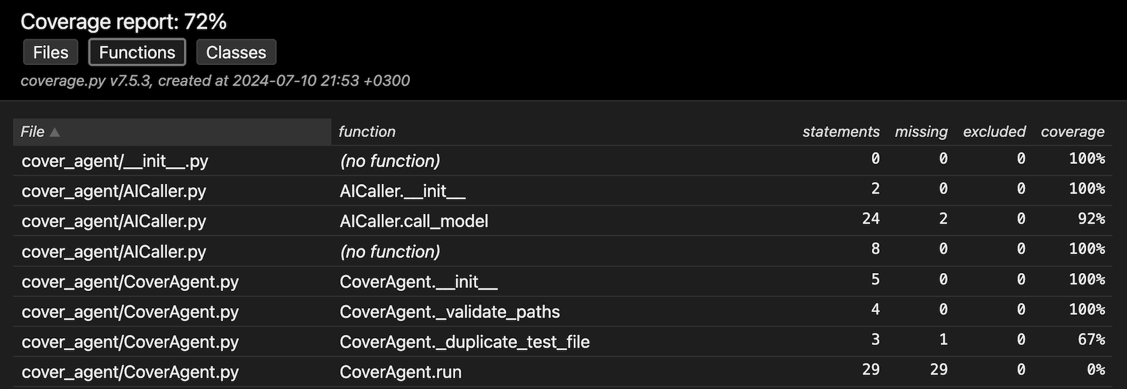
New:

This additional test file: test__duplicate_test_file_empty_path
firstly improves CoverAgent._init_ indirectly by 40% since creating an instance of “cover agent” requires running the “__init__” method. The test verifies that all the initial setup steps such as path validation and test file handling are executed correctly. This way the code paths of “__init__” are covered. )

CoverAgent._duplicate_test_file Function:

commit link: https://github.com/Codium-ai/cover-agent/commit/50cd963c83a470c3a8094f59a5ccafa817d62ce2

Old:

New:
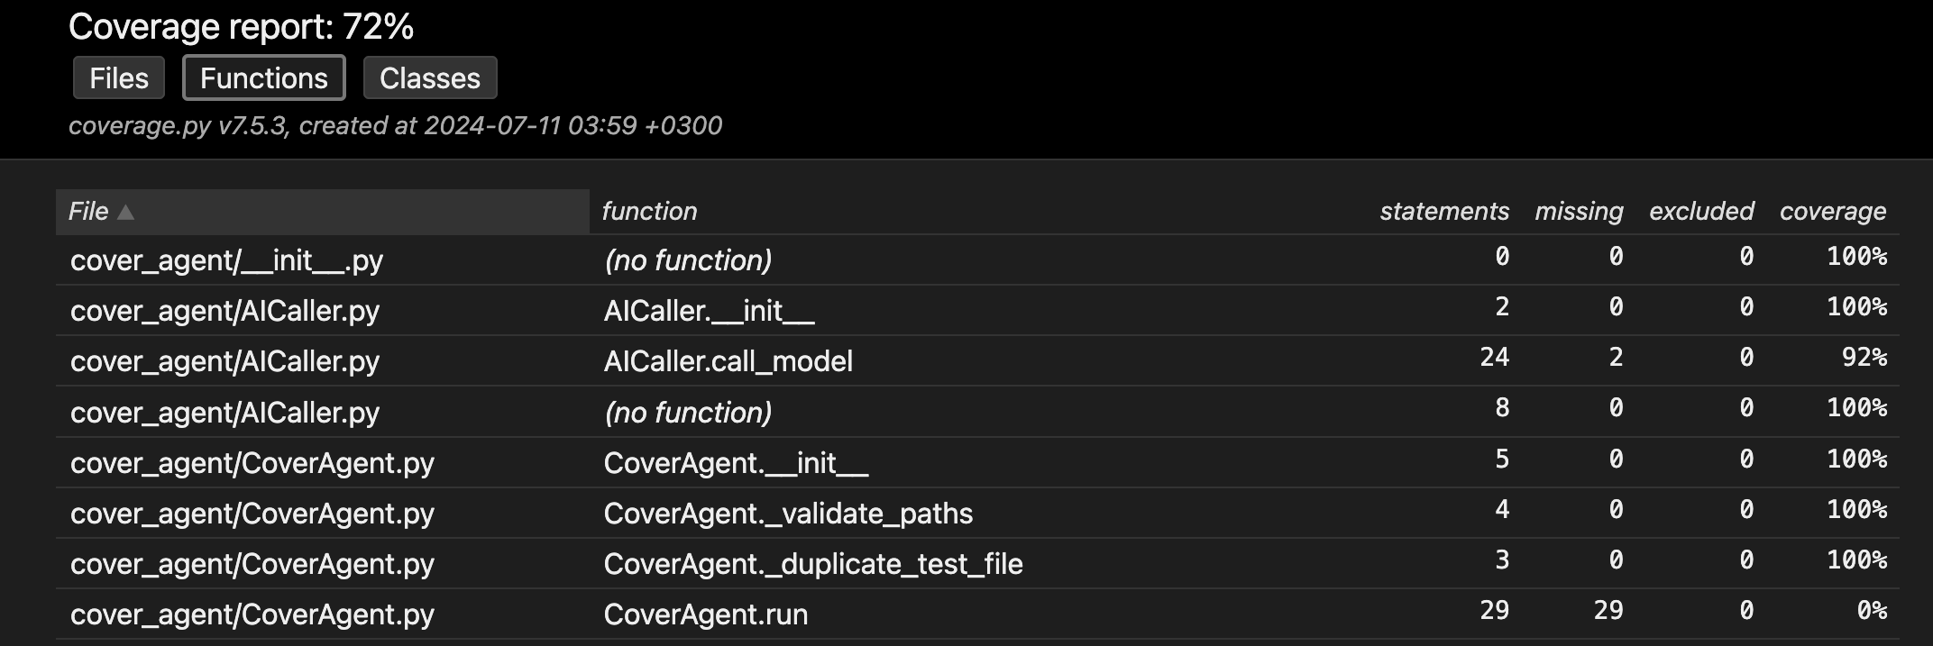

The additional test files: test__duplicate_test_file_empty_path & test__duplicate_test_file_with_output_path improve the coverage of the CoverAgent._duplicate_test_file by a 100% by checking on a duplicate test file with an empty path and checking on a duplicate test file which has the output as the path.

### Overall

Old:

New:

