

**Project Name**

**Website Designing for ShapesNGO**

**Course Code: CSE326**

**Course Name: INTERNET PROGRAMMING LABORATORY**

**Student Names:**

**Kshatri Syam Sahil Singh**

**Shaik sabeer hussain**

**Student Registration Numbers:**

**12212269**

**12322992**

Prepared for

Continuous Assessment 3

Spring 2025

**Table of Contents**

Revision History ii

1. Introduction 1

1.1 Purpose 1

1.2 Scope 1

1.3 Definitions, Acronyms, and Abbreviations 1

1.4 References 1

1.5 Overview 1

2. General Description 2

2.1 Product Perspective 2

2.2 Product Functions 2

2.3 User Characteristics 2

2.4 General Constraints 2

2.5 Assumptions and Dependencies 2

3. Specific Requirements 2

3.1 External Interface Requirements 3

3.1.1 User Interfaces 3

3.1.2 Hardware Interfaces 3

3.1.3 Software Interfaces 3

3.1.4 Communications Interfaces 3

3.2 Functional Requirements 3

3.2.1 <Functional Requirement or Feature #1> 3

3.2.2 <Functional Requirement or Feature #2> 3

3.5 Non-Functional Requirements 3

3.5.1 Performance 3

3.5.2 Reliability 3

3.5.3 Availability 3

3.5.4 Security 3

3.5.5 Maintainability 3

3.5.6 Portability 3

3.7 Design Constraints 3

3.9 Other Requirements 3

4. Analysis Models 4

4.1 Data Flow Diagrams (DFD) 4

5. Github link…………………………………………………………………………………………………….5

**6. DEPLOYED LINK………………………………………………………………………………………………...6**

7. CLIENT APPROVAL PROOF……………..…………………………………………………………………….7

**8. CLIENT LOCATION PROOF……………………………………………………………………………………8**

**9. TRANSACTION ID PROOF……………………………………………………………………………………...9**

**10. EMAIL ACKNOWLEDGEMENT…………………………………………………………………………….10**

**11. GST No…………………………………………………………………………………………………………...11**

A. Appendices

A.1 Appendix 1

A.2 Appendix 2

# 1. Introduction

This Software Requirements Specification (SRS) document provides a detailed overview of the website designed for **ShapesNGO**, focusing on its front-end development. The website was built using **HTML, CSS, and Bootstrap**, with the goal of delivering a responsive and user-friendly interface that accurately reflects the organization’s mission and services.

The purpose of this SRS is to outline all technical and functional requirements needed to design and implement the website. It serves as a guide for developers, testers, and stakeholders, ensuring a clear understanding of the website's structure, features, user interactions, and limitations.

The structure of this document follows the IEEE SRS standards and includes sections on general description, specific requirements (functional and non-functional), interface designs, and various supporting documentation such as deployment, client approvals, and related appendices. This ensures the website meets the organizational goals of **ShapesNGO** and provides a scalable, maintainable, and visually appealing platform for users.

## 1.1 Purpose

The purpose of this Software Requirements Specification (SRS) is to define the functional and non-functional requirements for the development of the **ShapesNGO website**. This document is intended to guide the design, implementation, and validation of the website, ensuring that it aligns with the client’s expectations and serves the needs of its users.

The primary audience for this document includes:

* **Web developers and designers**, responsible for building the front-end of the website using HTML, CSS, and Bootstrap.
* **Project stakeholders and clients** from ShapesNGO, to review and approve the planned features and flow of the website.
* **Testers**, to validate the website against the documented requirements.
* **Instructors and evaluators**, for academic assessment under the "Internet Programming Laboratory" course (CSE326).

This SRS serves as a blueprint to ensure that the website is delivered with the desired structure, user experience, and compatibility across different devices.

## 1.2 Scope

The software product to be developed is a **front-end website for ShapesNGO**, designed using HTML, CSS, and Bootstrap. The purpose of this website is to represent the organization's mission, showcase its services and activities, provide access to contact information, and enable users to interact with the NGO through forms and informational pages.

This website **will include**:

* A responsive user interface compatible with various devices and screen sizes.
* Informational pages such as About Us, Objectives, Programs, Events, and Gallery.
* Contact and registration forms for users to reach out or join initiatives.
* Visual and navigation elements aligned with modern web standards using Bootstrap.

This website **will not include**:

* Back-end functionalities such as database management or user authentication.
* Dynamic content updates (handled manually rather than via CMS or database).
* Payment gateways or e-commerce features.

**Application and Benefits**:

* Acts as a digital presence for ShapesNGO, improving visibility and outreach.
* Offers an intuitive and accessible platform for visitors to learn about the NGO’s mission and work.
* Enhances user experience with a clean, responsive, and well-structured design.
* Encourages engagement through interactive elements like forms and image galleries.

The scope of this software product is limited to front-end development, fulfilling academic objectives under the "Internet Programming Laboratory" course, while also serving real-world use by providing a functional and aesthetically pleasing website to a live client.

## 1.3 Definitions, Acronyms, and Abbreviations

• **HTML (HyperText Markup Language):** The standard language used to create and structure web pages and web applications.

• **CSS (Cascading Style Sheets):** A style sheet language used for describing the presentation of a web page, including layout, colors, and fonts.

• **Bootstrap:** A front-end framework used to design responsive and mobile-first websites using HTML, CSS, and JavaScript.

• **SRS (Software Requirements Specification):** A document that describes the software system to be developed, including its functional and non-functional requirements.

• **NGO (Non-Governmental Organization):** A non-profit organization that operates independently of government, typically one whose purpose is to address a social or political issue.

• **UI (User Interface):** The point of interaction between the user and the website or software.

• **UX (User Experience):** The overall experience and satisfaction a user has when interacting with a website or software application.

• **Responsive Design:** A web design approach that ensures a website looks good and functions well on all devices (desktops, tablets, smartphones).

• **Frontend Development:** The part of web development that involves creating the visual and interactive elements of a website that users see and interact with.

## 1.4 References

The following references have been used during the planning, design, and documentation of the ShapesNGO website project:

1. **IEEE Std 830-1998, IEEE Recommended Practice for Software Requirements Specifications**
   * Published by: IEEE Computer Society
   * Date: October 20, 1998
   * Source: [IEEE Xplore Digital Library](https://ieeexplore.ieee.org/)
2. **ShapesNGO Official Website**
   * Title: ShapesNGO – Official Website
   * URL: <https://shapesngo.com/Default/Pages/default.aspx>
   * Accessed: April 2025
3. **Bootstrap Official Documentation**
   * Title: Bootstrap v5 Documentation
   * URL: https://getbootstrap.com/docs/5.3/getting-started/introduction/
   * Publisher: Bootstrap Team, Twitter, Inc.
   * Accessed: April 2025
4. **HTML & CSS Standards**
   * Title: HTML Living Standard and CSS Snapshot 2023
   * Publisher: World Wide Web Consortium (W3C)
   * URLs: https://html.spec.whatwg.org/ and <https://www.w3.org/TR/css-2023/>
   * Accessed: April 2025

These references serve as the foundational guidelines for the structure, functionality, and documentation of the web project.

## 1.5 Overview

This Software Requirements Specification (SRS) document outlines the complete set of requirements for the development of the **ShapesNGO website**, which includes both functional and non-functional aspects of the front-end system.

The remainder of this document is organized as follows:

* **Section 2: General Description**  
  Provides a high-level overview of the product, including its context, features, user characteristics, constraints, and assumptions.
* **Section 3: Specific Requirements**  
  Details all the specific functional and non-functional requirements, including user interface expectations, software and hardware interfaces, and performance criteria.
* **Section 4: Analysis Models**  
  Contains diagrams or models (such as Data Flow Diagrams) used to analyze and support the understanding of requirements.
* **Section 5 to Section 11:**  
  Includes supplementary project components such as the GitHub repository link, deployed website link, and various forms of client approval or validation (where applicable).
* **Appendices:**  
  Provide supporting materials, references, and any additional documentation relevant to the project.

This document ensures that all stakeholders and developers have a clear and shared understanding of the scope, functionality, and goals of the project, serving as a guide throughout the development process.

# 2. General Description

This section provides a high-level overview of the front-end website being developed for **ShapesNGO**. It outlines general factors that influence the website’s design and development, helping to better understand the specific requirements defined later in the document. While it does not specify detailed functional or technical requirements, it establishes the context in which those requirements exist.

The project involves designing a visually appealing, responsive, and user-friendly website using **HTML, CSS, and Bootstrap**. The goal is to provide a digital platform where users can access information about ShapesNGO’s mission, services, programs, and contact details.

The key factors described in this section include the product's role relative to similar systems, the primary functions it will support, the characteristics of its intended users, and various constraints or dependencies that may influence the development process.

This foundational understanding ensures that the subsequent detailed requirements are interpreted and implemented effectively within the appropriate context.

## 2.1 Product Perspective

This project is a web-based front-end application developed using Bootstrap, HTML, and CSS. It is a responsive website designed for efficient presentation of information, inspired by the layout and design structure of **Shapes NGO**. Below is the perspective of the product in relation to other related products or projects:

#### ****1. System Interfaces****

This product primarily interfaces with web browsers via HTTP/HTTPS protocols. The application is designed to be a static website with no backend dependencies, meaning there are no interactions with databases or external systems. It relies on front-end technologies such as HTML for structure, CSS for styling, and Bootstrap for responsiveness. It can be hosted on any web server that supports standard web technologies.

#### ****2. User Interfaces****

The user interface of the product is designed to be clean and responsive, ensuring accessibility and usability across different devices (mobile, tablet, desktop). It is similar in design principles to other non-interactive NGO websites but aims to improve the user experience by providing intuitive navigation, easy-to-read layouts, and a responsive design that adapts seamlessly to various screen sizes.

#### ****3. Software Interfaces****

As a front-end web application, the product is compatible with all major web browsers such as Google Chrome, Mozilla Firefox, Safari, and Microsoft Edge. It uses no server-side scripting, focusing instead on creating a static experience with clean HTML and CSS, leveraging Bootstrap’s front-end framework for responsive design.

#### ****4. Hardware Interfaces****

The product is hardware-agnostic, meaning it can be accessed from any device capable of running a web browser. There are no specific hardware requirements, though the end user must have access to a device with a modern web browser and an internet connection.

#### ****5. Communication Interfaces****

The communication for this product happens over the web, using HTTP/HTTPS protocols. There are no complex communication mechanisms involved, as the product is purely front-end. However, if extended in the future to include backend functionality (such as forms, user authentication, or data submission), communication could extend to RESTful APIs or other web services.

#### ****6. Assumptions and Dependencies****

* **Assumptions**: The website assumes that users have access to a modern browser that supports HTML5, CSS3, and responsive web standards. It also assumes an active internet connection for loading the website’s content.
* **Dependencies**: The product relies on Bootstrap for responsive design, and the CSS and HTML standards for layout and style. The project is also dependent on the availability of hosting services to deploy the website for public access.

#### ****7. Context Diagram****

This web project is primarily a client-side application. The context diagram would illustrate a simple flow where the user interacts with the web browser, which fetches and displays static content from a web server hosting the HTML, CSS, and Bootstrap files.

#### ****8. Related Products****

* **Shapes NGO Website**: The design of this project draws inspiration from the **Shapes NGO** website, which serves as a similar charity-based platform aimed at providing relevant information to users in a visually appealing and accessible way. This project offers a responsive design that can be deployed as a model for NGO or community-based websites.
* **Other NGO Websites**: Many other NGO websites feature similar layouts and structures. These often prioritize accessibility and easy navigation but may vary in terms of interactive features, backend systems, and media types. This project distinguishes itself through its clean, responsive front-end using the latest web standards.

## 2.2 Product Functions

This subsection outlines the key functions and capabilities that the web project will provide. The product is primarily focused on delivering a responsive, user-friendly interface for displaying information. Below is a summary of the key functions:

1. **Responsive Layout and Design**
   * The website will adapt seamlessly to various screen sizes, ensuring optimal user experience on mobile, tablet, and desktop devices.
   * The use of the **Bootstrap framework** will ensure that the website layout adjusts dynamically based on the device's screen size, providing a consistent and accessible design across all platforms.
2. **Navigation and Content Display**
   * The website will provide an easy-to-use navigation system with a menu that allows users to quickly access different sections of the site.
   * Content such as text, images, and other media will be displayed in an organized manner, ensuring clarity and ease of access.
3. **Styling and Theming**
   * The website will utilize custom **CSS styles** in combination with Bootstrap's built-in styles to ensure a visually appealing, clean, and consistent design.
   * The theme of the website will be customizable to ensure it aligns with the branding of the NGO or organization it represents.
4. **Information Presentation**
   * The website will present static information about the organization, its mission, services, and other key details.
   * There will be a clear division of content sections (e.g., About Us, Services, Contact Information) for easy browsing.
5. **User Interaction Elements**
   * The website will include interactive elements such as:
     + **Buttons** for user actions, such as navigating to different pages or submitting forms.
     + **Forms** (if implemented in the future) for collecting user input, such as contact information or donation inquiries.
   * **Hover effects and animations** will be used to enhance the user experience and provide visual feedback on interactive elements.
6. **Accessibility Features**
   * The website will incorporate **best practices for accessibility**, ensuring that all users, including those with disabilities, can navigate and interact with the content.
   * This will include **keyboard navigation**, **screen reader compatibility**, and **contrast settings** to accommodate different needs.
7. **SEO Optimization**
   * The website will be optimized for search engines by using semantic HTML tags, proper metadata, and other on-page SEO techniques to enhance visibility on search engines.
8. **Cross-Browser Compatibility**
   * The website will be compatible with modern web browsers (e.g., Chrome, Firefox, Safari, Edge) to ensure that users can access the site regardless of their preferred browser.
9. **Static Content Management**
   * Although the website is static in nature, the structure and design will be such that it can be easily updated with new content or media without requiring advanced technical knowledge.
10. **Error Handling and Feedback**
    * The website will provide appropriate error messages and visual feedback to users in case of invalid inputs or issues while interacting with the site.

## 2.3 User Characteristics

This subsection outlines the general characteristics of the intended users of the web application, which will influence the design and functionality of the product. Understanding these characteristics is critical for ensuring that the product meets the needs of its users effectively.

#### ****1. User Demographics****

* **Age Range**: The website is designed to be accessible to a broad age range, from young adults to seniors. The layout, typography, and navigation should be easy to read and use for individuals of varying ages.
* **Tech Savviness**: The users of this web project will range from individuals with basic computer knowledge to more tech-savvy users. The interface will be intuitive and user-friendly to accommodate users with varying levels of digital literacy.
* **Geographic Location**: Users will primarily be from regions where internet access is readily available, with a focus on users from communities or countries where the NGO or organization operates. The website should be adaptable to different languages or regional preferences if needed in the future.

#### ****2. User Needs and Expectations****

* **Ease of Use**: Users expect a simple, straightforward navigation experience. The website will be designed with clear, easy-to-understand menu options, intuitive layouts, and minimal clutter to ensure that users can find information quickly.
* **Responsive Design**: Users will access the website from various devices (smartphones, tablets, laptops, desktops), so the website must offer a fully responsive design that adjusts seamlessly to different screen sizes.
* **Accessibility**: Users, including those with disabilities (e.g., visually impaired, hearing impaired, or motor-impaired), should be able to access and interact with the website. Features such as high-contrast modes, screen reader compatibility, and keyboard navigation will be important for this user group.
* **Content Delivery**: Users expect to access accurate, up-to-date information about the NGO or organization. Therefore, the content should be well-structured and easily navigable, providing relevant information such as services, contact details, and mission statements.

#### ****3. User Technical Environment****

* **Devices**: Users will primarily access the website from devices with internet connectivity, including smartphones, tablets, laptops, and desktop computers. The website must be compatible across a range of modern web browsers (Chrome, Firefox, Safari, Edge).
* **Internet Connectivity**: Users will likely have access to standard internet connections, so the website should be optimized for fast loading times, even on slower networks. This ensures that the website is accessible to users with varying internet speeds.
* **Browser Compatibility**: The website must function properly across all major browsers, including Google Chrome, Mozilla Firefox, Apple Safari, and Microsoft Edge. It must also support different operating systems, such as Windows, macOS, and mobile operating systems like Android and iOS.

#### ****4. User Goals****

* **Information Gathering**: The primary goal of most users will be to gather information about the NGO or organization, such as the organization’s mission, services, contact information, and other resources.
* **Engagement**: Users may want to engage with the organization through the website by signing up for newsletters, making donations, or contacting the organization for more details.
* **Ease of Navigation**: Users expect the website to be intuitive, making it easy for them to navigate and locate the specific information they are looking for quickly.

#### ****5. User Expectations for Interaction****

* **Visual Appeal**: Users expect the website to have an aesthetically pleasing design that aligns with modern web standards. The use of clean layouts, high-quality images, and smooth animations will enhance the user experience.
* **Error Handling**: Users expect clear and helpful error messages or feedback when something goes wrong, such as when an action is unsuccessful or if the user makes a mistake (e.g., incorrect form input).
* **Feedback Mechanisms**: Users expect immediate visual feedback when they interact with elements on the website, such as buttons, links, or form fields.

#### ****6. Accessibility and Language Requirements****

* **Multi-language Support**: The website may need to support multiple languages, depending on the target audience’s geographical location. Users should be able to easily switch between languages if necessary.
* **Accessibility Considerations**: Users with disabilities should be able to access the website using screen readers, keyboard navigation, and other assistive technologies. The website should conform to WCAG (Web Content Accessibility Guidelines) to ensure inclusivity.

## 2.4 General Constraints

This section outlines the general constraints that will limit or influence the design, development, and deployment of the web application. These constraints may be related to technologies, legal considerations, time limitations, or other external factors that impact the design and functionality of the system.

#### ****1. Technology Constraints****

* **Front-End Technologies**: The project is built using **HTML**, **CSS**, and **Bootstrap**. These technologies limit the design and functionality of the application to those that can be implemented within the confines of these tools. For example, the use of dynamic content or backend processes is not feasible unless additional technologies (like JavaScript or a backend framework) are integrated.
* **Browser Compatibility**: The website must be compatible with modern browsers (Google Chrome, Mozilla Firefox, Safari, and Microsoft Edge). This imposes limitations on certain design elements and features, as some older browsers may not fully support newer HTML5 and CSS3 standards.
* **Device Compatibility**: The responsive nature of the design must account for various screen sizes, including mobile, tablet, and desktop devices. This constraint will limit how some layout elements can be arranged, as the design must adapt seamlessly to different devices and resolutions.

#### ****2. Time Constraints****

* **Development Time**: The development of the front-end is subject to a specific project timeline. As a result, certain features, such as backend integrations or advanced interactive components (e.g., real-time data, user authentication), may need to be deferred or excluded to meet the deadlines.
* **Deployment Schedule**: The website may have a fixed timeline for deployment, which could restrict the scope of features and testing phases. The project needs to be completed in a way that allows for timely deployment to stakeholders or users.

#### ****3. Resource Constraints****

* **Design and Development Resources**: The project may have limited resources in terms of personnel and tools. This constraint could impact the development process, limiting the number of features that can be implemented, the level of design customization, or the ability to optimize the website for all potential devices and browsers.
* **Budget**: A limited budget could impact decisions related to the design, hosting, and maintenance of the website. For example, premium themes, additional libraries, or paid services (e.g., hosting with more storage and bandwidth) may need to be avoided to stay within budget.

#### ****4. Legal and Regulatory Constraints****

* **Data Privacy**: If the website collects any personal data from users (e.g., contact forms or newsletter sign-ups), it must comply with data protection laws such as **GDPR** (General Data Protection Regulation) or **CCPA** (California Consumer Privacy Act). This imposes constraints on the types of data that can be collected, how it is stored, and the transparency of the data collection process.
* **Accessibility Compliance**: The website must comply with **WCAG** (Web Content Accessibility Guidelines) to ensure that it is accessible to users with disabilities. This constraint affects the design and development, as certain features must be implemented to improve accessibility, such as providing alt text for images, keyboard navigation, and ensuring sufficient contrast between text and background colors.

#### ****5. Performance Constraints****

* **Page Load Speed**: The website must be optimized for quick loading times, especially since users may have varying internet connection speeds. This means minimizing the size of images, scripts, and other assets to ensure that the website performs well on both high-speed and slower internet connections.
* **Server Load and Hosting**: The project will need to be hosted on a server with sufficient bandwidth and performance capabilities to handle the expected traffic. This might limit the choice of hosting providers or require additional configurations to handle increased demand.

#### ****6. Security Constraints****

* **Security of User Data**: While the website is primarily static, any forms or user input fields must be designed with security in mind. For example, input validation and protection against common security vulnerabilities (such as Cross-Site Scripting, or XSS) should be implemented to safeguard user data.
* **No Backend Integration**: Since the current version of the website does not involve any server-side interactions, security constraints related to backend systems (e.g., databases, APIs) do not apply. However, future versions with dynamic content will need to address these concerns.

#### ****7. Content Management Constraints****

* **Static Content**: Since this is a static website, content updates (such as adding new text or images) will require manual changes to the HTML and CSS files. This constraint limits the ease with which content can be updated or managed without direct intervention from the developers.

#### ****8. Hosting and Deployment Constraints****

* **Hosting Environment**: The website will be hosted on a platform that supports static web content (e.g., GitHub Pages, Netlify, or other static website hosting services). This constraint limits the ability to integrate dynamic server-side functionality, such as user login systems or complex content management features, unless additional hosting solutions are considered.
* **Availability and Uptime**: The website must be hosted on a reliable platform to ensure continuous availability. Any downtime could result in the website being temporarily inaccessible to users, which may affect user experience and brand perception.

## 2.5 Assumptions and Dependencies

This section outlines the key assumptions and dependencies that may influence the design, development, and implementation of the web application. These factors are not constraints but rather conditions or events that the project relies on, and any changes to these assumptions or dependencies could impact the requirements in the Software Requirements Specification (SRS).

#### ****1. Assumptions****

* **Availability of Modern Web Browsers**: It is assumed that the end users will have access to modern web browsers (e.g., Google Chrome, Mozilla Firefox, Safari, Microsoft Edge). The design and development of the website are based on the assumption that users will access the site using these browsers, which support modern web standards such as HTML5, CSS3, and responsive design.
* **Availability of Internet Connectivity**: The website is assumed to be accessed over the internet, and users are expected to have a stable internet connection. Since the site is primarily a static website, minimal internet bandwidth is required, but a reliable connection is still assumed for optimal performance.
* **Device Availability**: The project assumes that users will access the website through devices that support modern web browsers, including smartphones, tablets, laptops, and desktop computers. The design has been tailored to ensure a responsive layout that adapts to a variety of screen sizes.
* **Content Stability**: It is assumed that the content of the website (e.g., text, images, videos) will not change frequently. While content can be updated as needed, the assumption is that the website will primarily feature static content with occasional updates rather than dynamic, frequently changing information.
* **User Demographics**: The project assumes that users will have basic knowledge of how to navigate a website. While the design will be user-friendly and intuitive, it assumes that users can interact with a website in a typical manner (e.g., clicking links, filling out forms).
* **Compliance with Accessibility Standards**: It is assumed that the project will follow accessibility guidelines such as WCAG 2.1 to ensure the website is usable by people with disabilities. This includes providing alternative text for images, ensuring proper color contrast, and enabling keyboard navigation.

#### ****2. Dependencies****

* **Bootstrap Framework**: The project heavily depends on the Bootstrap framework for its responsive design and layout. If there are any changes to Bootstrap (e.g., a new version or a significant update), it could impact the design and functionality of the website, requiring adjustments to the existing code.
* **Web Hosting Service**: The website is dependent on the availability of a suitable web hosting service to deploy the application. This hosting service must support static content (e.g., GitHub Pages, Netlify, or traditional web hosting). Any changes to the hosting provider’s terms, service capabilities, or performance could affect the website’s availability and performance.
* **Content Management**: While the website is designed as a static website, it assumes that content updates will be made manually by the developers. If future versions of the website require a dynamic content management system (CMS) or more frequent content updates, this would require additional dependencies on back-end technologies or CMS platforms.
* **Compliance with Legal and Regulatory Standards**: The project is dependent on the assumption that the website will comply with legal requirements related to privacy and data protection, such as GDPR or CCPA. Any changes in these regulations could affect how data is handled on the website, requiring updates to the privacy policy or implementation of additional security measures.
* **User Feedback**: The development of the website assumes that user feedback (e.g., from the organization or its stakeholders) will be provided in a timely manner to guide design and functionality decisions. Delays or changes in feedback could impact the project timeline and scope.
* **Browser and OS Compatibility**: The project assumes that users will primarily access the site using modern operating systems (Windows, macOS, Android, iOS). Changes or updates to these operating systems or browsers (e.g., new versions or deprecated support for certain features) could impact the compatibility and functionality of the website.
* **Security Protocols**: It is assumed that the website will not involve complex user authentication or sensitive data handling in its initial version. If future versions of the website require handling user data (e.g., personal information, payment details), the project will depend on the integration of additional security protocols such as SSL/TLS certificates for secure communication.

#### ****3. Potential Changes Affecting Requirements****

* **Changes in Bootstrap Framework**: If a new version of Bootstrap introduces breaking changes or new features, the design and layout of the website might need to be adjusted accordingly to remain compatible with the new version.
* **Changes in Legal Requirements**: If there are any changes in privacy or data protection laws (e.g., GDPR, CCPA), the website’s data handling and privacy policies may need to be updated to remain compliant with the new regulations.
* **Changes in User Demographics**: If there is a shift in the user base (e.g., younger or older users, or users from regions with different technological access), the design may need to be modified to cater to their specific needs, such as font size adjustments, simplified navigation, or language support.
* **Future Integration with Backend Systems**: The initial version of the website is static, but if future updates include backend integration (e.g., user login, content management, dynamic data fetching), the project would depend on selecting appropriate server-side technologies, databases, and API services.

# 3. Specific Requirements

This section describes the detailed software requirements for the web application. These requirements provide a basis for design, implementation, and testing. Each requirement is clear, verifiable, and traceable, ensuring the system aligns with user expectations and technical constraints.

### ****Functional Requirements****

#### ****Home Page Design****

* **ID:** FR-1.1
* **Description:** The system shall display a homepage with a welcoming layout that includes an introductory message, organization logo, and navigation menu.
* **Priority:** High
* **Verifiability:** Check for correct rendering and accessibility on desktop and mobile devices.

#### ****Navigation Bar****

* **ID:** FR-1.2
* **Description:** The system shall provide a responsive navigation bar that contains links to key sections such as "About Us", "Our Work", "Contact", and "Donate".
* **Priority:** High
* **Verifiability:** Click each link to ensure redirection to the correct section.

#### ****Responsive Layout****

* **ID:** FR-1.3
* **Description:** The system shall be responsive and provide optimal viewing on desktops, tablets, and mobile devices using Bootstrap’s grid system.
* **Priority:** High
* **Verifiability:** Test on multiple screen resolutions and browsers.

#### ****Image Gallery / Carousel****

* **ID:** FR-1.4
* **Description:** The system shall display an image carousel on the homepage to showcase the NGO’s activities.
* **Priority:** Medium
* **Verifiability:** Confirm images cycle correctly and auto-play is functional.

#### ****Contact Form****

* **ID:** FR-1.5
* **Description:** The system shall include a contact form that collects name, email, and message input from users. (Note: As the current project is static, form submission is non-functional.)
* **Priority:** Medium
* **Verifiability:** Check form fields and placeholder texts.

#### ****Footer with Organization Details****

* **ID:** FR-1.6
* **Description:** The system shall display a footer with NGO contact information, social media links, and copyright.
* **Priority:** High
* **Verifiability:** Ensure footer appears on every page and contains all listed elements.

### ****Non-Functional Requirements****

#### ****Performance****

* **ID:** NFR-2.1
* **Description:** The system shall load completely within 3 seconds on a standard broadband connection.
* **Priority:** Medium
* **Verifiability:** Use tools like Lighthouse or GTMetrix to test load times.

#### ****Compatibility****

* **ID:** NFR-2.2
* **Description:** The system shall function consistently across the latest versions of major browsers: Chrome, Firefox, Edge, Safari.
* **Priority:** High
* **Verifiability:** Test across browsers and document behavior.

#### ****Accessibility****

* **ID:** NFR-2.3
* **Description:** The system shall adhere to WCAG 2.1 Level AA standards for accessibility.
* **Priority:** Medium
* **Verifiability:** Use accessibility tools to check contrast, keyboard navigation, and alternative texts.

#### ****Maintainability****

* **ID:** NFR-2.4
* **Description:** The codebase shall be structured with readable class names and comments to support future maintenance and updates.
* **Priority:** Medium
* **Verifiability:** Review code for clarity and documentation.

### ****UI/UX Requirements****

#### ****Consistent Visual Theme****

* **ID:** UI-3.1
* **Description:** The system shall use a consistent color scheme and font family across all pages.
* **Priority:** High
* **Verifiability:** Visually inspect pages for styling consistency.

#### ****Mobile Navigation Menu****

* **ID:** UI-3.2
* **Description:** On mobile devices, the navigation menu shall collapse into a hamburger-style menu.
* **Priority:** High
* **Verifiability:** Test responsive menu on small screen devices.

#### ****Image Optimization****

* **ID:** UI-3.3
* **Description:** All images shall be optimized for the web to ensure fast loading without loss of quality.
* **Priority:** Medium
* **Verifiability:** Analyze image sizes and load behavior.

## 3.1 External Interface Requirements

This section outlines the interfaces between the website and its users, hardware, other software, and communication systems

3.1.1 User Interfaces

* The website features a responsive UI built with HTML, CSS, and Bootstrap.
* Key components include:
  + A navigation menu for accessing sections like Home, About Us, Contact, and Donate.
  + A carousel displaying images of NGO activities.
  + A contact form with fields for Name, Email, and Message.
  + A footer with NGO details and social media links.
* The interface adapts across screen sizes for mobile, tablet, and desktop users.
* Designed with basic accessibility principles (contrast, readable fonts, labels).

3.1.2 Hardware Interfaces

* No direct hardware interfaces are used.
* The system runs on any internet-enabled device including:
  + Desktop and laptop computers
  + Tablets and mobile devices
* Compatible with standard input devices (mouse, keyboard, touchscreen).

3.1.3 Software Interfaces

* The front-end is built using HTML5, CSS3, and Bootstrap.
* The backend is implemented using JavaScript, providing basic dynamic functionality such as:
  + Form validation
  + DOM manipulation
  + Optional AJAX requests for asynchronous operations
* The site is compatible with major web browsers:
  + Chrome, Firefox, Edge, Safari

3.1.4 Communications Interfaces

* Basic communication is supported via JavaScript-based form handling.
* Data transmission (if implemented using AJAX or APIs) uses HTTP/HTTPS protocols.
* Potential integration with third-party services like email APIs or database connections for dynamic updates.
* All communications are client-server in nature, utilizing JavaScript for handling request/response cycles where applicable.

## 3.2 Functional Requirements

This section describes the core features of the system.

### ****3.2.1 Contact Form Submission****

#### ****3.2.1.1 Introduction****

The contact form allows users to submit their name, email, and message to the NGO through the website.

#### ****3.2.1.2 Inputs****

* Name (text)
* Email (email format)
* Message (text)

#### ****3.2.1.3 Processing****

* Inputs are validated using JavaScript for completeness and correct format.
* If connected to backend services, data is sent to a server/API using AJAX or fetch.

#### ****3.2.1.4 Outputs****

* Success message: "Thank you for reaching out."
* Error message if validation fails.

#### ****3.2.1.5 Error Handling****

* Alerts for empty or invalid fields.
* Form does not submit until inputs are valid.

### ****3.2.2 Responsive Navigation Bar****

#### ****3.2.2.1 Introduction****

The navigation bar enables smooth navigation across sections of the site.

#### ****3.2.2.2 Inputs****

* Clicks on navigation items

#### ****3.2.2.3 Processing****

* Smooth scrolling to target section
* Collapse into hamburger menu on mobile view

#### ****3.2.2.4 Outputs****

* UI scrolls to selected section
* Toggle visibility of menu items on mobile

#### ****3.2.2.5 Error Handling****

* None required; basic UI behavior

### ****3.2.3 Image Carousel****

#### ****3.2.3.1 Introduction****

An automatic image slider displays NGO activities.

#### ****3.2.3.2 Inputs****

* Manual click on next/prev buttons (optional)

#### ****3.2.3.3 Processing****

* Timer-based automatic image rotation
* User interaction overrides autoplay

#### ****3.2.3.4 Outputs****

* Images and captions displayed in rotation

#### ****3.2.3.5 Error Handling****

* Fallback if images fail to load

…

## 3.5 Non-Functional Requirements

### ****3.5.1 Performance****

* The website shall load within **3 seconds** on a standard broadband connection.
* Page transitions and interactivity shall respond in under **200ms**.

### ****3.5.2 Reliability****

* The website shall operate with **99.5% uptime** in standard hosting environments.

### ****3.5.3 Availability****

* The system shall be accessible **24/7** except during scheduled maintenance.

### ****3.5.4 Security****

* Input fields must be sanitized to prevent script injection.
* HTTPS should be used to encrypt all data exchanges.

### ****3.5.5 Maintainability****

* Code is modular and well-documented.
* Styles are managed via a centralized CSS file and Bootstrap for consistency.

### ****3.5.6 Portability****

* The application shall be compatible with modern browsers (Chrome, Firefox, Edge, Safari).
* It should work on **Windows, macOS, Linux, Android, and iOS** platforms.

## 3.7 Design Constraints

* The system must use only **HTML, CSS, Bootstrap, and JavaScript**.
* Should mimic the design and structure of <https://shapesngo.com/>.
* No server-side framework (like PHP or Node.js) is allowed unless explicitly approved.
* Mobile-first design using Bootstrap grid system.

## 3.9 Other Requirements

• Social media icons must be linked correctly to NGO’s official handles.

• All images must be compressed and optimized for fast loading.

• The UI should reflect the NGO’s values: trust, transparency, and compassion.

# 4. Analysis Models

### ****4.1 Data Flow Diagram (DFD)****

#### ****Introduction****

The DFD describes how data moves through the system from user input to processing and final output.

#### ****Narrative Description****

1. **User** fills the contact form.
2. **JavaScript validation** checks the inputs.
3. **Form data** is sent (via fetch or AJAX) to backend or displayed on-screen.
4. If server integration exists, **data is stored or emailed** to the NGO admin.

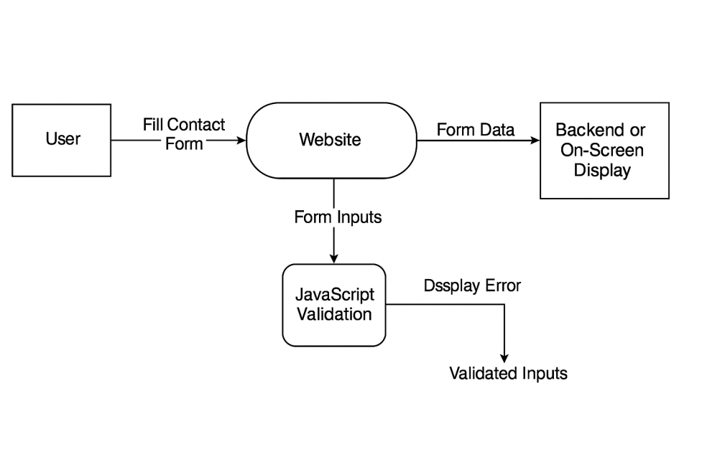

5. Github linK

<https://github.com/Kshatri-Sahil/HTML_project>

**6. DEPLOYED LINK**

<https://shapesngo.com/>

7. CLIENT APPROVAL PROOF

<https://drive.google.com/drive/folders/1-j71lGEyfGsl-Yk5PbDpJzn3pc5FSrQ6?usp=sharing>

**8. CLIENT LOCATION PROOF**

[**https://maps.app.goo.gl/XcsrzCmNsN7cwhQN8**](https://maps.app.goo.gl/XcsrzCmNsN7cwhQN8)

**9. TRANSACTION ID PROOF**

[**https://drive.google.com/drive/folders/1sgPEvyCGC6dXBJ7JshIB93akSKr91gJP?usp=sharing**](https://drive.google.com/drive/folders/1sgPEvyCGC6dXBJ7JshIB93akSKr91gJP?usp=sharing)

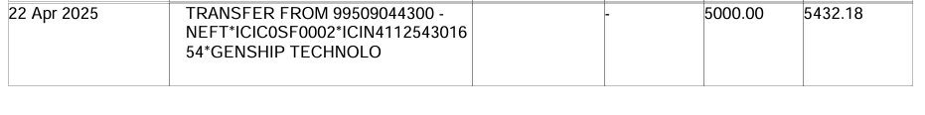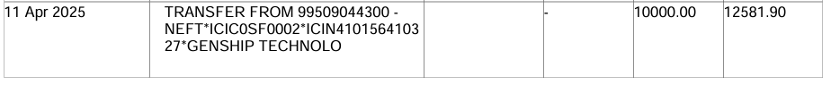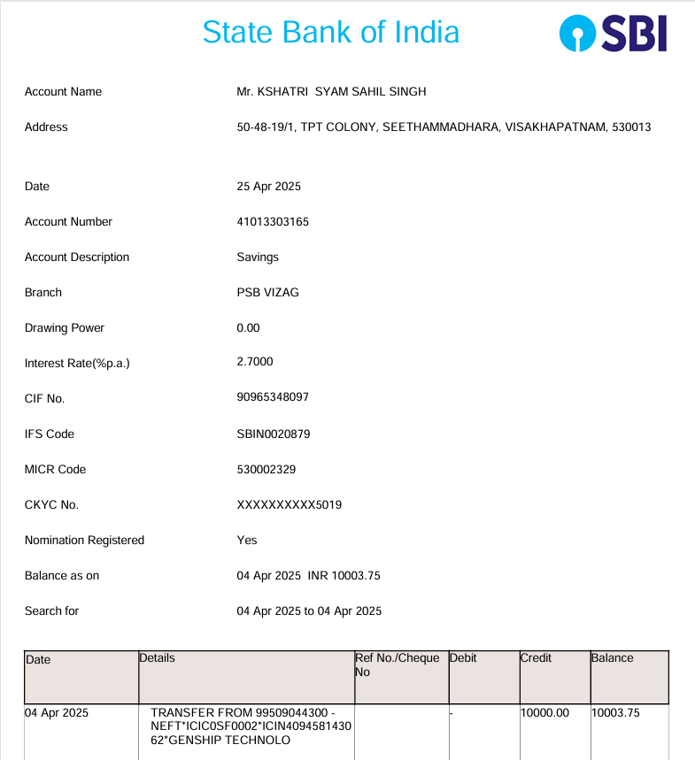

**10. EMAIL ACKNOWLEDGEMENT**

[**https://drive.google.com/drive/folders/1TEhONcSFMRhnsElg-V-ClZhF-c0N2_EG?usp=sharing**](https://drive.google.com/drive/folders/1TEhONcSFMRhnsElg-V-ClZhF-c0N2_EG?usp=sharing)

**11. GST No**

**37AAJCG1410G1ZY**

**12. Video presentation of project**

<https://drive.google.com/file/d/19GeguzAmGQ_j1lhngpIIFL57kbipfc6A/view?usp=drive_link>

# A. Appendices

### ****A.1 Appendix 1: Conceptual Documents****

**Project Title:**  
Website Revamp for SHAPES NGO

**Project Description:**  
This project aims to modernize and enhance the SHAPES NGO website to improve user engagement, provide easier access to information, and facilitate communication through interactive features like a contact form and responsive navigation. The updated site is developed using HTML, CSS, Bootstrap, and JavaScript.

**Objectives:**

* Provide a user-friendly interface
* Ensure mobile responsiveness
* • [Bootstrap Documentation](https://getbootstrap.com/)
* • JavaScript W3Schools Reference
* • [SHAPES NGO Website](https://shapesngo.com/)
* • IEEE SRS Guide: IEEE Std 830-1998
* Feature an image carousel showcasing NGO activities
* Maintain compatibility across major web browsers

## A.2 Appendix 2

• [Bootstrap Documentation](https://getbootstrap.com/)

• JavaScript W3Schools Reference

• [SHAPES NGO Website](https://shapesngo.com/)

• IEEE SRS Guide: IEEE Std 830-1998