**Intel College Excellence Program   
Project Synopsis**

**“Smart Car Parking System”**

|  |  |  |  |
| --- | --- | --- | --- |
| **Team member’s detail** | | | |
| **S.No.** | **Participant Name** | **Mobile No.** | **Email ID** |
| 1 | Kshatri Syam Sahil Singh | 7207419008 | Ksyamsahilsingh11@gmail.com |
| **Faculty(college) mentor detail** | | | |
| **S.No.** | **Mentor Name** | **Mobile No.** | **Email ID** |
| 1 | Dr. Shelej Khera |  |  |
| **College/University Name** | | | |
| **Lovely Professional University** | | | |

**ABSTRACT**

The Smart Car Parking system integrates IR sensors for entry/exit, ultrasonic sensors for slot occupancy, RFID for user identification, and a servo motor for gate control. Utilizing Arduino, the system dynamically updates slot availability on an I2C LCD. Challenges in sensor integration, calibration, and servo motor control were addressed for reliable performance. The proposed enhancements include IoT integration for remote monitoring. This project showcases an efficient solution for parking management, emphasizing automation, user identification, and real-time status updates.

**BACKGROUND**

Parking management in urban areas poses challenges due to limited space and increasing vehicle numbers. Traditional manual monitoring lacks efficiency and real-time updates, leading to congestion and inconvenience. The Smart Car Parking project addresses these issues using IoT and sensor technology. IR sensors detect vehicle entry/exit, while ultrasonic sensors monitor slot occupancy. A servo motor controls gate access based on availability, enhancing security and traffic flow. The Arduino microcontroller processes sensor data, updating an I2C LCD screen with slot status. Integrating automation streamlines parking operations, optimizing space utilization and improving user experience. Such systems align with smart city initiatives, promoting sustainable and efficient urban infrastructure management. The addition of RFID technology enhances security and enables personalized user access. These technologies, coupled with servo motor control for gate operation, create a comprehensive smart parking solution. The project aims to optimize parking space utilization and enhance user convenience through automated processes.

**COMPONENTS**

1. **IR Sensor** - IR sensors emit infrared light and contain a receiver to detect reflections. When an object, such as a vehicle, interrupts the emitted IR beam, the receiver detects the change in reflected light intensity, indicating the presence of the object. In the Smart Car Parking project, IR sensors play a crucial role in detecting vehicle presence at entry and exit points.
2. **Ultrasonic Sensor** - The sensor emits ultrasonic waves from its transmitter. These waves travel through the air until they encounter an obstacle, such as a vehicle. The ultrasonic sensor is a key component in the Smart Car Parking project, playing a crucial role in detecting vehicle presence in parking slots.
3. **Servo** - The servo motor is a crucial component in the Smart Car Parking project, responsible for controlling the gate barrier's movement based on sensor inputs. Unlike traditional motors, a servo motor can rotate to a specific angle, making it ideal for precise control tasks.
4. **I2C LCD** - The I2C LCD is a type of liquid crystal display that communicates over the I2C (Inter-Integrated Circuit) protocol, allowing for efficient data transfer between devices. It consists of a liquid crystal display panel and an I2C communication interface, which reduces the number of pins required for connection, making it ideal for projects with limited GPIO pins.
5. **RFID** - RFID (Radio-Frequency Identification) technology is integrated into the Smart Car Parking system to enhance user identification and security. Each authorized user is provided with an RFID tag or card containing unique identification information. When a user approaches the parking gate, the RFID reader scans the RFID tag, verifying the user's identity. This process allows seamless and secure access to the parking facility, preventing unauthorized entries. The RFID system adds an extra layer of security and convenience, streamlining the parking process for users while maintaining control over access to parking slots.

**OPERATIONAL PROCESS**

1. **Initialization:** The system initializes the IR sensors, ultrasonic sensors, servo motor, and LCD display upon startup. The servo motor starts in a closed gate position (90 degrees).
2. **Sensor Readings:** The Arduino continuously reads data from the IR sensors (for entry and exit) and ultrasonic sensors (for slot occupancy). The ultrasonic sensors detect the presence of vehicles in each parking slot.
3. **Gate Control:** When a vehicle approaches the entry IR sensor and a parking slot is available (detected by ultrasonic sensors), the gate opens by rotating the servo motor to 180 degrees. The LCD updates to reflect the current slot availability.
4. **Parking Status Update:** The system updates the parking slot status based on sensor readings. If a slot becomes occupied, the corresponding status on the LCD changes to "Fill." Conversely, when a vehicle exits, the slot status changes to "Empty."
5. **Dynamic Slot Management:** The system dynamically manages available parking slots, adjusting the slot count as vehicles enter or exit. It ensures that the gate opens only when a slot is available, preventing unauthorized entry when the parking lot is full.
6. **Gate Closing:** After a vehicle enters or exits, the gate automatically closes after a brief delay (1 second in this case), returning the servo motor to the closed position (90 degrees).
7. **Continuous Monitoring:** The system loops continuously to maintain real-time monitoring and parking slot management, providing an efficient and automated smart parking solution.

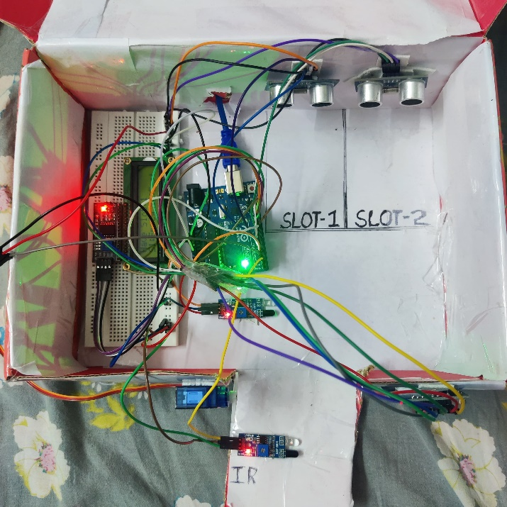**HARDWARE OUTPUT**

**PROTEUS OUTPUT**

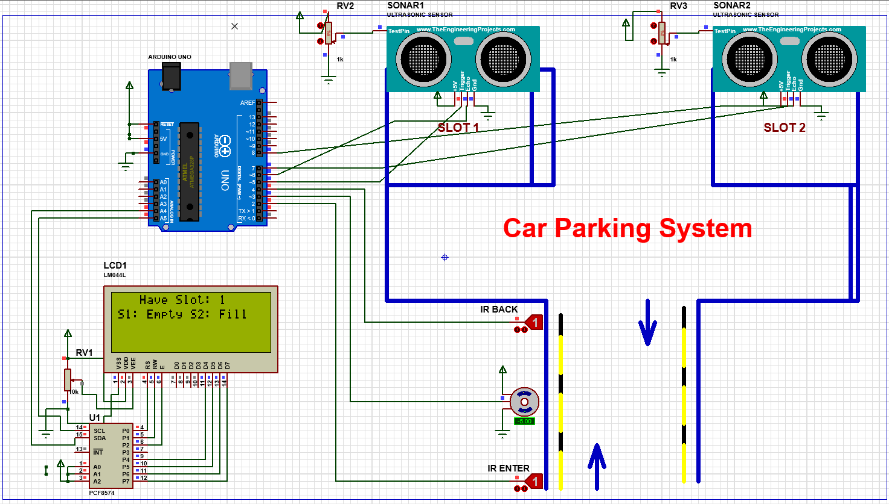

**PROBLEM FACED**

Integration of multiple sensors posed challenges in precise distance measurement and reliability, especially in varying environmental conditions. Calibration and tuning were necessary to ensure accurate slot occupancy detection. Additionally, servo motor control required fine-tuning for smooth gate operations without false triggers. Debugging communication issues with the I2C LCD and managing sensor interference during simultaneous readings were also encountered challenges during development.

**PROPOSED SOLUTION**

Address I2C communication issues through proper wiring, addressing conflicts, and ensuring consistent data transfer between Arduino and the LCD module.

**FUTURE SCOPE**

**IoT Integration:** Incorporate IoT connectivity to enable remote monitoring of parking status, user access logs, and system health. This allows facility managers to access real-time data and make informed decisions.

**Mobile App Interface:** Develop a mobile application for users to check parking availability, reserve slots, and receive notifications about their parking status. Integration with RFID for contactless entry can enhance user convenience.

**CONCLUSION**

In conclusion, the Smart Car Parking project showcases a functional and scalable solution for modern parking management needs. By leveraging IR sensors for entry/exit tracking, ultrasonic sensors for slot occupancy detection, and a servo motor for gate control, the system effectively optimizes parking space utilization.

The proposed future scope of integrating a payment system and RFID technology for membership access promises added security and convenience for users. This enhancement not only streamlines the parking process but also opens revenue opportunities through membership subscriptions or pay-per-use models.

**REFERENCES**

https://github.com/Kshatri-Sahil/Smart-Car-Parking.git