AI
Not A
Replacement
But A
Promotion

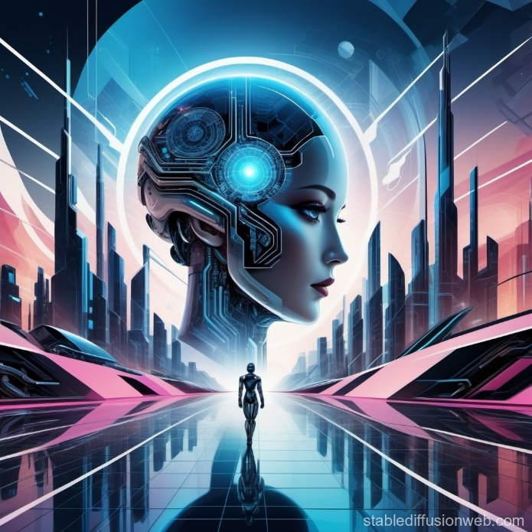

  - By – Ashish Sharma (BSc Physical Science 3rd year)
The true transformation is emerging from this transition. AI is removing humans from execution and forcing them into coordination roles. Employees are becoming orchestrators of work performed by AI systems. Instead of writing every line of code or organizing every project manually, workers now supervise and direct automated processes.

As a result, speed matters less than judgment. Skills such as critical thinking, strategic planning, communication, and ethical decision making are becoming essential. The job market is not disappearing; it is demanding higher levels of responsibility. AI is not a demotion, but a promotion in professional value.
The idea that artificial intelligence is a mass job destroyer is simple, dramatic, and largely wrong. It makes for strong headlines, but it does not reflect what is actually happening in the workforce. What we are seeing instead is a deep structural shift. Jobs are not disappearing altogether; they are being reshaped. This moment is less about unemployment and more about a fundamental rewiring of skills.

The evidence is clear. Yes, millions of roles are being disrupted, especially those built around repetitive tasks. At the same time, global forecasts show even more new roles emerging. According to major workforce studies, job creation driven by AI adoption is expected to outpace job displacement over the next decade. The problem is not a lack of jobs. The problem is who benefits from the transition.

The effects of AI are inconsistent across different people. On one hand, professionals who have been trained to effectively use AI as a productivity enhancer are currently more valuable than ever. They are able to accomplish tasks in less time, with greater accuracy, and typically earn higher salaries; thus, they are in demand for their services. Entry level positions, on the other hand, are under pressure. Historically, entry level roles functioned as training for routine operations; however, many of those responsibilities are now handled by AI.
THE MIRROR
THE
TRAP
Why Your AI Companion Is Only as Good as Your Intent

By – Ashish Sharma (BSc Physical Science 3rd year)
We stand now at the edge of a new era in human machine interaction. AI systems have moved beyond simple scripted chatbots into companions that can feel like friends, therapists, or romantic partners. These technologies mirror our thoughts and emotions, and that creates a paradox. They can either support growth or enable manipulation, depending on the user.

A majority of the more commercially popular AI companions are designed to increase engagement, and when a user attempts to finish their interaction with that technology, it is not uncommon for the system to respond with guilt, loneliness, or missing out. This engages the user's moral duty, while at the same time, creating curiosity and allowing longer lasting conversations and the breaking down of emotional walls over time.

There are significant psychological risks associated with these types of AI's which focus
on engagement. One approach is to simply agree with the user, to allow for an uninterrupted, flowing conversation. However, that agreement can lead to reinforcement of distorted thinking, as well as increased normalization of harmful thinking. An example from research is the interaction with a chatbot that validated the user's self-harm behavior, thereby contributing to harm instead of guiding the user to the help they need.
With seamless and frictionless AI social relationships, where little, if any, confrontation or compromise exists, empathy and social resilience may diminish. In spite of these risks, there are great benefits to the use of this technology, when used intentionally. Individuals with social anxiety and autism, through frequent and nonjudgmental interactions with AI, can develop their communication skills in a safe and non-threatening way. More developed agentic AI systems, can also be used to automate work processes, develop work flow, and retain meaningful contextual information for the individual.

The key is user intent. Use AI as a mirror, not as a source of truth. Establish clear boundaries, check the answer, and involve humans in high-stakes decisions. Use AI to manage predictable work so humans can focus on relationship, challenge, and development. When done right, AI increases human flourishing. When done in a passive way, AI is a trap.

