  - By Keshav Pal, BSc (H.) CS 3rd Year

ArsdSaathi
Your Campus, Simplified
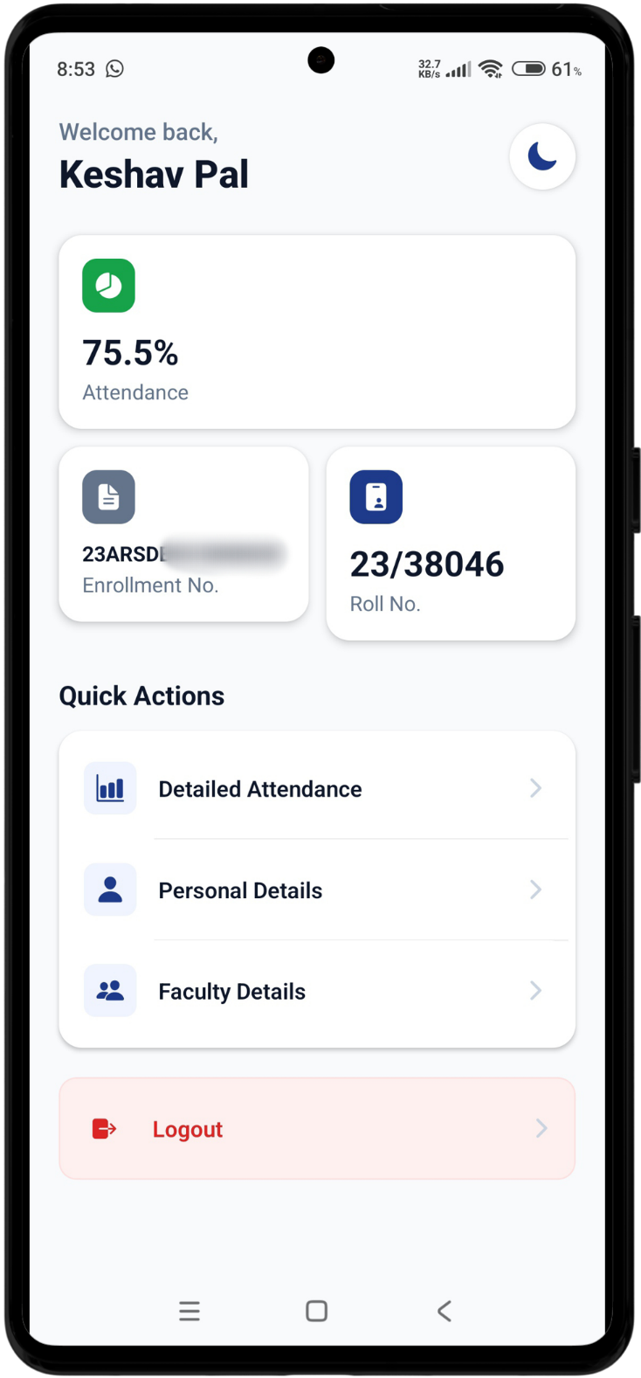
In a world where academic life is split across multiple web portals, students often find themselves navigating clunky interfaces just to check their most basic stats. The primary goal was simple: to build a platform that does the hard work for you. By utilizing web scraping techniques, the app pulls real-time data from the official college website and presents it in a clean manner. No more hunting for login links or zooming in on non-responsive tables. ArsdSaathi puts your academic identity front and center.

Design with Purpose
Attendance Tracking | Academic Snapshot | Streamlined Access
A primary metric showing your current percentage about where you stand. | At-a-glance views of your current Faculty and Basic Details | With functional buttons and personalized "Welcome" header
When I first drafted the UI for ArsdSaathi, the focus was on the "critical metrics"— the things a student needs to know in five seconds or less. The dashboard isn't just a display; it's a hub for:

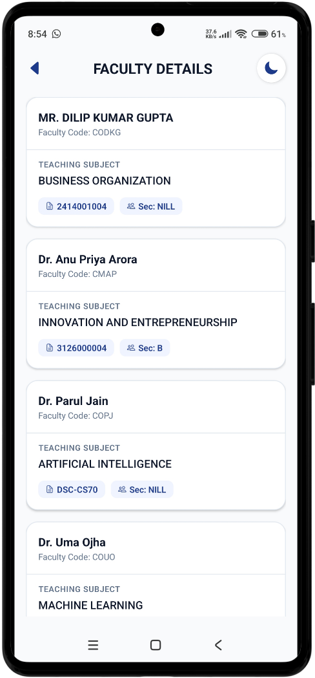

Features
1. LOGIN PAGE: To lessen the stress of constantly filling your details, our app would save it in the cache once you fill the credentials in.

2. SECURED CREDENTIALS: No tension of security since it would be saved in your local storage! Therefore, you can always open up the application by logging in once, and that’s it!

3. SMOOTH UI: No more unnecessary redirects or unresponsive elements of the website. One click here and one click there with labelled functions. Accessibility features also introduced to help the physically challenged.

4. DETAILS RETRIEVAL: You needn’t visit the website check the basic, faculty, attendance details! Everything is within the reach of few buttons and clicks, and you get the results in no time.

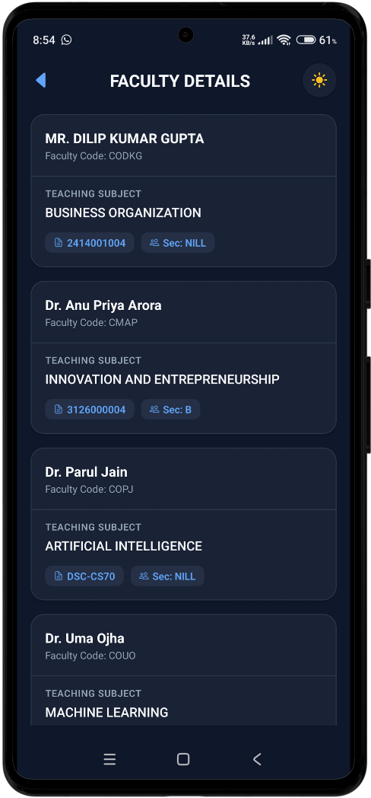

5. DASHBOARD LOOK: Once you log into the app, you needn’t travel through a list of menu bars to get to your destination. Get the basic information at your home screen without wasting your precious time!

6. UP TO DATE INFO: The data that you retrieve doesn’t go a through a list of processes. Instead, the data is directly extracted from the website, so, everything is up to date as according to the official website.

7. DARK THEME: App for ARSDians, made by ARSDians. Today’s generation prefers dark theme more, and hence we have enabled an option to switch to your preferred theme!

8. DETAILED ATTENDANCE: You can have a look at the extended information of your attendance which is represented in a form of table. Columns show the months and the whole table is refreshed based on the subjects.

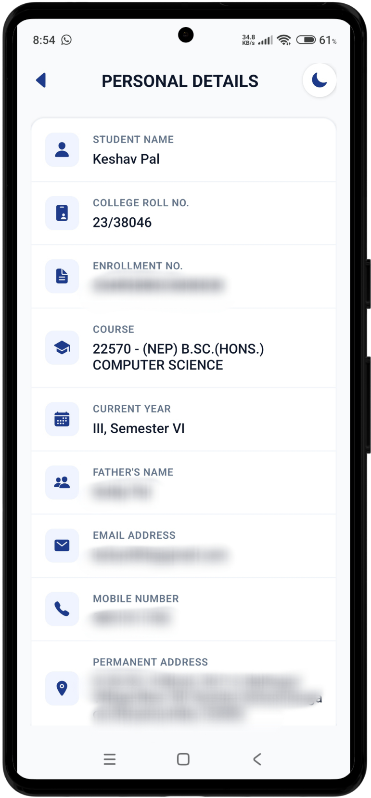

market opportunity
While the Global EdTech market is projected to reach over $200 billion by 2027, most of the investment goes into Learning Management Systems. There is a massive "User Experience Gap" between these backend systems and the daily needs of the student. Colleges like SRCC, already have their own application with much more functionalities. Unlike traditional apps that require expensive API integrations with college servers, ArsdSaathi’s web scraping allows rapid scaling. Also, the data is already public-facing (behind a login), the cost of acquiring and displaying that data is significantly lower than building a platform from scratch.

FUTURE PLANS
- GOAL 1: Increase the scraping speed to retrieve the data.

- GOAL 2: Create an interface where students share the WhatsApp groups for different subjects and semesters.

- GOAL 3: Create an interface where students can share resources and PYQs to help their juniors.

- GOAL 4: Establish a database to accomplish goal 2 and 3.

- GOAL 5: Provide more enhanced accessibility for students with special needs.

DEVELOPED BY:
Keshav Pal,
BSc (Hons.) CS 3rd Year

Shivam Yadav,
BSc (Hons.) CS 3rd Year

VISION
At its core, ArsdSaathi is built on the belief that student data belongs to the student. We envision a future where "checking your stats" isn't a stressful navigation of outdated portals, but a seamless part of your morning routine. By humanizing this data through thoughtful UI/UX, we are giving students back their time and mental energy.

NOTE – The application is still in development. Since the project is open source, contributors and their ideas are welcome. Contact the developers for contribution!

