


DEVELOPED BY
KESHAV PAL (23/38046)
SOMAY SINGH (23/38024)
SHIVAM YADAV (23/38040)
KUNWAR HARSHIT SINGH (23/38082)

Contents
Cover Page
Contents
1 Problem Statement 6
- 1.1 Overview 6
- 1.2 Challenges in the Current System 6
- 1.3 Proposed Solution 7
- 1.4 Conclusion 7

2 Process Model : Agile 9
- 2.1 Phases of the Agile Process 9
  - 2.1.1 Requirement Gathering & Analysis 9
  - 2.1.2 Planning 9
  - 2.1.3 Design 9
  - 2.1.4 Development 10
  - 2.1.5 Testing 10
  - 2.1.6 Deployment 10

3 Sequence and Data Flow 11
- 3.1 Data Flow Diagram Level 0 11
- 3.2 External Entities 11
- 3.3 Major Processes 11
- 3.4 Data Stores 12
- 3.5 Interactions 12
- 3.6 Data Flow Diagram Level 1 12
- 3.7 Detailed Processes 14
- 3.8 Structured Chart 15
- 3.9 Sequence Diagram 16

4 Data Dictionary 18
- 4.1 Entity: Patients 18
- 4.2 Entity: Exercises 19
- 4.3 Entity: Doctors 19
- 4.4 Entity: Appointments 20
- 4.5 Entity: Reports 20

5 Use Case Diagram 21
- 5.1 TherapEase System 21
  - 5.1.1 Description 21
  - 5.1.2 Main Features and Functionalities 22
  - 5.1.3 Actors and their Roles 22
- 5.2 Use Case 1: Book Appointment 23
- 5.3 Use Case 2: performExerciseSession 24
- 5.4 Use Case 3: viewProgressReports 25

6 SRS 27
- 6.1 Introduction 27
  - 6.1.1 Purpose 27
  - 6.1.2 Scope 27
  - 6.1.3 Definitions, Acronyms and Abbreviations 28
  - 6.1.4 References 28
  - 6.1.5 Overview 29
- 6.2 Overall Description 29
  - 6.2.1 Product Perspective 29
  - 6.2.2 Product Function 31
  - 6.2.3 User Characteristics 31
  - 6.2.4 Constraints 31
  - 6.2.5 Assumption and Dependencies 32
- 6.3 Specific Requirements 32
  - 6.3.1 Functional Requirements 32
  - 6.3.2 External Interface Requirements 32
  - 6.3.3 Performance Requirements 33
  - 6.3.4 Design Constraints 33
  - 6.3.5 Software System Attributes 34
- 6.4 Glossary 34

7 Function Point Analysis 35
- 7.1 Identify and Classify function 35
- 7.2 Complexity / Weight Assumptions 36
- 7.3 Count and Weight each Function 36
- 7.4 Unadjusted Function Points 37
- 7.5 Value Adjustment Factor 37
- 7.6 Result 38

8 Gantt Chart 41
- 8.1 Introduction 41
- 8.2 Project Timeline 41

9 Testing 42
- 9.1 Unit Testing Overview 42
- 9.2 Black Box Testing in Unit Testing 42
- 9.3 White Box Testing in Unit Testing 46
  - 9.3.1 Conclusion 49

10 Risks 50
- 10.1 Risk Table 50
  - 10.1.1 Identified Risks 50
  - 10.1.2 Mitigation Strategies 50
  - 10.1.3 Explanation of Probability and Impact 51

11 Feasibility Study 52
- 11.1 Introduction 52
  - 11.1.1 Technical Feasibility 52
  - 11.1.2 Operational Feasibility 52
  - 11.1.3 Financial Feasibility 53
- 11.2 Conclusion 53

11 UI Designs 54
- 12.1 Startup 54
- 12.2 Patient 55
- 12.3 Doctor 56
- 12.4 Extras 57
- 12.5 Link to the Repository 58

1 PROBLEM STATEMENT

1.1 Overview
The services related to Physiotherapy in large hospitals (such as AIIMS), generally face overcrowding and logistical challenges, which makes it difficult for the patients to receive care on time. Most of the patients live far away from the hospital, and require repeated travels for therapy sessions, which can negatively affect their treatment and recovery.
1.2 Challenges in the Current System
- Overcrowded Hospitals: Physiotherapists handle a large number of patients, which further leads to longer waiting times and also reduces one-on-one attention towards certain patients with critical conditions.
- Limited Accessibility: A patient who lives at a far distance from hospitals, faces difficulty in attending regular sessions, which causes interruptions in their therapy.
- No Proper Monitoring System: Performance of exercises at home is not tracked properly (like poses, incorrect rep count), hence, it makes hard for the doctor to assess progress between every visits.
- Delayed Feedback: Any errors in exercise execution go unnoticed until the patient visits the hospital again along with their progress reports, which may delay recovery.
- Inadequate Reporting: There is no systematic way to generate detailed reports on patient adherence, progress, or exercises’ pose correctness.
- Lack of Remote Consultation: Patients cannot easily consult doctors remotely for changes in therapy, resulting in repeated hospital visits.
These challenges often create a hurdle for efficient treatment, patient convenience, and effective monitoring. A new system is required to be introduced which provides real-time tracking and progress reporting both patients and doctors.
1.3 Proposed Solution
To solve these common challenges, a new At-Home Physiotherapy Monitoring App named as TherapEase is proposed. It uses modern mobile and web technologies to make therapy easier, more accessible, and trackable in real time. The main features of this app include:
- Exercise Pose Tracking: The app will monitor patients’ exercises through camera or sensor input, providing feedback on their performances and progressions.
- Automated Progress Reports: All exercise data will be automatically collected and converted into a clear, structured PDF report. Doctors can quickly review the patient’s progress, consistency, and performance.
- Remote Prescription Updates: Doctors can review the reports and adjust exercise plans, intensity, or frequency without needing an in-person visit. This keeps the treatment updated and personalized.
- Reduced Hospital Visits: By enabling home based therapy, this app will greatly reduce the need for frequent hospital travel, easing overcrowding and avoid unnecessary financial burden on travel expenses.
- User-Friendly Interface: The app will be designed for all the age groups, with simple and easy to learn navigation, exercise instructions, and reminders to improve their posture for speedy recovery and correct rep count.
- Data Security and Privacy: All patient data will be stored securely and encrypted, complying with medical data privacy standards.
- Mobile and Web Accessibility: Patients and doctors can access the platform from phones, tablets, or desktops. Everything—from exercise guidance to reports—is just one click away, making it highly convenient.

1.4 Conclusion
The current physiotherapy system struggles with overcrowding, limited accessibility, and the lack of proper monitoring tools, which directly affects patient recovery and overall treatment efficiency. The proposed TherapEase application addresses these issues by introducing a modern, technology-driven approach that enables real-time tracking, automated reporting, and remote doctor–patient interaction.
By reducing unnecessary hospital visits, providing accurate feedback on exercises, and ensuring consistent monitoring from home, TherapEase enhances both patient convenience and treatment quality. Its secure data handling, user-friendly design, and accessibility across multiple devices make it a practical and scalable solution for hospitals and physiotherapy departments.
In summary, TherapEase has the potential to transform the traditional physiotherapy workflow into a smarter, more efficient, and patient-centric system—ultimately improving recovery outcomes and reducing the burden on healthcare facilities.

2. PROCESS MODEL : AGILE

Given the dynamic nature of our application and the need for constant improvements, the Agile Development Model is the most suitable approach for developing the TherapEase. Agile allows for iterative development, frequent feedback, and real-time changes based on user needs and feedback.

2.1 Phases of the Agile Process
2.1.1 Requirement Gathering & Analysis
- Gather detailed requirements from patients, physiotherapists, and hospital administration to understand the major challenges in the current physiotherapy workflow.
- Collect feedback through surveys to identify the essential features needed in the system, such as exercise pose tracking, automated progress reporting, remote prescription updates, and appointment management.
- Analyze the need for monitoring, offline accessibility (e.g., downloadable PDF reports), secure data storage, and seamless doctor–patient communication to ensure the system meets practical and clinical expectations.

2.1.2 Planning
- Divide the project into ‘sprints’, with each sprint focusing on delivering specific features.
- Create a product backlog to manage priorities and ensure mandatory features.

2.1.3 Design
- Create mockups for the patient and doctor interface, ensuring user-friendly navigation.
- Design a machine learning model that supports reliable verification of different exercises.
- Initially for mobile accessibility.

2.1.4 Development
- Development to be carried out incrementally, with each spring focusing on completing a functional part of the system.
- Regular meetings to track progress.

2.1.5 Testing
- Each feature is tested individually as it’s developed.
- Testing includes ensuring that the model can filter out exercises correctly and able to produce feedback on each exercise session.
- Perform user testing to ensure the interface is clear and easy to use.

2.1.6 Deployment
- Once testing is complete, the system is deployed incrementally, with new features being rolled out after each sprint.
- A feedback loop to address any bugs or errors.

3 SEQUENCE AND DATA FLOW

3.1 Data Flow Diagram Level 0
The DFD Level 0 for the Physiotherapy Monitoring App provides a high-level overview of the system, showing how patients, physiotherapists, and doctors interact with the system to track exercises, receive feedback, and update prescriptions.
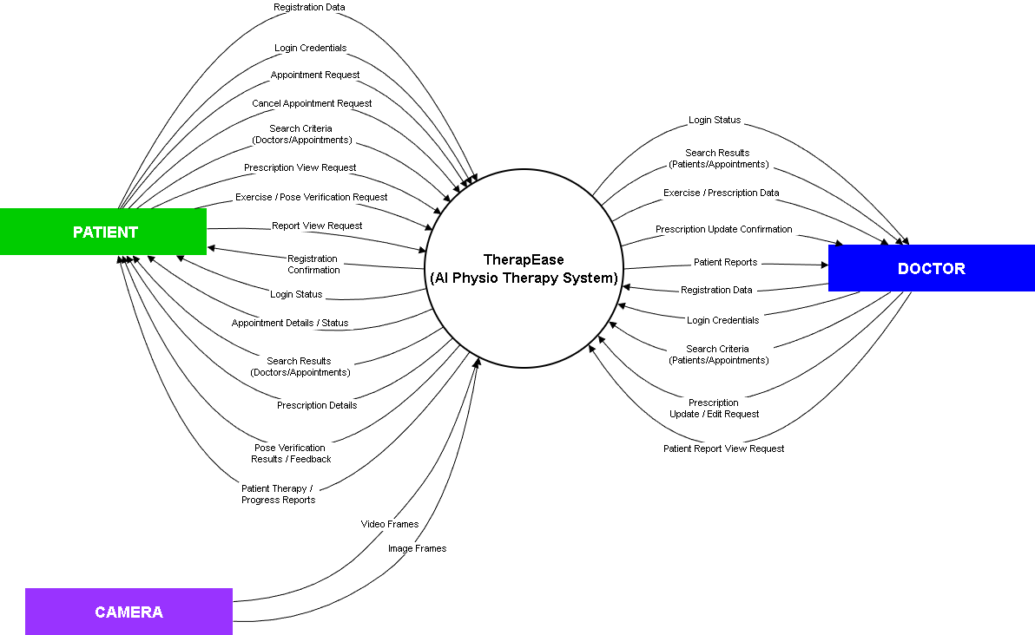
3.2 External Entities:
- Patient: Performs exercises at home and receives feedback.
- Doctor/Physiotherapist: Monitors patient progress, reviews reports, and updates therapy prescriptions.
3.3 Major Processes:
- Exercise Tracking: Captures patient’s exercise performance data.
- Feedback Generation: Analyzes exercise performance and provides feedback to the patient.
- Report Generation: Compiles exercise performance information into a structured report for doctor.
- Prescription Update: Allows the allotted doctor to modify therapy instructions based on the patient’s progress.

3.4 Data Stores
- Patient: Contains patient profiles, physical details, and login credentials.
- Doctor: Stores doctor profiles, qualifications, availability, and credentials.
- Exercises: Holds exercise names, types, and pose-related information.
- Appointments: Keeps track of scheduled dates, times, and assigned exercises.
- Reports: Saves feedback and performance results from each exercise session.

3.5 Interactions
- Patients enter their exercise data → the Exercise Tracking system analyzes it → feedback is immediately returned to the patient.
- Doctors view the generated reports → update or modify prescriptions → updated details are stored in the Appointments data store.

3.6 DFD Level 1
On the next page, DFD Level 1 offers a clearer and more detailed breakdown of how our Physiotherapy App, TherapEase, functions behind the scenes. It expands the high-level processes into specific subprocesses to show exactly how information moves through the system at each stage. It shows how patients begin by recording their exercises through our app, after which the system captures posture data, analyze their movements, and evaluate performance accuracy and structured progress reports.

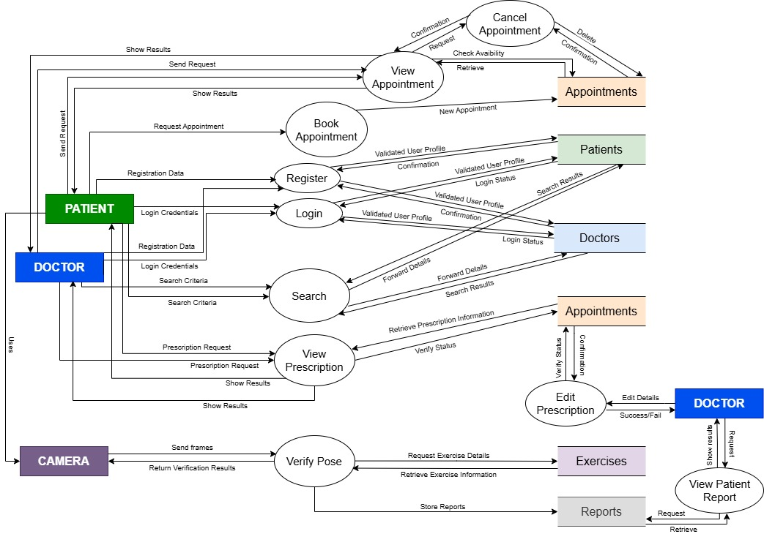
3.7 Detailed Processes:
- Exercise Tracking Subprocesses:
  - Capture Video/Sensor Data
  - Analyze Movements Against Prescribed Exercise
  - Detects Error and Pose deviations

- Feedback Generation Subprocesses:
  - Generate Reports
  - Provide the exercise form feedback to the patient
  - Log Feedback into Reports Data Store

- Report Generation Subprocesses:
  - Compile Exercise Logs
  - Calculate Pose Correctness and Performance Scores
  - Send Reports to the allotted doctor

- Prescription Update Subprocesses:
  - Doctor Reviews Report
  - He/She modifies Therapy or Exercises
  - Writes a personal feedback based on the reports provided
  - Stores Updated Prescription in Appointments Data Store

3.8 Structured Chart

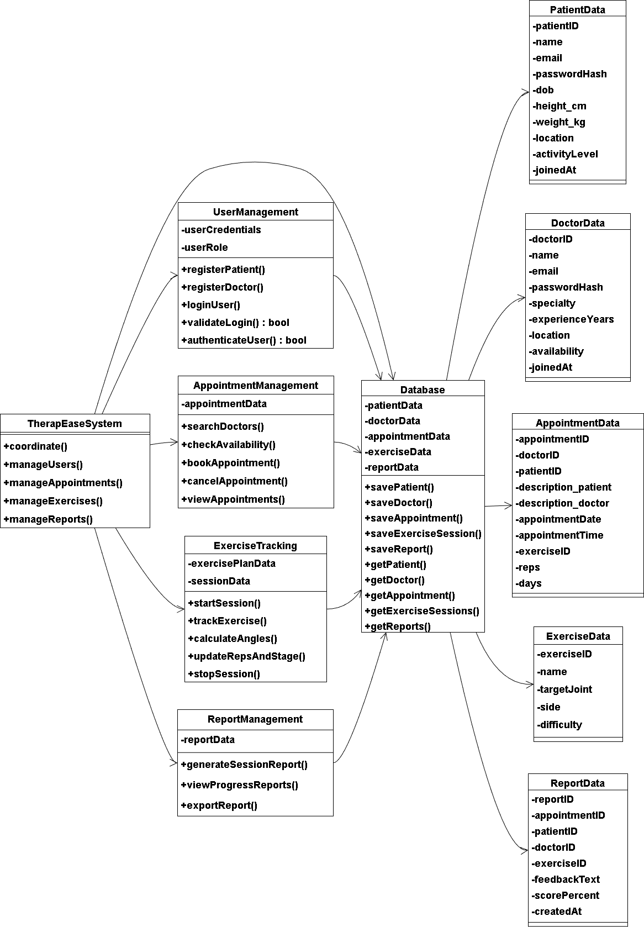

3.9 Sequence Diagram
This sequence diagram explains the flow for patient and doctor registration, authentication, searching for doctors/patients, and booking appointments. It highlights how the Therapease System, At-Home Physiotherapy communicates with backend services such as the Appointment Service, Patient Database, Detection Service, and Doctor Database.
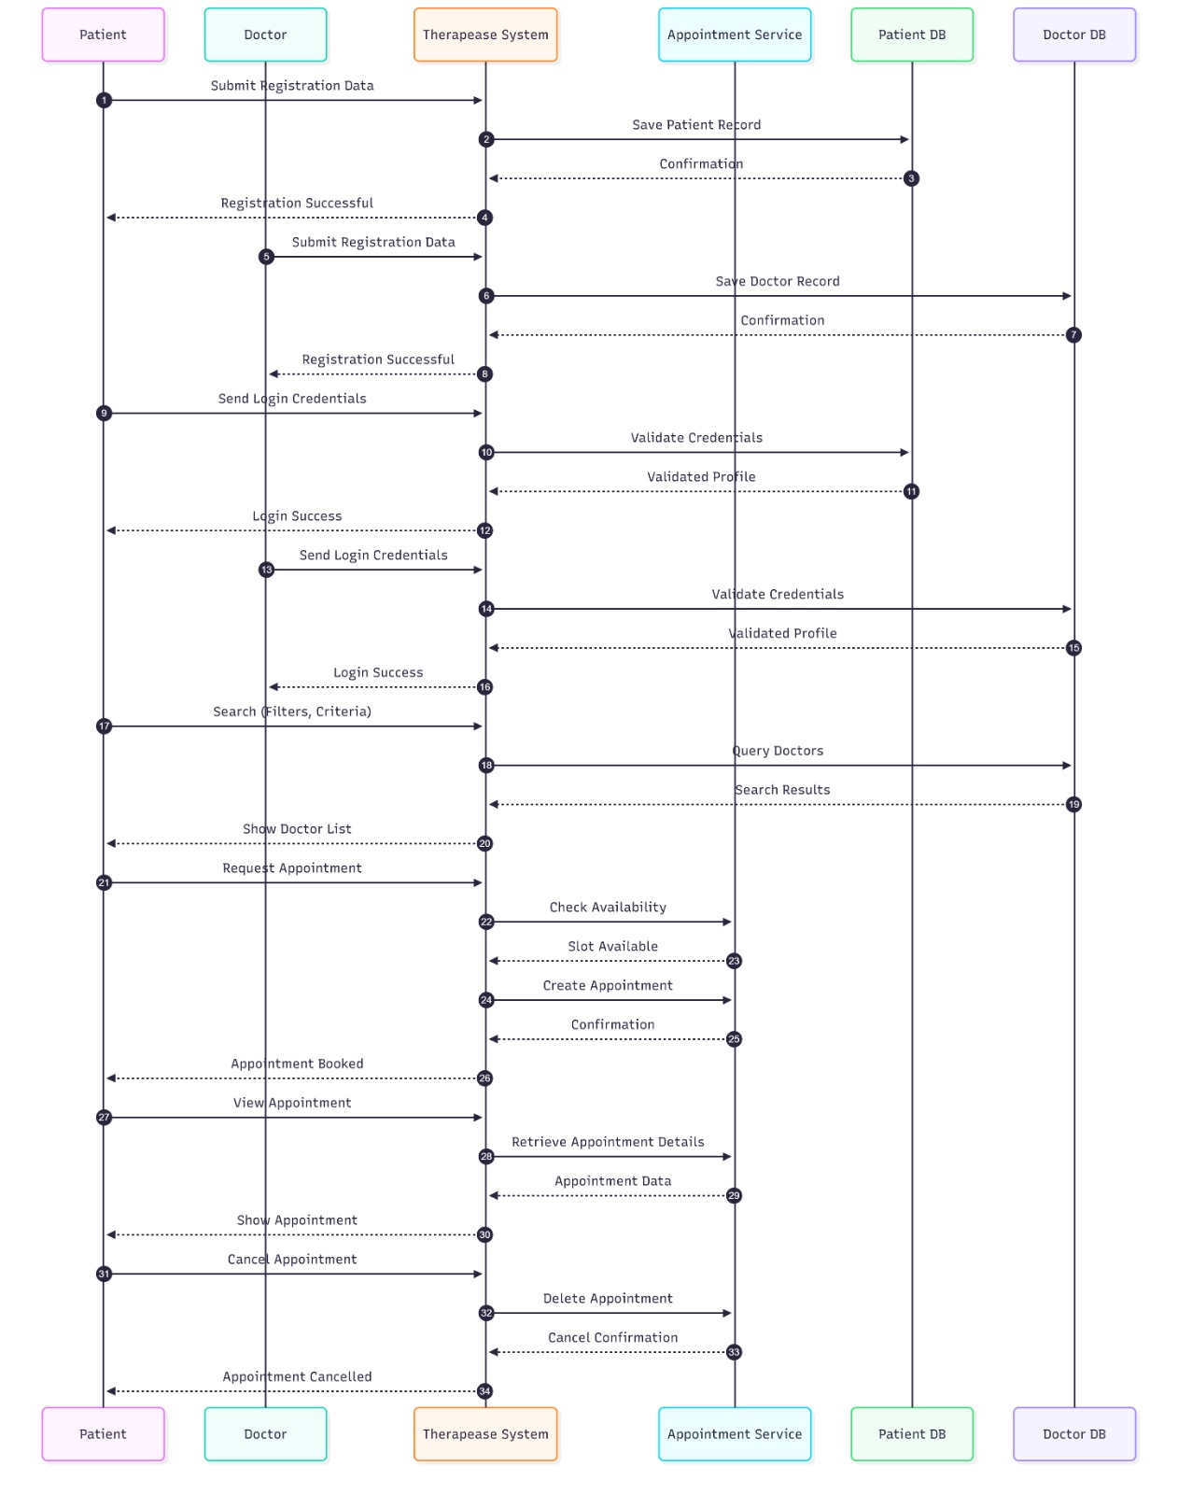

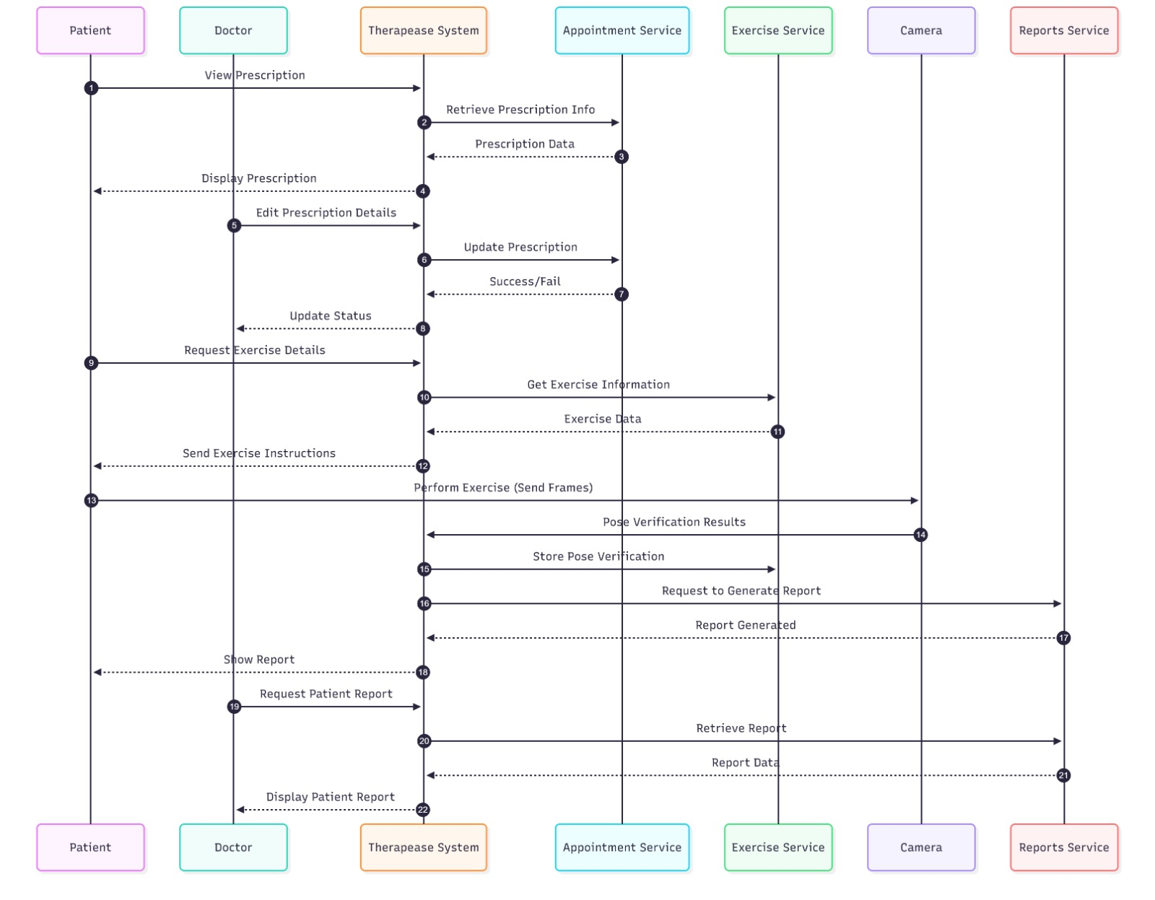

4 DATA DICTIONARY

4.1 ENTITY: PATIENTS
PATIENTS = id + email + password + name + dob + height_cm + weight_kg + location + activity + bio + badges_id + gender + joined_at
Attribute | Description | SQL Data Type | Example
id | Unique patient identifier | INT PRIMARY KEY | 1024
email | Email ID | VARCHAR(100) | riya@example.com
password | Encrypted password | VARCHAR(255) | 34$2328AJDK3##
name | Full name of patient | VARCHAR(50) | Riya Sharma
dob | Patient’s birth date | DATE | 2005-05-02
height_cm | Height in centimeters | INT | 167
weight_kg | Weight in kilograms | INT | 55
location | Location/address. | TEXT | Delhi
activity | Activeness scale | ENUM | minimal
bio | A little bit of profile enhancement | TEXT | I love football!
badges | Awards to signify achievements | TEXT | 100 REPS
gender | Gender of the patient | ENUM | female
joined_at | Date on which patient joined the app | DATE | 2025-25-11

4.2 ENTITY: EXERCISES
EXERCISES = id + name
Attribute | Description | SQL Data Type | Example
id | Unique report identifier | INT PRIMARY KEY | 0006
appointment_id | Appointment identifier | INT | 001
patient_id | Patient identifier | INT | 123
doctor_id | Doctor generating/reviewing report | INT | 112
exercise_id | Exercise identifier | INT | 2025-10-07
feedback | Feedback provided by the system | TEXT | Form can be better
score% | Overall score for the session | INT | 65
created_at | Report generation date | DATE | 2025-12-01

4.3 ENTITY: DOCTORS
DOCTORS = id + email + password + name + age + specialty + experience + location + availability + bio + gender + joined_at
Attribute | Description | SQL Data Type | Example
id | Unique doctor identifier | INT PRIMARY KEY | 11
email | Email ID | VARCHAR(100) | anil3433@gmail.com
password | Encrypted password | VARCHAR(255) | 4$$HELL032##RE
name | Full name of doctor | VARCHAR(50) | Anil Kumbal
specialty | Area of expertise | TEXT | Shoulder
experience | Years of experience. | INT | 3
dob | Doctor’s date of birth | DATE | 1990-11-11
location | Address | TEXT | Faridabad
availability | When doctor is active | ENUM | weekdays
bio | Doctor profile text | TEXT | An apple a day :(
gender | Gender of the doctor | ENUM | Male
joined_at | Date on which doctor joined the app | DATE | 2025-11-11

4.4 ENTITY: APPOINTMENTS
APPOINTMENTS = id + doctor_id + patient_id + description_patient + description_doctor + appointment_date + appointment_time + exercise_id + reps + days
id | Unique identifier for appointment | INT PRIMARY KEY | 002
doctor_id | Doctor allotted | INT | 211
patient_id | Patient involved | INT | 100
description_pation | Patient-provided notes for appointment. | TEXT | I am suffering from asthma.
description_doctor | Doctor's notes or diagnosis for the appointment. | TEXT | Do it before lunch.
appointment_date | Scheduled date | DATE | 2025-11-20
appointment_time | Scheduled time | TIME | 15:30
exercise_id | Prescribed exercise for this session | INT FOREIGN KEY | 2
reps | Number of repetitions prescribed. | INT | 30
days | For how many days prescribed for | INT | 5

4.5 ENTITY: REPORT
REPORTS = id + appointment_id + patient_id + doctor_id + exercise_id + feedback + score + created_at
Attribute | Description | SQL Data Type | Example
id | Unique report identifier | INT PRIMARY KEY | 0006
appointment_id | Appointment identifier | INT | 001
patient_id | Patient identifier | INT | 123
doctor_id | Doctor generating/reviewing report | INT | 112
exercise_id | Exercise identifier | INT | 2025-10-07
feedback | Feedback provided by the system | TEXT | Form can be better
score | Overall score for the session | TEXT | 65%
created_at | Report generation date | DATE | 2025-12-01

5 USE CASE DIAGRAM
5.1 Use Case Diagram: TherapEase System
5.1.1 Description
The Use Case Diagram for the TherapEase system represents the interaction between different types of users and the clinical functionalities they can access. The primary actors identified are:
• Patient: Uses the system to register, log in, search doctors, book and manage appointments, view prescriptions, perform guided exercise sessions, and track progress through reports.
• Doctor: Uses the system to manage their profile, view patient information, create and update prescriptions, define exercise plans, and review patient progress and reports.
• TherapEase Admin: Manages users and system configurations, ensuring that the platform remains secure, consistent, and up to date.
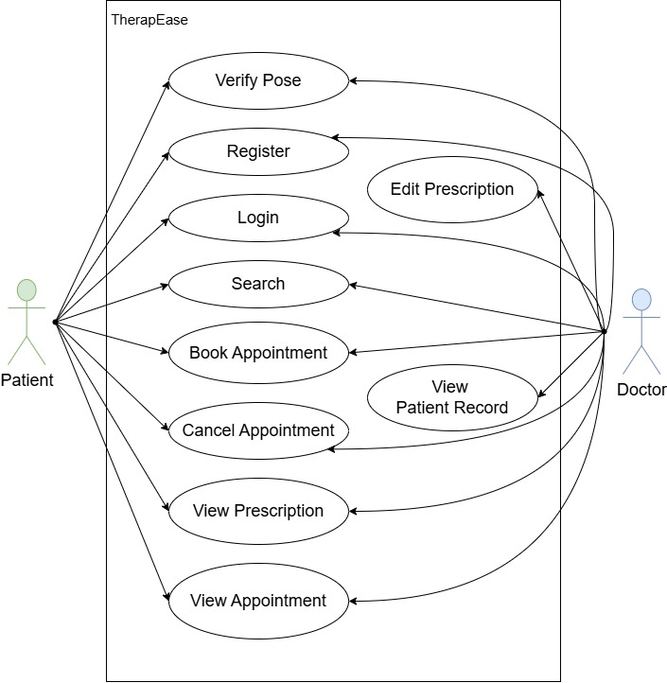

The diagram highlights how these actors interact with the TherapEase system to support end-to-end physiotherapy workflows, from appointment booking to exercise tracking and reporting.

5.1.2 Main Features and Functionalities
- Registration and Authentication:
• Patients, doctors, and admins can register and log in to the system.
• Users can manage their profile information after authentication.
- Appointment Management:
• Patients can search for doctors and view doctor details.
• Patients can book appointments after checking doctor availability.
• Patients can view and cancel their upcoming appointments.
- Prescription and Exercise Plan Management:
• Doctors can view and update patient prescriptions.
• Doctors can define or modify exercise plans based on the patient’s condition.
• Patients can view the latest prescribed exercises and related instructions.
- Exercise Tracking and Posture Evaluation:
• Patients can start a guided exercise session using the system.
• The system evaluates exercise form (e.g., posture and angles) during the session.
• The system updates internal data such as repetition counts, stages, and form quality.
- Progress and Reporting:
• Both patients and doctors can view progress and performance reports.
• The system generates reports using tracked exercise data and past sessions.
- Administration and System Management:
• The admin manages user accounts (patients and doctors).
• The admin configures system settings and monitors overall system behavior.
Figure 5.5: Use Case Diagram: TherapEase System
5.1.3 Actors and Their Roles
• Patient: Registers, logs in, searches for doctors, books and manages appointments, views prescriptions and exercise instructions, performs exercise sessions, and reviews progress reports.
• Doctor: Registers, logs in, manages their profile, views patient prescriptions, updates prescriptions and exercise plans, and reviews patient performance reports.
• TherapEase Admin: Logs in to manage users (patients and doctors), maintain system settings, and ensure smooth operation of the platform.
5.2 Use Case 1: Book Appointment
Use Case Name: bookAppointment
Actors:
– Patient
– (Doctor – as a notified/affected actor)
Description:
This use case defines the process of booking an appointment with a doctor. The patient searches for doctors, views doctor details, checks available time slots, and confirms a suitable appointment. The system ensures that only free slots are booked and stores the appointment details.
Preconditions:
– The patient is registered and logged into the TherapEase system.
– Doctor profiles and availability information are already stored in the system.
Postconditions:
– An appointment is created with a specific doctor, date, and time.
– Appointment details are stored and visible to both the patient and the doctor.
Flow of Events:
- The patient logs into the TherapEase system.
- The patient selects the option to search for doctors.
- The system displays search filters (specialization, location, availability, etc.).
- The patient enters search criteria and submits the request.
- The system retrieves and displays a list of matching doctors.
- The patient selects a doctor to view detailed information.
- The patient chooses the “Book Appointment” option.
- The system checks available appointment slots for the selected doctor.
- The patient selects a preferred date and time slot.
- The system verifies that the selected slot is still available.
- The system creates an appointment entry and stores it in the appointment database.
- A confirmation is shown to the patient, and the doctor’s schedule is updated.
Alternative Flows:
• If no doctors match the search criteria, the system displays an appropriate message and suggests modifying filters.
• If the selected time slot becomes unavailable during booking, the system notifies the patient and prompts them to choose another slot.
Exceptions:
• Failure to fetch doctor list due to backend or network error.
• Failure to create an appointment record due to database error.

5.3 Use Case 2: performExerciseSession
Use Case Name: performExerciseSession
Actors:
– Patient
– (Doctor – indirectly benefits by later viewing reports)
Description:
This use case describes how a patient performs a guided physiotherapy exercise session using TherapEase. The system uses the camera feed, tracks the patient’s movements, evaluates the exercise form, counts repetitions, and stores session data for later reporting.
Preconditions:
– The patient is registered and logged into the TherapEase system.
– The patient has an active prescription or exercise plan defined by a doctor.
– The patient’s device has a functioning camera and a stable internet connection.
Postconditions:
– Exercise session data (angles, counts, stages, timestamps, quality indicators) is stored.
– The system updates the patient’s progress, which can be used for reporting and analysis.
Flow of Events:
- The patient opens the TherapEase app and navigates to the exercise section.
- The patient selects an exercise from the prescribed list (e.g., bicep curl, squat).
- The patient starts the session by choosing “Start Exercise Session”.
- The system sends a request to start a new session on the backend.
- The backend activates the tracking process and starts reading frames from the camera.
- As the patient performs the exercise, pose landmarks are detected on each frame.
- The system calculates joint angles and applies exercise-specific logic to determine stage and count (e.g., “up”, “down”, repetitions).
- The system continuously updates session data, including angle, count, stage, and form quality.
- The patient can see live feedback (such as current count and form status) on the app.
- When finished, the patient selects “Stop Session”.
- The backend stops tracking and finalizes the session data.
- The session results are stored and made available for future viewing in reports.
Alternative Flows:
• If pose landmarks cannot be detected reliably (poor lighting or camera angle), the system may show an instruction message asking the patient to adjust position or camera.
• If the session is interrupted (e.g., network loss), partial data may be stored and an error message is shown to the user.
Exceptions:
• Failure to access the camera or permission denied on the device.
• Backend tracking thread not starting or stopping correctly due to server error.
5.4 Use Case 3: viewProgressReports
Use Case Name: viewProgressReports
Actors:
– Patient
– Doctor
Description:
This use case defines how patients and doctors access detailed progress and performance reports generated from past exercise sessions. Reports may include repetition counts, session dates, average angles, and form quality indicators.
Preconditions:
– Exercise session data has been previously recorded for the patient.
– The patient or doctor is logged into the TherapEase system with appropriate access rights.
Postconditions:
– The requested report is generated (if needed) and displayed to the user.
– The user can review progress over time and, if implemented, export or share the report.
Flow of Events:
- The user (patient or doctor) logs into the TherapEase system.
- The user navigates to the “Reports” or “Progress” section.
- The system prompts the user to select a time range or specific sessions (optional).
- The user selects the desired filters and submits the request.
- The system gathers stored exercise session data for the selected patient and time range.
- The system processes the data and generates a structured report (e.g., tables, charts, summary statistics).
- The generated report is displayed to the user.
- Optionally, the user may choose to download, export, or share the report (if such functionality is supported).
Alternative Flows:
• If there is no recorded data for the selected period, the system displays a message indicating that no sessions are available for reporting.
Exceptions:
• Failure to retrieve stored session data due to database or network errors.
• Error in report generation logic, resulting in incomplete or invalid output.

6 SRS

6.1 Introduction
The Introduction section provides an overview of the project, defining its goals, scope, and terminology. This section serves as a foundation to understand the document’s purpose and its relevance to all stakeholders involved in the system.
6.1.1 Purpose
The purpose of this document is to define the Software Requirements Specification (SRS) for the Physiotherapy Exercise Tracking System (PETS).
This document outlines:
• The functional requirements of the system, including exercise tracking, posture analysis, and repetition counting.
• The non-functional requirements such as performance, reliability, usability, and security.
• The interface requirements for users, software components, and hardware such as cameras and mobile devices.
The PETS aims to assist physiotherapists and patients by providing a system that uses pose estimation to monitor physiotherapy exercises. It tracks joint angles, counts repetitions, and provides visual feedback using a skeleton overlay. The system enables real-time monitoring using a webcam (for the backend) and a mobile application for interaction and display.
6.1.2 Scope
The Physiotherapy Exercise Tracking System (PETS) is designed to address the challenges of unsupervised physiotherapy at home and basic exercise monitoring in clinics. The system’s primary objectives are:
• Exercise Tracking: Monitor specific physiotherapy exercises like bicep curls, squats, shoulder abductions, knee extensions, leg raises, and side bends.
• Pose Analysis: Use pose estimation to calculate joint angles and determine the stage of movement (e.g., up/down, bent/extended).
• Repetition Counting: Automatically count exercise repetitions based on movement patterns.
• Real-Time Feedback: Display ongoing exercise metrics such as angle, count, stage, and basic form quality.
• Media-Based Analysis: Allow users to upload exercise videos or capture frames for analysis.
Key Users:
• Patients: Perform exercises and view real-time feedback.
• Physiotherapists: Use the system to demonstrate exercises and review basic tracking.
• Administrators/Developers: Manage deployment, configuration, and system maintenance.

6.1.3 Definitions, Acronyms, and Abbreviations
Term | Definition
PETS | Physiotherapy Exercise Tracking System
SRS | Software Requirements Specification
API | Application Programming Interface
UI | User Interface
Pose Estimation | Technique for detecting human joint locations from images or video
Repetition (Rep) | One complete cycle of an exercise movement
Backend | Server-side component (FastAPI, MediaPipe, OpenCV)
Frontend | Client-side mobile application (React Native with Expo)
Table 6.1: Definitions, Acronyms, and Abbreviations
6.1.4 References
• IEEE 830-1998 Standard for Software Requirements Specifications
• MediaPipe Pose official documentation
• FastAPI official documentation
• OpenCV documentation
• React Native and Expo documentation
• Institutional/project-level guidelines for health-related software

6.1.5 Overview
The document is organized as follows:
• Section 6 (SRS): Provides the purpose, scope, overall description, and specific requirements of the system.
• Section 9 (Testing): Describes unit, system, and user acceptance testing with black box and white box approaches and executed test cases.
• Section 10 (Risk): Presents a risk table and mitigation strategies.
• Section 11 (Feasibility Study): Evaluates technical, operational, and financial feasibility.
This SRS document serves as a guideline for developers, testers, physiotherapists, and other stakeholders, ensuring clarity and consistency throughout the development lifecycle of PETS.

6.2 Overall Description
This section provides an overarching view of the Physiotherapy Exercise Tracking System (PETS), describing its environment, interactions, and major characteristics. It outlines the product perspective, its users, constraints, assumptions, and requirement distribution.
6.2.1 Product Perspective
The PETS is a client–server based application that combines AI-based pose estimation and a mobile-friendly interface.
System Architecture:
• Backend: A FastAPI-based server processes frames captured from a webcam or uploaded media. It uses MediaPipe Pose and OpenCV to extract body landmarks, calculate joint angles, determine exercise stage, and count repetitions.
• Frontend: A React Native (Expo) mobile application acts as the client, allowing users to select exercises, start/stop sessions, upload or capture media, and visualize data including skeleton overlays.
Position in the Environment:
PETS operates as an independent monitoring tool but can be integrated in the future with:
• Hospital Information Systems
• Electronic Health Record (EHR) systems
• Cloud storage or analytics dashboards
System Interfaces:
PETS interacts with the following systems and components:
• Camera/Webcam: For video input to the backend.
• Mobile Device Hardware: For video/image capture and display.
• Network Services: For HTTP communication between mobile app and backend.
User Interfaces:
The system provides a simple, interactive UI for:
• Patients:
– Choose an exercise from a list
– Start and stop sessions
– Upload videos or capture frames
– View real-time values (angle, count, stage, form) and visual skeleton overlay
• Physiotherapists:
– Demonstrate exercises
– Observe counts and angles for basic evaluation
• Administrators/Developers:
– Configure backend IP, monitor logs, and maintain the system
UI Design includes:
• A dashboard-like screen showing selected exercise and live metrics.
• Buttons for start session, upload video, capture frame, and stop session.
• A preview area with video/image and skeleton overlay.
Hardware Interfaces:
• Client Devices: Android smartphones (and optionally iOS) running the React Native app.
• Server Machine: Laptop or desktop with webcam support to run FastAPI backend.
• Network Equipment: Routers/switches for communication between phone and server.
Software Interfaces:
• Operating Systems: Android for mobile; Windows/Linux/macOS for server.
• Libraries: FastAPI, MediaPipe, OpenCV, NumPy, Axios, React Native, Expo.
• APIs: RESTful endpoints for /start_session, /stop_session, /data, /analyze_frame.
Communication Interfaces:
• HTTP/HTTPS for API calls between mobile and backend.
• Local network (e.g., Wi-Fi) using IP address like http://192.168.x.x:8000.

6.2.2 Product Functions
The primary functions of PETS include:
• Exercise Selection: Allow users to choose between supported physiotherapy exercises.
• Session Management: Start and stop tracking sessions using the backend webcam.
• Pose Detection and Angle Calculation: Use pose estimation to compute angles at key joints (shoulder, elbow, hip, knee, ankle).
• Repetition Counting: Apply exercise-specific logic to count repetitions based on angle thresholds and stage transitions.
• Data Streaming: Provide current values (angle, count, stage, form, keypoints) through /data endpoint.
• Video/Image Analysis: Accept uploaded videos or frames and return analysis results.
• Skeleton Visualization: Provide keypoint locations so the frontend can draw a skeleton overlay.
6.2.3 User Characteristics
The system is intended for users with varied technical backgrounds:
• Patients:
– Basic smartphone proficiency.
– Able to follow on-screen instructions and stand in front of a camera.
• Physiotherapists:
– Moderate to advanced technology usage.
– Interested in understanding basic numeric feedback (angle, count, stage).
• Administrators/Developers:
– Familiar with networking, deployment, and debugging.
6.2.4 Constraints
• Environment Constraints:
– Requires sufficient lighting and clear visibility of the user’s body.
– Camera must capture the full body or relevant limb for accurate detection.
• Technical Constraints:
– Backend and mobile must share the same network (at least in development).
– Performance limited by CPU/GPU of the backend machine.
• Regulatory and Ethical Constraints:
– Although this is an academic prototype, care must be taken if used on real patients.
– Data privacy and consent practices must be respected.
6.2.5 Assumptions and Dependencies
• Users have access to a smartphone and a stable Wi-Fi connection.
• Only one active user/session at a time (global current_data structure).
• Pose estimation model (MediaPipe) works reliably under typical home/clinic lighting.
• The backend IP is correctly configured in the mobile app.

6.3 Specific Requirements
This section provides a breakdown of the functional, external interface, performance, design, and software attribute requirements for PETS.
6.3.1 Functional Requirements
Exercise Management
• The system shall display a list of exercises (bicep_curl, squat, shoulder_abduction, knee_extension, leg_raise, side_bend).
• The system shall allow the user to select exactly one exercise at a time.
Session Control
• The system shall start a new session when the user selects an exercise and initiates start.
• The system shall stop the current session upon user request and release the webcam.
Pose Detection and Analysis
• The system shall capture frames from the webcam during an active session.
• The system shall detect pose landmarks using MediaPipe Pose for each processed frame.
• The system shall calculate joint angles required for the selected exercise.
Repetition and Stage Logic
• The system shall maintain a stage value (e.g., “up”, “down”, “bent”, “extended”).
• The system shall increment count whenever a complete cycle of motion is detected based on angle thresholds.
Data Provisioning
• The system shall expose the current angle, count, stage, form, exercise, and keypoints to the frontend through the /data endpoint.
Media Upload and Analysis
• The system shall accept uploaded video/image files through /analyze_frame.
• The system shall return a JSON response including at least form, angle, count, stage, and exercise (current implementation uses placeholder logic).
Visualization Support
• The system shall provide normalized (x, y) coordinates of detected landmarks so the frontend can render a skeleton.
6.3.2 External Interface Requirements
User Interfaces
- A mobile interface shall show:
– Selected exercise name.
– Reporting netrics (angle, count, stage, form).
– Media uploading confirmation
– Buttons for starting/stopping sessions, uploading video, capturing frames etc.
Software Interfaces
- The frontend shall interact with the backend via RESTful APIs (/start_session, /stop_session, /data, /analyze_frame).
- The backend shall use MediaPipe and OpenCV libraries for pose estimation and frame processing.
Communication Interfaces
• All API calls shall use HTTP over the local network.
• The system should be configurable to use HTTPS in production setups.
6.3.3 Performance Requirements
• The /data endpoint should respond within 500 ms under normal load.
• The system should function acceptably with a single active user on a standard laptop.
6.3.4 Design Constraints
• The backend must be implemented using Python with FastAPI.
• Pose detection must be done using MediaPipe Pose.
• The frontend application must be developed using React Native with Expo.
• The solution must run on mid-range consumer hardware (no GPU dependency assumed).
6.3.5 Software System Attributes
Security
• Only devices that know the backend IP should be able to access the APIs in the current setup.
• For future production use, authentication and HTTPS should be added.
Reliability
• The system shall handle missing detections gracefully (no crash when no person is in frame).
• The system shall reset count and stage correctly when a new session starts.
Usability
• The UI shall be simple enough for non-technical users (patients).
• All important actions should be available via clearly labeled buttons.

6.4 Glossary
• Physiotherapy Exercise: A prescribed physical movement intended for rehabilitation.
• Joint Angle: Angle formed between bones at a joint; used to quantify movement.
• Stage: A label indicating current phase of motion in an exercise (e.g., “up”, “down”).
• Skeleton Overlay: Visual representation of joints and segments drawn over a video or image.

7 FUNCTION POINT ANALYSIS

7.1 Identify and Classify Functions

External Inputs (EI)
User-originated transactions that update or modify system data:
Function | Description | Type
Register | Patient/doctor enters details to create an account | EI
Login | Credentials input for authentication | EI
Book Appointment | Enter appointment request details | EI
Cancel Appointment | Request to cancel or delete an appointment | EI
Edit Prescription | Doctor updates patient prescription | EI
Generate Report | User requests system to generate therapy report | EI
Video Upload / Frames Input | Video/frame data for pose verification | EI

External Inquiries (EQ)
Interactive input + output with no change to persistent data:
Function | Description | Type
Search | Search doctors, patients, exercises, appointments | EQ
View Appointment | Retrieve and display appointment details | EQ
View Prescription | Retrieve and display prescription | EQ

External Outputs (EO)
Formatted or derived information sent out from the system:
Function | Description | Type
Appointment Confirmation / Status | Result of booking/cancel operations | EO
Prescription Display | System-generated formatted prescription | EO
Report (PDF / Summary) | Generated patient therapy report | EO

Internal Logical Files (ILF)
Logical data stores maintained within the system:
ILF Name
Patients
Doctors
Appointments
Reports
Exercises

External Interface Files (EIF)
No external shared files used i.e.
EIF = 0
7.2 Complexity / Weight Assumptions
Using IFPUG standard complexity weights:
Type | Low | Avg | High
EI | 3 | 4 | 6
EO | 4 | 5 | 7
EQ | 3 | 4 | 6
ILF | 7 | 10 | 15
EIF | 5 | 7 | 10
Assumption:
Use Average complexity when the function interacts with multiple data stores or performs processing.
Use Low complexity for simpler or single-step transactions.

7.3 Count and Weight Each Function

External Inputs (EI)
EI Function | Weight
Register | 4 (Avg)
Login | 3 (Low)
Book Appointment | 4 (Avg)
Cancel Appointment | 4 (Avg)
Edit Prescription | 3 (Low)
Generate Report | 3 (Low)
Video Upload | 4 (Avg)
Subtotal (EI) = 4 + 3 + 4 + 4 + 3 + 3 + 4 = 25
External Inquiries (EQ)
EQ Function | Weight
Search | 3 (Low)
View Appointment | 4 (Avg)
View Prescription | 4 (Avg)
Subtotal (EQ) = 3 + 4 + 4 = 11
External Outputs (EO)
EO Function | Weight
Appointment Confirmation / Status | 5 (Avg)
Prescription Display | 4 (Low)
Report Generation | 5 (Avg)
Subtotal (EO) = 5 + 4 + 5 = 14
Internal Logical Files (ILF)
ILF | Weight
Patients | 10 (Avg)
Doctors | 10 (Avg)
Appointments | 10 (Avg)
Reports | 10 (Avg)
Exercises | 10 (Avg)
Subtotal (ILF) = 10 + 10 + 10 + 10 + 10 = 50
External Interface Files (EIF)
Subtotal (EIF) = 0
7.4 Unadjusted Function Points (UFP)
UFP=EI+EO+EQ+ILF+EIF
UFP=25+11+14+50+0=100

7.5 Value Adjustment Factor (VAF)
FP=UFP×VAF
Where:
VAF=0.65+(0.01×ΣFi )
Two scenarios:

Scenario A — Minimal adjustment (unknown GSC values)
Assume each characteristic = 1:
ΣFi =14
VAF=0.65+0.14=0.79
FP=100×0.79=79

Scenario B — Typical medium complexity
Assume each characteristic = 3:
ΣFi =42
VAF=0.65+0.42=1.07
FP=100×1.07=107

7.6 Result
Unadjusted Function Points (UFP) = 100
Adjusted FP (moderate GSC) ≈ 107
This Function Point Analysis reflects the size and complexity of the AI-based Physiotherapy Management System.

8 GANTT CHART
8.1 Introduction
The Gantt chart provides a visual representation of the project schedule for TherapEase, outlining all major phases, tasks, and their corresponding durations. It highlights the sequence of development activities, dependencies between tasks, as well as the overall flow from planning to deployment. Each phase is allocated adequate time to ensure smooth progress of the mobile application and Streamlit prototype development, with milestones marked for phase completion.
8.2 Project Timeline
The project timeline has been divided into multiple phases, each consisting of clearly-defined tasks with specific start and end dates. The schedule spans from 10 September 2025 to 11 November 2025, covering the complete development lifecycle of TherapEase.
Each phase concludes with a major milestone, ensuring that progress is evaluated before moving on to the next stage. The durations are approximate but realistic, ensuring that adequate time is allotted for research, development, integration, and testing.
The timeline is structured into the following phases:

• Phase 1 – Requirements & Planning
Activities include requirement gathering and feasibility analysis. This phase ensures a clear understanding of system expectations before development begins.

• Phase 2 – Architecture & UX Design
High-level architecture is designed, followed by UX flow creation and interface wireframing for both the mobile app and prototype.

• Phase 3 – Streamlit Prototype Development
A working prototype is built to demonstrate the concept and provide a testable interface for pose detection and feedback.

• Phase 4 – React Native Core Development
Core mobile application components are implemented using Expo, including UI screens, navigation, and camera integration.

• Phase 5 – Backend & Pose Analysis Service
Backend APIs, pose detection logic, and feedback rules are developed and integrated to support the mobile app.

• Phase 6 – Integration
Both the frontend and backend are connected, ensuring smooth video upload, frame analysis, and real-time feedback flow.

• Phase 7 – Testing & QA
Unit testing and device-level testing are conducted to validate functionality, correctness, and user experience.

• Phase 8 – Deployment & Documentation
The final build is produced, and complete documentation is prepared for submission and demonstration. This structured timeline ensures an organized, step-by-step progression through the entire project, minimizing risks while maintaining development quality and consistency.

TherapEase – Project Timeline Table
ID | Phase / Task | Start Date | End Date | Duration | Completion (%)
1 | Phase 1: Requirements & Planning | 2025-09-10 | 2025-09-17 | 8 days | 100
2 | Requirement Gathering | 2025-09-10 | 2025-09-13 | 4 days | 100
3 | Technical Feasibility | 2025-09-14 | 2025-09-17 | 4 days | 100
4 | Phase 2: Architecture & UX Design | 2025-09-18 | 2025-09-26 | 9 days | 100
5 | System Architecture Design | 2025-09-18 | 2025-09-21 | 4 days | 100
6 | UX Flow & Wireframes | 2025-09-22 | 2025-09-26 | 5 days | 100
7 | Phase 3: Streamlit Prototype | 2025-09-27 | 2025-10-05 | 9 days | 100
8 | Streamlit UI Layout | 2025-09-27 | 2025-09-30 | 4 days | 100
9 | Prototype Logic Integration | 2025-10-01 | 2025-10-03 | 3 days | 100
10 | Presentation Prep & Demo | 2025-10-04 | 2025-10-05 | 2 days | 100
11 | Phase 4: React Native Core Development | 2025-10-06 | 2025-10-20 | 15 days | 100
12 | Expo Project Setup | 2025-10-06 | 2025-10-07 | 2 days | 100
13 | Navigation Setup | 2025-10-08 | 2025-10-10 | 3 days | 100
14 | Core Screens Implementation | 2025-10-11 | 2025-10-15 | 5 days | 100
15 | Camera / Media Handling | 2025-10-16 | 2025-10-20 | 5 days | 100
16 | Phase 5: Backend & Pose Analysis Service | 2025-10-21 | 2025-10-31 | 11 days | 100
17 | Pose Detection API | 2025-10-21 | 2025-10-25 | 5 days | 100
18 | Feedback Logic Rules | 2025-10-26 | 2025-10-29 | 4 days | 100
19 | API Endpoints & Integration | 2025-10-30 | 2025-10-31 | 2 days | 100
20 | Phase 6: Integration | 2025-11-01 | 2025-11-05 | 5 days | 100
21 | Mobile App ↔ Backend Integration | 2025-11-01 | 2025-11-03 | 3 days | 100
22 | Align Prototype & App Output | 2025-11-04 | 2025-11-05 | 2 days | 100
23 | Phase 7: Testing & Quality Assurance | 2025-11-06 | 2025-11-09 | 4 days | 100
24 | Unit Testing | 2025-11-06 | 2025-11-07 | 2 days | 100
25 | Device / Flow Testing | 2025-11-08 | 2025-11-09 | 2 days | 100
26 | Phase 8: Deployment & Documentation | 2025-11-10 | 2025-11-11 | 2 days | 100
27 | Expo Build for Demo | 2025-11-10 | 2025-11-10 | 1 day | 100
28 | Final Documentation & Wrap-up | 2025-11-10 | 2025-11-11 | 2 days | 100

d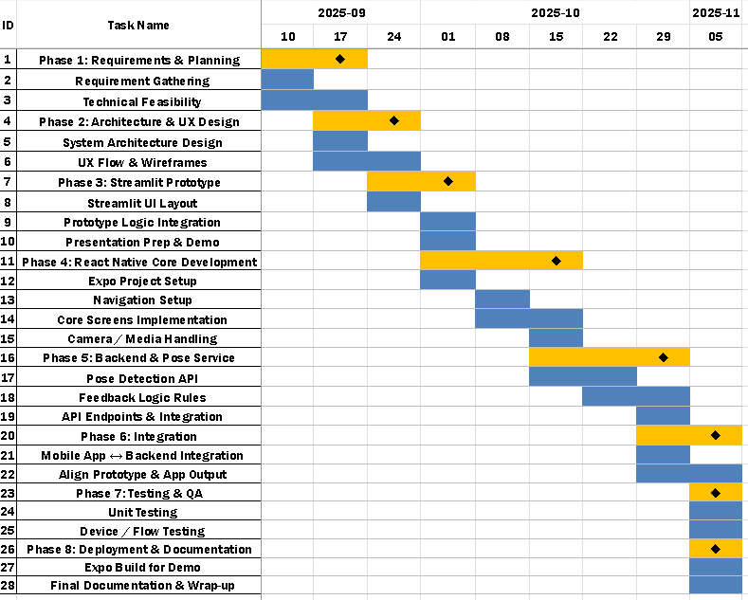

9 TESTING
9.1 Unit Testing Overview
Unit testing focuses on testing individual components such as angle calculation, exercise logic, and API handlers in isolation. It helps to ensure that each function behaves correctly before integrating it into the full system. In this project, unit testing was primarily applied to the backend functions of the Physiotherapy Exercise Tracking System (PETS), including:
- The calculate_angle function used to compute joint angles.
- The exercise logic used to determine stage and count (e.g., bicep curl, squat).
- The API endpoints responsible for starting/stopping sessions and returning live data.
9.2 Black Box Testing in Unit Testing
In black box unit testing, functions are tested purely based on input and output, without considering their internal implementation. The focus is on whether the function behaves as expected for given inputs.
Test Case BB-01: Angle Calculation with Known Points
Input:
Coordinates of three points forming a perfect right angle at the elbow, such as:
- a = (1, 0)
- b = (0, 0)
- c = (0, 1)
Expected Output:
calculate_angle() should return an angle close to 90°.
Actual Result:
The system returned 89.96°, which is within expected floating-point tolerance.

Status: PASS

Test Case BB-02: Bicep Curl Logic – Single Full Curl
Input:
Simulated pose landmark sequence where the elbow angle transitions from:
- Extended → angle > 160°
- Flexed → angle < 40°
Expected Output:
- Stage transitions "down" → "up"
- Count increases by +1
Actual Result:
- Stage correctly changed from "down" to "up"
- Count incremented from 0 to 1
Status: PASS
Test Case BB-03: Bicep Curl Logic – Multiple Repetitions
Input:
Landmark angle sequence for 5 complete curls repeating:
160° → 35° → 165° → 40° → ... (5 cycles)
Expected Output:
Total count = 5
Actual Result:
The backend returned count = 5, matching the expected repetitive pattern.
Status: PASS
Test Case BB-04: Squat Logic – Deep Squat Detection
Input:
Landmark angle sequence for 5 complete curls repeating:
- Knee angle transitions:
- Standing angle ≈ 170°
- Squat angle ≈ 85°
Expected Output:
- Stage transitions correctly: "up" → "down" → "up"
- Count increments by 1 after a full cycle

Actual Result:
- Stage changed as expected
- Count incremented by 1
Status: PASS
Test Case BB-05: No Landmarks Detected (Camera Not Seeing User)
Input:
A frame with no visible human body
Expected Output:
- No crash
- current_data must not update angles or count
- Stage should remain unchanged
Actual Result:
- System remained stable
- No angle/count changes occurred
- No exceptions were thrown
Status: PASS
Test Case BB-06: Invalid Video Upload Format
Input:
User uploads a non-video file (e.g., .txt)
Expected Output:
Backend should reject the file and return an error response.
Actual Result:
Backend responded with:
{"detail": "Invalid file format"}
App displayed an appropriate error message.
Status: PASS

Test Case BB-07: API Error Handling – Backend Offline
Input:
User attempts to start a session while the backend server is turned off.
Expected Output:
Frontend should show an error and remain stable.
Actual Result:
App showed:
“❌ Unable to connect to server.”
The application continued running without any crash.
Status: PASS
Test Case BB-08: Data Endpoint Response Under Load
Input:
User performs quick, continuous movements for 20 seconds.
Expected Output:
- /data should still return valid readings
- No delay > 1 second
- Angle + count values must update continuously
Actual Result:
- No delays observed
- All values updated smoothly
- No frame skips significant enough to affect output consistency
Status: PASS

9.3 White Box Testing in Unit Testing
Cyclomatic Complexity of Backend Functions
Cyclomatic Complexity (CC) is used to measure the structural complexity of a function.
In this project, we calculate CC using the formula:
CC = D + 1
Where, D = number of predicate (decision) nodes (e.g., if, elif, while, for).
Below are the white box activity diagrams and CC calculations for the three primary functions used in exercise tracking.

1. Activity Diagram: calculate_angle(a, b, c)
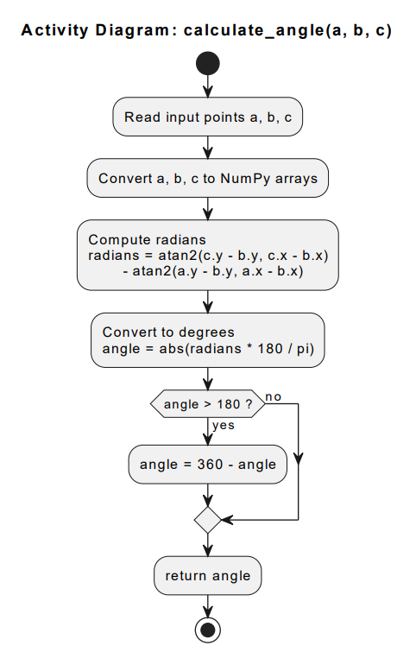

This activity diagram visualizes the internal logic of the calculate_angle() function. It accepts three points (a, b, c), converts them into arrays, computes the angle using inverse tangent functions, converts to degrees, and ensures the angle remains within the 0–180° usable range.
Decision Nodes
- if angle > 180 → 1 predicate
Cyclomatic Complexity Calculation
- D = 1
- CC = D + 1 = 1 + 1 = 2
2. Activity Diagram: track_exercise(exercise)
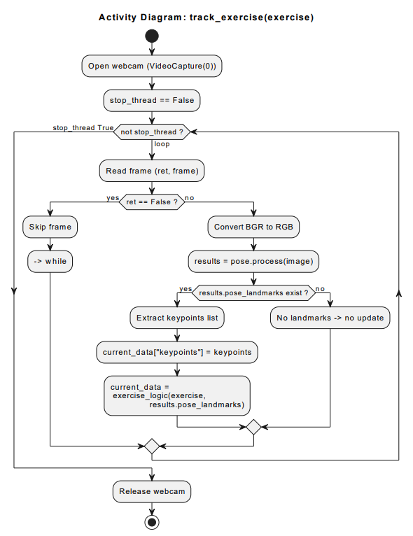

This diagram illustrates the real-time tracking loop that captures webcam frames, processes pose landmarks, updates keypoints, applies exercise logic, and continues until the stop flag is triggered.
Decision Nodes
- while not stop_thread → 1
- if ret == False → 1
- if results.pose_landmarks exist → 1
Total predicates: 3

Cyclomatic Complexity Calculation
- D = 3
- CC = 3 + 1 = 4
Final CC for analyze_frame(): 1

3. Activity Diagram: track_exercise(exercise)
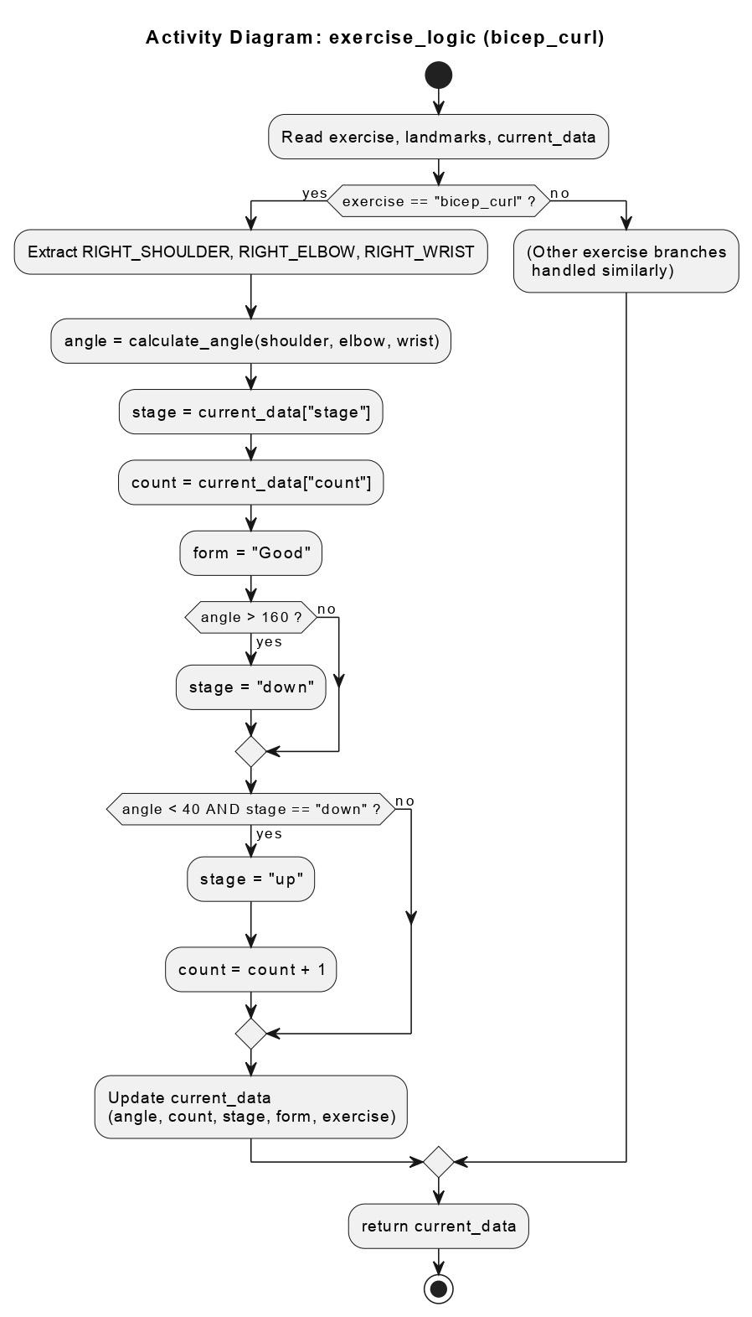

This activity diagram represents the internal logic for the bicep_curl branch inside exercise_logic(). The full function contains multiple branches for other exercises, but this diagram shows one complete flow: extracting landmarks, computing angles, updating stage, validating movement, and incrementing repetition count.
Decision Nodes
For bicep_curl, decisions are:
- if exercise == "bicep_curl"
- If angle > 160
- if angle < 40 AND stage == "down"
Total for this single branch: 3
However, the full function contains 6 exercise branches and 12 inner conditions.

Full Function Cyclomatic Complexity Calculation
- Outer exercise selection: 6
- Inner conditions: 12
- D = 18
- CC = D + 1 = 18 + 1 = 19
9.3.1 Conclusion
- calculate_angle() has a Cyclomatic Complexity of 2, meaning it is simple, linear, and easy to test fully.
- track_exercise() has a Cyclomatic Complexity of 4, typical for loop-based frame processing with multiple checks. It remains testable but requires path-based verification for all branches.
- exercise_logic() has a Cyclomatic Complexity of 19, indicating:
  - High decision density
  - Multiple branches
  - Requires extensive test coverage
  - Ideal candidate for path coverage and decision coverage testing techniques

10 RISK
10.1 Risk Table
This section outlines potential risks specific to the Physiotherapy Exercise Tracking System (PETS) and their mitigation strategies.

10.1.1 Identified Risks
Risk ID | Risk Description | Probability | Impact | Risk Category
1 | Inaccurate pose detection due to poor lighting or angle | 3 | 2 | Critical
2 | Performance issues during pose tracking (low FPS) | 2 | 2 | Critical
3 | Network connectivity failure between mobile and backend | 3 | 2 | Critical
4 | Placeholder logic in /analyze_frame not updated in time | 2 | 2 | Critical
5 | Misinterpretation of data by users as medical diagnosis | 2 | 3 | Catastrophic
6 | Single-session limitation due to global state | 2 | 2 | Critical
7 | Camera permission denied on mobile device | 2 | 1 | High Priority
8 | Security risks if backend is exposed on public network | 2 | 3 | Catastrophic
Table 10.1: Identified Risks for PETS

10.1.2 Mitigation Strategies
• Risk 1: Inaccurate Pose Detection
– Mitigation: Provide on-screen guidance for distance, orientation, and lighting. Include instructions in documentation.
• Risk 2: Performance Issues (Low FPS)
– Mitigation: Optimize frame processing by skipping frames, using efficient NumPy operations, and tuning MediaPipe settings.
• Risk 3: Network Connectivity Failure
– Mitigation: Clearly display connection errors, allow configuration of backend IP, and use retries where appropriate.
• Risk 4: Placeholder Logic in /analyze_frame
– Mitigation: Plan an enhancement milestone to implement real video analysis and clearly mention limitation in documentation.
• Risk 5: Misinterpretation as Medical Diagnosis
– Mitigation: Display strong disclaimers: “This system is a support tool, not a medical device or diagnostic system.” Encourage supervision by physiotherapists.
• Risk 6: Single-Session Limitation
– Mitigation: For academic scope, restrict demo to single user; plan a multi-session architecture as future work.
• Risk 7: Camera Permission Denied
– Mitigation: Use clear permission prompts and show an explanatory message when permission is denied. Provide option to retry.
• Risk 8: Security Risks on Public Network
– Mitigation: Restrict use to local network for demo, recommend using HTTPS and authentication for any wider deployment.

10.1.3 Explanation of Probability and Impact
• Probability:
– 1: Low – Unlikely to happen.
– 2: Medium – May occur.
– 3: High – Likely to occur.
• Impact:
– 1: Low – Limited disruption.
– 2: Medium – Noticeable but manageable.
– 3: High – Severe disruption or serious consequence

11 FEASIBILITY STUDY
11.1 Feasibility Study
The feasibility study examines whether the Physiotherapy Exercise Tracking System (PETS) is practical and viable from technical, operational, and financial perspectives.
11.1.1 Technical Feasibility
Key Considerations:
• Technology Stack:
– Backend: FastAPI (Python), MediaPipe Pose, OpenCV, NumPy.
– Frontend: React Native (Expo), Axios, React Native SVG, Expo Camera, Expo Image Picker.
• Compatibility:
– Can run on common laptops/desktops for backend.
– Mobile app can run on Android devices used by students/patients.
• Scalability:
– Designed initially for single user/single session, but architecture can be expanded with additional session management.
• Security and Privacy:
– Minimal data stored by default; images/videos can be processed in-memory.
Conclusion: Technical feasibility is high. All required technologies are stable, open source, and within the team’s skill set.
11.1.2 Operational Feasibility
Key Considerations:
• User Acceptance:
– Patients can easily interact through simple buttons and visual feedback.
– Physiotherapists can understand angle and count metrics.
• Ease of Use:
– The mobile interface is designed to be intuitive, showing only essential information.
– No complex configuration is required for demonstration setups.
• Training Needs:
– A short demonstration is sufficient for end-users to understand core features.
– Basic user documentation or in-app tips can cover the rest.
• Maintenance:
– Backend and frontend are modular and can be updated independently.
Conclusion: Operational feasibility is good. The system integrates well into typical physiotherapy or academic demo workflows.
11.1.3 Financial Feasibility
Key Considerations:
• Development Costs:
– Uses free and open-source tools (FastAPI, MediaPipe, OpenCV, React Native).
– Requires only standard hardware (no dedicated server or paid libraries).
• Operational Costs:
– Primarily electricity and internet connectivity during demonstrations.
– Optional cloud hosting if extended, but not required for local use.
• Cost–Benefit Perspective:
– Provides educational value and demonstration of AI-based healthcare assistance.
– Could reduce manual effort in counting repetitions and observing form.
Conclusion: Financial feasibility is high for an academic project, as additional monetary investment is minimal.
11.2 Conclusion
The feasibility study concludes that the Physiotherapy Exercise Tracking System (PETS) is:
• Technically feasible using modern, open-source technologies.
• Operationally feasible, as it is easy to use and fits into practical demonstration and training scenarios.
• Financially feasible, with low development and operational costs.
Therefore, the project is viable and justified for development and presentation as an academic/portfolio-level system.

12 UI DESIGN
12.1 User Interface: Startup
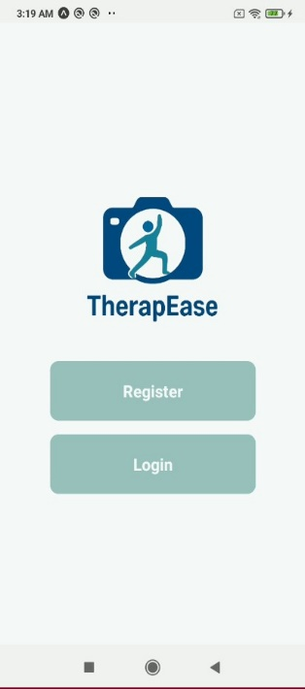
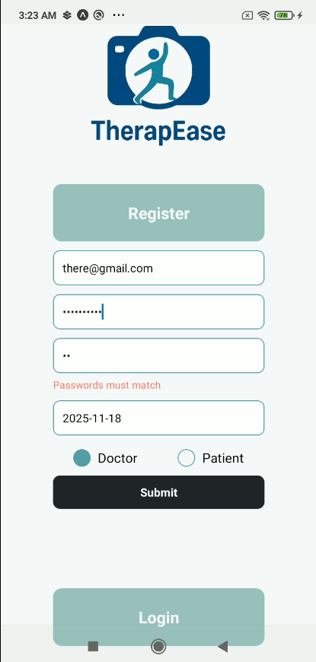
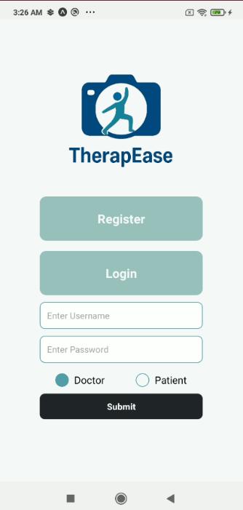
The following images demonstrate the design of the user interface for the TherapEase Startup. The UI has been designed to offer simple and essential services with minimal designing.

Fig 11.1 Registration Screen

12.2 User Interface: Patient
The following images demonstrate the design of the user interface for the page when Patient is logged into the system along with some of the prescriptions.
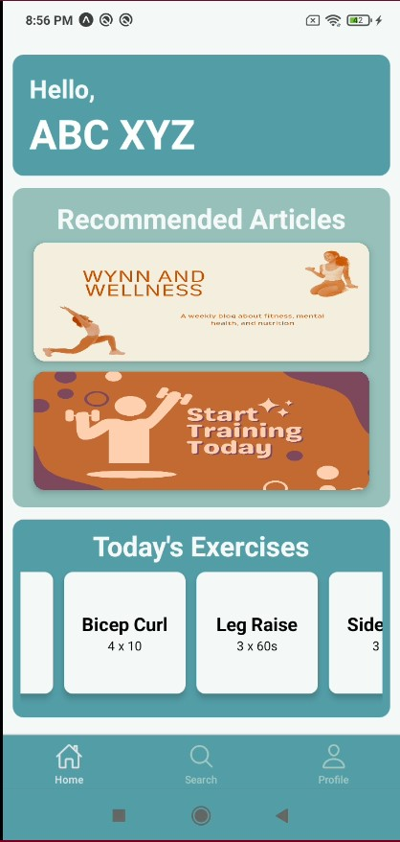
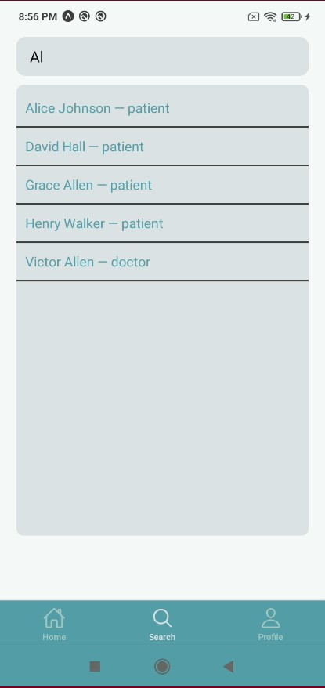
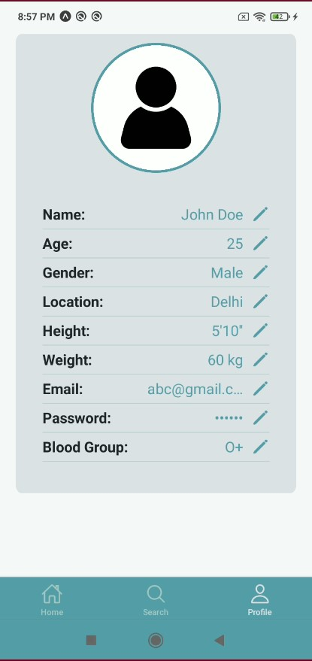

Fig 11.2 Patient Screen

12.3 User Interface: Doctor
The following images demonstrate the design of the user interface for the page when an entity, Doctor is logged into the system along with some of the prescriptions.
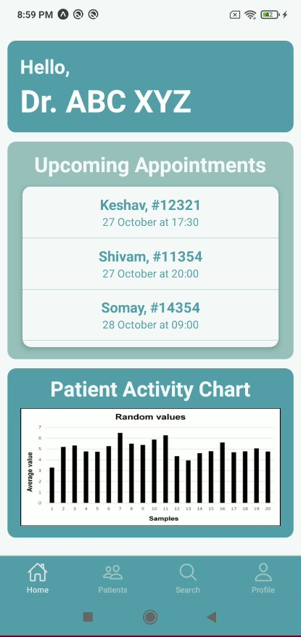
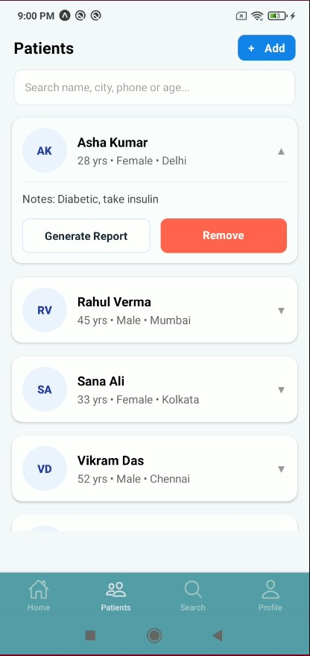
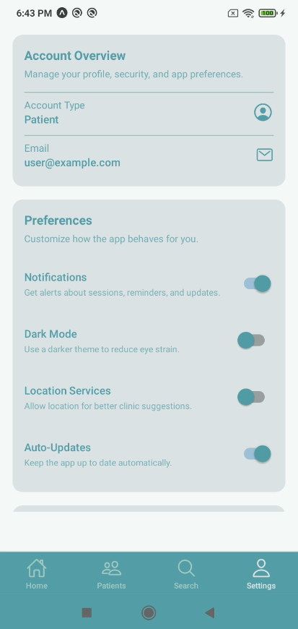

Fig 11.3 Doctor Screen

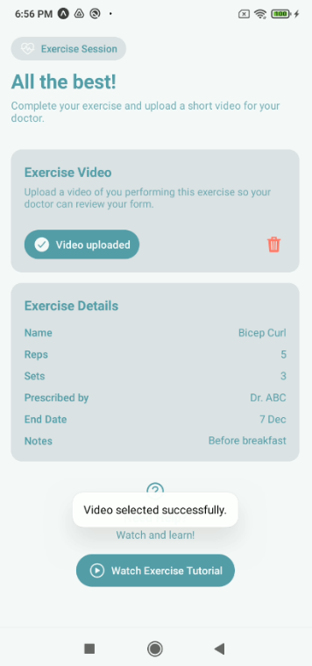
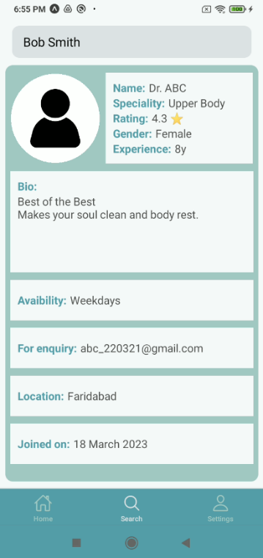
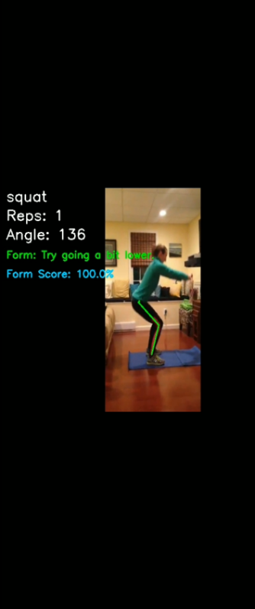
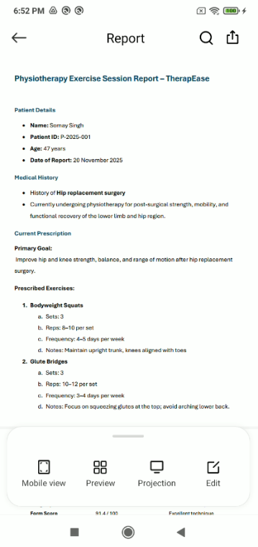
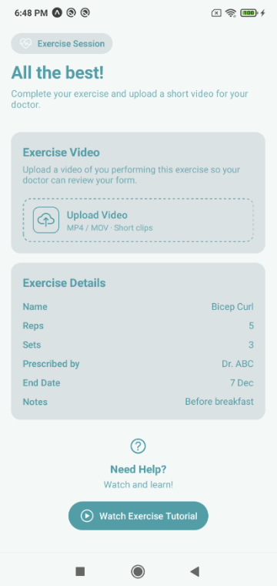
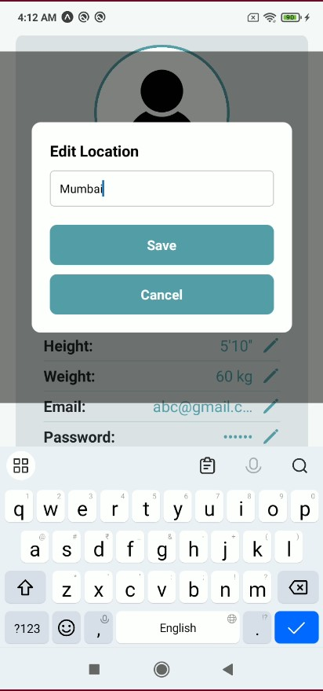
12.4 User Interface: Extras
Fig 11.4 Edit Details Interface | Fig 11.5 Exercise Session Interface | Fig 11.6 Profile found in the Search Results

Fig 11.7 Upload Video Successful | Fig 11.8 Generated PDF | Fig 11.9 Feedback on the basis of pose formation

12.5 Link To The Repository
www.github.com/$$$$$$$$$$$$

