Problem Statement
Overview
The services related to Physiotherapy in large hospitals (such as AIIMS), generally face overcrowding and logistical challenges, which makes it difficult for the patients to receive care on time. Most of the patients live far away from the hospital, and require repeated travels for therapy sessions, which can negatively affect their treatment and recovery.
Challenges in the Current System
The major issues currently faced in the physiotherapy system include:
- Overcrowded Hospitals: Physiotherapists handle a large number of patients, which further leads to longer wait times and also reduces one-on-one attention towards certain patients with critical conditions.
- Limited Accessibility: Patients who live at a far distance from hospitals, face difficulty in attending regular sessions, which causes interruptions in their therapy.
- No Proper Monitoring System: Performance of exercises at home is not tracked properly (like poses, incorrect rep count), hence, it makes hard for the doctor to assess progress between every visits.
- Delayed Feedback: Any errors in exercise execution go unnoticed until the patient visits the hospital again along with their progress reports, which may delay recovery.
- Inadequate Reporting: There is no systematic way to generate detailed reports on patient adherence, progress, or exercises’ pose correctness.
- Lack of Remote Consultation: Patients cannot easily consult doctors remotely for changes in therapy, resulting in repeated hospital visits.
These challenges often create a hurdle for efficient treatment, patient convenience, and effective monitoring. A new system is required to be introduced which provides real-time tracking, progress reporting, and improved accessibility for both patients and doctors.
Proposed Solution:
At-Home Physiotherapy Monitoring App ( TherapEase )
To solve these common challenges, a new At-Home Physiotherapy Monitoring App named as TherapEase is proposed. It uses modern mobile and web technologies to make therapy easier, more accessible, and trackable in real time. The main features of this app include:
- Exercise Pose Tracking: The app will monitor patients’ exercises through camera or sensor input, providing feedback on their performances and progressions.
- Automated Progress Reports: All exercise data will be automatically collected and converted into a clear, structured PDF report. Doctors can quickly review the patient’s progress, consistency, and performance.
- Remote Prescription Updates: Doctors can review the reports and adjust exercise plans, intensity, or frequency without needing an in-person visit. This keeps the treatment updated and personalized.
- Reduced Hospital Visits: By enabling home based therapy, this app will greatly reduce the need for frequent hospital travel, easing overcrowding and avoid unnecessary financial burden on travel expenses.
- User-Friendly Interface: The app will be designed for all the age groups, with simple and easy to learn navigation, exercise instructions, and reminders to improve their posture for speedy recovery and correct rep count.
- Data Security and Privacy: All patient data will be stored securely and encrypted, complying with medical data privacy standards.
- Mobile and Web Accessibility: Patients and doctors can access the platform from phones, tablets, or desktops. Everything—from exercise guidance to reports—is just one click away, making it highly convenient.

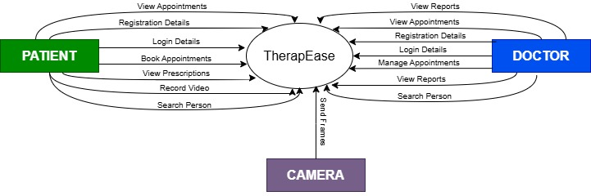
DFD Level 0
The DFD Level 0 for the Physiotherapy Monitoring App provides a high-level overview of the system, showing how patients, physiotherapists, and doctors interact with the system to track exercises, receive feedback, and update prescriptions.

External Entities:
- Patient: Performs exercises at home and receives feedback.
- Doctor/Physiotherapist: Monitors patient progress, reviews reports, and updates therapy prescriptions.

Major Processes:
- Exercise Tracking: Captures patient’s exercise performance data.
- Feedback Generation: Analyzes exercise performance and provides feedback to the patient.
- Report Generation: Compiles exercise performance information into a structured report for doctor.
- Prescription Update: Allows the allotted doctor to modify therapy instructions based on the patient’s progress.
Data Stores:
- Patient: Contains patient profiles, physical details, and login credentials.
- Doctor: Stores doctor profiles, qualifications, availability, and credentials.
- Exercises: Holds exercise names, types, and pose-related information.
- Appointments: Keeps track of scheduled dates, times, and assigned exercises.
- Reports: Saves feedback and performance results from each exercise session.

Interactions:
- Patients enter their exercise data → the Exercise Tracking system analyzes it → feedback is immediately returned to the patient.
- Doctors view the generated reports → update or modify prescriptions → updated details are stored in the Appointments data store.
DFD Level 1
On the next page, DFD Level 1 offers a clearer and more detailed breakdown of how our Physiotherapy App, TherapEase, functions behind the scenes. It expands the high-level processes into specific subprocesses to show exactly how information moves through the system at each stage. It shows how patients begin by recording their exercises through our app, after which the system captures posture data, analyzes their movements, and evaluates performance accuracy. The flow then moves toward processing this analyzed data to generate structured progress reports. These reports are securely stored and made available to the doctor assigned to that patient. The doctor can then review the detailed insights, compare the patient’s progress with the prescribed plan, and update the therapy routine as needed. DFD Level 1 visually demonstrates the full cycle, from exercise input, tracking, and analysis, to data storage, report generation, and prescription adjustments, thus making the internal workflow of TherapEase easy to follow and understand.
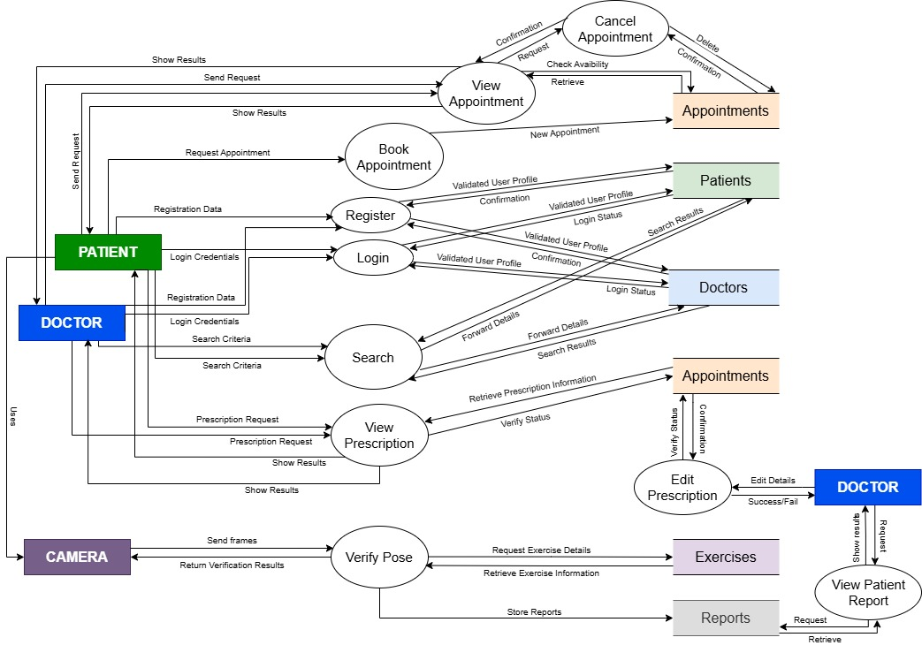

Detailed Processes:
- Exercise Tracking Subprocesses:
  - Capture Video/Sensor Data
  - Analyze Movements Against Prescribed Exercise
  - Detects Error and Pose deviations

- Feedback Generation Subprocesses:
  - Generate Reports
  - Provide the exercise form feedback to the patient
  - Log Feedback into Reports Data Store

- Report Generation Subprocesses:
  - Compile Exercise Logs
  - Calculate Pose Correctness and Performance Scores
  - Send Reports to the allotted doctor

- Prescription Update Subprocesses:
  - Doctor Reviews Report
  - He/She modifies Therapy or Exercises
  - Writes a personal feedback based on the reports provided
  - Stores Updated Prescription in Appointments Data Store

Data Dictionary:

1. ENTITY: PATIENTS
Notation:
PATIENTS = id + email + password + name + dob + height_cm + weight_kg + location + activity + bio + badges_id + gender + joined_at
Attribute | Description | SQL Data Type | Example
id | Unique patient identifier | INT PRIMARY KEY | 1024
email | Email ID | VARCHAR(100) | riya@example.com
password | Encrypted password | VARCHAR(255) | 34$2328AJDK3##
name | Full name of patient | VARCHAR(50) | Riya Sharma
dob | Patient’s birth date | DATE | 2005-05-02
height_cm | Height in centimeters | INT | 167
weight_kg | Weight in kilograms | INT | 55
location | Location/address. | TEXT | Delhi
activity | Activeness scale | ENUM | minimal
bio | A little bit of profile enhancement | TEXT | I love football!
badges | Awards to signify achievements | TEXT | 100 REPS
gender | Gender of the patient | ENUM | female
joined_at | Date on which patient joined the app | DATE | 2025-25-11

2. ENTITY: DOCTORS
Notation:
DOCTORS = id + email + password + name + age + specialty + experience + location + availability + bio + gender + joined_at

Attribute | Description | SQL Data Type | Example
id | Unique doctor identifier | INT PRIMARY KEY | 11
email | Email ID | VARCHAR(100) | anil3433@gmail.com
password | Encrypted password | VARCHAR(255) | 4$$HELL032##RE
name | Full name of doctor | VARCHAR(50) | Anil Kumbal
specialty | Area of expertise | TEXT | Shoulder
experience | Years of experience. | INT | 3
dob | Doctor’s date of birth | DATE | 1990-11-11
location | Address | TEXT | Faridabad
availability | When doctor is active | ENUM | weekdays
bio | Doctor profile text | TEXT | An apple a day :(
gender | Gender of the doctor | ENUM | Male
joined_at | Date on which doctor joined the app | DATE | 2025-11-11

3. ENTITY: APPOINTMENTS
Notation:
APPOINTMENTS = id + doctor_id + patient_id + description_patient + description_doctor + appointment_date + appointment_time + exercise_id + reps + days

Attribute | Description | SQL Data Type | Example
id | Unique identifier for appointment | INT PRIMARY KEY | 002
doctor_id | Doctor allotted | INT | 211
patient_id | Patient involved | INT | 100
description_pation | Patient-provided notes for appointment. | TEXT | I am suffering from asthma.
description_doctor | Doctor's notes or diagnosis for the appointment. | TEXT | Do it before lunch.
appointment_date | Scheduled date | DATE | 2025-11-20
appointment_time | Scheduled time | TIME | 15:30
exercise_id | Prescribed exercise for this session | INT FOREIGN KEY | 2
reps | Number of repetitions prescribed. | INT | 30
days | For how many days prescribed for | INT | 5

4. ENTITY: EXERCISES
Notation:
EXERCISES = id + name

Attribute | Description | SQL Data Type | Example
id | Unique exercise identifier | INT PRIMARY KEY | 01
name | Exercise name | TEXT | knee_extension

5. ENTITY: REPORT
Notation:
REPORTS = id + appointment_id + patient_id + doctor_id + exercise_id + feedback + score + created_at

Attribute | Description | SQL Data Type | Example
id | Unique report identifier | INT PRIMARY KEY | 0006
appointment_id | Appointment identifier | INT | 001
patient_id | Patient identifier | INT | 123
doctor_id | Doctor generating/reviewing report | INT | 112
exercise_id | Exercise identifier | INT | 2025-10-07
feedback | Feedback provided by the system | TEXT | Form can be better
score | Overall score for the session | TEXT | 65%
created_at | Report generation date | DATE | 2025-12-01

Function Point

1) Identify and classify functions
External Inputs (EI) — user-originated transactions that update the system:
- Register (patient details entry) – EI
- Login (credentials entry) – EI
- Book Appointment (request/enter details) – EI
- Cancel Appointment (request to delete/cancel appointment) – EI
- Edit Prescription (request to change) – EI
- Generate Report (request to generate) – EI
- Video Upload (entry for pose verification) – EI
External Inquiries (EQ) — interactive input + output with no persistent update:
- Search (search doctors/patients/appointments) — EQ
- View Appointment (retrieve/display appointment details) — EQ
- View prescriptions (retrieve/display prescription) — EQ
External Outputs (EO) — outputs/reports containing derived or formatted data (from system to user):
- Appointment confirmation / status output — EO
- Report.pdf — EO
- Show prescription – EO
Internal Logical Files (ILF) — logical data stores maintained by the application (from DFD boxes):
- Patients
- Doctors
- Appointments
- Reports
- Exercises
External Interface Files (EIF) — None

2) Complexity/Weight assumptions
- EI: Low=3, Avg=4, High=6
- EO: Low=4, Avg=5, High=7
- EQ: Low=3, Avg=4, High=6
- ILF: Low=7, Avg=10, High=15
- EIF: Low=5, Avg=7, High=10
For this estimate, our team will use Average complexity for transactions that interact with multiple data stores or perform some processing; Low for simple ones. Specific choices are presented below.

3) Count and weight each function
External Inputs (EI)
- Register — Average → 4
- Login — Low → 3
- Book Appointment — Average → 4
- Cancel Appointment — Average → 4
- Edit Prescription – Low → 3
- Generate Report – Low → 3
- Video Upload – Average → 4
Subtotal = 4 + 3 + 4 + 4 + 3 + 3 + 3 = 25

External Inquiries (EQ)
- Search — Low → 3
- View Appointment — Average → 4
- View prescriptions — Average → 4
Subtotal = 3 + 4 + 4 = 11
External Outputs (EO)
- Appointment confirmation — Average → 5
- Prescription display — Low → 4
- Report Generation – Average → 5
Subtotal = 5 + 4 + 5 = 14

Internal Logical Files (ILF)
- Patients — Average → 10
- Doctors — Average → 10
- Appointments — Average → 10
- Reports — Average → 10
- Exercises – Average → 10
Subtotal = 10 + 10 + 10 + 10 + 10 = 50

External Interface Files (EIF) = 0

4) Unadjusted Function Points (UFP)
UFP = EI + EO + EQ + ILF + EIF
UFP = 25 + 11 + 14 + 50 + 0 = 100

5) Adjustment (Value Adjustment Factor — VAF)
The final, adjusted FP = UFP × VAF, where VAF = 0.65 + (0.01 × Σ_{Fi})
and Σ_{Fi} is the sum of 14 General System Characteristic ratings (0–5 each).

Because the DFD does not contain GSC ratings, here are two straightforward scenarios:
- No adjustment / unknown GSCs (treat VAF = 1.0 for simplicity):
VAF = 0.65 + (0.01 x 14) = 0.65 + 0.14 = 0.79
FP = 100 x 0.79 = 79
- Typical moderate adjustment (assume an average GSC rating of 3 for each of the 14 characteristics)
VAF = 0.65 + (0.01 x (14 x 3)) = 0.65 + 0.42 = 1.07
FP = 100 × 1.07 = 107

6) Result
- Unadjusted Function Points (UFP) = 100
- Adjusted (example with average GSCs) = 107

