Administer User Profile

Use Case Analysis Model (OOA)

Entity classes: Administrator

Boundary classes: UserProfile,UserSchema

Control classes: UserProfileController

Sequence diagram modeling the use-case behavior: 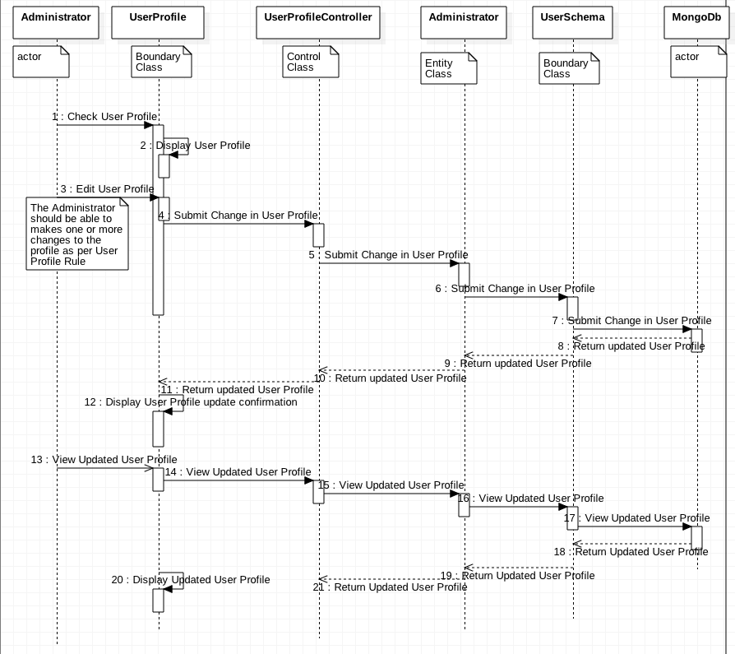

Class diagram (based on the sequence diagram) modeling the use-case structure:

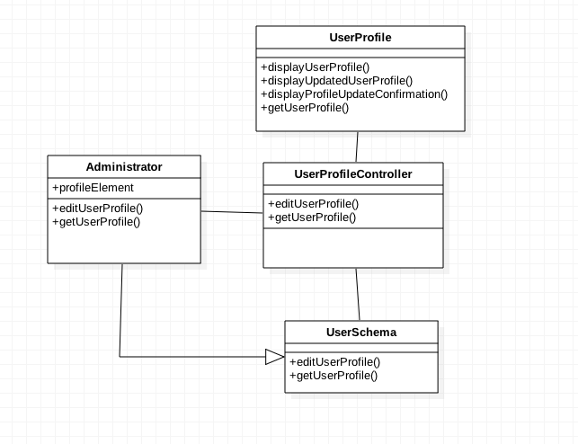

Design Model:

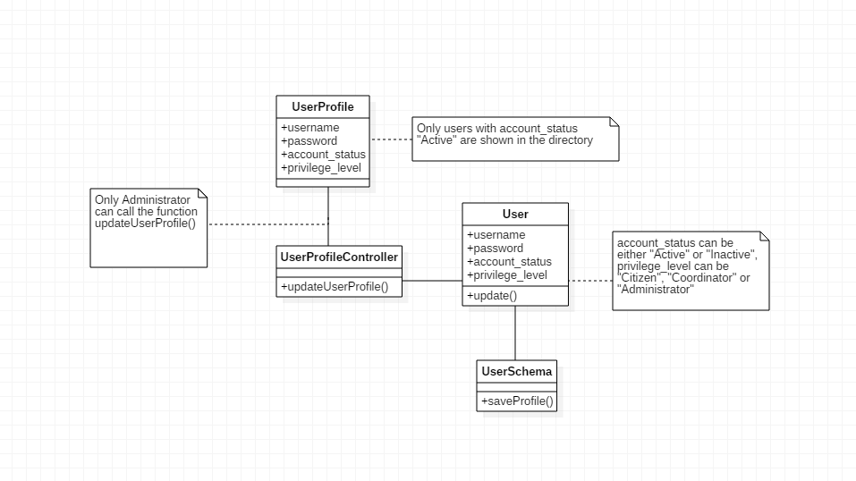

Mapping Between Analysis Classes and Code:

|  |  |  |
| --- | --- | --- |
| **Analysis Classes** | **Design Elements** | **Implementation Elements**  (e.g. modules, files, components, databases) |
| Administrator | User | app/models/users.js:User |
| UserProfile | UserProfile | app/views/Directory.html |
| UserProfileController | UserProfileController | app/routes/DirectoryController |
| UserSchema | UserSchema | app/models/users.js:User_Schema |