Embedding-BasedRetrievalandCausalChainStructuralMapping
forDiagnosisandPrognosisofNTSBFAR121AviationAccidents
KanuShetkar,SankaranMahadevan,JesseSpencer-Smith
VanderbiltUniversity
Abstract
Aviationsafetyanalysishaslongreliedonthestructuredcodedfieldsinaccidentinvestiga-tion reports.Bayesian network models built on this coded data have been effective at capturing causalrelationshipsbetweenevents,buttheunstructurednarrativereportswrittenbypilots, crews,andinvestigatorsareleftoutoftheanalysiseventhoughtheyholdcontextthatthe codedfieldscannotcapture.Inthispaper,weextendtheBayesiannetworkworkofZhang and Mahadevan (2021) on the National Transportation Safety Board (NTSB) FAR 121 accident databasebyusinglargelanguagemodels(LLMs)tobringnarrativeinformationintotheanal-ysis.WefirstdescribeapureLLMpipelineandthelimitationsweobservedwithit,including hallucination,inconsistentprobabilities,andsensitivitytoinputphrasing.Theselimitations motivatedahybridapproachinwhichtheLLMisusedforsemanticretrievalandclustering whiletheprobabilitycalculationsarekeptgroundedinfrequencycountstakenfromtheac-tualdata.Thehybridapproachusesaconditionalprobabilityarchitecturebasedonthelawof totalprobabilityacrossclusteredincidenttypes,andsupportsbothdiagnosis(backwardinfer-ence fromoutcomes to causes) and prognosis (forward inference fromprecursorsto downstream events).Wethendescribeastructuralmappingextensionthataddsasecondsimilaritysignal grounded in the underlying causal mechanism of each incident, and combines it with the embed-ding score through a single-line fusion formula to rerank the top retrieved candidates.We apply bothmethodologiestothesameFAR121datasetfrom1982to2016usedinthepriorBayesian network research,which lets us compare the two directly.On a held-out test set of 77 incidents, thestructuralmappingextensionimprovesTop-1diagnosisaccuracyby2.6percentagepoints overtheembedding-onlybaseline,with2strictwinsand0strictlossesonthebinaryoutcome. Theimprovementisreproducible,statisticallysupported,andtraceabletospecificstructural agreementbetweenthequeryandtheretrievedincidents.
1 Introduction
Overthepastthreedecades,globalcommercialaviationhascontinuedtogrowatafastpace. According to the International Air Transport Association (IATA, 2019), commercial airline carriers moveclosetoonebillionpassengerswithintheUnitedStateseachyear.Theconsequencesofan aviationaccidentaresevere,andthismakestheanalysisofpastaccidentsanimportanttoolfor preventingfutureones.Reportscollectedoverthepastseveraldecadesgiveusarecordwecan studytounderstandhowsmallabnormaleventsgrowintoaccidents.
TheNTSBaccidentdatabaseholdstwokindsofinformationforeveryincident.Thefirstis structureddata:codedeventsequences,occurrencecodes,subjectcodes,findings,injurydata, andaircraftdamagedata.Thesefieldsuseafixedvocabulary,whichmakesthemwellsuitedfor statisticalmodels.Thesecondisunstructureddata:free-formnarrativeswrittenbypilots,crews, andinvestigators,alongwiththeprobablecausestatementswrittenbyNTSBanalysts.These
1

narrativescarrycontextthatthecodedfieldscannotcapture,suchasapilotreportinganunusual vibration during climb, or a comment about weather conditions and human factors that did not get coded into a fixed category.The structured data gives consistency, and the narratives give context. Theworkinthispaperaimstobringbothintothesameanalysis.
ZhangandMahadevan(2021)appliedaBayesiannetworktotheNTSBaviationaccident database, focusing on FAR 121 accidents from 1982 to 2016.Their network captures the causal rela-tionships in the event sequences and supports both forward inference, which predicts outcomes from causes,andbackwardinference,whichidentifieslikelycausesfromobservedoutcomes.Bayesian networksofthistyperequirepredefinednodesandprobabilitytables,sotheycanonlyoperateon the coded fields.The narratives are left out of the model, even though they often contain the detail thatdetermineshowagivenaccidentactuallyunfolded.BeforeLLMs,bringingnarrativetextinto theanalysiswouldhaverequiredmanualconversionofeverysentenceintoacodedform,whichis notpracticalatthescaleofthefullFAR121dataset.
Recentprogressinlargelanguagemodelshaschangedthis.LLMscanreadnarrativetextdi-rectly,findsimilarpastincidentsbasedonmeaningratherthankeywords,andproducestructured outputsthatdownstreamcodecanuse.Thisopensthedoortobringingthenarrativedatainto theanalysiswithoutthrowingawaytherigoroftheexistingBayesianframework.Inourinitial experimentsweusedanLLMend-to-endforbothretrievalandprobabilityestimation.Thatap-proachturnedouttohaveseveralproblems.TheLLMproducedprobabilitiesthatdidnotmatch the underlying frequencies in the data, made confident claims that were not supported by any cited incident,andchangeditsanswerwhenthewordingoftheinputquerychangedbyasmallamount. WesummarizetheseissuesinSection1.1andtheyarethereasonwemovedtoahybriddesignin whichtheLLMisusedonlyforthepartsitdoeswell.
InthispaperwedescribetwomethodologiesthatbuildonZhangandMahadevan(2021). ThefirstisahybridapproachinwhichtheLLMhandlesnarrativeretrievalandclustering,and frequency-based counts handle the probability calculations through the law of total probability.The secondisastructuralmappingextensionthataddsasecondsimilaritysignalbasedonthecausal chainofeachincidentandusesittorerankthetopcandidatesreturnedbythehybridpipeline. BothmethodologiesareappliedtothesameFAR121datasetfrom1982to2016usedintheprior Bayesiannetworkwork,whichletsuscomparethetwoapproachesdirectly.
1.1 LimitationsofthePureLLMApproach
Beforesettlingonthehybriddesign,webuiltapipelineinwhichanLLMwasresponsiblefor theentirereasoningprocess:retrievingsimilarpastcases,extractingcontextualfactorsfromthe narratives, scoring and ranking candidate causes, and producing recommendations.Three problems with this approach made it unsuitable for the task.First, the LLM does not produce probabilities in the way a Bayesian network does.It infers relationships from learned language patterns rather than fromexplicitfrequencycounts,sothenumbersitreturnsarenotgroundedintheactualdataand are not reproducible across runs.Second, the LLM sometimes produced confident outputs that were notsupportedbyanyincidentinthedatabase,abehavioroftencalledhallucination.Evenwith retrieval grounding, the model still tended to overstate certainty.Third, the system was sensitive to small changes in how the query was phrased, which is not acceptable for a safety analysis tool.From theseissueswedrewthelessonthatLLMsaregoodatretrievingandstructuringnarrativetext, and frequency-based counts taken from the actual data are good at producing reliable probabilities, andthesetwopartsshouldbekeptseparate.ThehybridapproachinSection5isbuiltonthis lesson.
2

1.2 Contributions
Thecontributionsofthispaperaresummarizedasfollows.
1.WeextendtheBayesiannetworkworkofZhangandMahadevan(2021)bybringingthenarra-tivereportsintheNTSBFAR121databaseintotheanalysisthroughahybridpipelinethat combinesLLM-basedretrievalwithfrequency-basedprobabilitycalculationsusingthelawof totalprobability.
2.Weapplythehybridpipelinetobothdiagnosis(causeidentificationfromaqueryincident)and prognosis(next-eventpredictionfromadefiningevent),usingthesameFAR121datasetfrom 1982to2016usedinthepriorwork.
3.We add a structural mapping extension that extracts a structured causal chain for each incident, computesastructuralsimilarityscoreusingsequencealignment,andcombinesthisscorewith the embedding cosine through a single-line fusion formula to rerank the top retrieved candidates.
4.Weevaluatethestructuralmappingextensiononaheld-outtestsetof77FAR121incidents, usingpairedstatisticaltests,andshowa2.6percentagepointimprovementinTop-1diagnosis accuracywith2strictwinsand0strictlossesonthebinaryoutcome.
Therestofthepaperisorganizedasfollows.Section2reviewsrelatedworkinaviationsafety analysis,structure-mappingtheory,andtwo-stageretrieval.Section3describestheNTSBFAR 121accidentdataandthefieldsusedinthiswork.Section4introducesthebackgroundconcepts thatthemethodologiesrelyon,includingembeddings,k-meansclustering,thelawoftotalprob-ability,andtheNeedleman-Wunschsequencealignmentalgorithm.Section5presentsthehybrid LLMmethodologyindetail,andSection6presentsthestructuralmappingextension.Section7 works through a full numerical example of the hybrid pipeline for both diagnosis and prognosis, and Section8reportstheresultsofthestructuralmappingextensionontheheld-outtestset,includ-ingstatisticalanalysisandcasestudies.Section9comparesthetwoapproaches,andSection10 concludeswithcontributions,limitations,andfuturework.
2 RelatedWork
This work draws on three lines of prior research:Bayesian and statistical models of aviation accident data,structure-mappingtheoryincognitivescience,andtwo-stageretrievalwithrerankingin informationretrieval.
2.1 AviationAccidentAnalysis
ThemostdirectpriorworkforthispaperistheBayesiannetworkmodelofZhangandMahadevan (2021),whichbuildsadirectedgraphicalmodeloftheNTSBFAR121accidentdatabaseand supportsbothforward(causetooutcome)andbackward(outcometocause)inference. That model relies entirely on the structured coded fields, since a Bayesian network needs a fixed node set anddiscreteconditionalprobabilitytables.ZhangandMahadevan(2019)earlierappliedensemble machinelearningmodelstoarelatedaviationincidentriskpredictiontask,againusingstructured featuresonly.Ourworkextendsthislinebybringingthenarrativereportsintotheanalysis,while keepingtheprobabilitycalculationsinthespiritofthepriorworkbygroundingtheminfrequency countstakenfromthesameFAR121data.
3

2.2 Structure-MappingTheory
Thestructuralmappingextensioninthispaperoperationalizesideasfromstructure-mappingthe-oryincognitivescience.Gentner(1983)introducedstructure-mappingasatheoreticalframework for analogical reasoning, with the central claim that deep similarity between two situations is about therelationalstructure(whichobjectsplaywhichroles,inwhatcausalorder),notthesurfaceat-tributesoftheobjects.GentnerandMarkman(1997)sharpenedthisviewbyseparatinganalogy (matchingonrelationalstructurewithlittlesurfaceoverlap)fromliteralsimilarity(matchingon both relational structure and surface attributes), and argued that human similarity judgments give moreweighttosystematicrelationsthantofirst-orderrelationsorattributes.Falkenhaineretal. (1989)developedtheStructure-MappingEngine(SME),analgorithmthatsearchesforthebest mappingbetweentwostructuredrepresentationsandassignsevidencevaluestocandidatematch hypotheses,withhigher-orderstructureprovidingtrickle-downsupporttolower-levelmatches. Goldstone (1994) showed that human similarity judgments incorporate alignment and feature com-parisontogetherratherthanasindependentstages.Spencer-SmithandGoldstone(1997)showed thattheweightsgiventodifferentfeaturesduringsimilaritycomparisonshiftdynamicallywith thecomparisoncontext,whichisconsistentwiththerole-system-mechanismweightinginourstep similarityformula.WedonotimplementSMEdirectly.Weimplementasmall,domain-tuned version of the same idea:a fixed three-field schema (role, system, mechanism), a per-step similarity thatweightsrolemostheavily,andachainscorethatclassifiesalignedpairsintostrong,partial, andunmappedcategories.
2.3 Two-StageRetrievalandReranking
ThefusionstepinSection6.6fitsinsidethebroaderpatternoftwo-stageretrievalininformation retrieval.NogueiraandCho(2019)introducedatwo-stagearchitectureinwhichafastfirst-pass retriever(BM25orasimilarindex-basedscorer)returnsacandidatesetofpassagesandasecond, more expensive scorer reranks them using alearned model.The structuralmapping extensionuses thesameshape:theembeddingcosineplaystheroleofthefastfirst-passscoreandthestructural similarity plays the role of the slower per-pair reranker.The alignment step itself uses the dynamic programming algorithm of Needleman and Wunsch (1970), which was originally developed for global alignmentoftwoproteinsequencesandisnowstandardforanytwo-sequencealignmenttaskwith aper-positionsimilarityfunctionandagappenalty.
3 NTSBAccidentInvestigationData
TheNationalTransportationSafetyBoard(NTSB)isanindependentfederalagency,createdin 1967,thatinvestigatesaccidentsandincidentsacrossallmodesoftransportationintheUnited States,includingaviation,highway,rail,marine,andpipeline.Theworkinthispaperfocuseson theaviationportionofthedatabase,andwithinaviationwefocusonFAR121aircarriers,which coverlargeU.S.-basedairlines,regionalaircarriers,andall-cargooperators. Thisisthesame populationusedbyZhangandMahadevan(2021),whichletsuscompareresultsdirectlywiththe priorBayesiannetworkwork.
TheFAR121portionoftheNTSBdatabasefrom1982to2016contains2,243accidentand incident reports,each spread across 14 separate files.The files cover aircraft characteristics,engine characteristics,sequencesofevents,occurrences,findings,injurydata,andthenarrativereports writtenbypilots,crews,andinvestigators.Forthisworkwemergethe14filesintoasinglerecord perincident,keyedbytheNTSBeventID,sothatthestructuredfieldsandthenarrativesfora
4

givenincidentcanberetrievedtogether.Themergeddatasetpreservesthesame2,243incidents asthepriorworkandaddsnothingnewattherowlevel.Thenarrativetextiswhatisnewfroma modelingperspective,sincethepriorBayesiannetworkworkonlyusedthecodedfields.
Two structured fields are used heavily in the methodology that follows.The first is the sequence of events for each incident, which is an ordered chain of occurrences with one occurrence marked as thedefiningevent.Thedefiningeventactsastheanchorfortheprognosistask:theeventsbefore theanchoraretheprecursors,andtheeventsaftertheanchorarethedownstreamconsequences. Thesecondisthefindingsfield,whichliststhecausesandcontributingfactorsidentifiedbythe NTSBinvestigators,andwhichweuseasthegroundtruthforthediagnosistask.Thenarrative textsupportstheretrievalstepinthemethodologyandisalsousedinthestructuralmapping extensiontoextractastructuredcausalchainforeachincident.
4 BackgroundConcepts
ThissectionintroducesthefourbackgroundconceptsthatthemethodologiesinSection5and Section6buildon.Thegoalistofixnotationandgivetheminimumneededtofollowtherestof thepaper.
4.1 VectorEmbeddingsandCosineSimilarity
Avectorembeddingmapsapieceoftexttoafixed-lengthvectorofrealnumbersinaway thatplacestextswithsimilarmeaningclosetogetherinthevectorspace. WeuseOpenAI’s text-embedding-3-small model, which produces 1,536-dimensional vectors.Each dimension does nothaveasinglehuman-interpretablemeaning,buttogetherthedimensionscapturetopic,phase offlight,typeoffailure,andotherlatentfeaturesofthetext.
Oncethetextsaremappedtovectors,thesimilaritybetweenanytwotextscanbecomputed mathematically.Thestandardmeasureiscosinesimilarity.Givenaqueryembeddingqandan incidentembeddingi,thecosinesimilarityis
sim(q, i) = | q · i  ∥q∥∥i∥, | (1)
whereq · iisthedotproductand∥· ∥istheEuclideannorm.Thedotproductmeasuresthe directionaloverlapbetweenthetwovectors,anddividingbythemagnitudesnormalizestheresult sothatthescoredependsondirectionratherthanlength.Theoutputrangesfrom0,meaning thetwotextsareunrelated,to1,meaningthetwotextshaveidenticalmeaning.Forexample, thequerylossofenginepowerduringcruiseflightreturnsasimilarityof0.81againsttheincident turbinebladeseparationduringcruiseand only 0.25 against birdstrikeonground,because the first issemanticallyrelatedandthesecondisnot.
4.2 K-meansClustering
K-meansisanunsupervisedclusteringalgorithmthatpartitionsasetofdatapointsintokgroups, whereeachpointisassignedtothegroupwhosecentroiditisclosestto.Thealgorithmminimizes thesumofsquareddistancesbetweeneachpointanditsassignedcentroid.Weusek-meanswith k=50onthe2,243incidentembeddingstoorganizethedatabaseinto50incident-typeclusters duringaone-timesetupstep.EachclusteristhengivenashorttextlabelproducedbyGPT-4o-mini,basedontheincidentsthatfallinthecluster,sothatdownstreamcodecanrefertoclusters byname(forexample,turbinebladefailureorenginefire).
5

4.3 LawofTotalProbability
The law of total probability gives a way to compute the marginal probability of an event from a set of conditionalprobabilitiesandtheirassociatedweights.IfCistheeventofinterest,K1, K2, . . . , Km isapartitionofthesamplespace,andQisaquery,then
P(C| Q) = | ∑ | P(C| Kj) P(Kj| Q). | (2)
j=1
InSection5,Cwillbeacandidatecause,KjwillbeoneoftheclustersfromSection4.2,andQ willbeaqueryincident.TheconditionaltermsP(C| Kj)areestimatedascluster-levelfrequency counts,andtheweightsP(Kj|Q)arecomputedfromthecosinesimilaritiesbetweenthequery andtheincidentsineachcluster.
4.4 Needleman-WunschSequenceAlignment
Needleman-Wunschisadynamicprogrammingalgorithmoriginallydevelopedforaligningtwo proteinsequences(NeedlemanandWunsch,1970).Thealgorithmfindsthebestglobalalignment oftwosequencesbyfillingatwo-dimensionaltabledpwiththebestscorereachableateach(i, j) position.Ateachcell,thealgorithmchoosesthebestofthreemoves:alignpositioniinsequence AwithpositionjinsequenceB,skipapositioninA,orskipapositioninB.Therecurrenceis
dp[i][j] = max |   dp[i −1][j −1] + sim(A[i], B[j]) | align, | (3)
dp[i][j] = max | dp[i −1][j] + g    dp[i][j −1] + g | skipinA, | (3)
dp[i][j] = max | dp[i −1][j] + g    dp[i][j −1] + g | skipinB, | (3)
wheresim(A[i], B[j])istheper-positionsimilarityscoreandgisasmallnegativegappenaltythat allowsbutdiscouragesskipping.Thefinalcelldp[n][m]holdsthebestscoreforaligningthefull twosequences.WeusethisalgorithminSection6toalignthestructuredcausalchainsoftwo incidents,whereeachpositioninthesequenceisonestepinthecausalchain.
5 Phase2Methodology:HybridLLMApproach
ThissectiondescribesthehybridpipelinethatcombinesLLM-basedretrievalandclusteringwith frequency-basedprobabilitycalculationsusingthelawoftotalprobability.Thepipelinesupports both diagnosis and prognosis,and both modes share the same retrieval and clustering steps inSec-tions 5.1 through 5.4.The two modes diverge at the probability step, which is described separately for diagnosis in Section 5.5 and for prognosis in Section 5.6.A full numerical walk-through for each modeisgivenlaterinSection7.
5.1 MergedDataset
The14NTSBfilesdescribedinSection3aremergedintoasinglerecordperincident,keyedon theNTSBeventID.Eachmergedrecordholdsthestructuredfields(events,occurrences,subject codes,findings,injury and damage data) and the narrative text for that incident in one place.The mergeddatasetisstoredasJSONforfastlookup.Thisstepisone-timeandoffline.Atquerytime thesystemonlyreadsfromthemergedfile,whichavoidsthecostofcross-referencingmultiplefiles foreveryincident.
6

5.2 Embeddings
EachincidentinthemergeddatasetisconvertedintoasetofembeddingvectorsusingOpe-nAI’stext-embedding-3-smallmodel,whichproduces1,536-dimensionalvectorsasdefinedin Section4.1. Weembedthenarrativetext,thefindings,andtheentriesfromtheNTSBevent dictionary(thect_seqevt.txtfilethatmapsnumericaleventcodessuchas1452totheirEnglish meanings).Weembedallthreeofthesebecausethesystemneedstobeabletomatchafree-form query against either the free narrative text, the structured cause findings, or the standardized event descriptions.In total,embedding the 2,243 incidents produces 4,360 embedding vectors,since each incidentcontributesmultipletextpieces.Theresultisasearchableembeddingindexoverthefull database.Auserqueryisembeddedwiththesamemodelsothatitlivesinthesamevectorspace astheindexedincidents.
5.3 SimilaritySearch
Givenanembeddedquery,thesystemretrievesthemostrelevantpastincidentsusingthecosine similarityfromEquation1.Thequeryembeddingiscomparedagainstall4,360embeddingsin theindex,andthetop50mostsimilarincidentsarekeptforthenextstep.Fiftywaschosenas acompromisebetweencoverage(enoughincidentstosupportcluster-levelfrequencycounts)and focus(fewenoughthattheretrievedsetstillconcentratesonthequerytopic).Forexample,the querylossofenginepowerduringcruiseflightretrievesturbinebladeseparationduringcruiseat 0.81,enginefailureandfireinflightat0.80,compressorstallduringclimbat0.71,andbirdstrike ongroundat0.25.Onlythefirstthreepasstherelevancebarandwouldappearinthetop50;the birdstrikeexampleillustratesthekindofincidentthecosinescorecorrectlypushesout.
5.4 Clustering
Thetop50retrievedincidentsarenotasinglehomogeneousgroup.Theyareamixoffailure scenariosthatmayhaveverydifferentcausalpatternsanddownstreamconsequences.Toorganize them,weusethepre-computedk-meansclustersdescribedinSection4.2.Duringtheone-time setupstep,k-meanswithk=50wasrunonall2,243incidentembeddings,andeachclusterwas given a short label produced by GPT-4o-mini.These cluster labels are stored directly in the merged dataset,soatquerytimethesystemonlyneedstolookuptheclusterofeachretrievedincident. Fortheexamplequerylossofenginepowerduringcruiseflight,thetop50incidentsdistributeas follows:12fallintheturbinebladefailurecluster,5intheenginefirecluster,5intheiceingestion cluster,andtheremainderspreadacrosssmallerclusters.Theclusterassignmentsaretheinputto theprobabilitystepinthenexttwosections.
5.5 Diagnosis
Indiagnosismode,thegoalistoestimatetheprobabilityofeachcandidatecausegiventhequery, P(Cause | Q).TheclusterorganizationfromSection5.4letsuswritethisasasumacrossclusters usingthelawoftotalprobability,witheachclustercontributinginproportiontohowrelevantit istothequery.
5.5.1 Cluster-LevelCauseProbabilities
For each cluster Kj, we compute the cluster-level cause distribution P(Cause | Kj) by counting how ofteneachcauseappearsintheincidentsthatbelongtothatcluster.Thecausesforeachincident
7

come from the NTSB findings field,where we use natural language processing to extract the causal phrasesrecordedbytheinvestigators(forexample,fuelcontamination,orfailureofthehydraulic system).Eachincidentmaylistmorethanonecause,sinceaviationaccidentsareoftentheresult of multiple contributing factors.For one cluster, we go through each incident in the cluster, extract everycausementioned,andcounthowofteneachuniquecauseappears.Dividingeachcountby thetotalnumberofcausementionsintheclustergivesthecluster-levelcauseprobability.The same procedure is repeated for every cluster,so that every cluster ends up with its own probability distributionovercauses.
5.5.2 ClusterWeights
TheclusterweightP(Kj|Q)measureshowrelevantclusterKjistothequery.Wecomputethe unnormalizedclusterweightastheaveragecosinesimilarityoftheincidentsfromKjthatappear inthetop50,multipliedbythenumberofsuchincidents:
wj=¯sj· nj, (4)
where¯sjisthemeancosinesimilarityoftheincidentsfromclusterKjthatappearinthetop 50,andnjisthecountofsuchincidents.Thetwofactorscapturethetwowaysaclustercanbe relevant:itcanhavemanyretrievedincidents,oritcanhaveafewhighlysimilarones,orboth.
Theweightsarethennormalizedtoaprobabilitydistribution
5.5.3 | P(Kj| Q) = | wj∑  kwk | . | (5)
5.5.3 | CombiningAcrossClusters | wj∑  kwk | . | (5)
Thecluster-levelcauseprobabilitiesfromSection5.5.1andtheclusterweightsfromSection5.5.2 arecombinedusingthelawoftotalprobabilityfromEquation2:
P(Cause | Q) = | ∑ | P(Cause | Kj) P(Kj| Q). | (6)
j
Thisproducesaprobabilitydistributionovercandidatecauses,andthemostprobablecauseis returnedasthesystem’sprimarydiagnosis. Asasmallinlineexample,iftheclusterweight P(turbinebladefailure | Q) is 0.56 and the cluster-level cause probability P(impropermaintenance | turbinebladefailure) is 0.35,then the contribution of this cluster to P(impropermaintenance | Q) is0.56 × 0.35 = 0.196.Afullmulti-clusterwalk-throughwithrealnumbersisgiveninSection7.
5.6 Prognosis
Inprognosismode,thequestionisreversed.Givenacurrentevent,thesystempredictswhatis most likely to happen next.If a pilot reports a loss of engine power, the system returns a probability distribution over the events that historically follow that condition, so that preventive actions can be consideredbeforethenexteventhappens.TheprognosispipelinereusesSections5.1through5.4 unchanged.Theonlydifferenceiswhatisextractedfromtheretrievedincidents.
5.6.1 SequenceofEventsData
Foreachincident,theNTSBsequenceofeventsfieldgivesanorderedchainofoccurrencesinthe ordertheyhappened.Oneoccurrenceinthechainismarkedasthedefiningevent,whichisthe
8

maineventthattriggeredtheNTSBinvestigation.Thedefiningeventactsastheanchor:the eventsbeforeitaretheprecursors,andtheeventsafteritarethedownstreamconsequences.For prognosis,weareinterestedinthedownstreamevents.Foreachretrievedincident,wefindthe definingeventinitssequenceandrecordwhatcomesimmediatelyafter.
5.6.2 Cluster-LevelNext-EventProbabilities
ForeachclusterKjwecomputethecluster-levelnext-eventdistributionP(NextEvent|Kj)by countinghowofteneacheventappearsastheimmediatesuccessorofthedefiningeventacrossthe incidentsinthatcluster.Theprocedurehasfivesteps.First,wetakeonecluster,forexample turbinebladefailurewith12incidents.Second,foreachofthoseincidents,wefindthedefining eventinitssequence.Third,werecordwhateventcomesimmediatelyafterthedefiningevent. Fourth,wecountthefrequencyofeachnexteventacrossthecluster.Fifth,wedivideeachcount bythetotalnumberofsequencescontributedbytheclustertogetthecluster-levelnext-event probability.Thesameprocedureisrepeatedforeverycluster.
5.6.3 CombiningAcrossClusters
The same form of the law of total probability used for diagnosis applies to prognosis,with the next eventinplaceofthecause:
P(NextEvent | Q) = | ∑ | P(NextEvent | Kj) P(Kj| Q). | (7)
j
TheclusterweightsP(Kj| Q)arecomputedinthesamewayasinSection5.5.2.Theoutputisa probabilitydistributionovercandidatenextevents,andthemostprobableoneisreturnedasthe predictednextevent.
5.6.4 Multi-StepPrediction
Aviation incidents do not stop at one event.Events cascade in a sequence:A leads to B, Bleads to C, and so on.To predict events further down the chain, we use transition probabilities.A transition probabilityisaconditionalprobabilityoversequentialevents,P(Eventt|Eventt−1),thattellsus whattendstofolloweachevent.Onceweknowthedistributionatstept −1,thedistributionat steptisgivenbyanotherapplicationofthelawoftotalprobability:
P(Eventt| Q) = | ∑ | P(Eventt| Eventt−1= e) P(Eventt−1= e | Q). | (8)
e
Thetransitionprobabilitiesareestimatedfromallconsecutivepairsinthesequencedataacross theretrievedincidents.Forexample,ifengineshutdownisfollowedbyfireorsmokein7outof20 sequencesinthedata,thenP(fireorsmoke|engineshutdown)=7/20=0.35.Thisstepcanbe appliedrepeatedlytoextendthepredictionfurtherdownthechain,withoneextraapplicationof Equation8peradditionalstep.
6 Phase3Methodology:StructuralMappingExtension
The hybrid approach in Section 5 relies on text similarity to decide which past incidents are relevant to a new query, and then on cluster-level frequency counts to combine evidence across the retrieved set.Thisworkswellwhenthewordingofthenewincidentlinesupwiththewordingofthecause
9

findingitshouldmatch.Theapproachhasaknownblindspot,whichwedescribeinSection6.1, and the structural mapping extension in this section is built specifically to address it.The extension isanoperationalizationofthestructure-mappingframeworkofGentner(1983)ontheNTSBdata, withthealignmentcarriedoutbythedynamicprogrammingalgorithmofNeedlemanandWunsch (1970) and the reranking step following the two-stage retrieval pattern of Nogueira and Cho (2019).
6.1 Motivation
Two incidents with very different causal mechanisms can read similar in plain text, and two incidents withthesameunderlyingmechanismcanbedescribedinverydifferentvocabulary.Thephrase lossofenginepowerduringcruisecanmatchagainstanincidentcausedbyfuelcontamination,an incidentcausedbyamaintenanceerroronaturbineblade,oranincidentcausedbyiceingestion. Theembeddingdoesnotknowwhichofthesemechanismsthenewqueryactuallybelongsto.It onlyknowsthatthewordssoundsimilar.GentnerandMarkman(1997)makethesamepointin generalterms:matchingonwordsandmatchingoncausalstructurearetwodifferentthings,and thestructuralmatchistheonethattellsyouwhethertwocasesarereallyalike.Thestructural mapping extension addresses this by adding a second similarity signal that compares the underlying causalmechanismoftwoincidents,notjusttheirwording,andusesittorerankthetopretrieved candidates.
6.2 CausalChainSchema
For every incident we extract a structured causal chain.The chain is a list of steps in the order they occurred,andeachstephasthreefields.Therolefieldcaptureswherethestepsitsinthecausal sequence,withallowedvaluesinitiatingevent,propagation,systemcompromise,systemfailure, terminalfailure, operational consequence, and outcome.The systemfield captures which subsystem thestepbelongsto,withallowedvaluessuchasenginemechanical,lubrication,fuel,hydraulic, electrical,structural,flightcontrols,landinggear,propulsion,fireprotection,environment,human performance, maintenance, and aircraft.The mechanism field captures what physically went wrong at that step, with allowed values such as maintenance error, material degradation, fatigue, corrosion, contamination,thermaldamage,mechanicalloosening,deprivation,overheating,fire,separation, powerloss,lossofcontrol,terraincollision,proceduralerror,anddesigndeficiency.
In addition to the chain itself, each incident has a list of contributing factors and a single failure patternlabelsuchasthermalcascade,maintenancelatentdefectcascade,orhumanperformance chain.Theschema is fixed so that two incidents extractedindependently canbecomparedfield by field,whichiswhatallowsthealignmentstepinSection6.5toproduceameaningfulscore.
6.3 ExtractionwiththeLLM
The structured chain is extracted by sending the incident text to GPT-4o-mini with a fixed schema prompt.The model returns a JSON object that we then normalize against the allowed values listed inSection6.2.Anythingoutsidetheallowedlistiscoercedtoadefaultvaluesuchasunknown, sothatthedownstreamscoringcodeisneversurprisedbyanunexpectedcategory.Thisisthe onlyplaceinthepipelinewhereanLLMisinvolvedbeyondtheretrievalembeddingstep.The extractionisrunonceperincidentinthetrainingsetandonceperquery,andtheresultiswritten toacachefile.ThereisnoLLMcallduringranking,scoring,orfusion.
10

6.4 StepSimilarity
Tocomparetwocausalchainswefirstneedawaytocomparetwoindividualsteps.GivenstepA fromonechainandstepBfromanother,wecomputeastepsimilarityscore
sim(A, B) = 0.50 · r(A, B) + 0.30 · m(A, B) + 0.20 · s(A, B), (9)
wherer,m,andsaretherole,mechanism,andsystemcomponentscores.Theweights(0.50for role,0.30formechanism,0.20forsystem)reflecttherelativeimportanceofeachfieldandfollow therelationalhierarchyofGentner(1983),inwhichsystematicrelationsgetmoreweightthan first-orderrelationsorattributes.Rolegetsthehighestweightbecauseitcaptureswhereinthe causalsequencethestepsits,whichisthemostdiagnosticfieldfordistinguishingonemechanism fromanother.Mechanismgetsthenext-highestweightbecauseitdescribesthecausalconnec-tionbetweenconsecutivesteps.Systemgetsthelowestweightbecausetwoincidentscaninvolve differentphysicalcomponentsandstillsharethesameunderlyingfailurepattern.Spencer-Smith andGoldstone(1997)showedthathumansimilarityjudgmentsshifttheweightsgiventodifferent featuresdependingonthecomparisoncontext,whichprovidesfurthersupportfortreatingthese three fields as distinct contributions rather than as a single concatenated bag of words.If two steps have the exact same role, rreturns 1.0.If the roles are different but adjacent in the causal sequence (forexample,propagationandsystemcompromise),rreturnsavaluebetween0.7and0.95froma smalllookuptable.Thesystemandmechanismscoresworkthesameway,withacompatibility tablethatgivespartialcreditforrelatedcategoriessuchasfuelandenginemechanical,orfatigue andmaterialdegradation.Theoutputisasinglenumberbetween0and1thatmeasureshowclose thetwostepsare.
6.5 ChainAlignment
Twoincidentsdonotalwayshavethesamenumberofstepsintheirchain,andthestepsdonot alwaysappearinthesameorder.TocomparethetwofullchainsweusetheNeedleman-Wunsch alignment algorithm from Section 4.4, with the per-step similarity from Equation 9 as the alignment scoreandaconstantgappenaltyofg= −0.05sothatskippingastepisallowedbutdiscouraged. Afterthedynamicprogrammingtableisfilled,thefinalcellholdsthebestscoreforaligningthe twofullchains.
We then walk the alignment back and classify each aligned position into one of three categories. Ifthestepsimilarityisatleast0.70,thepaircountsasastrongmatch.Ifitisbetween0.35and 0.70,itcountsasapartialmatch.Alignedpairsbelow0.35andanypositionsleftasgapsinthe alignmentcountasunmapped.Thestructuralsimilarityisthencomputedas
struct_sim =strong + 0.5 · partial |A| + |B| | −0.10 ·unmapped |A| + |B|, | (10)
where|A|and|B|arethelengthsofthetwochainsbeingcompared,sothedenominatoristhe totalnumberofsteppositionsacrossbothchains.Thestrong/partialsplitisasmall,domain-tunedversionoftheevidenceframeworkusedintheStructure-MappingEngine(Falkenhaineret al.,1989),wherematchhypothesesreceivepartialevidencevaluesandstructuralagreementatone levelprovidestrickle-downsupporttolower-levelmatches.Theunmappedpenaltytermsubtracts asmallfractionproportionaltothenumberofpositionsthatdidnotfindagoodmatch,sothat two chains with many gaps cannot reach a high score on the strength of a few matched steps alone. Thefinalstructuralsimilarityisanumberbetween0and1.
11

6.6 ScoreFusion
The structural similarity does not replace the embedding score.It reweights it.For each candidate incident,thenewscoreis
new_score = max(0, cos _sim) · exp(α · struct_sim), (11)
wherecos _simisthecosinesimilarityfromSection5.2,struct_simisthestructuralsimilarity fromSection6.5,andαisatuningparameterthatcontrolshowstronglythestructuralsignal influences the ranking.The two-stage shape of fast first-pass retrieval followed by a slower per-pair rerankeristhestandardpatternofNogueiraandCho(2019);theembeddingcosineplaystherole ofthefastfirstpassandthestructuralsimilarityplaystheroleoftheslowerreranker.Combining thetwoscoresintoasinglerankingscore,ratherthanrunningthemasfullyindependentstages, isconsistentwithGoldstone(1994),whichshowedthathumansimilarityjudgmentsincorporate alignmentandfeaturecomparisontogetherratherthanasindependentstages.Basedoninitial experiments,wesetα=2.0. Whenthestructuralsimilarityis0,theexponentialfactoris1 andthenewscorereducestotheembeddingcosine.Thefusioncannevermakeacandidatelook moresimilarthanitalreadywasontextaloneunlessthestructuralsignalalsoagrees.Thenew scoresaresorted,andthetopcandidatebecomesthepredictionreturnedbythesystem.Asa smallinlineexample,acandidatewithcosine0.62andstructuralsimilarity0.78hasanewscore of0.62 · exp(2 · 0.78) = 2.96,whileacandidatewiththesamecosine0.62andstructuralsimilarity 0.40hasanewscoreof0.62 · exp(2 · 0.40) = 1.38.Thefirstcandidategetsamuchlargerboost,so itmovesabovethesecondintheranking.
7 Verification:Phase2WorkedExample
Thissectionwalksthroughafullnumericalexampleofthehybridpipeline.Section7.1works throughthediagnosismodeendtoendonasamplequery,andSection7.2worksthroughthe prognosismodeonthesamequery.
7.1 DiagnosisWalkthrough
The query for this walkthrough is loss of engine power during cruise flight.The top 50 most similar incidentshavebeenretrievedusingcosinesimilarity,asinSection5.3,andtheclusterassignments havebeenlookedupfromthepre-computedclusters,asinSection5.4.Forclarity,theworked examplebelowusesonlythetopthreeclusters.Thesameprocedurerunsforeveryclusterinthe fullretrieval,butthesmallersetisenoughtoillustratethecalculation.
Thetopthreeclustersandtheirsummarystatisticsare:turbinebladefailurewith12incidents andaveragecosinesimilarity0.82;enginefirewith5incidentsandaveragecosinesimilarity0.79; andiceingestionwith5incidentsandaveragecosinesimilarity0.75.Wefirstcomputethecluster weightsusingEquation4.
wturbine= 0.82 × 12 = 9.84,
wfire= 0.79 × 5 = 3.95,
wice= 0.75 × 5 = 3.75.
Thetotalweightis9.84 + 3.95 + 3.75 = 17.54.Normalizingeachclusterweightbythetotalgives
12

theclusterprobabilities:
P(turbinebladefailure | Q) = 9.84/17.54 = 0.56,
P(enginefire | Q) = 3.95/17.54 = 0.23,
P(iceingestion | Q) = 3.75/17.54 = 0.21.
The turbine blade failure cluster gets the largest weight because it has both the most incidents and thehighestaveragesimilarity.
Foreachcluster,wethencomputethecluster-levelcauseprobabilitiesP(Cause | Kj)usingthe procedureinSection5.5.1.Asoneexample,considertheenginefailurecluster,whichcontains12 incidents in this query’s top 50.We extract every cause mentioned in those 12 incidents and end up with 20 total cause mentions, since some incidents list more than one cause.Across the 20 mentions, impropermaintenanceappears7times,fuelcontaminationappears5times,manufacturingdefects appears3times,andpiloterrorappears2times.Dividingeachcountby20gives
P(impropermaintenance | enginefailure) = 7/20 = 0.35,
P(fuelcontamination | enginefailure) = 5/20 = 0.25,
P(manufacturingdefects | enginefailure) = 3/20 = 0.15,
P(piloterror | enginefailure) = 2/20 = 0.10.
Thesameprocedurerunsforeverycluster,soeachclusterendsupwithitsownprobabilitydistri-butionovercandidatecauses.
Wenowcombinetheclusterweightswiththecluster-levelcauseprobabilitiesusingthelawof totalprobabilityfromEquation6.Theoutputisaprobabilitydistributionovercandidatecauses, andthecausewiththehighestprobabilityisthesystem’sprimarydiagnosis.Thesameprocedure runsoverthefulltop50retrieval,notonlythethreeclustersshownhere,butthestructureofthe calculationisthesame.
7.2 PrognosisWalkthrough
Usingthesamequeryandthesametopthreeclusters,wenowworkthroughtheprognosismode endtoend.Thetargeteventforthiswalkthroughisengineshutdown:thequestionis,giventhe currentconditiondescribedbythequery,whatistheprobabilitythatthenexteventisengine shutdown?
Wefirstcomputethecluster-levelnext-eventprobabilitiesP(engineshutdown|Kj)usingthe procedureinSection5.6.2.Asanillustration,taketheturbinebladefailurecluster,whichcontains 12incidentsinthetop50.Ofthose12,10haveacleardefiningeventwithatleastoneevent afterit. Wegothrougheachofthose10incidents,findthedefiningevent,andrecordwhat comesimmediatelyafter.Acrossthe10sequences,engineshutdownappears4times,powerplant malfunctionappears3times,fireorsmokenon-impactappears2times,andlossofenginepower appears1time.Dividingeachcountby10gives
P(engineshutdown | turbinebladefailure) = 4/10 = 0.40,
P(powerplantmalfunction | turbinebladefailure) = 3/10 = 0.30,
P(fireorsmoke | turbinebladefailure) = 2/10 = 0.20,
P(lossofenginepower | turbinebladefailure) = 1/10 = 0.10.
Thesameprocedurerunsfortheenginefireandiceingestionclusters.Supposethewithin-cluster probabilitiesofengineshutdownforthethreeclustersare0.40,0.50,and0.00respectively.
13

We now apply the law of total probability from Equation 7,using the cluster weights computed inSection7.1.
P(engineshutdown | Q) = 0.40 × 0.56 + 0.50 × 0.23 + 0.00 × 0.21
= 0.224 + 0.115 + 0.000
= 0.339.
Theprobabilitythatengineshutdownisthenexteventis33.9%.Theturbinebladefailurecluster contributes the most, both because it has the largest cluster weight (P(K| Q) = 0.56) and because engineshutdownisacommondownstreameventinthatcluster(P(shutdown|K)=0.40).The enginefireclusteralsocontributesmeaningfullyeventhoughithasfewerincidents,becauseengine shutdownisanevenmorecommondownstreameventinthatcluster(0.50).Theiceingestion cluster contributes nothing in this case because engine shutdown does not appear as a next event in that cluster’s sequences.The same calculation runs for every candidate next event, which produces acompleteprobabilitydistributionoverwhatcouldhappennextafterthequeryevent.
To extend the prediction one more step forward,we apply Equation 8.Continuing the example above,supposethetransitionprobabilityfromengineshutdowntofireorsmokeis7/20=0.35 based on the consecutive pairs in the retrieved sequences.The contribution of the engine-shutdown branchtotheprobabilityoffireorsmoketwostepsoutis0.35 × 0.339=0.119.Repeatingthis acrosseverystep-1eventandsummingthecontributionsgivesthefullstep-2distribution.The sameprocedurecanbeappliedagainforstep3,withoneextraapplicationofEquation8per additionalstep.
8 Verification:Phase3ResultsandCaseStudies
This section reports the results of the structural mapping extension on a held-out test set, including aggregatemetrics,statisticaltests,distributionanalysis,andcasestudiesthatexplainthemecha-nism behind the wins and the losses.Section 8.1 describes the evaluation setup, Section 8.2 reports aggregate metrics, Section 8.3 reports the statistical analysis, Section 8.4 analyzes the distributions andrankbehavior,Section8.5worksthroughthecaseswherethestructuralmappingextension was correct and the embedding baseline was wrong,and Section 8.6 works through the cases where thestructuralmappingextensionproducedalowermatchscorethanthebaseline.
8.1 EvaluationSetup
WesplittheFAR121incidentsetinto177trainingincidentsand77held-outtestincidents.The trainingsetisusedtobuildthestructuralcache,theembeddingindex,andthecluster-levelfre-quencytablesthatfeedthelawoftotalprobability. Thetestsetisneverseenduringcache construction,retrievalindexbuilding,oranystepofthepipeline.Allmetricsreportedinthis sectionarecomputedonthe77held-outincidents.
We comparetwoconditions onthesame77 testincidents.ConditionA0istheembedding-only baselinefromSection5,withnostructuralreranking.ConditionA2isthestructuralmapping extensionfromSection6,withthefusionstepappliedtothetopretrievedcandidates.Thepaired designletsususetheMcNemartestandbootstrapintervalsonper-incidentdifferences,whichare morepowerfulthantreatingthetwoconditionsasindependentsamples.
ThediagnosismetricisthesameM1scoreusedthroughoutthiswork.Foreachtestincident, thesystem’stoppredictedcauseiscomparedtotheofficialcausefindingswrittenbyNTSBinves-tigators.Thepredictionpassesiftheembeddingcosinesimilaritybetweenthepredictionandany
14

ofthetruecausefindingsisatleast0.75.Top-1accuracyisthefractionofthe77testincidents thatpassatrank1.Recallat5isthefractionwhereanyofthetopfivepredictionspass.The averagematchpercentisthemeanofthecosinesimilaritybetweenthetop-1predictionandthe closesttruecausefinding,expressedasapercentage.
Theevaluationinthispaperisrestrictedtothediagnosistask.Prognosisunderthestructural rerankerislefttofutureworkinSection10.3.
8.2 AggregateResults
Table 1 reports the aggregate diagnosis results for the embedding-only baseline (A0) and the struc-turalmappingextension(A2)onthe77testincidents.Figure1showsthesamenumbersasabar chartwith95%Wilsonconfidenceintervalsontheratemetrics.
Table1:Aggregatediagnosisperformanceonthe77held-outFAR121testincidents.A0isthe embedding-only baseline.A2 is the structural mapping extension.∆is the difference in percentage points.
Metric | A0 | A2 | ∆
Top-1accuracy | 32.5% | 35.1% | +2.6 pp
Recall@5 | 54.5% | 57.1% | +2.6 pp
Avgmatch% | 63.31% | 64.63% | +1.32 pp
Top-1errorrate | 67.5% | 64.9% | −2.6 pp
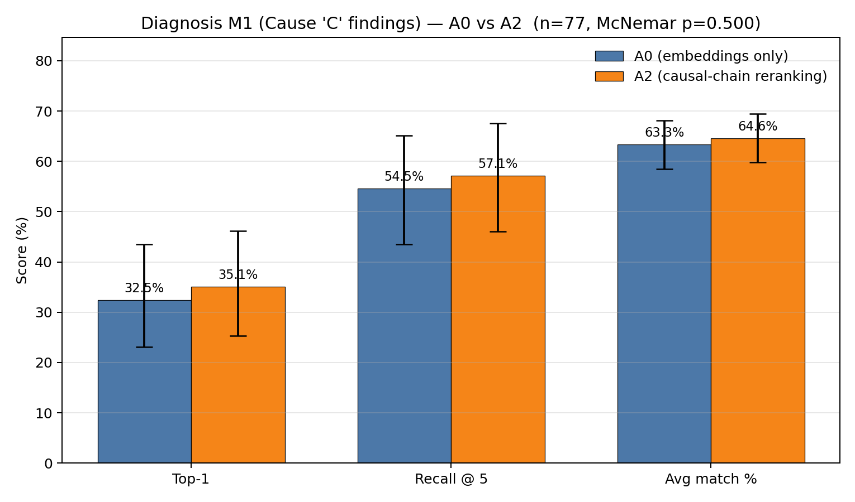
Figure 1:Top-1 accuracy, Recall at 5, and average match percent for A0 and A2 on the 77 held-out test incidents, with 95% Wilson confidence intervals on the rate metrics.McNemar exact two-sided p-valueshowninthetitle.
Thestructuralmappingextensionimprovesoneverymetric.TheimprovementonTop-1accu-racyis+2.6percentage points,which correspondsto goingfrom25correcttestincidentsunderA0
15

to27correcttestincidentsunderA2.
8.3 StatisticalAnalysis
Because the test set is small (n = 77) and the differences are modest, we ran three statistical checks ontheresults.ThefullintervalsarereportedinTable2.
First,wecomputedWilsonconfidenceintervalsoneachindividualrate.Wilsonisthestandard intervalforbinomialproportionsandbehaveswellatmoderatesamplesizes. Second,weran McNemar’sexacttestonthepairedbinaryoutcome(theM1hitindicator)forthe77incidents. McNemaristherighttestforthiscomparisonbecauseA0andA2areevaluatedonthesame incidents,sotheper-incidentoutcomesarepaired.Third,wecomputedbootstrap95%confidence intervalsontheper-metricdifferencebetweenA0andA2,using10,000pairedresamples.
Table2:Statisticalintervalsforthefourdiagnosismetrics.Wilsonintervalsarereportedonthe rate metrics.Difference intervals arebootstrap 95% confidence intervals onthe paired per-incident difference,with10,000resamples.
Metric | A0 | A095%CI | A2 | A295%CI | Difference95%CI
Top-1accuracy | 32.5% | [23.1, 43.5] | 35.1% | [25.3, 46.2] | [0.0, +6.5] pp
Recall@5 | 54.5% | [43.5, 65.2] | 57.1% | [46.0, 67.6] | [0.0, +6.5] pp
Avgmatch% | 63.31% | — | 64.63% | — | [+0.18, +2.87] pp
Thebootstrapintervalonthedifferenceexcludeszerofortheaveragematchpercentandlies entirelyonthenon-negativesideofzeroforTop-1accuracyandRecallat5. Underrepeated samplingthedirectionoftheimprovementisconsistentacrossallthreemetrics:thelowerbound oneverypaireddifferenceisatorabovezero.
TheMcNemarpairedfliptableisthestrongestsinglepieceofevidenceinthissection,andis showninFigure2.Ofthe77testincidents,25werecorrectunderbothmethods,50werewrong underboth,2werecorrectonlyunderA2,and0werecorrectonlyunderA0. TheMcNemar exacttwo-sidedp-valueis0.500,whichisabovetheconventional0.05cutoff,butthesplititselfis thebestpossibleoutcomeforapairedcomparison:A2nevermadethingsworse.Everyincident wherethetwomethodsdisagreedwentinA2’sfavor.Thereisnotasingletestincidentwherethe structuralrerankingknockedapreviouslycorrectanswerbelowthethreshold.Thep-valuesitsat 0.500becausethereareonly2disagreementsintotal,notbecausetheeffectisweak.TheWilson intervalsontherates,thebootstrapintervalsonthecontinuousmetrics,andtheone-sidedflip patternintheMcNemartableallpointthesameway.
8.4 DistributionandRankBehavior
Tocheckwhethertheimprovementisconcentratedinafewextremecasesorspreadacrossthe testset,weplottedthedistributionofthetop-1matchscoreforbothmethods.Figure3shows theresult.TheA2distributionhasmoremassabovethe0.75thresholdandthemeanshiftsfrom 63.3% to 64.6%.So A2 is not just flipping a couple of edge cases.The whole distribution shifts up, withextraweightlandinginthehigh-similaritybinsabovethethreshold.
Wealsoplottedtherankpositionofthefirstpassingpredictionundereachmethod.Figure4 showstheresult.UnderA2,thefirstpassingpredictionlandsatrank1for27incidents(versus25 underA0),andtwofewerincidentshavenopassingpredictioninthetop5(33versus35).This istherankshiftbehindtheRecallat5andaveragematchpercentimprovements:thestructural
16

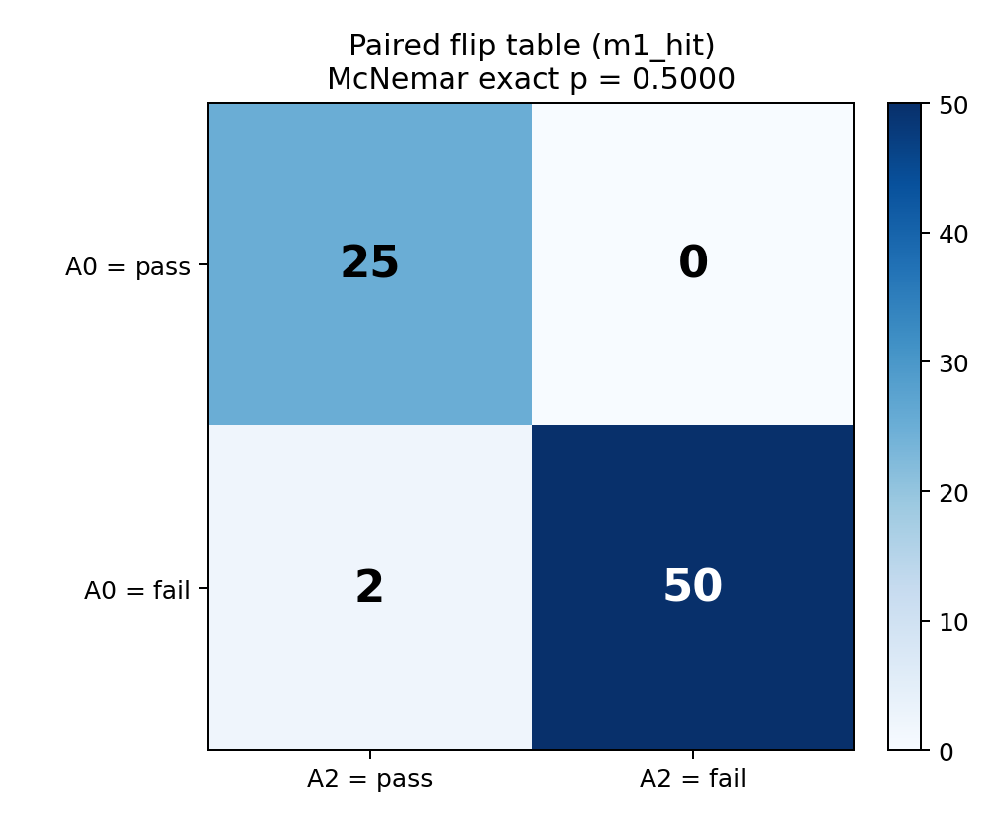
Figure2:McNemarpairedfliptableonthebinaryM1outcomeatthe0.75cosinethresholdfor the77testincidents.Bothcorrect:25.Bothwrong:50.A2correctonly:2.A0correctonly:0. McNemarexacttwo-sidedp = 0.500.
rerankingispullingcorrectanswershigheruptherankedlist,whichistheintendedbehaviorofa reranker.
8.5 CaseStudies:StrictWins
TheaggregatestatisticsshowthatA2isbetteronaverage,buttheydonotbythemselvesexplain whythererankingmovesthingsinthewayitdoes.Thissectionwalksthroughthetwocases whereA2wascorrectandA0waswrong,andshowswhatchangedatthecause-textlevel.Table3 summarizesthetwostrictwins.
Table3:ThetwotestincidentswhereA2wascorrectandA0waswrong.Match%isthetop-1 cosinesimilarityscorebetweenthepredictedcauseandtheclosesttruecausefinding.
IncidentID | A0match% | A2match% | ∆
20100114X11754 | 42.2 | 76.8 | +34.6 pp
20120802X03552 | 58.5 | 87.1 | +28.6 pp
Bothwinsarelarge.Thesmallergainis+28.6percentagepointsandthelargeris+34.6.In oneofthetwowins,A0returnedagenericenvironmentalcausefindingaboutclear-airturbulence affectingpersonnel,aphrasethatappearsmanytimesinthecorpusandlivesinapartofthe embeddingspacethatpullsmanynarrativestowardit.Thepureembeddingrankingfallsinto thisattractorwheneverthenewqueryusesenvironmentalwordssuchascruiseordescent.Inthe otherwin,A0returnedagenericorganizationalcauseaboutequipmentmanufacturethatcaptures none oftheunderlyingmechanism.The structuralmapping extensionisbuilttocatch bothfailure modes:itlookspastthewordingandaskswhetherthecandidate’scausalchainactuallymatches thequery’schain,soitcanpullmechanism-matchedcandidatesabovethegenericonesthatonly soundright.
17

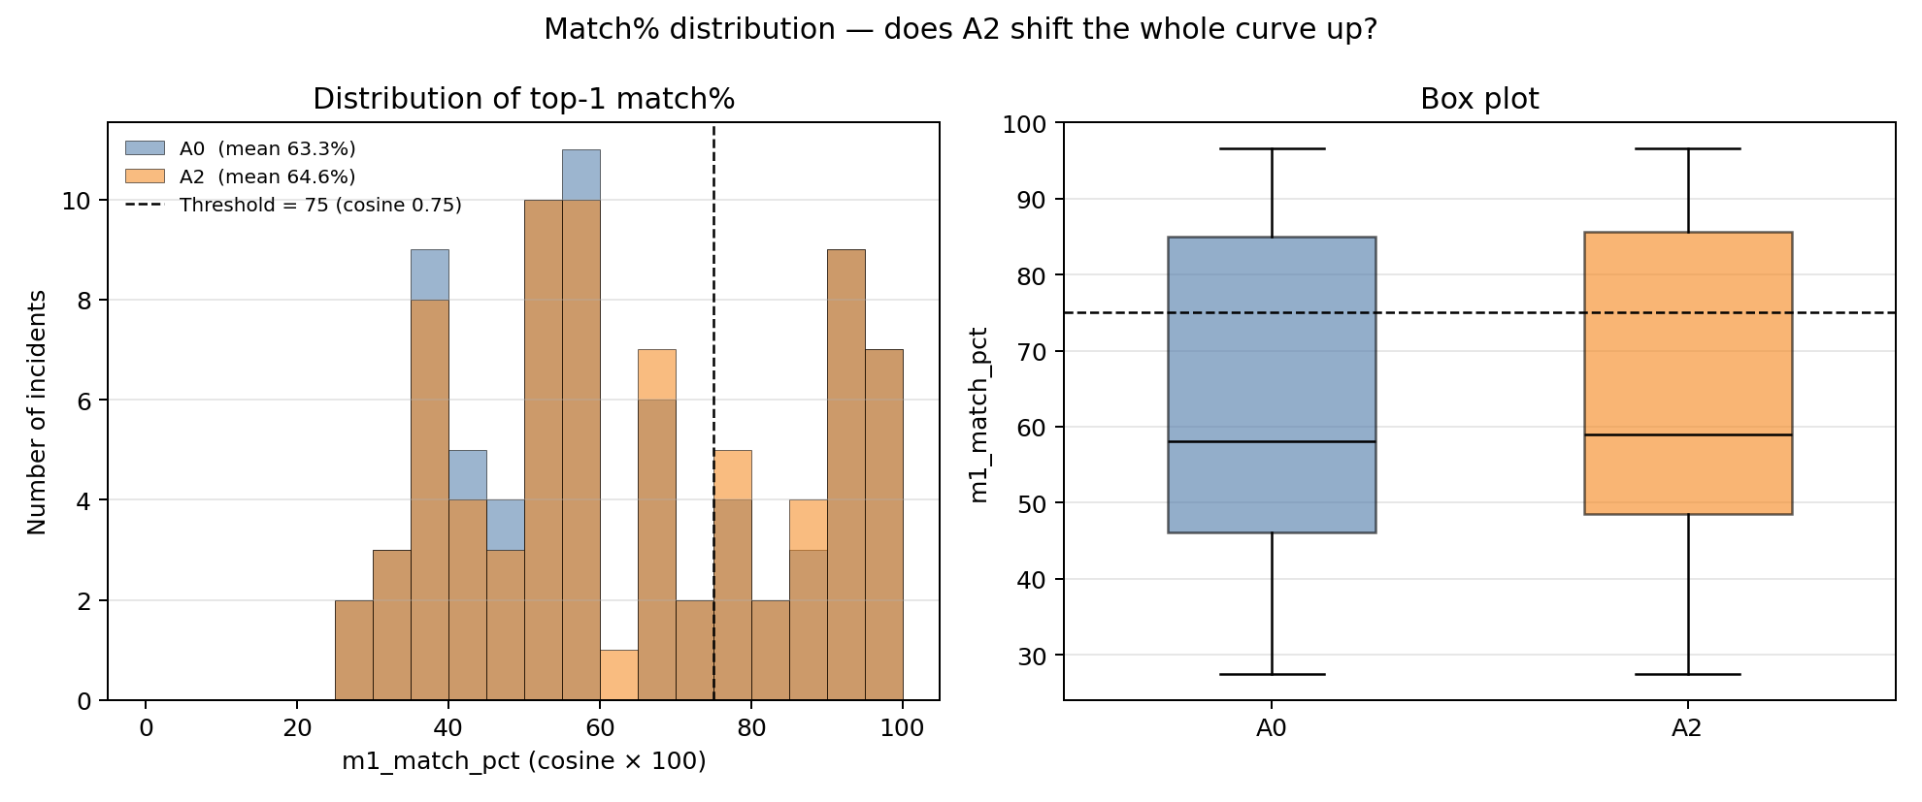
Figure3:Histogramandboxplotofthetop-1matchscoreacrossthe77testincidents,forA0and A2.Thedashedlineat75%marksthecosinethresholdusedtodefineahit.
8.5.1 WorkedExample:Incident20100114X11754
The truth for this incident is aircraftpowerplant,enginefuelandcontrol,fueldistribution,failure. A0pickedorganizationalissues,development,manufacture/production,equipmentmanufacture, manufacturerand scored42.2% on the match metric,which isbelow the0.75 threshold andcounts asamiss.A2pickedaircraftpowerplant,engine(turbine/turboprop),turbinesection,failureand scored76.8%,whichisabovethethresholdandcountsasahit.
TheA0pickisagenericorganizationalcausethatsaysnothingaboutthephysicalmecha-nismthatbroughttheenginedown.TheA2pickisaspecificpower-plantturbinesectionfailure, whichsitsinthesameengine-failuremechanismfamilyasthetruth’sfuel-distributionfailure.The structuralrerankerfoundthiscandidatebecauseitsextractedcausalchain(fuelsystemmaterial degradation,propagationtothermaldamage,terminalenginefailure)alignedwiththequery’s chainattheroleandmechanismlevel,whilethemanufacturercandidate’schainhadalmostno overlapwiththequery’schain.TheboostfactorinEquation11fortheturbine-sectioncandidate wasthereforemuchlargerthanforthemanufacturercandidate,whichmoveditpastA0’spickin theranking.
8.5.2 WorkedExample:Incident20120802X03552
The truth for this incident is environmentalissues,physicalenvironment,object/animal/substance, animal/bird,effectonoperation.A0pickedenvironmentalissues,conditions/weather/phenomena, turbulence,clearairturbulence,effectonpersonnelandscored58.5%.A2pickedenvironmental issues, physical environment, object/animal/substance, animal/bird, effect on equipment and scored 87.1%, which differs from the recorded truth by a single word (equipment vs operation) and is correct inmechanism.
The two candidates are both environmental causes,but only one matches the underlying mech-anismofthequery.Thebird-strikecandidate’scausalchain(initiatingeventintheenvironment, propagation to aircraft systems, terminal effect on equipment) lines up with the query’s chain at ev-erystep.Theclear-airturbulencecandidate’schainmatchesthequeryonlyontheinitiating-event role,anddivergesonmechanism.Thestructuralsimilarityforthebirdcandidatewastherefore largerthanfortheturbulencecandidate,theboostfactorwascorrespondinglylarger,andthebird candidatemovedtorank1.
18

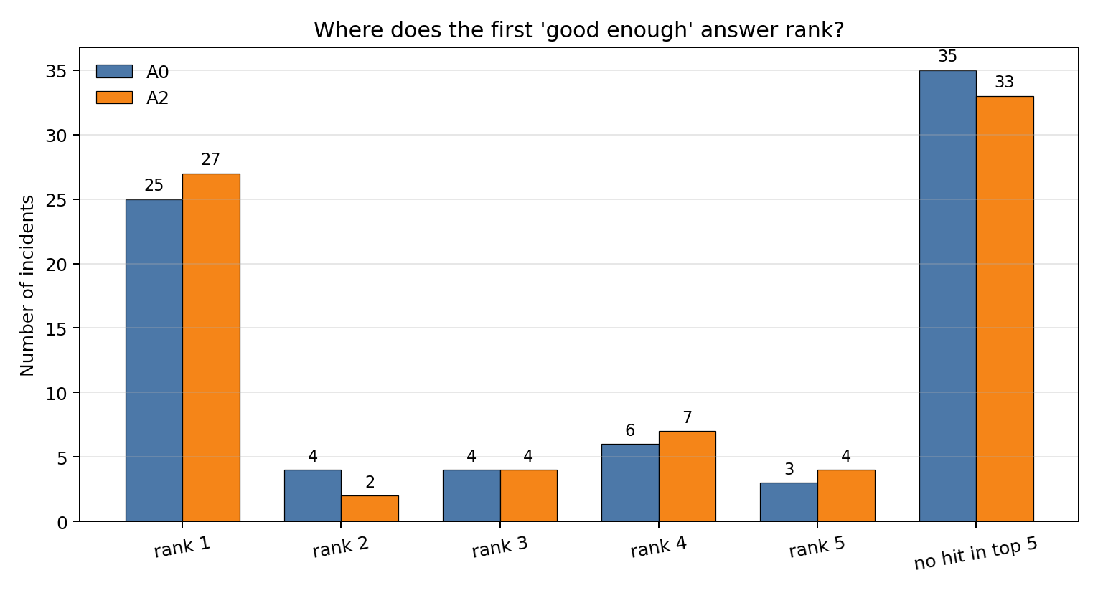
Figure4:Rankpositionofthefirstpassingpredictionundereachmethodacrossthe77test incidents.Barsshowthecountofincidentswhosefirstpassingpredictionlandsatrank1,2,3,4, 5,orhasnohitinthetop5.
8.5.3 DemotionMechanics
AusefulsubtletyaboutthefusionformulainEquation11isthatitneverliterallylowersany candidate’s score.The factor exp(α·struct_sim) is at least 1 for non-negative structural similarity, soeverycandidate’sscoreeitherstaysthesameorgoesupunderA2. WhatA2doesisraise everyone’sscore,butraisesomecandidatesmorethanothers.Acandidatewithlowstructural similaritygetsasmallboost.Acandidatewithhighstructuralsimilaritygetsalargeboost.The low-boostcandidategetspassedintherankingbythehigh-boostcandidate.Thatiswhatwe mean when we say A2 demoted a candidate.In the bird-strike case in Section 8.5.2,the turbulence candidate’sscorewentupunderA2,butthebird-strikecandidate’sscorewentupmore,sothe turbulencecandidatefellfromrank1toalowerrank.Theworstcaseforacandidateiswhenits extractedchainhasnothingincommonwiththequery.Itsstructuralsimilarityis0,soitsboost factor is exp(0) = 1 and its score does not change at all under A2.Meanwhile every other candidate withrealchainagreementgetsmultipliedupandpassesitintheranking.
8.6 CaseStudies:Losses
ForcompletenesswealsoreportthecaseswhereA2’scontinuousmatchscoreislowerthanA0’s. Fourteen test incidents fall into this group.Table 4 shows the four largest drops;the remaining ten areallatorbelowonetenthofapercentagepointandareessentiallynumericalnoise.
Two observations support the no-regression claim from Section 8.3.First,the two largest drops areonincidentsthatwerealreadyfailingunderA0,sothestructuralrerankingdidnotbreaka case the baseline was getting right;it just left a wrong answer wrong with a slightly different score. Second,thenexttwodropsaretiny(−0.1percentagepoints)andoccuronincidentsthatpass the0.75thresholdunderbothmethods,sothererankingdidnotpushthemacrossthethreshold either.ThereisnotasingletestincidentwhereA0wascorrectatthe0.75thresholdandA2’s rerankingknockedtheanswerbelowthethreshold.ThisisthesamefindingthattheMcNemar
19

Table 4:Test incidents where A2’s match percent is lower than A0’s, sorted by the size of the drop. Noneofthesedropscrossesthe0.75hitthreshold.
IncidentID | A0match% | A2match% | ∆ | A0hit | A2hit
20131220X70905 | 43.9 | 41.2 | −2.8 pp | no | no
20170308X73155 | 37.2 | 36.2 | −1.0 pp | no | no
20090921X73211 | 81.6 | 81.5 | −0.1 pp | yes | yes
20110417X11718 | 76.1 | 76.0 | −0.1 pp | yes | yes
tableinSection8.3showsinadifferentform.
8.6.1 WorkedExample:Incident20131220X70905
ThetruthforthelargestA2dropisaircraftsystems,equipment/furnishings,cargocompartments, incorrectuse/operation.A0pickedenvironmentalissues,conditions/weather/phenomena,turbu-lence,convective turbulence,effect on personneland scored 43.9%.A2 picked organizational issues, development,manufacture/production,equipmentmanufacture,manufacturerandscored41.2%. Bothpredictionsarewrongonthebinaryoutcomeandthegapbetweenthemisunderthreeper-centagepoints.
Thequeryisacargo-compartmentincorrect-operationincident,whichinvolvesahuman-action mechanismonanaircraftsystemssubsystem.Neithercandidateisagoodmatch.Theconvective-turbulencecandidatefromA0isinthewrongsubsystementirely(environmentinsteadofaircraft systems)andispurelyapassiveenvironmentalcause.ThemanufacturercandidatefromA2is intherightvicinity(anorganizationalcausethattouchesequipment)butdoesnotcapturethe cargo-compartmentoperationmechanismeither.Thererankerpulledthemanufacturercandidate aheadbecauseitschainhasslightlymoreincommonwiththequery’schainattherolelevel(both involveanorganizationalorhumancontribution),butthecosinesimilaritytothestandardized truthphrasingdroppedbecausethetruthiswritteninaircraft-systemsvocabulary.Thedropis smallinabsoluteterms(−2.8percentagepoints)andonanincidentthatwasnevergoingtopass thethresholdundereithermethod,soithasnoeffectonthebinaryoutcome.
TheremainingdropsinTable4aresimilarincharacter.Thetwo−0.1percentagepointdrops occuronincidentsthatpassthe0.75thresholdunderbothmethods,sothestructuralreranking didnotchangetheanswerorthebinaryoutcomeonthosecases.Noneofthe14dropscrossesthe thresholdineitherdirection.
9 ComparisonandDiscussion
Thetwomethodologiesinthispapersitatdifferentpointsonatradeoffbetweensimplicityand discriminationpower.ThehybridapproachinSection5isthesimplerofthetwo:itreliesonlyon text embeddings,k-means clusters,and frequency counts,and it produces probability distributions thatcanbereadoffdirectly.Itworkswellaslongasthewordingofthequerylinesupwiththe wordingofthecausefindingitshouldmatch.ThestructuralmappingextensioninSection6adds aone-timeper-incidentextractionstepandasingle-linererankingformulaontopofthehybrid pipeline.It does not change any of the upstream retrieval or clustering steps, and it does not replace theembeddingscore;itonlyreweightsthetopcandidatesbasedoncausalmechanismagreement.
TheverificationresultsinSection8showthatthestructuralmappingextensionimprovesTop-1diagnosisaccuracyby2.6percentagepointsontheheld-outtestset,with2strictwinsand0
20

strictlossesonthebinaryoutcome.Theaggregateimprovementismoderate,buttheshapeofthe improvement is the more important finding.Every disagreement between the two methods went in thestructuralmappingextension’sfavoratthebinarylevel.Thecaseswheretheextensionwon werelargewins,+28.6and+34.6percentagepointsonthecontinuousmatchscore.Thecases wheretheextensionlostweresmall,withthelargestdropat−2.8percentagepointsandmost underonetenthofapercentagepoint,andneverbrokeacasethebaselinewasgettingright.This isthesignatureofarealsignalratherthannoise.ThecasestudiesinSections8.5and8.6trace eachdisagreementtothecandidatecausetextandtheunderlyingchainagreement,sothechanges canbeexplainedoneincidentatatimeandnotonlyasanaggregatestatistic.
Thehybridapproachistherightstartingpointwhentheretrievalsetislargeandthecause vocabularyisvaried,becauseitisfast,transparent,andgroundedincounts. Thestructural mappingextensionistherightadd-onwhentheretrievalsetcontainsincidentswhosewordingis similarbutwhoseunderlyingmechanismisnot.Inthatcase,theembeddingcosinealoneisnot enoughtoseparatetherelevantfromtheirrelevant,andthestructuralsignaldoestheworkof breakingthetie.
10 Conclusion
10.1 Contributions
ThispapermakesfourcontributionstotheanalysisoftheNTSBFAR121accidentdatabase. First,weextendtheBayesiannetworkworkofZhangandMahadevan(2021)bybringingthe narrativereportsintotheanalysisthroughahybridpipelinethatcombinesLLM-basedretrieval andclusteringwithfrequency-basedprobabilitycalculationsusingthelawoftotalprobability. Second,weapplythehybridpipelinetobothdiagnosisandprognosis,usingthesameFAR121 datasetfrom1982to2016usedinthepriorwork,andweprovideafullnumericalwalk-through ofbothmodes.Third,weaddastructuralmappingextensionthatextractsastructuredcausal chainforeachincident,computesastructuralsimilarityscoreusingNeedleman-Wunschsequence alignment,andcombinesthisscorewiththeembeddingcosinethroughasingle-linefusionformula torerankthetopretrievedcandidates.Fourth,weevaluatethestructuralmappingextensionona held-outtestsetof77FAR121incidentsusingpairedstatisticaltests,andwetraceeachwinand eachlosstotheactualstructuralagreementvaluesthatdrovethedecision,sotheresultcanbe explainedatthelevelofindividualincidentsandnotonlyasanaggregatestatistic.
10.2 Limitations
Severallimitationsshouldbeaddressedinfuturework.First,thetestsetsize(n = 77)ismodest, which limits the power of the McNemar test and widens the confidence intervals on the rate metrics. A larger held-out set, or k-fold cross validation across the FAR 121 set, would give tighter intervals. Second,thestructuralextractionstepdependsonanLLM,anderrorsinextraction(suchasa wrongsystemormechanismlabel)propagateintothealignmentandproducenoisystructural similarities.Wemitigatethisbynormalizingallextractedvaluesagainstafixedallowedlist,but the schema is finite and may not cover every nuance of every incident.A schema with finer-grained subsystemlabelswouldlikelyimprovethestructuralsignal.
Third,thefusionparameterαin Equation11wassetto2.0basedoninitialexperiments.Agridsearchonaheld-outsubsetwould allowαtobepickedfromdatainsteadofbyhand,whichmaypushthegainhigher.Fourth, theM1matchscoremeasurescosinesimilaritybetweenthepredictedcausetextandtheNTSB causetext,whichisitselfaproxyforwhatwecareabout.Incaseswherethestructuralmapping
21

extensionpicksacandidatewithstrongmechanismagreementbutdifferentwording,themetric canpunishthepredictionevenwhentheanswermaybemoreusefulforaninvestigator.Ametric thatscoresmechanismagreementdirectlywouldlikelyshowA2doingbetterthanthematchscore alonesuggests.
Asecondobservationaboutthemetricconcernsitssensitivityatthethreshold.TheTop-1hit metric is binary at 0.75 cosine similarity, so a candidate at 0.74 counts as a miss while a candidate at 0.76countsasahit.Someoftherankmovementthatthestructuralrerankerproducesisinvisible tothismetric:acandidatethatgoesfromrank5torank1withamatchscorethatstaysbelow 0.75 does not flip the binary outcome even though it is a meaningful improvement to a user reading the ranked list.The average match percent is more sensitive in this respect, and shows a consistent positiveshiftunderA2.
10.3 FutureWork
Therearethreeplacesthisworkcangonext.First,thestructuralrerankercanbecarriedover totheprognosispipelineinSection5.6.Thererankerplugsintothesameretrievalstagethat prognosis already uses,with a small change to the cluster-weight formula in Equation 4 so that the weightsarecomputedfromthefusedscoreratherthantherawcosine.Thenext-eventprediction taskcanthenbeevaluatedunderA2thesamewaydiagnosiswasevaluatedinSection8.Second, the per-step similarity weights in Equation 9 were set by hand at 0.50, 0.30, and 0.20, following the relational hierarchy of Gentner (1983).These weights are grounded in theory rather than tuned on data,andcanbelearnedfromtheheld-outsetinfuturework,whichwouldletthefusionadapt tothestructureofthedatainsteadofrelyingonafixedprior.Third,afinalstagethatscoresthe candidate’spredictedcausetextagainstthequery’snarrativedirectly,inadditiontothecurrent structuralandcosinesignals,wouldaddressthefailuremodeinSection8.6.1wheremechanism agreementandtextagreementdiverge.
References
B.Falkenhainer,K.D.Forbus,andD.Gentner.Thestructure-mappingengine:Algorithmand examples.ArtificialIntelligence,41(1):1–63,1989.
D. Gentner.Structure-mapping:A theoretical framework for analogy.CognitiveScience, 7(2):155– 170,1983.
D.GentnerandA.B.Markman.Structuremappinginanalogyandsimilarity.AmericanPsychol- ogist,52(1):45–56,1997.
R.L.Goldstone.Similarity,interactiveactivation,andmapping.JournalofExperimentalPsy- chology:Learning,Memory,andCognition,20(1):3–28,1994.
InternationalAirTransportAssociation.IATAforecastpredicts8.2billionairtravelersin2037, 2019..
S.B.NeedlemanandC.D.Wunsch.Ageneralmethodapplicabletothesearchforsimilaritiesin theaminoacidsequenceoftwoproteins.JournalofMolecularBiology,48(3):443–453,1970.
R.NogueiraandK.Cho.Passagere-rankingwithBERT.arXivpreprintarXiv:1901.04085,2019.
J.Spencer-SmithandR.L.Goldstone.Thedynamicsofsimilarity.CognitiveStudies:Bulletinof theJapaneseCognitiveScienceSociety,4:38–56,1997.
22

X.ZhangandS.Mahadevan.Ensemblemachinelearningmodelsforaviationincidentriskpredic- tion.DecisionSupportSystems,116:48–63,2019.
X.ZhangandS.Mahadevan. Bayesiannetworkmodelingofaccidentinvestigationreportsfor aviationsafetyassessment.ReliabilityEngineeringandSystemSafety,209:107371,2021.
23

