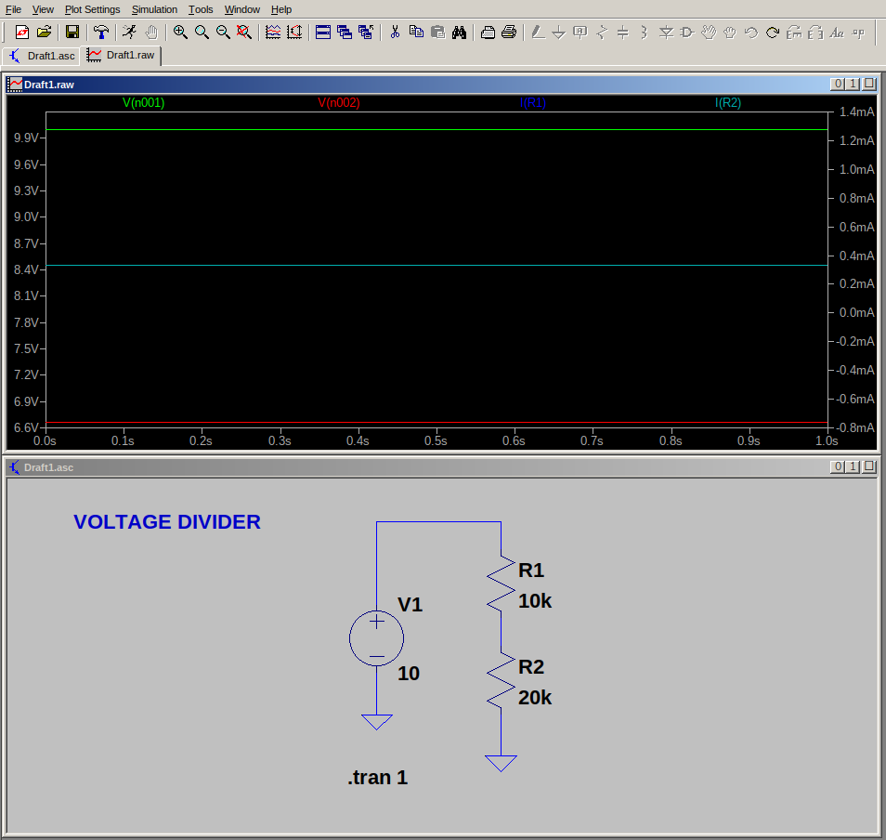
VOLTAGE DIVIDER
Voltage divider is a simple circuit used to produce lower voltage from a higher voltage source.

GRAPH DESCRIPTION:
- Green – Input voltage
- Red- Output Voltage(Taken in between the points were two resistors connected)
- Blue- Current is resistors R1 & R2.

