DAA Lab-5

Name: Kshitij Kumar Sharma Roll No.: 1905514 Date: 07/08/2021

**Q-5.1)** Write a program to sort a given set of elements with the Quick sort.

1)Repeat the experiment for different values of n = 5000, 10000, 50000, 100000 and report the time (in seconds) required to sort the elements.

2)For each of aforementioned case, consider arrays as random, sorted, and reverse-sorted and observe running time variation for different types of input for quick sort. [Provide your observation regarding sensitivity of quick sort on the input in your lab record.]

**Program:**

/*

Written by: Kshitij Kumar Sharma Roll No.: 1905514

Idea of the solution:

At first I have implemented the quick_sort() and partition() functions and then generated random, sorted and reverse sorted array to pass into the quick_sort() function and stored their timings separately. The partition function divides the array into two halfs with respect to a value called pivot which is the last element of the array, the left half contains all the values which are smaller than that of pivot and the right half contains all the grater than the pivot value and it returns the index of the pivot element. The quick_sort() function calls the partition() function, after getting the index of the pivot element the quick_sort() function recursively calls itself for the left half and right half of the pivot and it does so until single element is left in the left and right sub arrays.

*/

#include<bits/stdc++.h>

#include<stdio.h>

#include<stdlib.h>

#include<time.h>

using namespace std;

int partition(int a[],int p,int r)

{

int j,t,i=p-1; //latest index of elements less than pivot

int pivot=a[r]; //assigning last element as pivot

for(j=p;j<=r-1;j++)

{

if(a[j]<=pivot) //checking for element smaller than pivot

{

i++;

t=a[i]; //swapping the element

a[i]=a[j];

a[j]=t;

}

}

t=a[i+1]; //putting pivot element at its position

a[i+1]=a[r];

a[r]=t;

return i+1;

}

void quick_sort(int a[],int p,int r)

{

int q;

if(p<r)

{

q=partition(a,p,r); //calling partition() for getting pivot’s index

quick_sort(a,p,q-1); //recursively sending left sub half

quick_sort(a,q+1,r); //recursively sending right sub half

}

}

int main()

{

int n,i,j,k;

clock_t start, end; //Variables for keeping start and end time

double cpu_time_used; //Variable for keeping cpu time used

for(i=0;i<4;i++)

{

cout<<endl;

cout<<"Enter the size of the array : ";

cin>>n;

int a[n];

srand(time(0));

for(j=0;j<n;j++)

a[j]=rand()%1000000; //generating random array

cout<<"For n= "<<n<<endl;

start=clock(); //keeping start time of the clock for random array

quick_sort(a,0,n-1); //sorting

end=clock(); //keeping end time of the clock for random array

cpu_time_used=((double)(end-start))/CLOCKS_PER_SEC;

printf("Time taken for random : %fsec \n",cpu_time_used);

sort(a,a+n);

start=clock(); //keeping start time of the clock for sorted array

quick_sort(a,0,n-1); //sorting

end=clock(); //keeping end time of the clock for sorted array

cpu_time_used=((double)(end-start))/CLOCKS_PER_SEC;

printf("Time taken for sorted : %fsec \n",cpu_time_used);

sort(a,a+n,greater<int>());

start=clock(); //keeping start time of the clock for reverse sorted array

quick_sort(a,0,n-1); //sorting

end=clock(); //keeping end time of the clock for reverse sorted array

cpu_time_used=((double)(end-start))/CLOCKS_PER_SEC;

printf("Time taken for reverse sorted : %fsec \n",cpu_time_used);

}

}

**Outputs:**

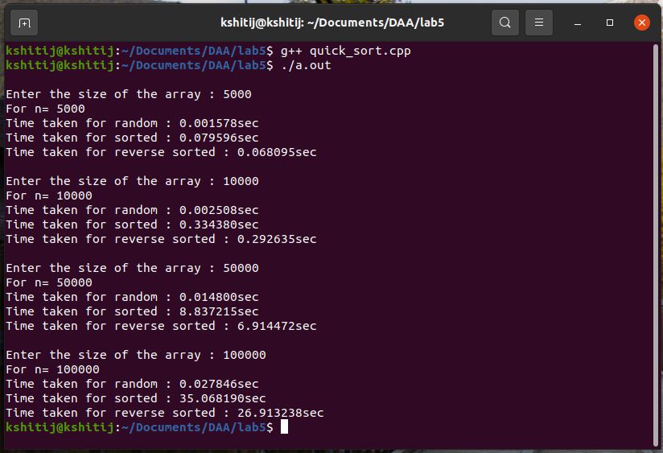

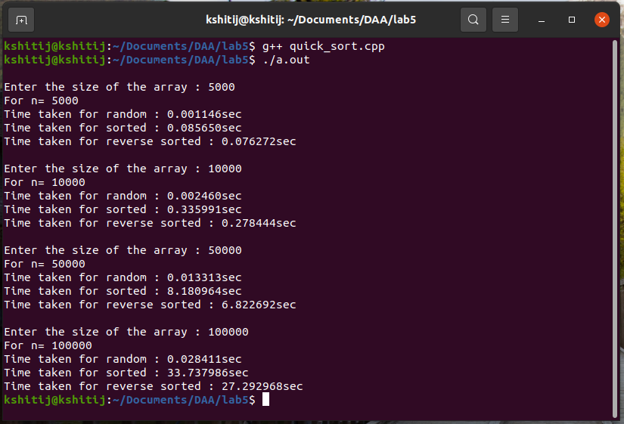

**Q-5.2)** Repeat implementation of 5.1 with a randomized version of quick sort in which partition selects the pivot element randomly. Compare the previous version with randomized quick sort.

**Program:**

/*

Written by: Kshitij Kumar Sharma Roll No.: 1905514

Idea of the solution:

At first I have implemented the random_quick_sort(), random_partition() and partition() functions and then generated random, sorted and reverse sorted array to pass into the random_quick_sort() function and stored their timings separately. The partition function divides the array into two halfs with respect to a value called pivot which is the last element of the array, the left half contains all the values which are smaller than that of pivot and the right half contains all the grater than the pivot value and it returns the index of the pivot element. The random_partition() function generates a random index value, in between p and r and then swaps that index value with the last index value and then calls the partition() function. The random_quick_sort() function calls the random_partition() function, after getting the index of the pivot element the random_quick_sort() function recursively calls itself for the left half and right half of the pivot and it does so until single element is left in the left and right sub arrays.

*/

#include<bits/stdc++.h>

#include<stdio.h>

#include<stdlib.h>

#include<time.h>

using namespace std;

int partition(int a[],int p,int r)

{

int j,t,i=p-1; //latest index of elements less than pivot

int pivot=a[r]; //assigning last element as pivot

for(j=p;j<=r-1;j++)

{

if(a[j]<=pivot) //checking for element smaller than pivot

{

i++;

t=a[i]; //swapping the element

a[i]=a[j];

a[j]=t;

}

}

t=a[i+1]; //putting pivot element at its position

a[i+1]=a[r];

a[r]=t;

return i+1;

}

int random_partition(int a[],int p,int r) //for choosing random pivot

{

srand(time(0));

int i=(rand()%(r-p+1))+p; //generating random index between p and r

int t=a[r]; //swapping the last element with the random

a[r]=a[i]; // index value.

a[i]=t;

return partition(a,p,r); //calling partition()

}

void random_quick_sort(int a[],int p,int r)

{

int q;

if(p<r)

{

q=random_partition(a,p,r); //calling for pivot’s index

random_quick_sort(a,p,q-1); //recursively sending left sub half

random_quick_sort(a,q+1,r); //recursively sending right sub half

}

}

int main()

{

int n,i,j,k;

clock_t start, end; //Variables for keeping start and end time

double cpu_time_used; //Variable for keeping cpu time used

for(i=0;i<4;i++)

{

cout<<endl;

cout<<"Enter the size of the array : ";

cin>>n;

int a[n];

srand(time(0));

for(j=0;j<n;j++)

a[j]=rand()%1000000; //generating random array

cout<<"For n= "<<n<<endl;

start=clock(); //keeping start time of the clock for random array

random_quick_sort(a,0,n-1); //sorting

end=clock(); //keeping end time of the clock for random array

cpu_time_used=((double)(end-start))/CLOCKS_PER_SEC;

printf("Time taken for random : %fsec \n",cpu_time_used);

sort(a,a+n);

start=clock(); //keeping start time of the clock for sorted array

random_quick_sort(a,0,n-1); //sorting

end=clock(); //keeping end time of the clock for sorted array

cpu_time_used=((double)(end-start))/CLOCKS_PER_SEC;

printf("Time taken for sorted : %fsec \n",cpu_time_used);

sort(a,a+n,greater<int>());

start=clock(); //keeping start time of the clock for reverse sorted array

random_quick_sort(a,0,n-1); //sorting

end=clock(); //keeping end time of the clock for reverse sorted array

cpu_time_used=((double)(end-start))/CLOCKS_PER_SEC;

printf("Time taken for reverse sorted : %fsec \n",cpu_time_used);

}

}

**Outputs:**

