DAA Lab-7

Name: Kshitij Kumar Sharma Roll No.: 1905514 Date: 02/09/2021

**Q-7.1)** Write a program to sort a given set of elements with the Heap sort.

1) Repeat the experiment for different values of n = 20000, 50000, 100000, 500000 and report the time (in seconds) required to sort the elements.

2)For each of aforementioned case, consider arrays as random, sorted, and reverse-sorted and observe running time variation for different types of input for heap sort. [Provide your observation regarding sensitivity of heap sort on the input in your lab record.]

**Program:**

/*

Written by: Kshitij Kumar Sharma Roll No.: 1905514

Idea of the solution:

I have implemented heapify() to convert the array into a heap data structure and generate the max heap. The heap_sort() function calls the heapify(). The idea behind the concept is that the parent node is always grater then the child nodes and that is what I have tried to implement trough this program.

*/

#include <bits/stdc++.h>

using namespace std;

void heapify(int a[], int n, int i) //converting to heap data structure

{ //and max-heap generation

    int l,r,largest=i;

    l=2*i+1;  //left child

    r=2*i+2;  //right child

    if (l<n&&a[l]>a[largest]) //checking for the largest among the three

        largest=l;

    if (r<n&&a[r]>a[largest])

        largest=r;

    if (largest!=i)

    {

        swap(a[i],a[largest]); //swapping

        heapify(a,n,largest); //recursively calling

    }

}

void heap_sort(int a[], int n) //heap sort

{

    int i;

    for (i=n/2-1;i>=0;i--)

        heapify(a,n,i);

    for (i=n-1;i>0;i--)

    {

        swap(a[0],a[i]);

        heapify(a,i,0);

    }

}

int main()

{

    int n,i,j,k,s[]={20000,50000,100000,500000};       //different array sizes to test

    clock_t start, end;              //time variables for timing analysis

    double cpu_time_used;

    for(i=0;i<4;i++)

     {

        cout<<endl;

        n=s[i];

        int a[n];

        srand(time(0));

        for(j=0;j<n;j++)

            a[j]=rand()%1000000; //generating random array

        cout<<"For n= "<<n<<endl;

        start=clock();

        heap_sort(a,n);

        end=clock();

        cpu_time_used=((double)(end-start))/CLOCKS_PER_SEC;

        printf("Time taken for random : %fsec \n",cpu_time_used);

        sort(a,a+n);

        start=clock();

        heap_sort(a,n);

        end=clock();

        cpu_time_used=((double)(end-start))/CLOCKS_PER_SEC;

        printf("Time taken for sorted : %fsec \n",cpu_time_used);

        sort(a,a+n,greater<int>());

        start=clock();

        heap_sort(a,n);

        end=clock();

        cpu_time_used=((double)(end-start))/CLOCKS_PER_SEC;

        printf("Time taken for reverse sorted : %fsec \n",cpu_time_used);

    }

}

**Output:**

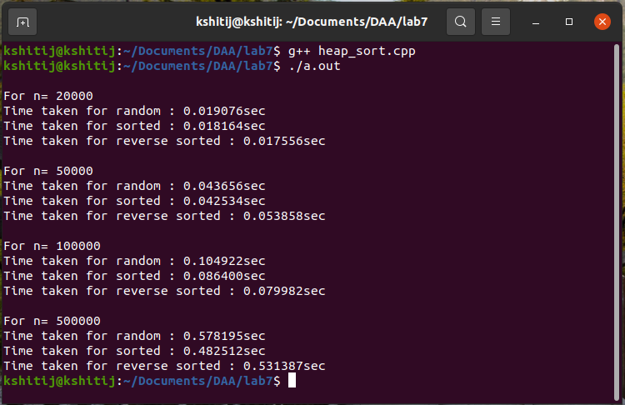

**Q-7.2)** Compare running time (in seconds) of heap sort with insertion sort, merge sort, and quick sort on different input sizes and also for different input types (random/sorted/reverse-sorted).

**Program:**

/*

Written by: Kshitij Kumar Sharma Roll No.: 1905514

Idea of the solution:

The concept of heap sort is same just adding merge sort and random quick sort which I have did in previous labs. Included them as a header file in this program to avoid repetition of the same code.

*/

#include <bits/stdc++.h>

#include "merge_sort.cpp" //merge sort header file

#include "quick_sort_random.cpp" //random quick sort header file

using namespace std;

//everything remains same as before

void heapify(int a[], int n, int i)

{

    int l,r,largest=i;

    l=2*i+1;

    r=2*i+2;

    if (l<n&&a[l]>a[largest])

        largest=l;

    if (r<n&&a[r]>a[largest])

        largest=r;

    if (largest!=i)

    {

        swap(a[i],a[largest]);

        heapify(a,n,largest);

    }

}

void heap_sort(int a[], int n)

{

    int i;

    for (i=n/2-1;i>=0;i--)

        heapify(a,n,i);

    for (i=n-1;i>0;i--)

    {

        swap(a[0],a[i]);

        heapify(a,i,0);

    }

}

int main() //some changes into the main function for analysing all the algorithms together

{

    int n,i,j,k,s[]={20000,50000,100000,500000};

    clock_t start, end;

    double cpu_time_used;

    for(i=0;i<4;i++)

     {

        cout<<endl;

        n=s[i];

        int a[n];

        srand(time(0));

        for(j=0;j<n;j++)

            a[j]=rand()%1000000;

        cout<<"For n= "<<n<<endl;

        cout<<"  Random Array \n";

        start=clock();

        heap_sort(a,n);

        end=clock();

        cpu_time_used=((double)(end-start))/CLOCKS_PER_SEC;

        printf("    Heap sort : %fsec \n",cpu_time_used);

        start=clock();

        merge_sort(a,0,n-1);

        end=clock();

        cpu_time_used=((double)(end-start))/CLOCKS_PER_SEC;

        printf("    Merge sort : %fsec \n",cpu_time_used);

        start=clock();

        random_quick_sort(a,0,n-1);

        end=clock();

        cpu_time_used=((double)(end-start))/CLOCKS_PER_SEC;

        printf("    Quick sort : %fsec \n",cpu_time_used);

        cout<<"  Sorted Array \n";

        sort(a,a+n);

        start=clock();

        heap_sort(a,n);

        end=clock();

        cpu_time_used=((double)(end-start))/CLOCKS_PER_SEC;

        printf("    Heap sort : %fsec \n",cpu_time_used);

        start=clock();

        merge_sort(a,0,n-1);

        end=clock();

        cpu_time_used=((double)(end-start))/CLOCKS_PER_SEC;

        printf("    Merge sort : %fsec \n",cpu_time_used);

        start=clock();

        random_quick_sort(a,0,n-1);

        end=clock();

        cpu_time_used=((double)(end-start))/CLOCKS_PER_SEC;

        printf("    Quick sort : %fsec \n",cpu_time_used);

        cout<<"  Reverse Sorted Array \n";

        sort(a,a+n,greater<int>());

        start=clock();

        heap_sort(a,n);

        end=clock();

        cpu_time_used=((double)(end-start))/CLOCKS_PER_SEC;

        printf("    Heap sort : %fsec \n",cpu_time_used);

        start=clock();

        merge_sort(a,0,n-1);

        end=clock();

        cpu_time_used=((double)(end-start))/CLOCKS_PER_SEC;

        printf("    Merge sort : %fsec \n",cpu_time_used);

        start=clock();

        random_quick_sort(a,0,n-1);

        end=clock();

        cpu_time_used=((double)(end-start))/CLOCKS_PER_SEC;

        printf("    Quick sort : %fsec \n",cpu_time_used);

    }

}

**Output:**

