**DNS**

1. **Steps to make a system globally accessible**

Prerequisite: Need to have a purchased domain name.

Steps:

1. open the domain management page

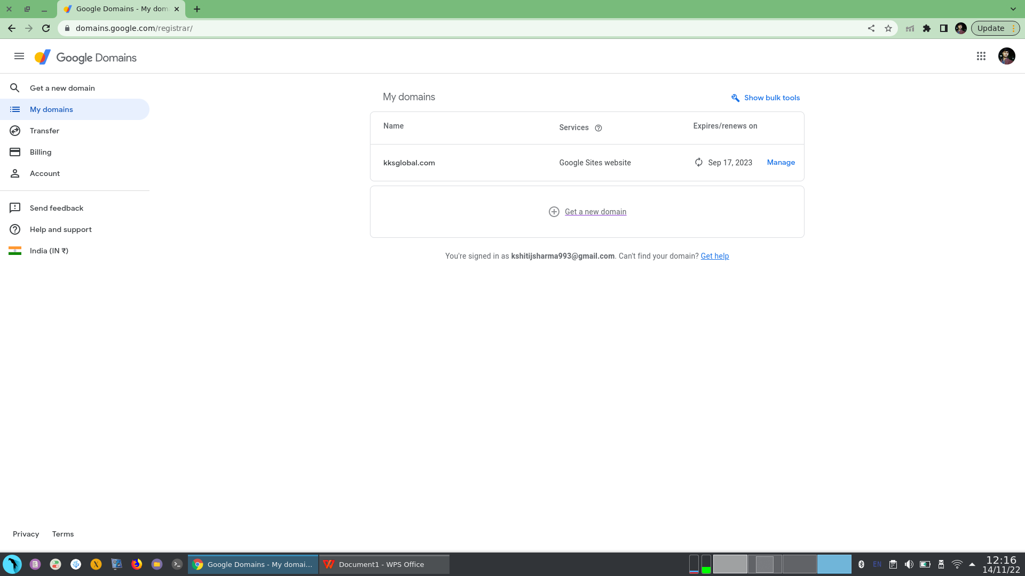

1. Click on the domain name.

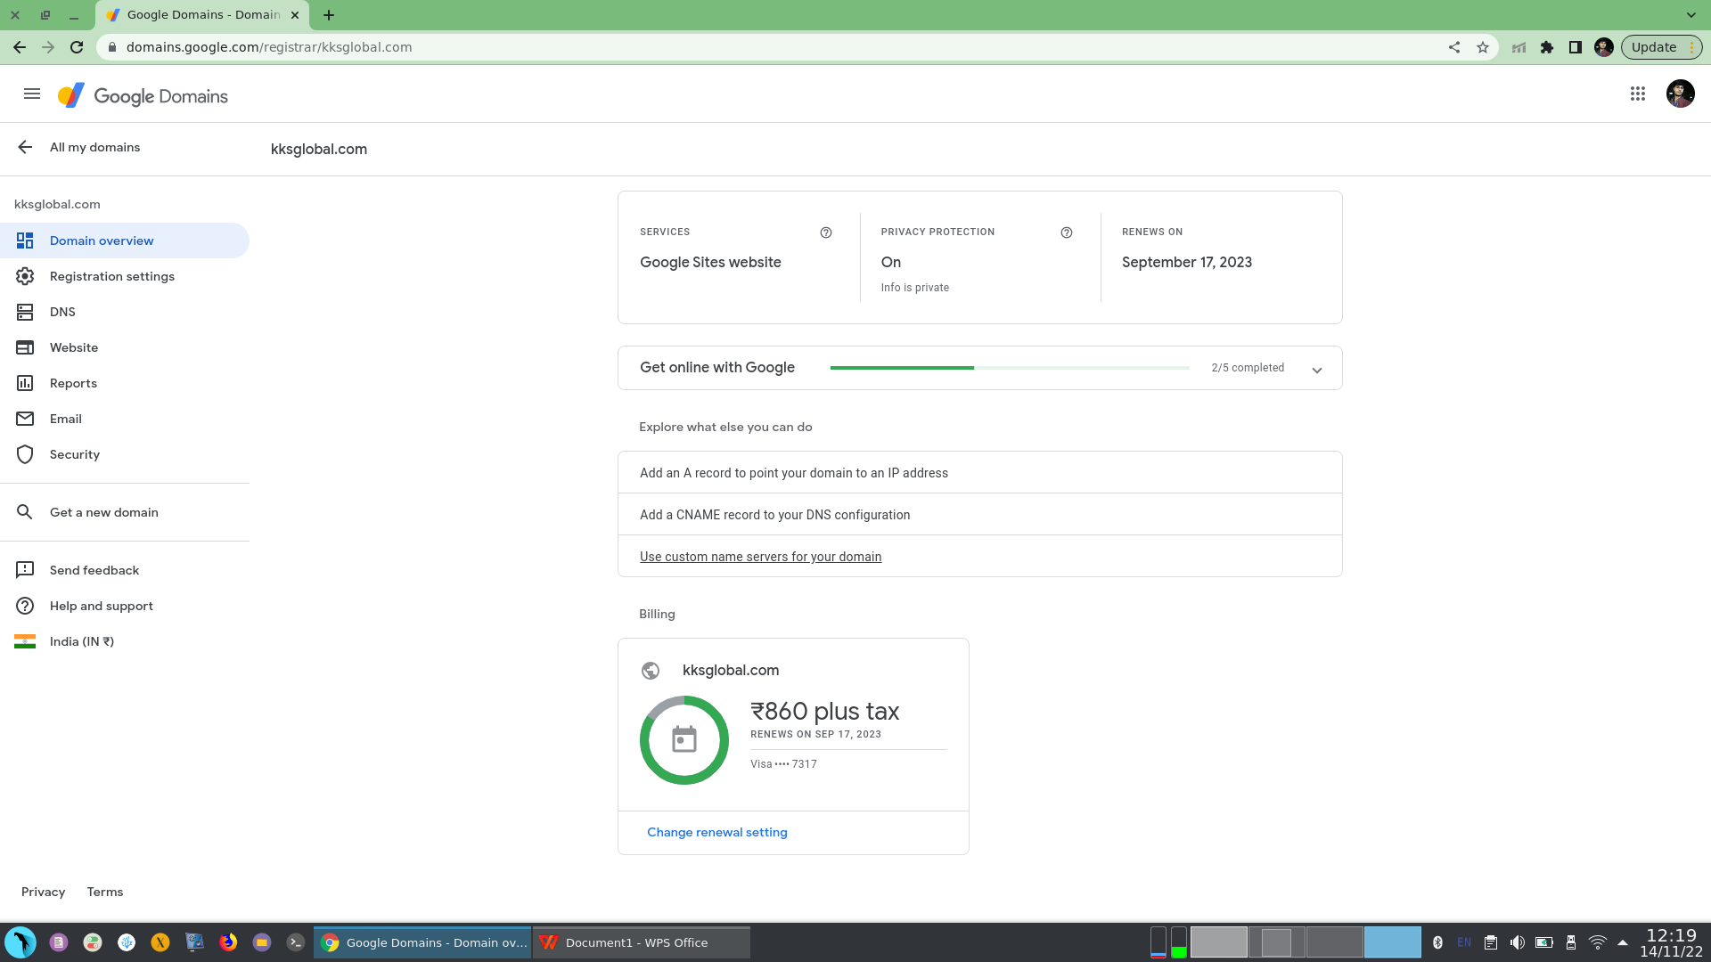

1. Click on DNS from the left side panel.

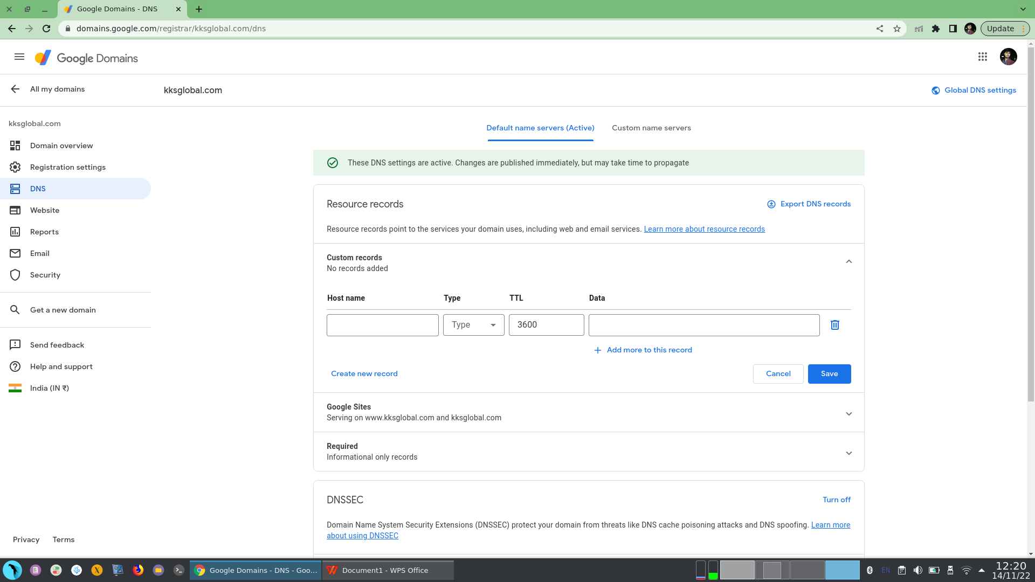

1. Scroll down and click on advanced settings.

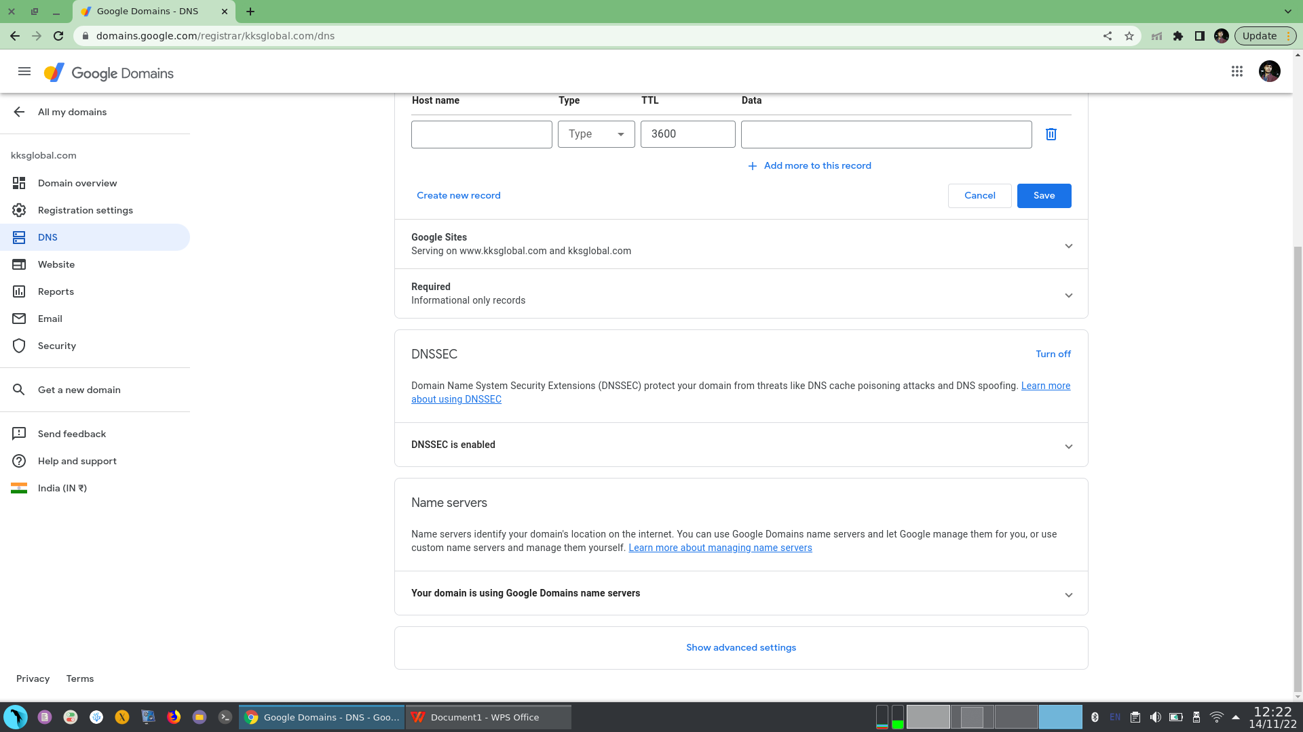

on clicking the advanced settings we will be able to see the Dynamic DNS management settings.

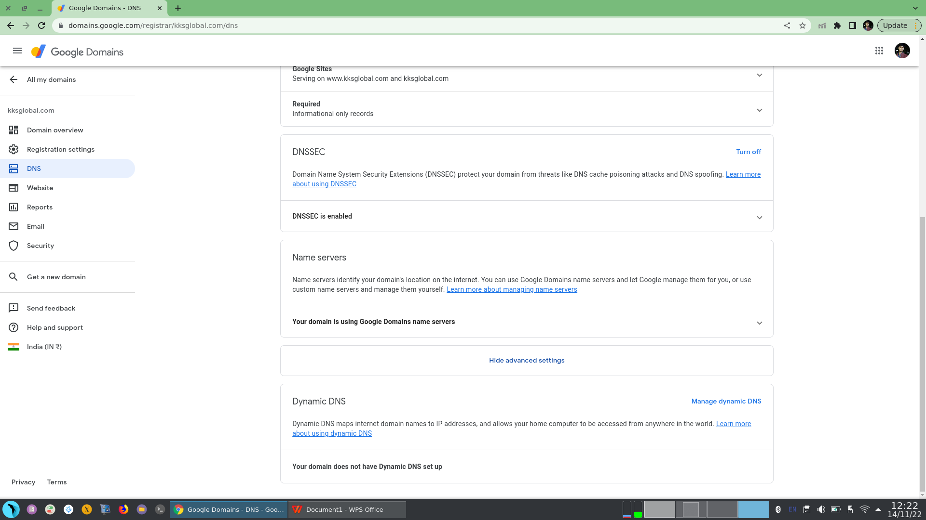

Now we can see the dynamic DNS setup at the bottom.

**What Dynamic DNS does?**

**Dynamic DNS maps internet domain names to IP addresses, and allows your home computer to be accessed from anywhere in the world.**

1. Now we will check our IP address and and start any server in our system to check the Dynamic DNS functionality.

command: **ifconfig**

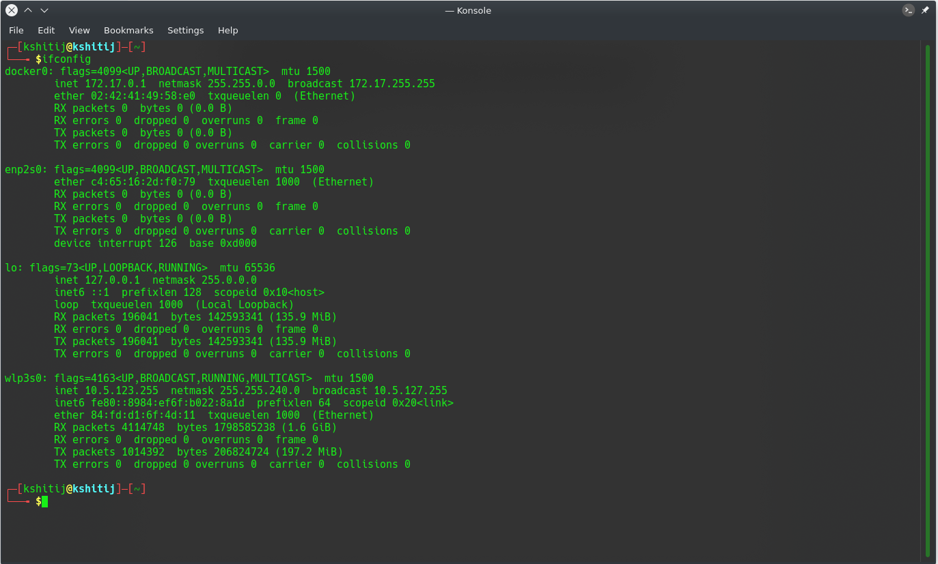

now we will start our apachae server

command: **service apache2 start**

and we will check whether it is started or not.

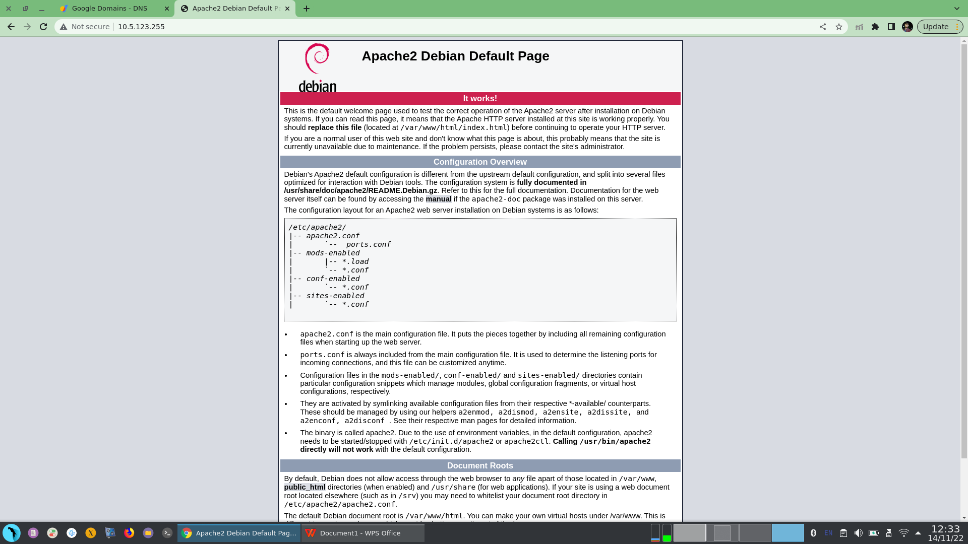

Now we can clearly see that our server is running at our IP address.

**now we will make it publicly accessible.**

1. Now click on Manage Dynamic DNS

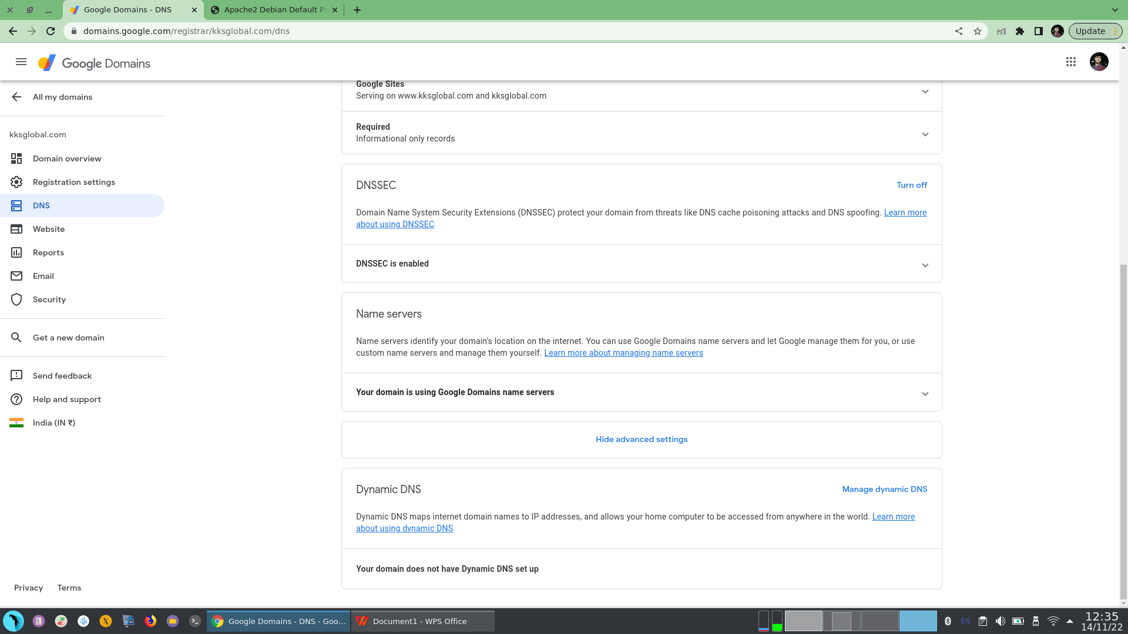

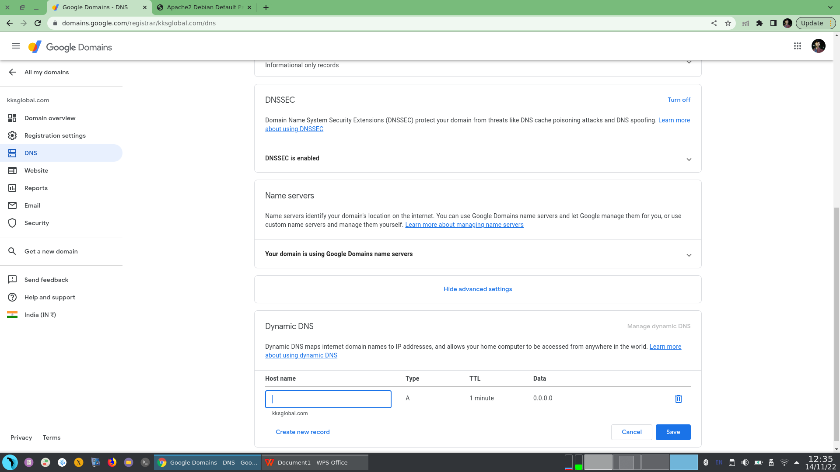

On clicking to manage dynamic DNS you will get an option to add host at the bottom.

1. Add a host name of you choice I an adding test.kksglobal.com

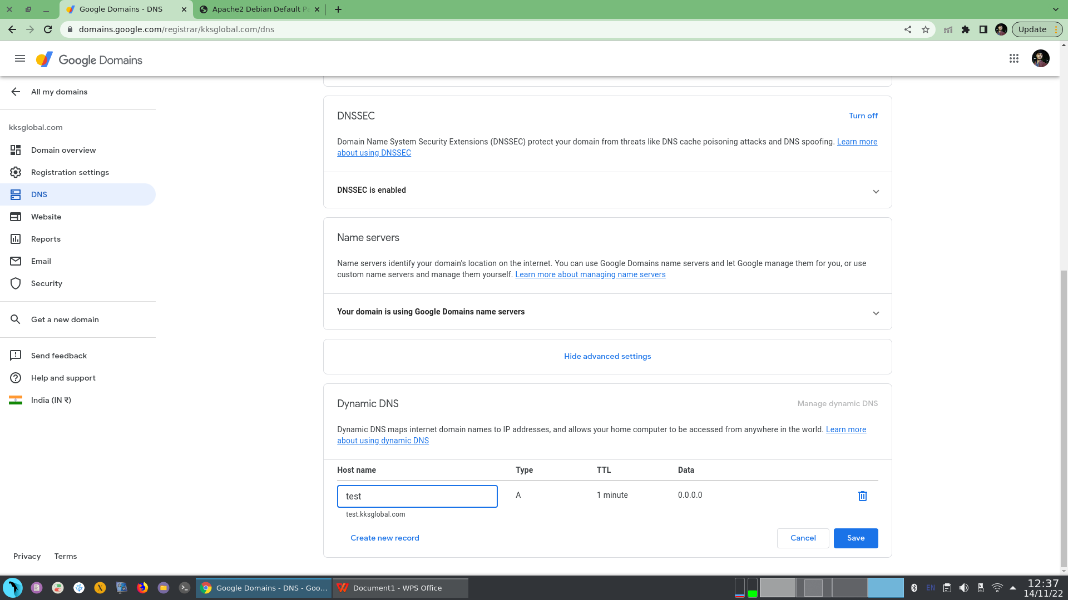

now just save and continue.

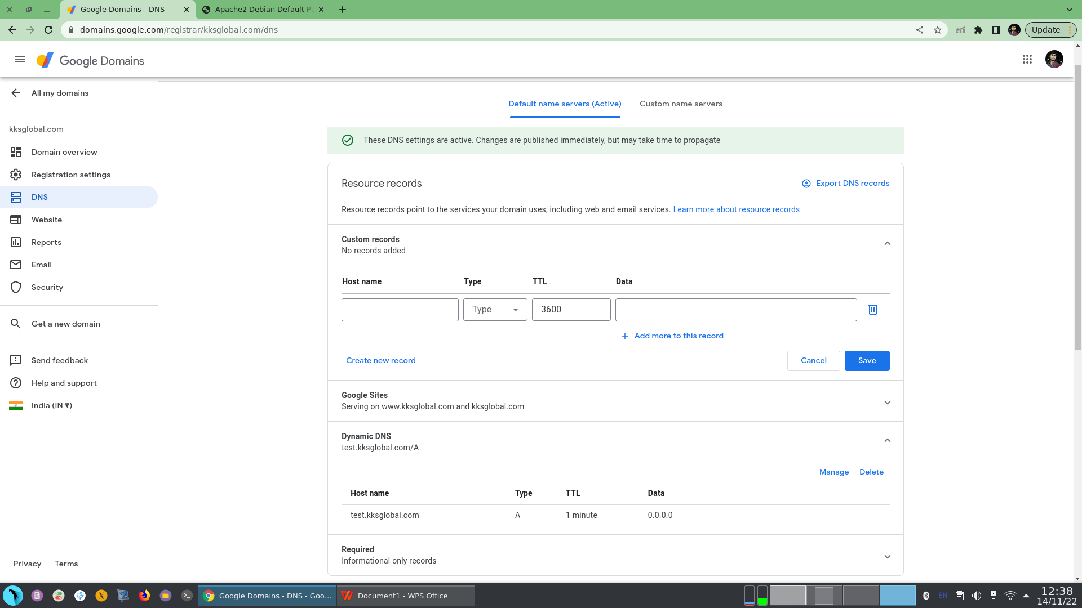

you will receive a message like this and a Dynamic DNS will be added.

1. Now we will check weather we are able to access our IP through our domain or not.

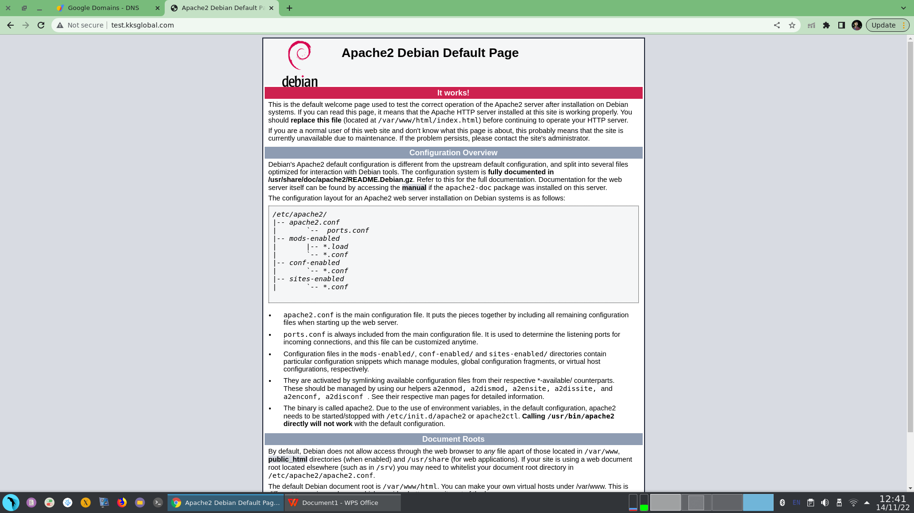

Now we can clearly see that we are able to access our systems public IP globally through our domain.