A PROJECT REPORT

on
DEVELOPING AUTOMATED TEST SUITES

Submitted to

KIIT Deemed to be University

In Partial Fulfillment of the Requirement for the Award of

BACHELOR’S DEGREE IN

COMPUTER SCIENCE AND ENGINEERING

By

KSHITIJ KUMAR SHARMA (1905514)

UNDER THE GUIDANCE OF

Mr. Samarendra Sahoo and Mr. Salil Kumar Ghosh
Of
HighRadius Corporation



SCHOOL OF COMPUTER ENGINEERING

KALINGA INSTITUTE OF INDUSTRIAL TECHNOLOGY

BHUBANESWAR, ODISHA - 751024

October 2022

CERTIFICATE

This is to Certify that Kshitij Kumar Sharma (1905514), in partial fulfillment of the requirement for the degree of Bachelor of Technology in Computer Science and Engineering at the School of Computer Engineering, KIIT UNIVERSITY, Bhubaneswar during academic year 2022-23 has carried out projects entitled DEVELOPING AUTOMATED TEST SUITES and worked with the team of AUTO UI for HighRadius Technologies Private Limited, Bhubaneswar during the Internship at the company and sincerely completed the assigned tasks.
Date: October 23, 2022

SAMARENDRA SAHOO SALIL KUMAR GHOSH
Project Manager Associate Software Engineer
HighRadius Corporation HighRadius Corporation

ACKNOWLEDGEMENT

I would like to take this opportunity to thank all my sources of aspiration during the course of the internship.
I am grateful to Mr. SAMARENDRA SAHOO, Mr. SALIL KUMAR GHOSH who gave me an opportunity to work on projects at HighRadius Technologies and for their continuous support during the internship and for their patience, motivation and immense knowledge. They helped us and guided us throughout the internship and development.
Also I would like to thank Mr. Jay Kishan Singh under whose expert guidance I learned all the concepts of Automation testing very thoroughly. Which was very helpful when we are working on live projects.
I hereby take the privilege to express my gratitude to all the people who were directly or indirectly involved in the execution of this work without whom this project would not have been a success.
I am also thankful to my senior developers and team leads for their valuable guidance, support, and cooperation extended by them. Then I would like to thank my project team members for their kind cooperation, help and never-ending support.
I am also thankful to KIIT Bhubaneswar for providing me with technical skills and facilities which proved to be very useful for our project.

KSHITIJ KUMAR SHARMA
(1905514)

ABSTRACT
This project was done under HighRadius Corporation where I was a trainee in the Automation UI department. As my project, I created multiple automated test suites for HighRadius DMS and Claims & POD Automation.

Contents

S. No. Title Page
Abstract
Table of Contents
1 CHAPTER 1: INTRODUCTION
1.1 What is Test Automation?
1.1.1 Uses of Automation Testing
1.1.2 When is Test Automation done1.1.3 Advantages and Disadvantages of Automated Testing
1.1.4 Tools and Technologies
1.1.4.1 Selenium
1.1.4.2 Cucumber
1.1.4.3 TestNG
1.1.4.4 Jenkins
1.1.5 Automated Testing Life-cycle
2 CHAPTER 2: HIGHRADIUS CORPORATION
2.1 About HighRadius
2.2 Career at HighRadius2.3 Account Receivables and Business Analytics
3 CHAPTER 3: DEDUCTIONS CLOUD
3.1 What is Deductions Cloud3.2 Benefits3.3 Key Features3.4 Advantages3.5 My Contribution
3.5.1 DMS
3.5.2 CPAConclusion
References

Chapter 1: INTRODUCTION

What is Test Automation?

Automation Testing or Test Automation is a software testing technique that performs using special automated testing software tools to execute a test case suite. On the contrary, Manual Testing is performed by a human sitting in front of a computer carefully executing the test steps.
The automation testing software can also enter test data into the SystemUnder Test, compare expected and actual results and generate detailed test reports. Test Automation demands considerable investments of money and resources.
Successive development cycles will require execution of same test suite repeatedly. Using a test automation tool, it's possible to record this test suite and re-play it as required. Once the test suite is automated, no human intervention is required. This improved ROI of Test Automation. The goal of Automation is to reduce the number of test cases to be run manually and not to eliminate Manual Testing altogether.

Uses of Automation Testing

Test Automation is the best way to increase the effectiveness, test coverage, and execution speed in software testing. Automated software testing is important due to the following reasons:
- Manual Testing of all work flows, all fields, all negative scenarios is time and money consuming •
- It is difficult to test for multilingual sites manually •
- Test Automation does not require Human intervention. You can run automated test unattended (overnight) 7 •
- Test Automation increases the speed of test execution •
- Automation helps increase Test Coverage •
- Manual Testing can become boring and hence error-prone.

When is Test Automation done
- Test cases to be automated can be selected using the following criterion to increase the automation ROIHigh Risk - Business Critical test cases •
- Test cases that are repeatedly executed •
- Test Cases that are very tedious or difficult to perform manually •
- Test Cases which are time-consumingThe following category of test cases are not suitable for automation:Test Cases that are newly designed and not executed manually at least once•
- Test Cases for which the requirements are frequently changing •
Test cases which are executed on an ad-hoc basis.
Advantages and Disadvantages of Automated Testing

- Test Automation is the best way to increase the effectiveness, test coverage, and execution speed in software testing. Automated software testing is important due to the following reasons:Manual Testing of all workflows, all fields, all negative scenarios is time and money consuming •
- It is difficult to test for multilingual sites manually •
- Test Automation does not require Human intervention. You can run automated test unattended (overnight) •
- Test Automation increases the speed of test execution •
- Automation helps increase Test Coverage •
- Manual Testing can become boring and hence error-prone.

Apart from all the advantages and upsides of automated testing, there are also drawbacks of automated testing:
- Expensive tools and developers – automated testing tools are expensive and the price of automated QA engineers is higher than manual. 
- Developing time – it takes some time to write software tests. 
- You can never test a product like a real user. 
It is difficult to test the UI/UX product.We need to support a test program– if you change some logic, you need to change the way to test the program.

Tools and Technologies

- Selenium:

Selenium is a portable framework for testing web applications. Selenium provides a playback tool for authoring functional tests without the need to learn a test scripting language (Selenium IDE). It also provides a test domain-specific language (Selenese) to write tests in a number of popular programming languages, including C#, Groovy, Java, Perl, PHP, Python, Ruby and Scala. The tests can then run against most modern web browsers. Selenium runs on Windows, Linux, and macOS. It is open-source software released under the Apache License 2.0.
Selenium is not just a single tool but a suite of software, each with a different approach to support automation testing. It comprises of four major components which include:
- Selenium Integrated Development Environment (IDE)
- Selenium Remote Control (Now Deprecated)
WebDriver Selenium Grid 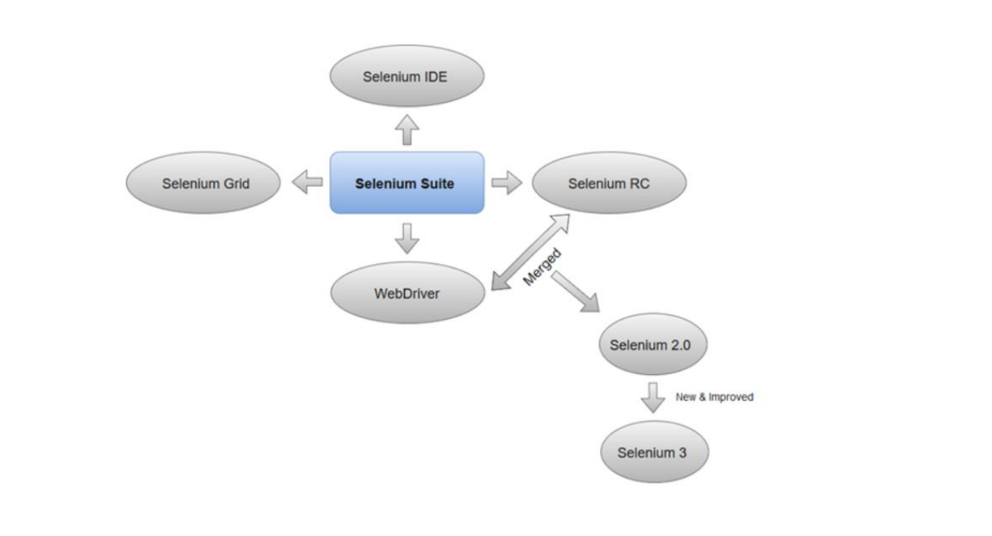
- Selenium Integrated Development Environment (IDE)

Selenium IDE is implemented as Firefox extension which provides record and playback functionality on test scripts. It allows testers to export recorded scripts in many languages like HTML, Java, Ruby, RSpec, Python, C#, JUnit and TestNG. You can use these exported script in Selenium RC or Webdriver.

Selenium IDE has limited scope and the generated test scripts are not very robust and portable.

Selenium Remote ControlSelenium RC (officially deprecated by selenium)allows testers to write automated web application UI test in any of the supported programming languages. It also involves an HTTP proxy server which enables the browser to believe that the web application being tested comes from the domain provided by proxy server.

Selenium RC comes with two components.
- Selenium RC Server (acts as a HTTP proxy for web requests).
Selenium RC Client (library containing your programming language code). Selenium WebDriver
Selenium WebDriver (Selenium 2) is the successor to SeleniumRC and is by far the most important component of Selenium Suite. Selenium WebDriver provides a programming interface to create and execute test cases. Test scripts are written in order to identify web elements on web pages and then desired actions are performed on those elements
Selenium WebDriver performs much faster as compared to SeleniumRC because it makes direct calls to the web browsers. RC on the other hand needs an RC server to interact with the web browser.

Since, WebDriver directly calls the methods of different browsers hence we have separate driver for each browser. Some of the most widely used web drivers include:
Mozilla Firefox Driver (Gecko Driver) Google Chrome Driver Internet Explorer Driver Opera Driver Safari Driver HTML Unit Driver (a special headless driver)
Selenium Grid
Selenium Grid is also an important component of Selenium Suite which allows us to run our tests on different machines against different browsers in parallel. In simple words, we can run our tests simultaneously on different machines running different browsers and operating systems.

Selenium Grid follows the Hub-Node Architecture to achieve parallel execution of test scripts. The Hub is considered as master of the network and the other will be the nodes. Hub controls the execution of test scripts on various nodes of the network.

- Cucumber:

Cucumber is a testing tool that supports Behavior Driven Development (BDD) framework. It defines application behavior using simple English text, defined by a language called Gherkin.

Cucumber allows automation functional validation that is easily read and understood. Cucumber was initially implemented in Ruby and then extended to Java framework. Both the tools support native JUnit.

How it Works

By the time the code is ready, test scripts are ready too. The code has to pass the test scripts defined in BDD. If it does not happen, code refactoring will be needed. Code gets freezed only after successful execution of defined test scripts.

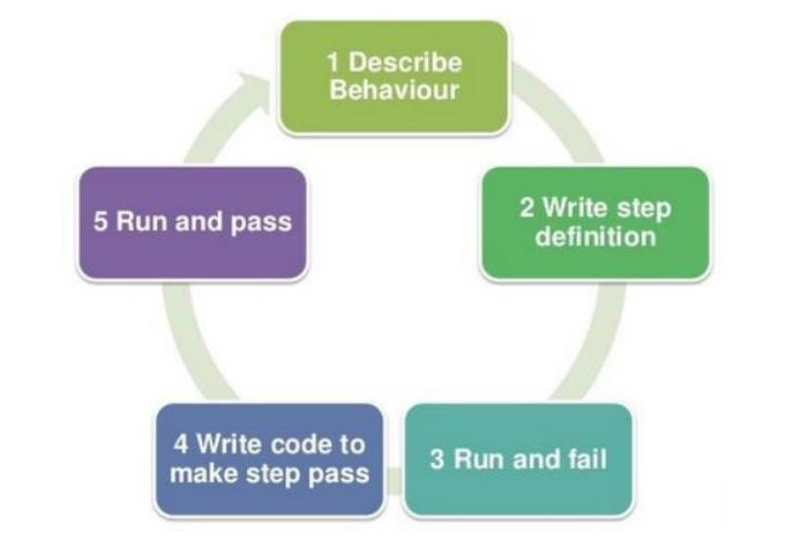
It is a very simple notion, but what we need in order to get this concept implemented. The answer is, Behavior Driven Development (BDD) Framework. Cucumber is one such open source tool, which supports behavior driven development. To be more precise, Cucumber can be defined as a testing framework, driven by plain English text. It serves as documentation, automated tests, and a development aid – all in one.

TestNG
TestNG is a testing framework developed in the lines of JUnit and NUnit, however it introduces some new functionalities that make it more powerful and easier to use. TestNG is designed to cover all categories of tests: unit, functional, end-to-end, integration, etc., and it requires JDK 5 or higher. This tutorial provides a good understanding on TestNG framework needed to test an enterprise-level application to deliver it with robustness and reliability. TestNG can be invoked in several different ways −
- With a testng.xml file. •
- With ANT. •
- From the command line.

In TestNG, we cannot define a suite in testing source code, but it is represented by one XML file, as suite is the feature of execution. It also allows flexible configuration of the tests to be run. A suite can contain one or more tests and is defined by the tag. is the root tag of your testng.xml. It describes a test suite, which in turn is made of several sections.

Jenkins:
Jenkins is a powerful application that allows continuous integration and continuous delivery of projects, regardless of the platform you are working on. It is a free source that can handle any kind of build or continuous integration. You can integrate Jenkins with a number of testing and deployment technologies. Jenkins will be installed on a server where the central build will take place. The following flowchart demonstrates a very simple workflow of how Jenkins works.

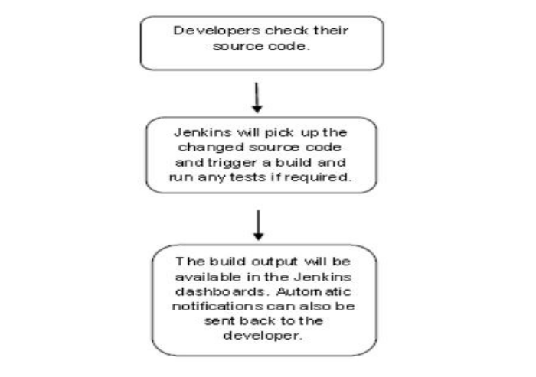
What is Continuous Integration?

Continuous Integration is a development practice that requires developers to integrate code into a shared repository at regular intervals. This concept was meant to remove the problem of finding later occurrence of issues in the buildlife-cycle. Continuous integration requires the developers to have frequent builds. The common practice is that whenever a code commit occurs, a build should be triggered.

Process of Automated Testing or Automated Testing Life-cycle

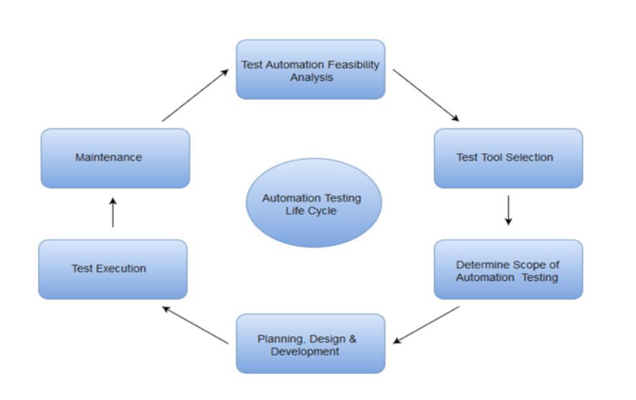

- As the above diagram suggests, there are the following steps in automated testing:Test Automation Feasibility Analysis
Test Tool Selection Determine Scope of Automation Testing Planning, Design & Development Test Execution 6. Maintenance
- Test Automation Feasibility Analysis: In this process the test case to be automated is analyzed and it is decided whether or not it is a good idea to automate the test case.

- Test Tool Selection: Test Tool selection largely depends on the technology the Application Under Test is built on. For instance, QTP does not support Informatica. So QTP cannot be used for testing Informatica applications. It's a good idea to conduct a Proof of Concept of Tool on AUT.
- Determine Scope of Automation Testing: The scope of automation is the area of your Application Under Test which will be automated. Following points help determine scope: •
- The features that are important for the business•
- Scenarios which have a large amount of data •
- Common functionalities across applications •
- Technical feasibility •
- The extent to which business components are reused •
- The complexity of test cases •
- Ability to use the same test cases for cross-browser testing

- Planning, Design & Development: During this phase, you create an Automation strategy & plan, which contains the following details-
Automation tools selected • Framework design and its features • In-Scope and Out-of-scope items of automation • Automation testbed preparation • Schedule and Timeline of scripting and execution • Deliverable of Automation Testing Test Execution: Automation Scripts are executed during this phase. The scripts need input test data before there are set to run. Once executed they provide detailed test reports. Execution can be performed using the automation tool directly or through the Test Management tool which will invoke the automation tool. Example: Quality center is the Test Management tool which in turn it will invoke QTP for execution of automation scripts. Scripts can be executed in a single machine or a group of machines. The execution can be done during the night, to save time. Maintenance: Test Automation Maintenance Approach is an automation testing phase carried out to test whether the new functionalities added to the software are working fine or not. Maintenance in automation testing is executed when new automation scripts are added and need to be reviewed and maintained in order to improve the effectiveness of automation scripts with each successive release cycle.

Chapter 2: HIGHRADIUS CORPORATION
About HighRadius
HighRadius is a Fintech enterprise Software-as-a-Service (SaaS) company which leverages Artificial Intelligence-based Autonomous Systems to help companies automate Accounts Receivable and Treasury processes. The HighRadius® Integrated Receivables platform reduces cycle times in your order-to-cash process by automating receivables and payments processes across credit, electronic billing and payment processing, cash application,deductions, and collections.

HighRadius® Treasury Management Applications help teams achieve touch-less cash management, accurate cash forecasting, and seamless bank reconciliation. Powered by the Rivana™ Artificial Intelligence Engine purpose-built for finance and the Freeda™ Digital Assistant, HighRadius enables teams to leverage machine learning to predict future outcomes and automate routine, labor-intensive tasks.

The radiusOne™ B2B Collaboration Network allows suppliers to digitally connect with buyers, closing the loop from supplier receivable processes to buyer payable processes. HighRadius solutions have a proven track record of delivering increased operational efficiency through automation, accurate cash flow forecasting, optimized cash management, lower days sales outstanding (DSO), and bad debt, to help companies achieve strong ROI in just a few months.
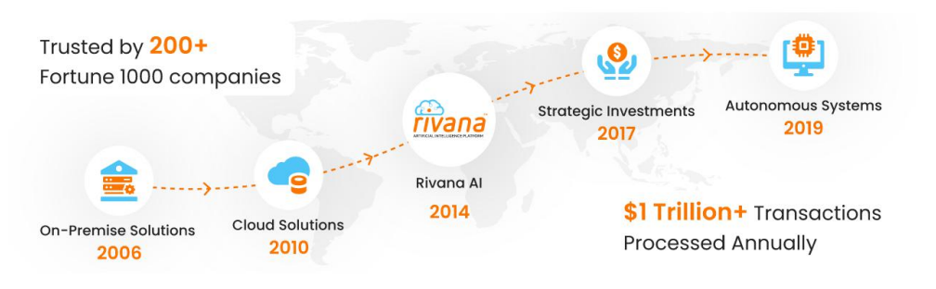HighRadius products provide value to a wide range of customers and are especially relevant to industries like consumer products, manufacturing, distribution, energy, and others that sell products or provide a service to other businesses.

Highradius customers range from some of the largest global corporations including more than 200 Fortune 1000 companies as well as mid-size enterprises that don’t have the IT resources to consolidate on an ERP platform but still want to automate and streamline their receivables and treasury processes.
Founded in: 2006
Founder: Sashi Narahari
Headquarter: Greater Houston Area, Southern US

Career At HighRadius
HighRadius is an early-stage company providing software solutions for automating a business’ order-to-cash cycle. For most businesses, accounts receivable is either the largest or the second largest asset on their balance sheet (in fact, it accounts for 40%, on average, of all the assets by value). Efficient management of accounts receivable has a direct impact on the financial health of a business. HighRadius is dedicated to helping businesses efficiently manage this asset. The products, uniquely complement traditional ERP systems and are delivered both as a service over the web, deployed as software-as-a-service (SaaS) in the cloud, and as add-ons to standard ERP functionality, deployed on-premises in the business’ ERP landscape. Over the last few years, these innovative products have gained significant traction in the market and the company is no win an accelerated growth phase. HighRadius seeks great minds, across different functions, to be a part of the growth story.

- At HighRadius, you get:an opportunity to build innovative products that customers love
a challenging work environment.
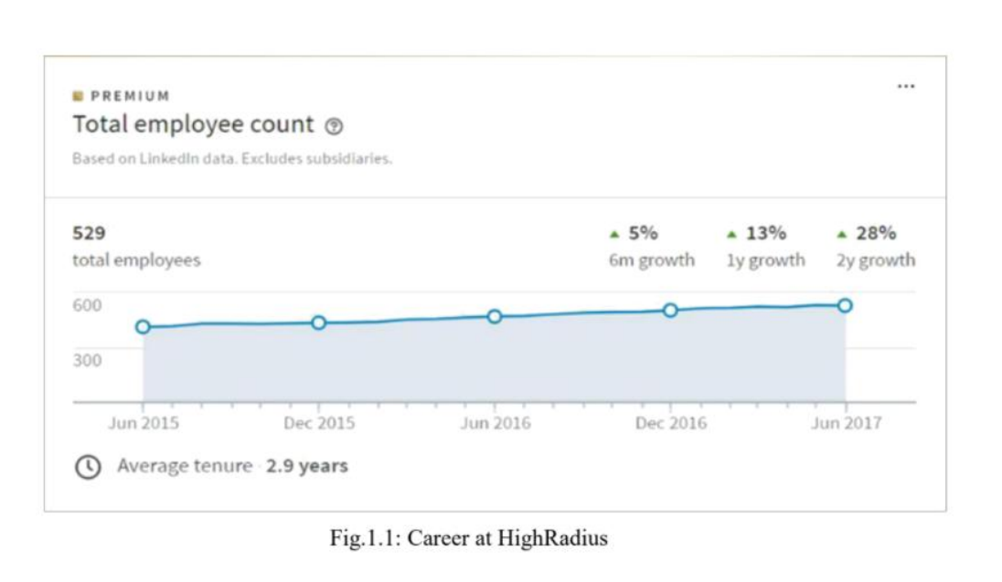
Account Receivables and Business Analytics

Accounts receivable is a legally enforceable claim for payment held by a business for goods supplied and/or services rendered that customers/clients have ordered but not paid for. These are generally in the form of invoices raised by a business and delivered to the customer for payment within an agreed time frame. Accounts receivable is shown in a balance sheet as an asset. It is one of a series of accounting transactions dealing with the billing of a customer for goods and services that the customer has ordered. These may be distinguished from notes receivable, which are debts created through formal legal instruments called promissory notes.

Business analytics is used to be the practice of iterative, methodical exploration of an organizations data with emphasis on statistical analysis. It is used by companies with systematic data collection procedure to make data-driven decisions. However, over the last 15 years the business analytics field went through a great transition, as the amount of data available increased significantly. Specifically, this deluge of data calls for automated methods of data analysis, where researchers looked machine for help. Therefore, it is not surprising machine learning algorithm began to emerge as a dominating force in the business analytics industry. According to Murphy, machine learning is a set of methods that automatically detect patterns in data and then use the uncovered data patterns to predict future data, or to perform.

decision making under uncertainty based on knowledge from data. Machine learning empower one’s ability to transform the data into
The transformation potential of predictive analytics are as follows:

- Creating transparency of business information
- Enabling experimentation to discover needs, expose variability, and improve performance
- Segmenting populations to customize actions
- Replacing/supporting human decision making with automated algorithms
Innovating new business models, products, and services.With these characteristics of business analytics, it is found a general pattern that customers, consumers, and citizens benefit from the economic surplus enabled by data they are both direct and indirect beneficiaries of big-data-related innovation. It is also, worth noticing that some sectors are expected to enjoy bigger gain when powering by business analytics. Because of the abundance of data, computer and electronic product is no doubt the leading sector for its strong productivity growth and potential gain from the use of business analytics.

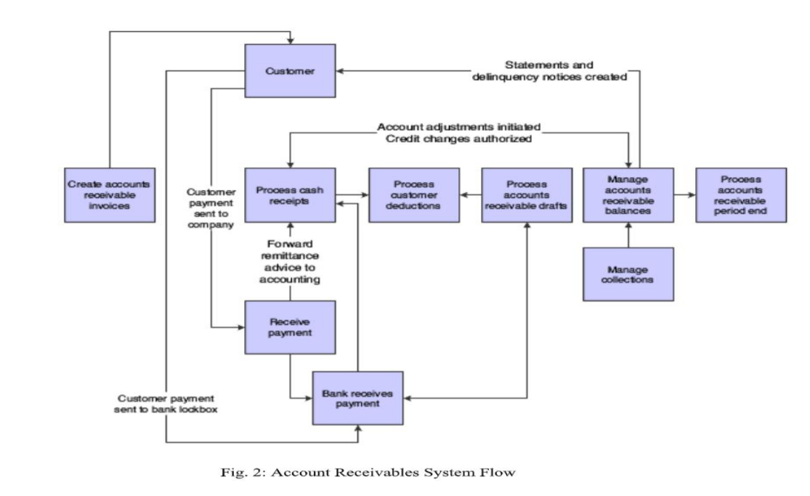

Chapter 3: DEDUCTIONS CLOUD
What is Deductions Cloud?
It is a HighRadius product to ensure proactive deduction management to prevent bottom-line erosion. Deductions Cloud automates the aggregation of backup documents, deduction research and provides a common platform for cross- department and customer collaboration.

Benefits1. Claims and POD Aggregation Engine to auto-capture backup documents The robust claims and POD aggregation engine helps to auto-capture backup documents from various sources such as TPM, carrier portals, customer portals, and consolidate them in a single platform for the analysts to review.
2. Collaborative workflow and automated correspondence for internal approvals and customer interaction A structured workflow and collaboration engine ensures streamlined inter- department collaboration and faster approvals. The automated correspondence helps to interact with customers and capture information from them.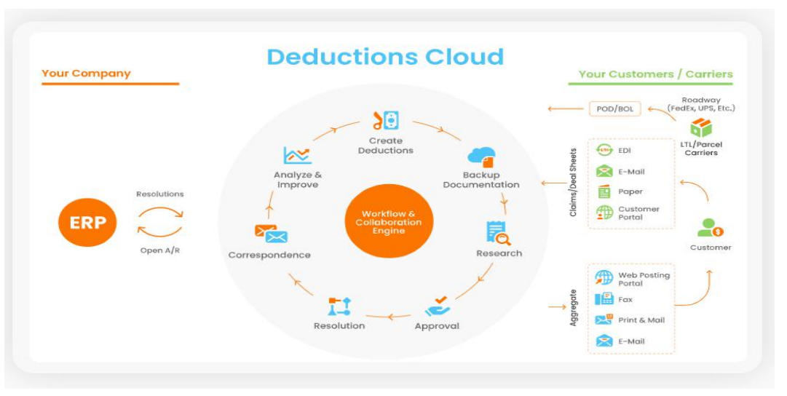
3. Faster deduction resolution with AI-based dispute validity predictor Your deduction teams can reduce the overall resolution cycle by leveraging AI - based dispute validity prediction to identify the invalid deductions upfront. Recommendations on resolution lead to faster decisions and lower write-offs.
- Easy to deploy, ERP agnostic solution HighRadius Deductions Cloud can seamlessly integrate with your existing ERP/s across the globe without any major business disruption.

Key Features

- Auto-Aggregation and Linking of Backup Documents such as Claims, PODs, BOLs Automate capture of backup documents such as claims, PODs, BOLs from customer A/P portals, carrier portals, paper claims ensuring better utilization of the analyst’s time. Auto-link sales invoices, commitments from the TPM, claims, PODs with the deductions to reduce the overall research time.

- Automated Research for Trade and Non-Trade Deductions Seamlessly integrate with TPM systems such as Accenture CAS, SAP to ensure auto-settlement of trade deductions. Reduce the research time by auto-determining the validity of the claims through Pricing Variance(via sales invoice, pricing sheet and claim), Return Variance(via sales invoice and claim), Deal-Sheet Variance(via retail trade documents) and ePOS Matching(via integration with third party ePOSdata)

- AI-Based Dispute Validity Predictor to Prioritize Research and Resolution Predict proactively the validity of disputes with AI-based capabilities. Fast-track the recovery rate of invalid disputes by triggering an automated workflow to collectors notifying them about the invalid deductions

4. Collaborative E-Workflows for Deduction Status Tracking, Approval and Settlement Get recommended next steps for each deduction and tracking of deduction status. Initiate approval workflows across hierarchies to fast track resolutions internally with stakeholders across A/R, sales, customer service, and broker teams.
- Automated Deduction Correspondence Simplify customer collaboration by automating generation and distribution of denial correspondence to customers along with all supporting documents as per individual customer requirements.

6. Automated Data-Push to Customer Portals Automatically integrate with customer A/P portals to ensure automated push of credit memo and denial correspondences for seamless collaboration

Benefits

Real-time visibility on analyst productivity and deduction metrics Gain end-to-end process visibility with out-of-the-box reports and dashboards to track team productivity and key deduction metrics including DDO, NRR, and Average Resolution Time. Receivables Analytics offers intuitive data visualization which helps you drill down into individual reports to identify bottlenecks or issues in the deductions process.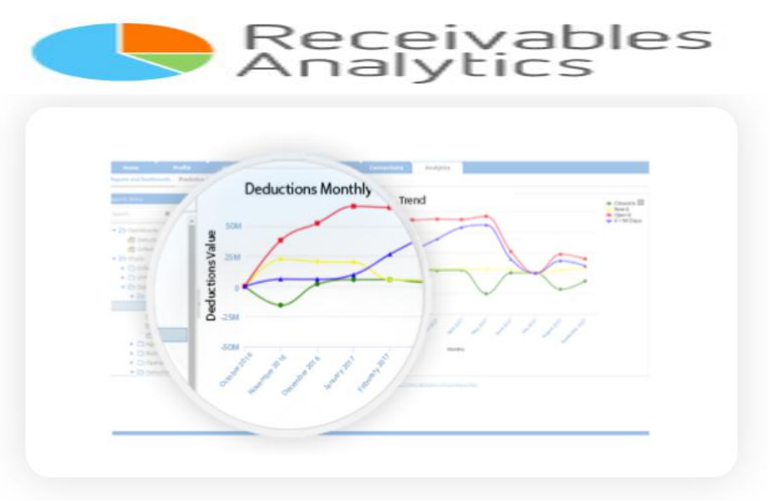Deductions Cloud: AI-Edition Predict invalid deductions and improve the bottom-line Predict the validity of deductions using the Rivana Artificial Intelligence platform to eliminate time lost working on valid deductions. The machine learning algorithm has been trained on more than $30B of deductions from real-world A/R data. By leveraging invalid deductions prediction, A/R teams will now be able to control inaccurate write-offs, improve net recovery rate, and also perform root- cause analysis to prevent deductions at the source.
Self-service collection of missing deduction back-up documents Leverage the radiusOne TM network to automate the collection of claims and POD documents for deductions with missing backup information. Automatically send email correspondence for customers and carriers to upload backup documents to the radiusOne TM portal.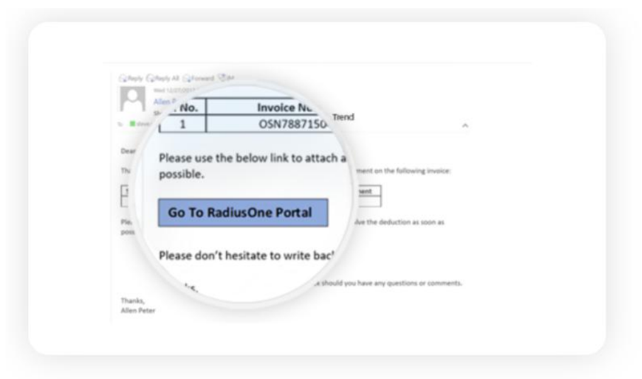

My Contributions
As a part of the Automation UI team, my contribution was the development of suites for the automation of multiple test scenarios on the Deductions CloudUI, for the detection and correction of features/processes in the product of DMS and CPA.
In DMS, I worked for a month and during that time I developed many user scenarios like checking for UI working properly or not on deductions page, Picklist data validation from the database and many more.In CPA, I worked for the rest of my entire internship and here also I developed many user scenarios for UI testing like checking whether the pop up disturb the elements in the background or not, checking for mobility of a popup in the entire screen.I have also worked on the stabilization of some user scenarios in the DMS as well as the CPA scenarios.Overall in total I have developed more than 30 user scenarios and worked on many stabilization work.

CONCLUSIONAs a part of Deduction Cloud Automation Team and a member of HighRadius Corporation, I learned the working of an organization and the way of corporate life. I also got familiar with Tools such as Selenium, Cucumber, Jenkins and TestNG and learned more about Maven Projects.
I'm hoping that this experience will benefit me more in the future.To sum up my project, working on real-world projects for HighRadius Technologies, a company that constantly aspires to improve its offering and provide customers with high-quality goods, has been a wonderful experience.

REFRENCES
- About Selenium:
selenium.dev
guru99.com/selenium-tutorial.html
guru99.com/introduction-to-selenium.html
javatpoint.com/selenium-webdriver
- About Cucumber:

About TestNG:testng.org
toolsqa.com/testng-tutorial
intellipaat.com/blog/tutorial/selenium-tutorial/testng-in-selenium

About Jenkins:

About Test Automation:

About Highradius:

About Deduction Cloud:

