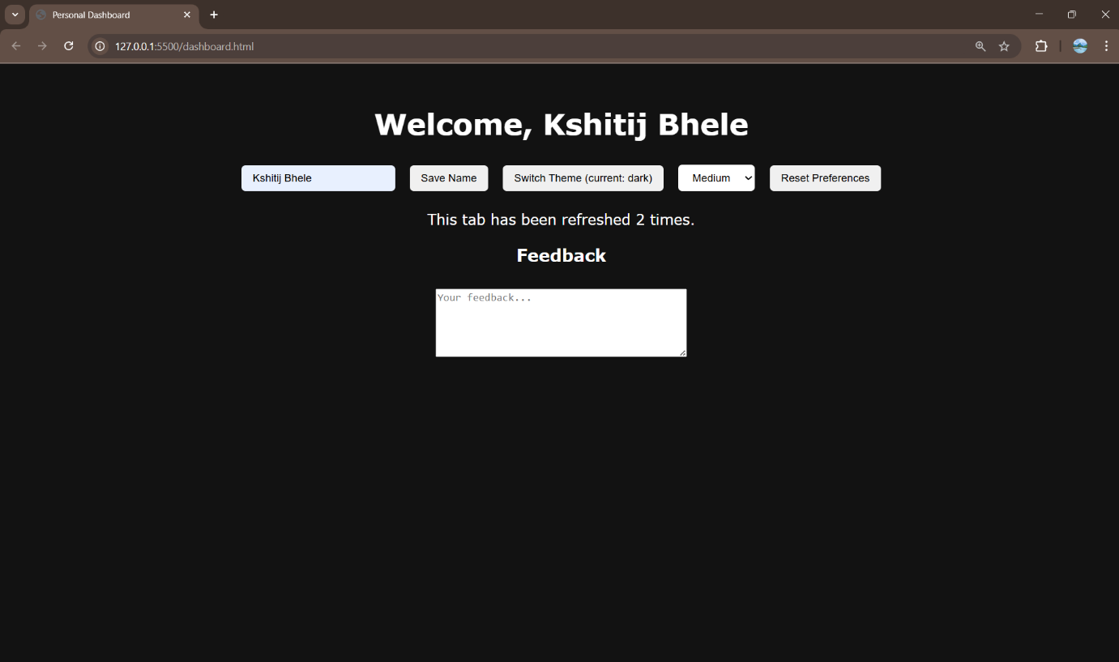
Issues / mistakes I found (with justification)
- Inconsistent theme keys
  - Starter used both "ThemeMode" and "theme" and later localStorage.setItem("theme", ...). That creates unpredictable behavior. I unified to theme.
  - Also the default was set to "Dark" — requirement asked default light. I set default to "light".
- Wrong class assignment for theme
  - The intern used document.body.classList = t; which is invalid (classList is a DOMTokenList, not assignable to a string). Use className = t or classList.add/remove/toggle. I used className = t to ensure only the 'light' or 'dark' class is present.
- Font key capitalization mismatch
  - Code saved under fontsizePref but attempted to read fontSizePref. I chose fontSizePref and used it consistently.
- Font values were raw tokens, not actual CSS sizes
  - The select values were small/medium/large but code set document.body.style.fontSize = f — that doesn't produce a useful size unless you map them to valid CSS units. I mapped them to pixel sizes (14px/18px/22px) and stored the choice token (small/medium/large) in localStorage.
- Username saved incorrectly
  - Starter set localStorage.name = user; and then read localStorage.getItem("username") — inconsistent. I used localStorage.setItem("username", user) and localStorage.getItem("username") everywhere.
- No initial username display
  - The starter never read saved username on load. I read it on startup and populated both the welcome text and the input value.
- Session counter logic wrong (post-increment placement and types)
  - Code used let count = sessionStorage.getItem("visits") ?? 1; sessionStorage.setItem("visits", count++); — this mixes strings, uses post-increment incorrectly, and sets a wrong default. I convert to Number, increment, then store, so it increases by 1 on every reload and is reset only when the tab is closed (sessionStorage behavior).
- Feedback used innerHTML instead of value
  - The textarea’s content must be read/written with .value, not .innerHTML. I fixed storage to use fb.value and restore from sessionStorage on load. This keeps draft only in the same tab.
- Missing Reset Preferences button
  - I added a Reset Preferences button and made it remove the three localStorage keys used (theme, font, username) then reload. It deliberately does not clear sessionStorage, per the spec.
- Minor UX improvements / robustness
  - Button label shows current theme for clarity.
  - Default font applied on load if nothing stored.
  - Trimming username input and allowing clearing (if user saves empty string, preference removed).

