PREDICTIVE ANALYTICS | CA3 PROJECT REPORT
Predicting Online Shoppers' Purchasing Intention
A KDD-based classification study with a data-leakage investigation of the PageValues feature
Submitted by: Kshitij Bhele
Dataset: Online Shoppers Purchasing Intention (UCI Machine Learning Repository)
Tools: Python, pandas, scikit-learn, matplotlib, seaborn (Google Colab)
Date: October 2026

Abstract
E-commerce sites convert only a small share of visits into purchases, so identifying purchase intent while a session is still running lets a business time its interventions (offers, live chat, reminders). This project builds and evaluates classifiers that predict whether a browsing session ends in a purchase, using the Online Shoppers Purchasing Intention dataset (12,330 sessions, 18 attributes, 15.5% positive class). The work follows the Knowledge Discovery in Databases (KDD) process: data selection, pre-processing, transformation, data mining and evaluation.
After removing 125 duplicate sessions, the data were split 80/20 with stratification and transformed with a leakage-safe scikit-learn ColumnTransformer. Logistic Regression, Decision Tree, Random Forest and Gradient Boosting were tuned with 5-fold stratified cross-validation and compared with a dummy baseline. Because the PageValues attribute is computed from purchase outcomes, every model was trained twice: with and without it.
Key finding. With PageValues the best model, Gradient Boosting, reached a test ROC-AUC of 0.937, PR-AUC of 0.744 and F1 of 0.681. Without it the same model fell to ROC-AUC 0.784, PR-AUC 0.356 and F1 0.110. PageValues alone carried 77.8% of the Gradient Boosting feature importance. The leakage-free result is therefore the more honest estimate of what the model could do on a live session, where exit rate, time on product pages and month of year become the main signals.
Contents
1. Introduction – Background, problem statement, objectives, dataset
2. Literature Review – KDD, purchase-intent prediction, algorithms, imbalance, leakage
3. Workflow / Predictive Modelling Process – Selection, pre-processing, transformation, PageValues experiment, modelling, evaluation
4. Results and Discussion – EDA, model comparison, PageValues effect, confusion matrices, interpretation
5. Conclusion – Summary, business implications, limitations and future work
6. References

1. Introduction

1.1 Background and motivation
Online retail attracts large volumes of traffic, yet most sessions end without a transaction. In the dataset used here only 15.5% of sessions generated revenue. A generic marketing message sent to every visitor wastes budget on people who were never going to buy and arrives too late for those who were about to leave. A model that scores purchase intent from behaviour observed during the session allows targeted action, such as a discount for a hesitant visitor or live chat for someone stuck on product pages.

1.2 Problem statement
Research question: Can we accurately predict whether a website visitor will complete a purchase during a session, using browsing behaviour, visitor attributes and temporal characteristics?
This is a binary classification problem. The target variable Revenue is True when the session ended in a transaction and False otherwise.

1.3 Objectives
- Understand and profile the Online Shoppers Purchasing Intention dataset and quantify its class imbalance.
- Build a pre-processing pipeline that cannot leak test information into training.
- Train, tune and compare four classifiers against a dummy baseline using metrics suited to imbalanced data (ROC-AUC, PR-AUC, F1).
- Investigate whether the PageValues attribute leaks the outcome and measure how much model performance depends on it.
- Interpret the models to identify the behavioural signals that drive purchase prediction.

1.4 Dataset description
The data come from the UCI Machine Learning Repository (file online_shoppers_intention.csv). There are 12,330 sessions and 18 columns, with no missing values. Ten attributes are numerical and eight are categorical in the original description; in the loaded data they appear as 14 numeric columns, 2 text columns (Month, VisitorType) and 2 boolean columns (Weekend, Revenue).
Attribute group | Columns | Meaning
Page-visit counts | Administrative, Informational, ProductRelated | Number of pages of each type visited in the session
Time spent | Administrative_Duration, Informational_Duration, ProductRelated_Duration | Seconds spent on each page type
Google Analytics metrics | BounceRates, ExitRates, PageValues | Average bounce rate, exit rate and page value of pages visited
Calendar | SpecialDay, Month, Weekend | Closeness to a special day, month of visit, weekend flag
Technical / source | OperatingSystems, Browser, Region, TrafficType | Coded visitor environment and traffic source
Visitor | VisitorType | New_Visitor, Returning_Visitor or Other
Target | Revenue | True if the session ended in a purchase

1.5 Scope and limitations
The dataset holds one row per session, so the model predicts session outcomes rather than modelling a customer over time. Predictions in a live setting may only use information available up to the moment of scoring. This constraint is the reason the PageValues experiment is central to the project (Chapter 3 and Chapter 4).

1.6 Report organisation
Chapter 2 reviews related work. Chapter 3 describes the workflow, mapped to the KDD stages. Chapter 4 reports and discusses results. Chapter 5 concludes with limitations and future work. Chapter 6 lists references.

2. Literature Review

2.1 Knowledge discovery and the KDD process
Fayyad, Piatetsky-Shapiro and Smyth (1996) describe KDD as the non-trivial process of identifying valid, novel, useful and understandable patterns in data. The process runs from selection of target data through pre-processing, transformation and data mining to interpretation and evaluation. Chapman et al. (2000) formalised a closely related industry process, CRISP-DM, that begins with business understanding. This project uses KDD as the organising frame and borrows CRISP-DM's emphasis on stating the business problem first.

2.2 Predicting purchase intent from clickstream data
Moe (2003) showed that shoppers can be separated into behavioural types from in-store navigation clickstreams, such as buying, searching and browsing, which established that session behaviour carries information about intent. The dataset used in this project was introduced by Sakar et al. (2019), who studied real-time prediction of purchase intention with multilayer perceptron and LSTM networks and examined how features such as page values and exit rates relate to the outcome. Their work frames the task as session-level prediction suited to live use, which is the same framing adopted here.

2.3 Classification algorithms used
- Logistic Regression is a linear, interpretable baseline whose coefficients show the direction and strength of each feature's effect (Hastie, Tibshirani and Friedman, 2009).
- Decision Trees partition the feature space with simple rules. They are easy to explain but unstable when grown deep.
- Random Forests average many decorrelated trees built on bootstrap samples and random feature subsets, which reduces variance (Breiman, 2001).
- Gradient Boosting builds trees sequentially, each correcting the errors of the ensemble so far (Friedman, 2001), and is often the strongest method on tabular data.

2.4 Class imbalance and evaluation metrics
When one class is rare, accuracy is misleading because always predicting the majority class already scores highly. Fawcett (2006) explains ROC analysis as a threshold-independent way to rank classifiers. Saito and Rehmsmeier (2015) show that precision-recall curves are more informative than ROC curves on imbalanced data because they focus on the positive class. Chawla et al. (2002) proposed SMOTE oversampling as one remedy. This project instead uses class weights where the algorithm supports them and evaluates with ROC-AUC, PR-AUC and F1.

2.5 Data leakage
Kaufman, Rosset and Perlich (2012) define leakage as the introduction of information about the target that would not legitimately be available when the model is used, and note that it produces overly optimistic results that fail in deployment. Two forms matter here. First, pre-processing steps fitted on the full dataset leak test statistics into training. Second, a feature computed from the outcome acts as a proxy for the target. PageValues belongs to the second group, which motivates the controlled experiment in this report.

2.6 Research gap addressed
Many studies report headline accuracy on this dataset without separating what comes from features that exist only retrospectively. This project quantifies that dependence directly by running an identical modelling pipeline with and without PageValues, using imbalance-aware metrics throughout.

3. Workflow / Predictive Modelling Process
The project follows the KDD stages. Figure 3.1 summarises the flow and the sections below describe each stage as implemented in the notebook (Predictive_Analysis_Project.ipynb).
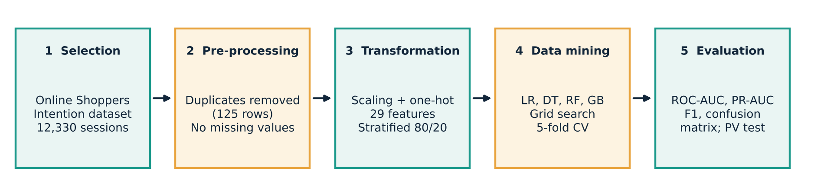
Figure 3.1: KDD workflow followed in this project

3.1 Stage 1: Data selection and understanding
The CSV was extracted from the UCI archive and loaded into a pandas DataFrame. Integrity checks showed 12,330 rows, 18 columns, no missing values and 125 duplicated rows. The target is heavily imbalanced: 84.5% of sessions did not purchase and 15.5% did.
Check | Result
Rows / columns | 12,330 / 18
Missing values | 0 in every column
Duplicate rows | 125 (about 1%)
Class balance (Revenue) | False 84.5%, True 15.5%
Months present | 10 (Feb, Mar, May, June, Jul, Aug, Sep, Oct, Nov, Dec)
Visitor types | Returning_Visitor, New_Visitor, Other
Notable ranges | PageValues up to 361.8; ProductRelated_Duration up to 63,973 s; ProductRelated up to 705 pages

3.2 Stage 2: Pre-processing
- Duplicate sessions were dropped, leaving 12,205 rows. Keeping them would let identical rows appear in both training and test sets and inflate scores.
- No imputation was needed because no values were missing.
- Class imbalance was handled in the modelling stage by class weights rather than by resampling the data, so the test set keeps its natural distribution.

3.3 Stage 3: Transformation
The data were split first and transformed second. A stratified 80/20 split (random_state = 42) gave 9,764 training rows and 2,441 test rows, with the positive rate kept at 15.6% in both. A ColumnTransformer was then fitted on the training set only and applied to both sets:
- Numerical (14 columns): standardised with StandardScaler.
- Categorical (Month, VisitorType, Weekend): one-hot encoded with handle_unknown = 'ignore'.
The result is 29 model features. Fitting the transformer on training data alone is what prevents test-set statistics from leaking into the scaler or encoder.

3.4 The PageValues experiment (leakage investigation)
PageValues is the average value of the pages a visitor viewed before a transaction, computed from the revenue those pages generated. Because it is derived from purchase outcomes, it can act as a proxy for the target and may not be reliably available early in a live session. Two parallel configurations were built:
Configuration | Features | Purpose
A: With PageValues | 29 | Upper-bound performance on historical data
B: Without PageValues | 28 | Realistic estimate for early-session prediction

Every model below was tuned and evaluated on both configurations using identical splits, folds and seeds, so differences are attributable to the feature.

3.5 Stage 4: Data mining (model development)
Four classifiers were tuned with GridSearchCV using 5-fold stratified cross-validation (shuffle = True, random_state = 42) and ROC-AUC as the selection metric. Logistic Regression, Decision Tree and Random Forest used class_weight = 'balanced'. Gradient Boosting in scikit-learn has no class_weight option, so it was trained on the original distribution. A stratified DummyClassifier served as the baseline.
Model | Grid searched | Best (with PV) | CV AUC with | CV AUC without
Logistic Regression | C in {0.01, 0.1, 1, 10} | C = 0.1 | 0.8999 | 0.7375
Decision Tree | max_depth {3,5,8,12}; min_samples_split {2,10} | depth 3 | 0.9125 | 0.7437
Random Forest | n_estimators {50,100}; max_depth {5,10,15} | 100, depth 15 | 0.9275 | 0.7688
Gradient Boosting | n_estimators {50,100}; learning_rate {0.01,0.1,0.2} | 50, lr 0.1 | 0.9296 | 0.7698
Table 3.1: Hyperparameter grids and best cross-validated ROC-AUC. Best parameters without PageValues: LR C = 0.1; DT depth 5; RF 100 trees, depth 10; GB 100 trees, learning rate 0.1.

3.6 Stage 5: Evaluation and interpretation
All models were scored once on the untouched test set using accuracy, precision, recall, F1, ROC-AUC and PR-AUC. ROC and precision-recall curves and confusion matrices were produced for comparison, and feature importances (tree models) and coefficients (Logistic Regression) were extracted to interpret what each configuration relies on.

4. Results and Discussion

4.1 Exploratory findings
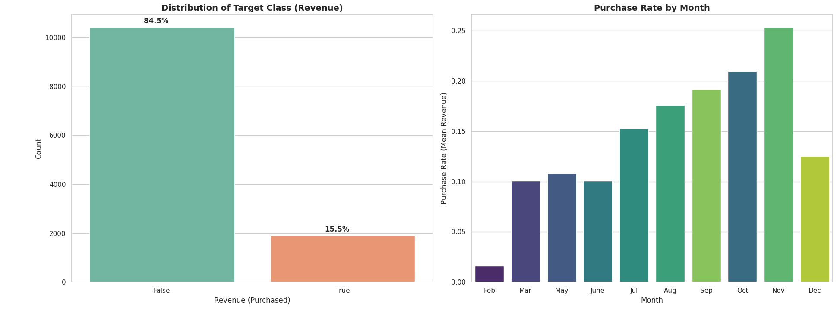
Figure 4.1: Target distribution (left) and purchase rate by month (right)
- Imbalance: only 15.5% of sessions purchase, so accuracy alone would be misleading.
- Seasonality: November has the highest purchase rate (about 25%), followed by October and September, while February is close to zero. Month is therefore a real signal.
- Visitor type: new visitors convert at roughly 24% against about 14% for returning visitors, although returning visitors make up most traffic.
- Correlations: PageValues has the strongest correlation with Revenue (0.49). ExitRates (-0.21) and BounceRates (-0.15) correlate negatively. BounceRates and ExitRates are highly correlated with each other (0.91), as are ProductRelated and ProductRelated_Duration (0.86).

4.2 Model performance with PageValues
Model | Accuracy | Precision | Recall | F1 | ROC-AUC | PR-AUC
Gradient Boosting | 0.906 | 0.728 | 0.639 | 0.681 | 0.937 | 0.744
Random Forest | 0.898 | 0.682 | 0.657 | 0.669 | 0.929 | 0.725
Decision Tree | 0.848 | 0.508 | 0.861 | 0.639 | 0.920 | 0.718
Logistic Regression | 0.853 | 0.519 | 0.788 | 0.626 | 0.911 | 0.662
Dummy baseline | 0.737 | 0.164 | 0.165 | 0.164 | 0.504 | 0.230
Table 4.1: Test-set results, Configuration A (with PageValues). Best model highlighted.
All four models clearly beat the dummy baseline (ROC-AUC 0.504). Gradient Boosting is best on ROC-AUC, PR-AUC, F1, precision and accuracy. Logistic Regression and the Decision Tree reach higher recall (0.79 and 0.86) but at the cost of precision near 0.51 to 0.52, which is the expected effect of balanced class weights shifting the decision threshold toward the minority class.

4.3 Model performance without PageValues
Model | Accuracy | Precision | Recall | F1 | ROC-AUC | PR-AUC
Gradient Boosting | 0.841 | 0.453 | 0.063 | 0.110 | 0.784 | 0.356
Random Forest | 0.727 | 0.307 | 0.592 | 0.404 | 0.768 | 0.345
Logistic Regression | 0.635 | 0.267 | 0.767 | 0.396 | 0.751 | 0.318
Decision Tree | 0.646 | 0.268 | 0.728 | 0.392 | 0.746 | 0.350
Dummy baseline | 0.737 | 0.164 | 0.165 | 0.164 | 0.504 | 0.230
Table 4.2: Test-set results, Configuration B (without PageValues). Best ROC-AUC highlighted.
Removing PageValues lowers every model substantially. Gradient Boosting still has the best ranking quality (ROC-AUC 0.784, PR-AUC 0.356) but its default-threshold recall collapses to 0.063, meaning it identifies only 24 of 382 buyers. Random Forest and Logistic Regression, which use class weights, give the best F1 (0.404 and 0.396). The models still outperform the dummy baseline on ROC-AUC and PR-AUC, so genuine early-session signal remains.
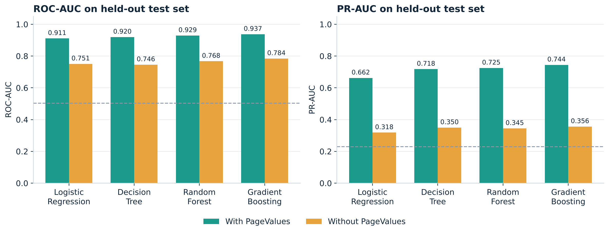
Figure 4.2: ROC-AUC and PR-AUC with and without PageValues (dummy baseline: ROC-AUC 0.504, PR-AUC 0.230)
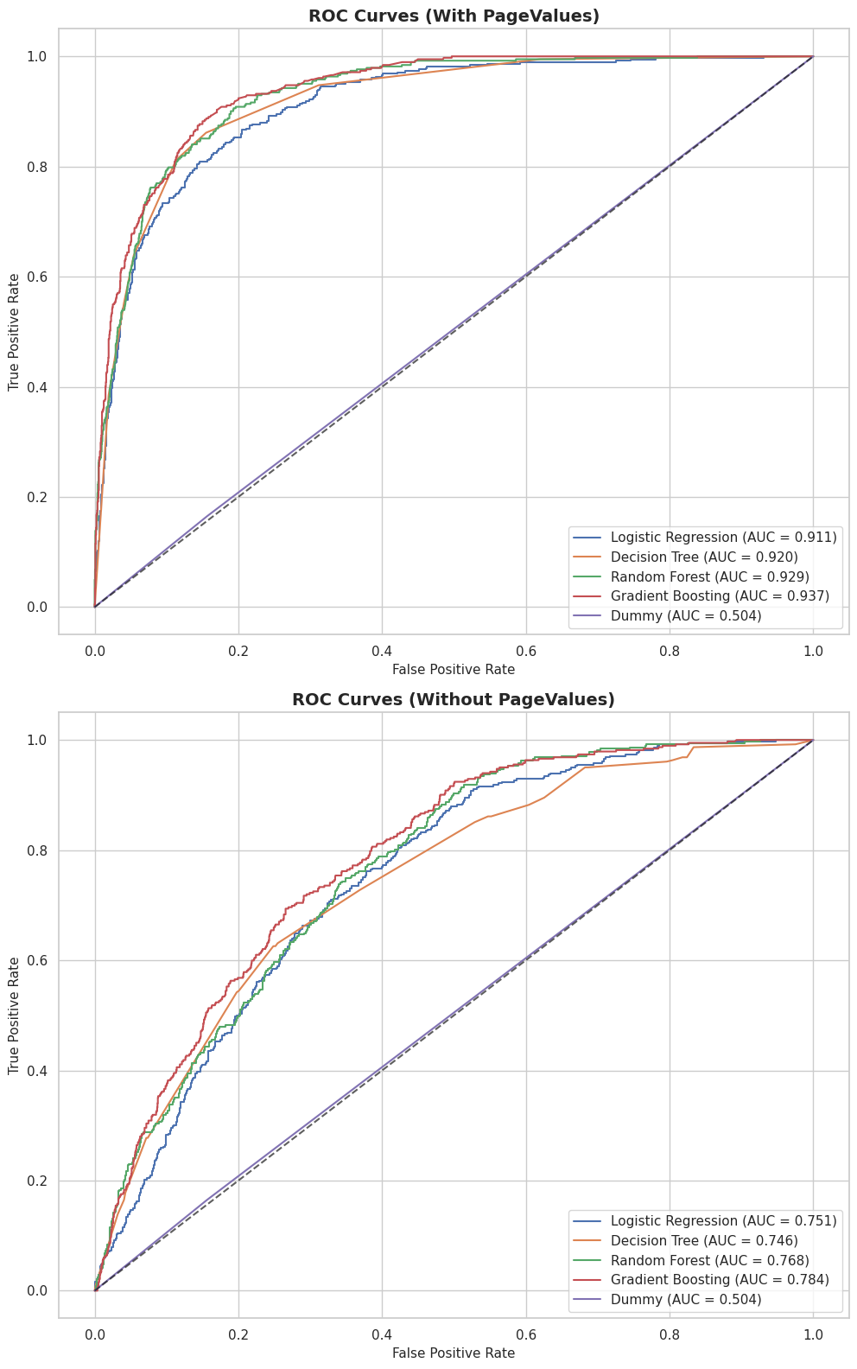
Figure 4.3: ROC curves with (top) and without (bottom) PageValues
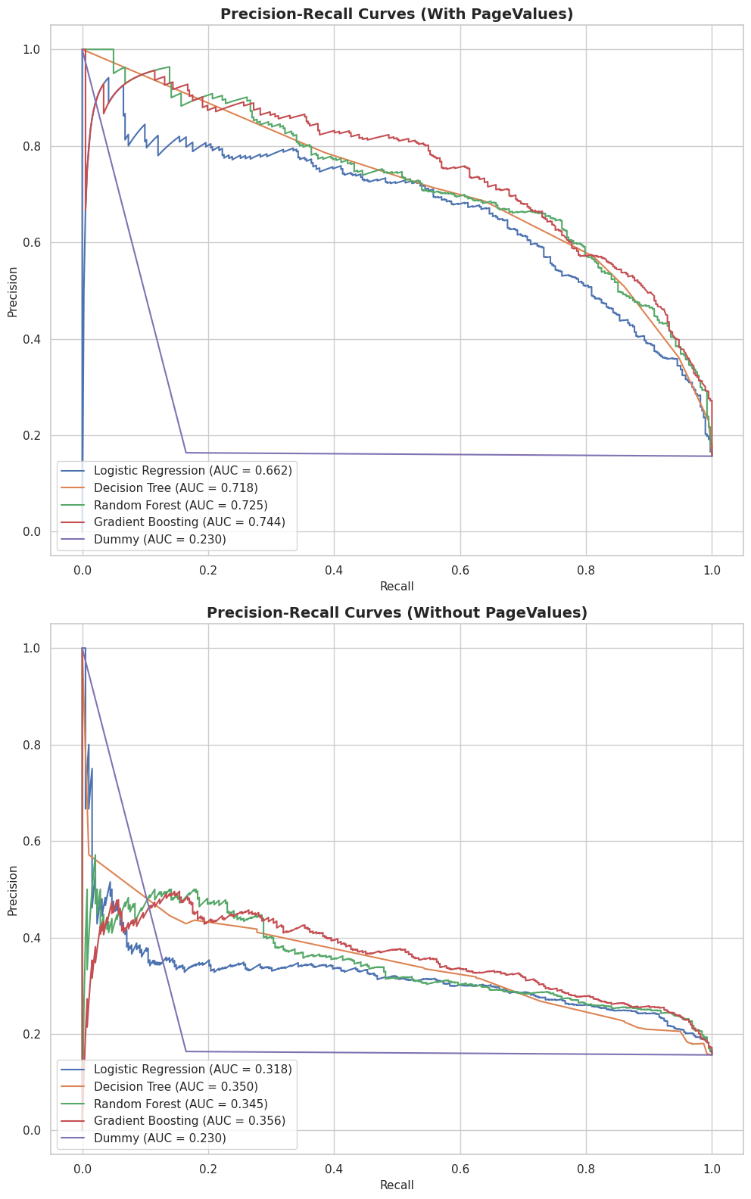
Figure 4.4: Precision-recall curves with (top) and without (bottom) PageValues

4.4 Quantifying the effect of PageValues
Gradient Boosting metric | With PV | Without PV | Change
ROC-AUC | 0.937 | 0.784 | -0.153 (-16%)
PR-AUC | 0.744 | 0.356 | -0.388 (-52%)
F1-score | 0.681 | 0.110 | -0.570 (-84%)
Precision | 0.728 | 0.453 | -0.276
Recall | 0.639 | 0.063 | -0.576
Cross-validated ROC-AUC | 0.930 | 0.770 | -0.160
Table 4.3: Change in Gradient Boosting performance when PageValues is removed.
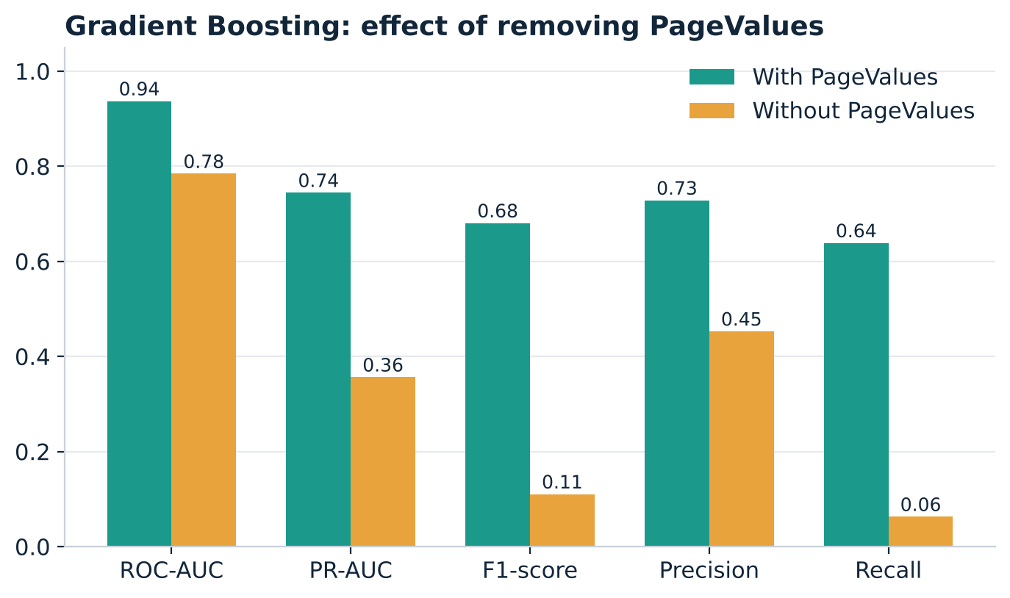
Figure 4.5: Gradient Boosting metrics with and without PageValues
The PR-AUC drop is the clearest indicator. PR-AUC reflects how well the model finds the rare positive class, and it more than halves. A single attribute computed from purchase value is responsible for most of the apparent skill.

4.5 Confusion matrices
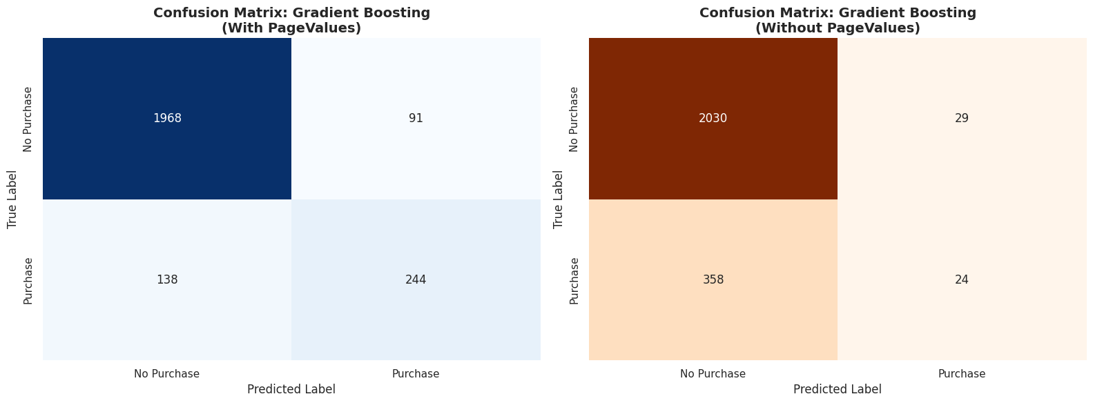
Figure 4.6: Gradient Boosting confusion matrices on the 2,441-session test set (with PageValues left, without right)
Gradient Boosting | True positives | False negatives | False positives
With PageValues | 244 | 138 | 91
Without PageValues | 24 | 358 | 29

With PageValues the model finds 244 of the 382 buyers in the test set while flagging 91 non-buyers. Without it, the model misses 358 buyers. For a business that wants to reach likely buyers, this model needs a lower decision threshold or class weighting before use (see Section 5.3).

4.6 Feature importance and interpretation
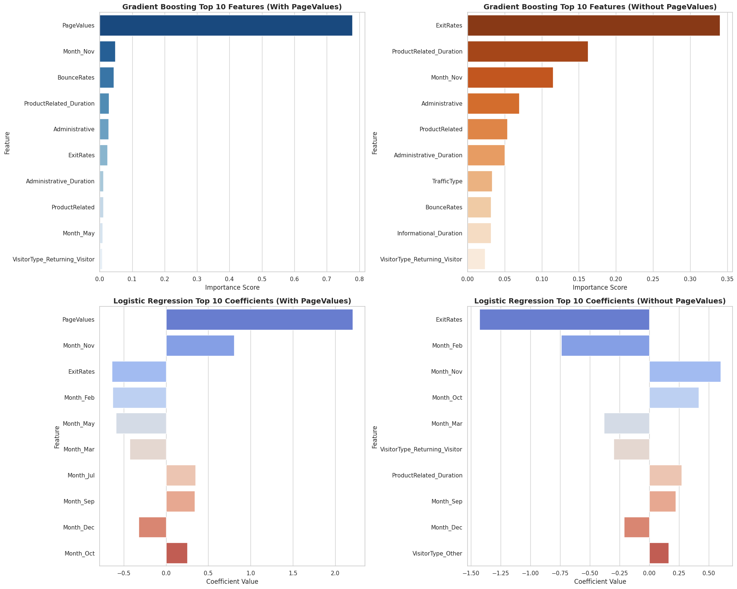
Figure 4.7: Top-10 Gradient Boosting importances (top) and Logistic Regression coefficients (bottom), with and without PageValues
Rank | With PageValues (GB importance) | Without PageValues (GB importance)
1 | PageValues (0.778) | ExitRates (0.340)
2 | Month_Nov (0.047) | ProductRelated_Duration (0.162)
3 | BounceRates (0.043) | Month_Nov (0.115)
4 | ProductRelated_Duration (0.029) | Administrative (0.069)
5 | Administrative (0.028) | ProductRelated (0.054)

- With PageValues, one feature dominates. PageValues holds 77.8% of Gradient Boosting importance and has the largest Logistic Regression coefficient (about +2.2 on the standardised scale). The model is effectively reading the answer.
- Without it, behaviour takes over. ExitRates becomes the top signal in both Gradient Boosting and Logistic Regression (a negative coefficient of about -1.4: higher exit rates mean lower purchase probability). Time on product pages and the number of administrative pages visited also rank highly.
- Calendar effects persist in both settings. Month_Nov raises purchase probability and Month_Feb lowers it, consistent with the seasonal pattern in Figure 4.1.

4.7 Discussion
Three conclusions follow. First, the strong headline performance is largely attributable to PageValues. Second, the leakage-free models still beat the baseline, which shows that browsing behaviour contains predictive information, although much weaker. Third, on imbalanced data the choice of metric and threshold changes which model looks best: Gradient Boosting ranks sessions best by ROC-AUC and PR-AUC without PageValues, yet at the default threshold it flags almost no buyers, while class-weighted models trade precision for recall.

5. Conclusion

5.1 Summary
This project applied the KDD process to predict purchase intent in online shopping sessions. A leakage-safe pipeline, stratified cross-validation and imbalance-aware metrics were used to tune four classifiers against a dummy baseline. Gradient Boosting performed best, with test ROC-AUC 0.937, PR-AUC 0.744 and F1 0.681 when PageValues was included.
The PageValues experiment is the main contribution. Removing the feature cut Gradient Boosting to ROC-AUC 0.784, PR-AUC 0.356 and F1 0.110, and feature importance showed PageValues supplying nearly 78% of the model's signal. For a system meant to act during a live session, the without-PageValues figures are the realistic expectation, and the experiment guards against deploying a model whose accuracy depends on information that is only known after the fact.

5.2 Business implications
- Exit rate, time spent on product pages and the month of the visit are usable early-session signals and can drive intervention rules.
- New visitors convert at a higher rate than returning ones, so first-visit experience is worth optimising.
- Seasonality is strong (November highest, February lowest), so campaign budgets and score thresholds should vary by month.

5.3 Limitations and future work
- Results come from one stratified 80/20 split with a fixed seed. Repeated cross-validation or confidence intervals would show how stable the differences are.
- Decision thresholds were not tuned. Selecting a threshold from the precision-recall curve for a stated business cost would materially change recall and precision, especially for Gradient Boosting without PageValues.
- Imbalance was handled only through class weights. Resampling (such as SMOTE) and cost-sensitive boosting are untested alternatives.
- The dataset is a cross-section of sessions from one site over ten months. Performance on other sites or later periods is unknown, and the sessions cannot be linked to individual customers.
- Possible extensions are session-sequence models that update the score as pages are viewed, model calibration, and deploying the pipeline as a scoring service.

6. References
Breiman, L. (2001). Random forests. Machine Learning, 45(1), 5-32.
Chapman, P., Clinton, J., Kerber, R., Khabaza, T., Reinartz, T., Shearer, C., & Wirth, R. (2000). CRISP-DM 1.0: Step-by-step data mining guide. SPSS Inc.
Chawla, N. V., Bowyer, K. W., Hall, L. O., & Kegelmeyer, W. P. (2002). SMOTE: Synthetic minority over-sampling technique. Journal of Artificial Intelligence Research, 16, 321-357.
Fawcett, T. (2006). An introduction to ROC analysis. Pattern Recognition Letters, 27(8), 861-874.
Fayyad, U., Piatetsky-Shapiro, G., & Smyth, P. (1996). From data mining to knowledge discovery in databases. AI Magazine, 17(3), 37-54.
Friedman, J. H. (2001). Greedy function approximation: A gradient boosting machine. Annals of Statistics, 29(5), 1189-1232.
Hastie, T., Tibshirani, R., & Friedman, J. (2009). The Elements of Statistical Learning (2nd ed.). Springer.
Kaufman, S., Rosset, S., Perlich, C., & Stitelman, O. (2012). Leakage in data mining: Formulation, detection, and avoidance. ACM Transactions on Knowledge Discovery from Data, 6(4), Article 15.
Moe, W. W. (2003). Buying, searching, or browsing: Differentiating between online shoppers using in-store navigational clickstream. Journal of Consumer Psychology, 13(1-2), 29-39.
Pedregosa, F., et al. (2011). Scikit-learn: Machine learning in Python. Journal of Machine Learning Research, 12, 2825-2830.
Saito, T., & Rehmsmeier, M. (2015). The precision-recall plot is more informative than the ROC plot when evaluating binary classifiers on imbalanced datasets. PLoS ONE, 10(3), e0118432.
Sakar, C. O., Polat, S. O., Katircioglu, M., & Kastro, Y. (2019). Real-time prediction of online shoppers' purchasing intention using multilayer perceptron and LSTM recurrent neural networks. Neural Computing and Applications, 31, 6893-6908.
UCI Machine Learning Repository. Online Shoppers Purchasing Intention Dataset. https://archive.ics.uci.edu/dataset/468
Project notebook and code: https://github.com/KshitijBhele/Predective-Analysis-CA3

