Kshitij Bramhecha

Roll No: 7

1) Insertion -

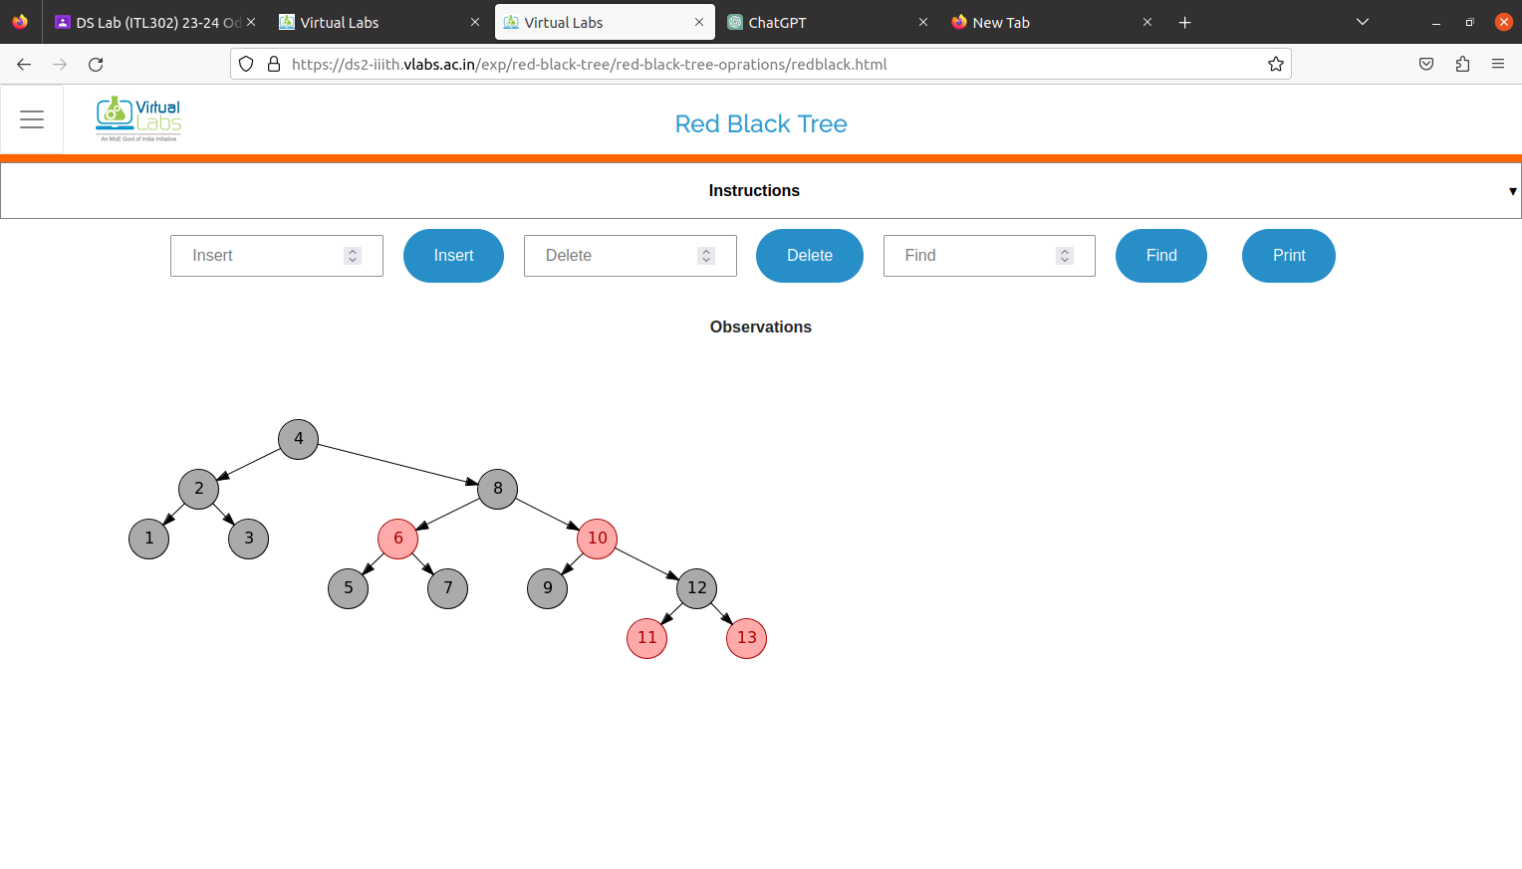

2) Deletion -

