5 April 2024

**Importing and Exporting Data using Pandas**

**Algorithm Screenshot**

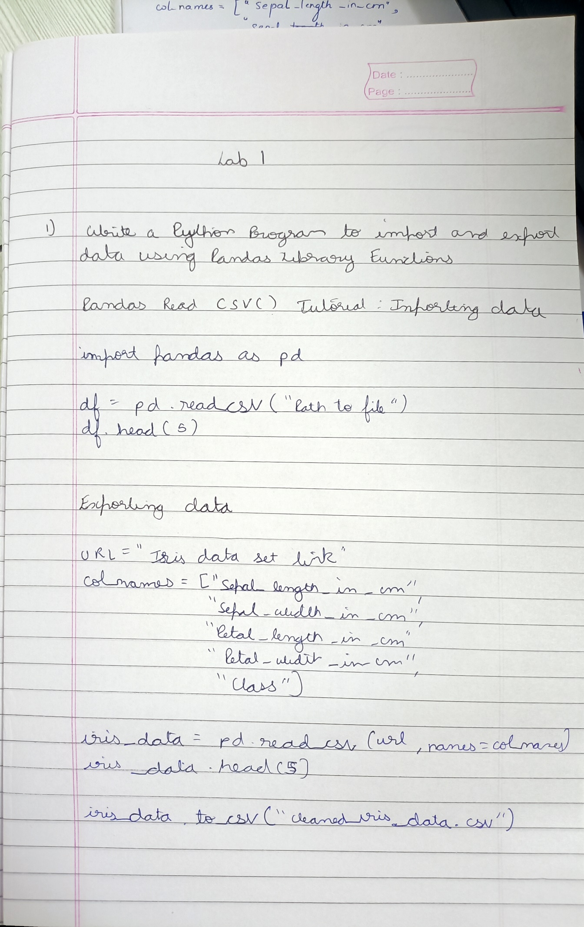

**Code Screenshot**

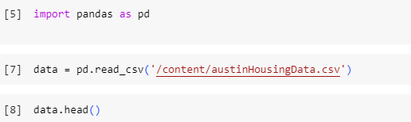

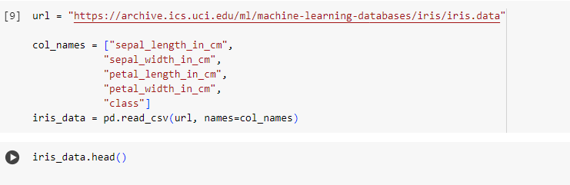



**Output:**

