REST ASSIGNMENT PART-2

NOTE- Questions having incompatible dependencies with each other and the ddifferent kind of versionings are in comment so that the Api work properly.

--------Internationalization-------------
Package name – ques 1
GET localhost:8080/hello-world{name}
Accept-Language german
Accept-Language swedish
Accept-Language us

-------CONTENT NEGOTIATION-----------

In content negotiation , firstly the dependency for changing the requests of GET and POST from JSON to Xml is added , which is-

compile group: 'com.fasterxml.jackson.dataformat', name: 'jackson-dataformat-xml', version: '2.10.3'

Now, inside Postman , for GET request we added header -

Accept Application/xml

Now, the output is in xml format.

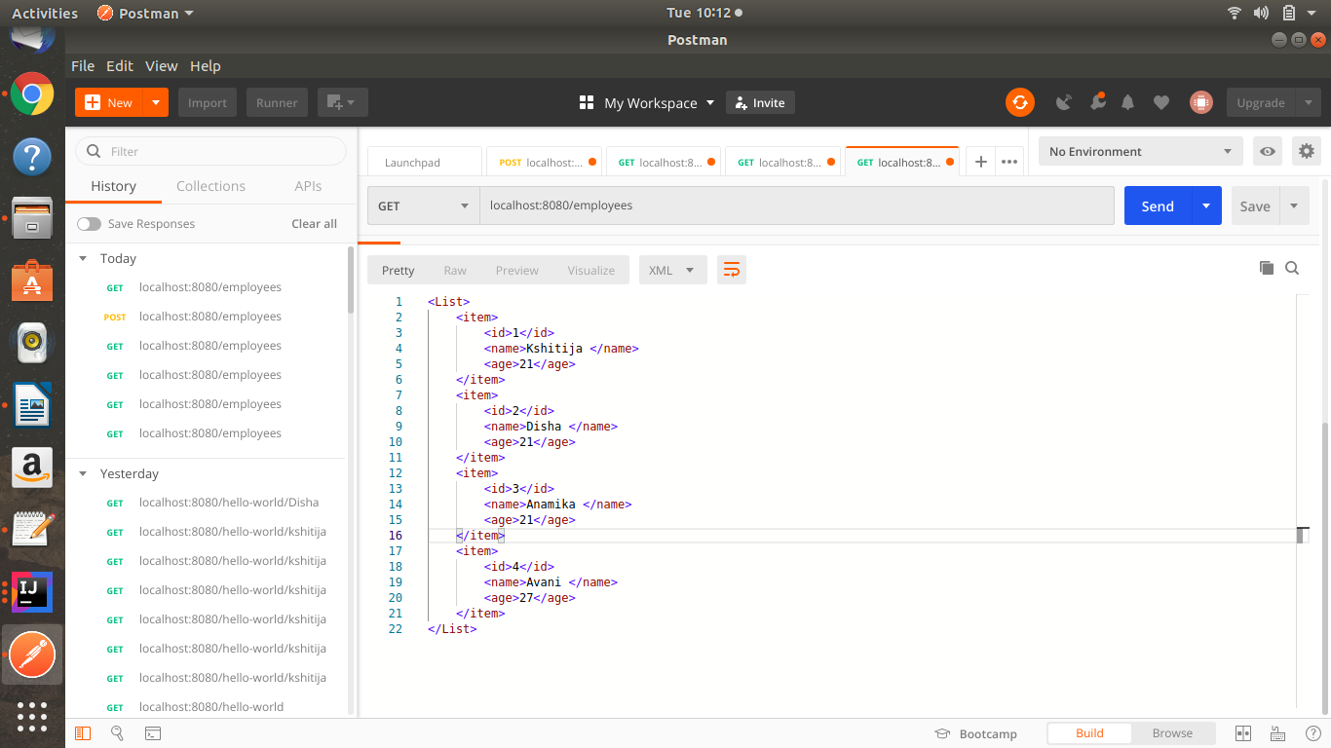

For PUT request , we have changed inside body > raw > JSON to body>raw>XML.

The input is also in xml format like this-

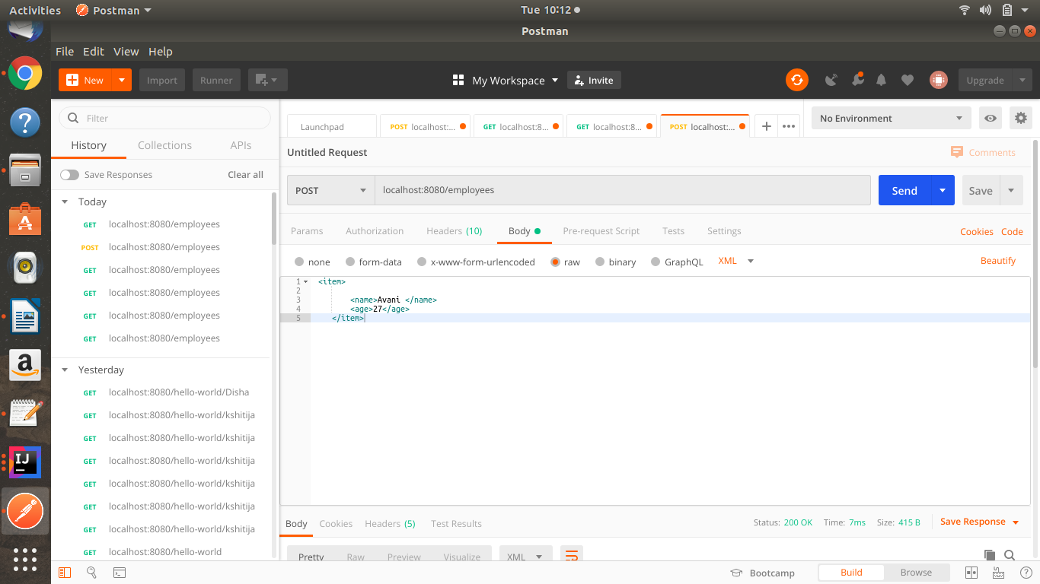

---------------------SWAGGER------------------------

Added dependencies-

compile group: 'io.springfox', name: 'springfox-swagger2',version:'2.9.2'
compile group: 'io.springfox', name: 'springfox-swagger-ui', version: '2.9.2'

Now, added description of class using @ApiModel(description = “”)
and
@ApiModelProperty(notes=””)
localhost:8080/v2/api-docs {for documentation details in json}
localhost:8080/swagger-ui.html {for ui description}

---------Static and Dyamic Filtering--------
Package – Filtering
Static filtering-
GET localhost:8080/static-filtering
GET localhost:8080/static-filtering-list
Dynamic Filtering-
GET localhost:8080/dynamic-filtering
GET localhost:8080/dynamic-filtering-list

------Versioning Restful Apis -------
Package- users {Having two apis one for basic user details and other for enhanced details}

MimeType Versioning
Basic users- localhost:8080/users/produces
Inside header-
Accept application/vnd.company.app-v1+json
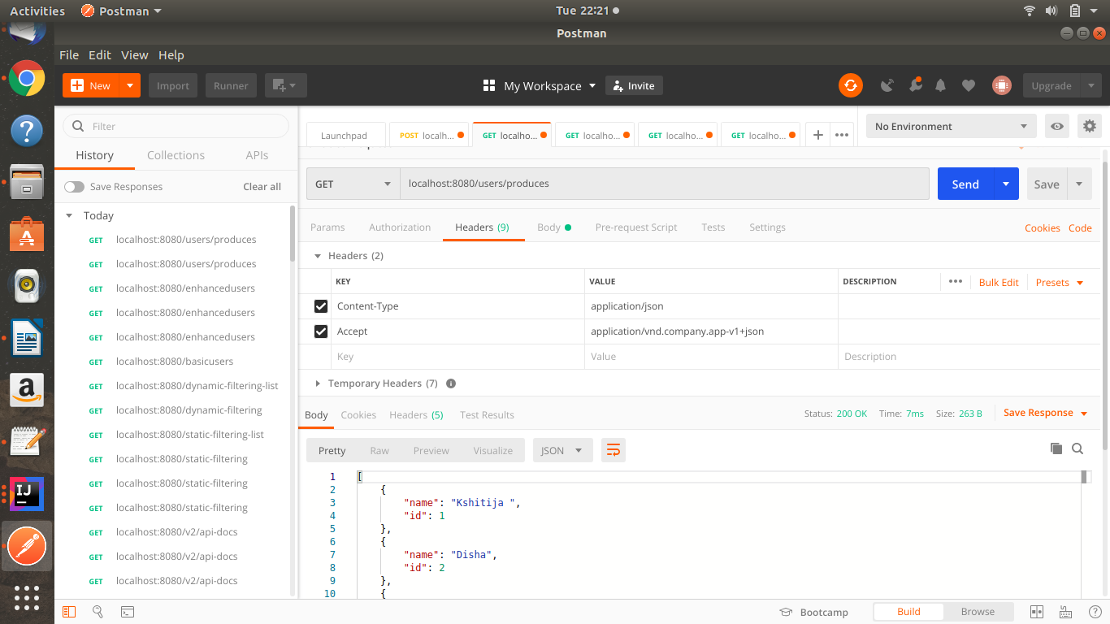
Enhanced users-localhost:8080/users/produces
Inside header-
Accept application/vnd.company.app-v2+json
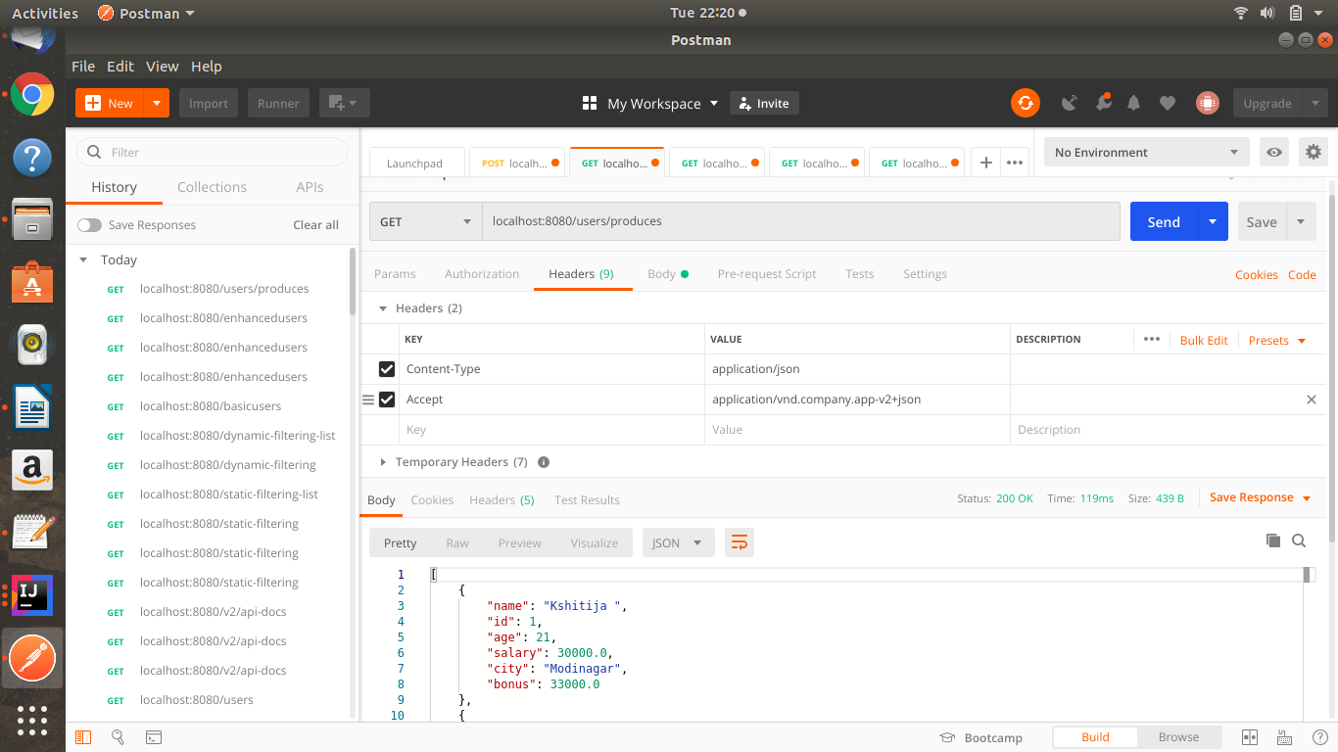

URI versioning
Basic users- localhost:8080/v1/users
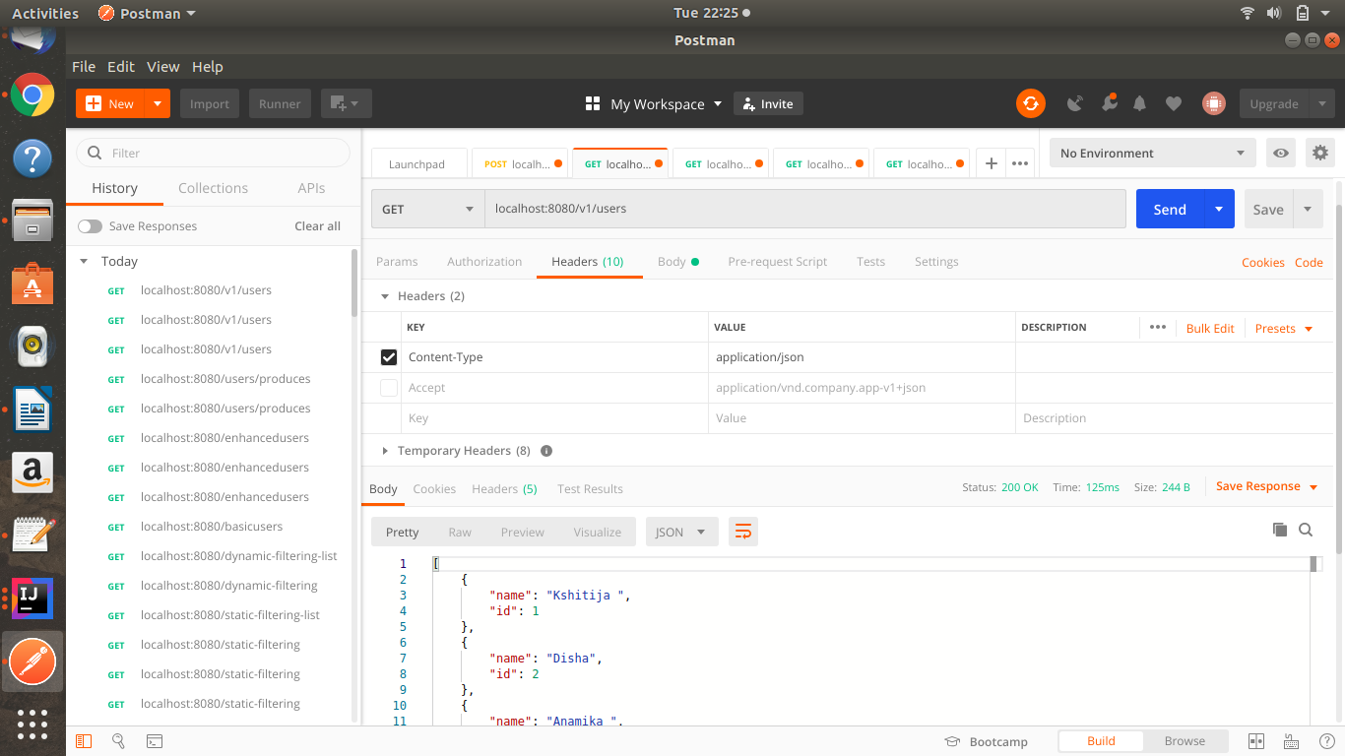
Enhanced users- localhost:8080/v2/users
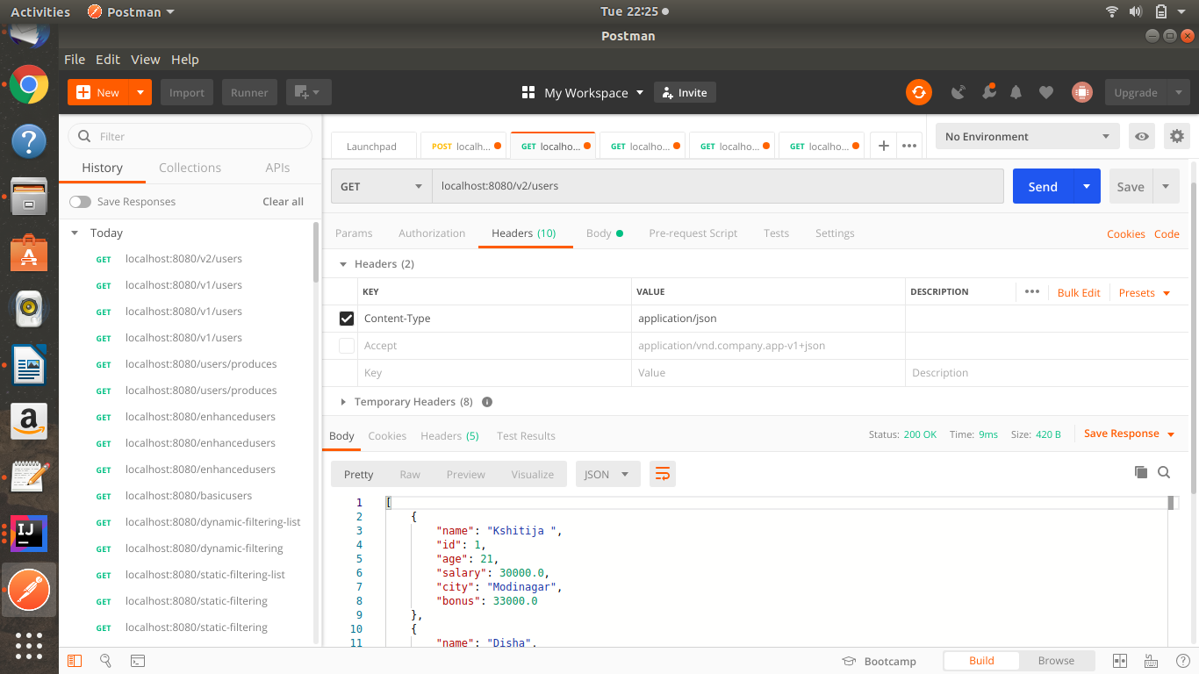

Request Parameter versioning
Basic users – localhost:8080/users/param?version=1
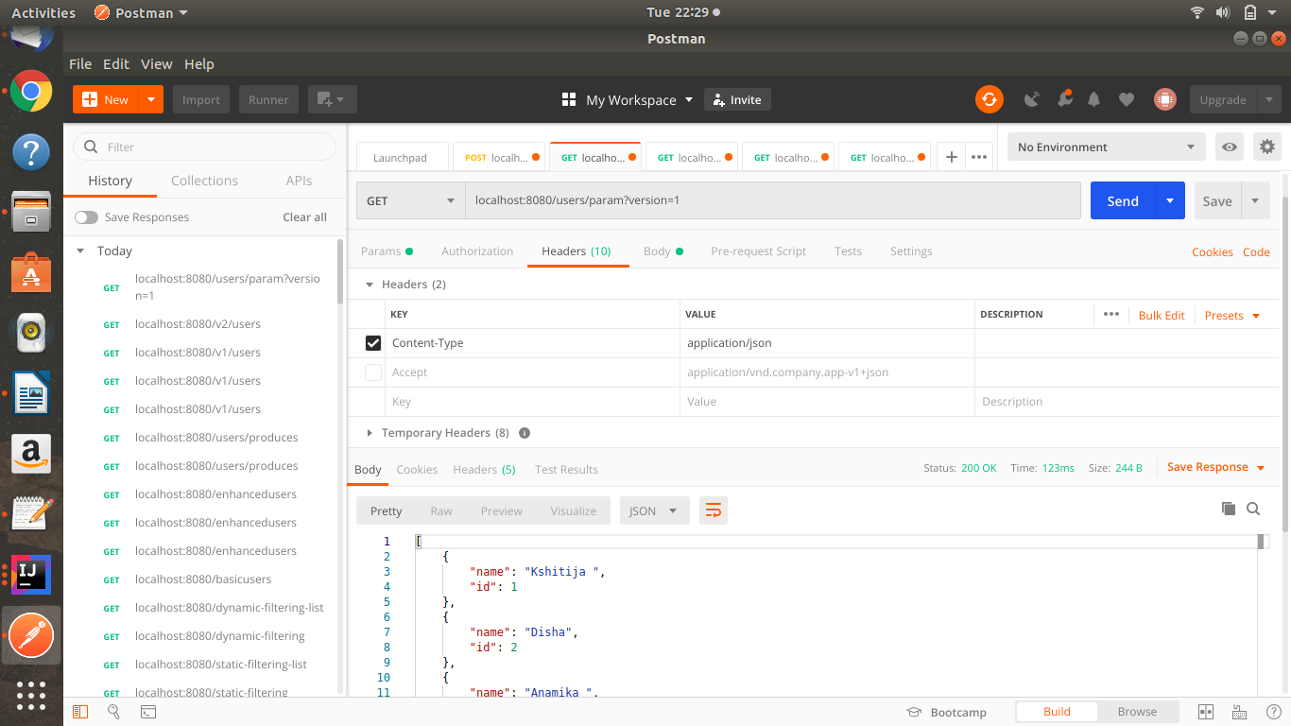
Enhanced users – localhost:8080/users/param?version=2
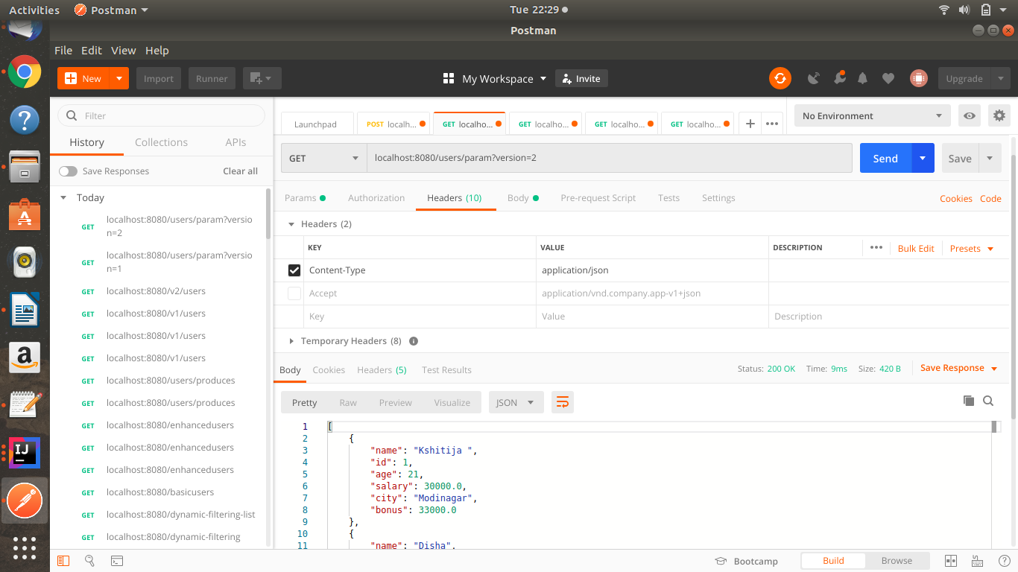
Custom Header Versioning
Basic users – localhost:8080/users/header
Inside header-
X-API-Version 1
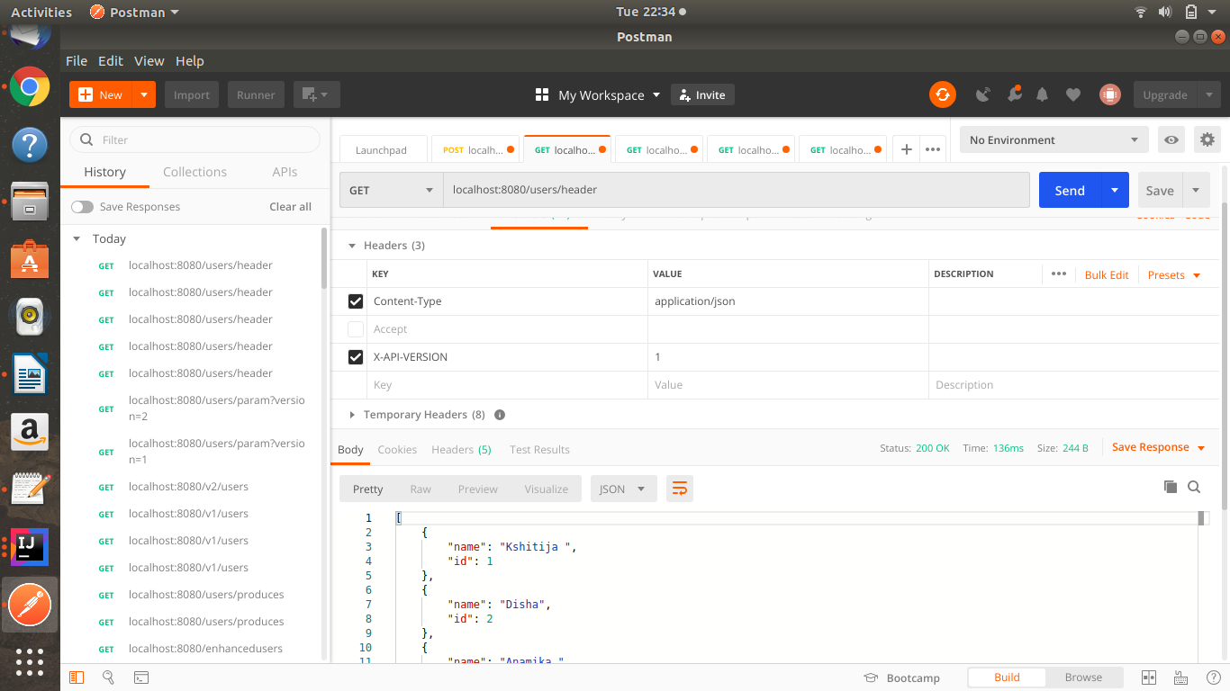

Basic users – localhost:8080/users/header
Inside header-
X-API-Version 2
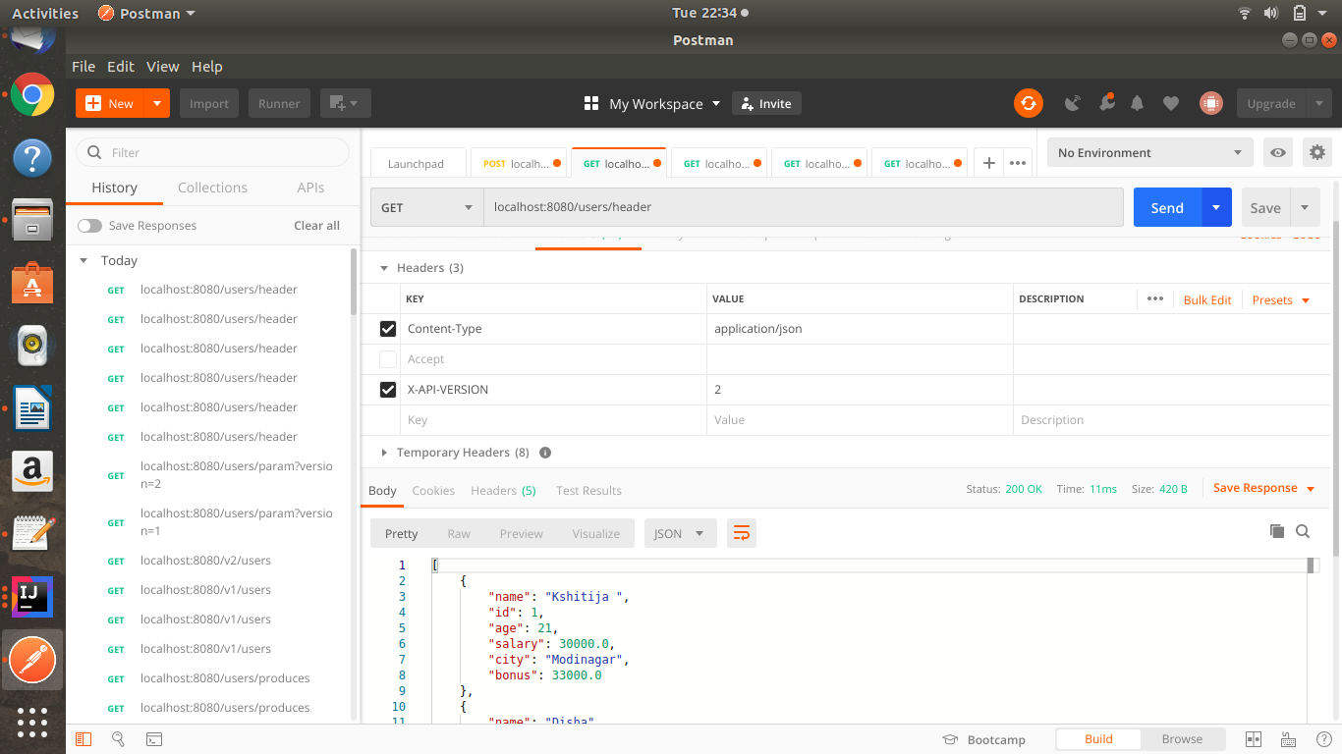

-------------------------HATEOAS--------------------
Add dependencies-
compile group: 'org.springframework.boot', name: 'spring-boot-starter-hateoas', version: '2.2.5.RELEASE'

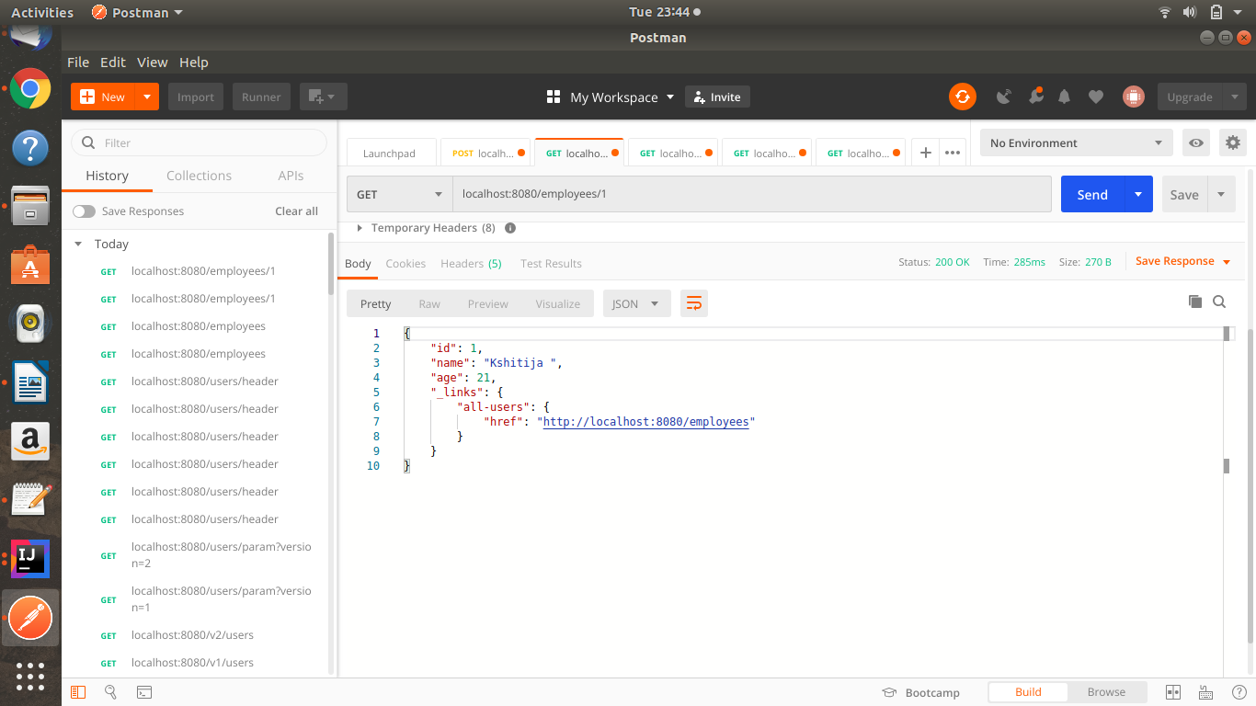
Note- Swagger dependencies were incompatible with hateoas , so it is commented and its imported classes also.

