**Netflix Stock Prediction with LSTM**

Overview

This repository contains a simple implementation of time series prediction using a Long Short-Term Memory (LSTM) neural network. The code is written in Python and utilizes the PyTorch deep learning framework. The primary goal is to forecast future values based on historical closing prices from a given dataset.

Getting Started

Using Anaconda Jupyter Notebook.

Install Dependencies:

* pip install matplotlib
* pip install MinMaxScaler
* pip install torch

Import Dataset

Ensure you have a CSV file containing time series data, with at least a "Close" column.

Update the file path in the code: df = pd.read_csv(r"path/to/your/dataset.csv").

Usage

Run the time_series_prediction.py script to train the LSTM model and generate predictions. Adjust the hyperparameters and dataset path as needed.

Model Architecture

The LSTM model consists of an LSTM layer followed by a fully connected layer. Hyperparameters such as the input size and hidden size can be modified in the Model class within the script.

Results

The script visualizes the predicted and actual values on the test set using Matplotlib. The plot will be displayed at the end of the script execution.

License

This project is licensed under the MIT License - see the LICENSE file for details.

Acknowledgments

The code is based on standard practices for time series prediction with LSTMs.

Thanks to the open-source community for providing essential libraries and frameworks.

Feel free to explore, modify, and enhance the code for your specific use case. If you have any questions or suggestions, please don't hesitate to reach out!

OUTPUT

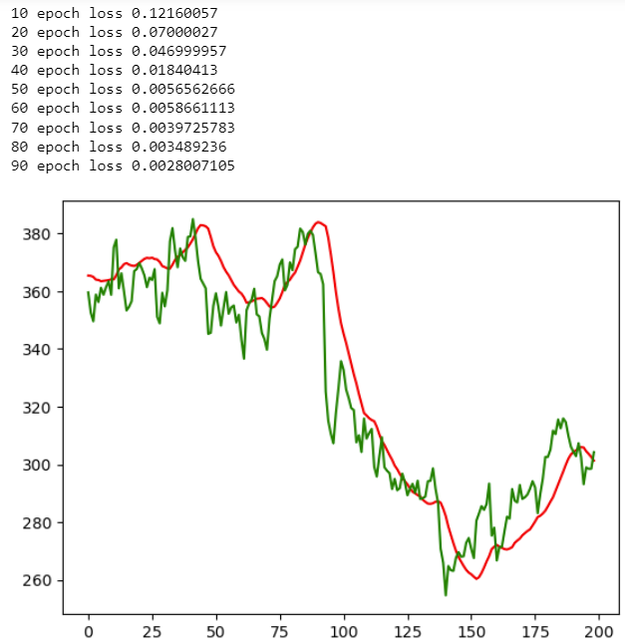

Output: RED: Predicted GREEN: Real