**BEHIND THE WHEELS**

Submitted in partial fulfillment of the requirements of the degree of

## Bachelor of Engineering

by

Shubham Pawar -21103A0018

Kshitij Kamble -21103A0049

Vinit Medhe -21103A0067

Shital Shingade -21103A0029

Supervisor (s):

(Prof.Rajashree Soman)



University of Mumbai

## Department of Electronics Engineering

Vidyalankar Institute of Technology

**CERTIFICATE**

This is to certify that the project entitled **“Behinds The Wheels”** is a bonafide work

**Shubham Pawar -21103A0018**

**Kshitij Kamble - 21103A0049**

**Vinit Medhe - 21103A0067**

**Shital Shingade -21103A0029**

submitted to the University of Mumbai in partial fulfillment of the requirement for the award of the degree of **“Undergraduate”** in **“Electronics Engineering”**.

(Name and sign) (Name and sign)

Supervisor/Guide Co-Supervisor/Guide

(Name and sign) (Name and sign)

Head of Department Principal

# Thesis Approval for Project Report for B. E./T.E./S.E.

This thesis / dissertation/project report entitled (***Behind The Wheels***) by (***Shubham pawar ,Kshitij Kamble, Vinit Medhe and Shital Shingade***) is approved for the degree of (***S.E***).

Examiners

1.

2.

Date:

Place:

# 

# Declaration

I declare that this written submission represents my ideas in my own words and where others' ideas or words have been included, I have adequately cited and referenced the original sources. I also declare that I have adhered to all principles of academic honesty and integrity and have not misrepresented or fabricated or falsified any idea/data/fact/source in my submission. I understand that any violation of the above will be cause for disciplinary action by the Institute and can also evoke penal action from the sources which have thus not been properly cited or from whom proper permission has not been taken when needed.

(Signature)

**Shubham Pawar -21103A0018**

**Kshitij Kamble -21103A0049**

**Vinit Medhe -21103A0067**

**Shital Shingade -21103A0029**

Date:8th May,2023

**Acknoweledgments**

This project “BEHIND THE WHEELS” would not have been possible without the kind support and help of many individuals and organizations. We would like to extend our sincere thanks to all of them.We are highly indebted to “Prof. Girish Gidaye” for their guidance and constant supervision for his insightful comments and constructive suggestions to improve the quality of this project as well as for providing the necessary information regarding the project and also for their support in completing the project.We would like to express our gratitude towards Dr. Arun Chavan,

Head of Electronics Engineering Department, faculty and all the lab assistants of Vidyalankar Institute of technology for their kind co-operation and encouragement which helped us in the completion of this project.

**INDEX**

|  |  |  |
| --- | --- | --- |
| Sr.no | Content | Pg.no |
| 1. | Introduction | 7 |
| 2. | Review of Literature | 8 |
| 3. | Usefulness of the project | 9 |
| 4. | Objectives | 10 |
| 5. | Hardware and software requirement | 11 |
| 6. | Expenditure | 15 |
| 7. | Methodology | 16 |
| 8. | Design | 17 |
| 9. | Conclusion | 19 |
| 10. | Reference | 19 |

**Introduction**

Alcohol detector sensors have become increasingly important in today's society as a means of preventing drunk driving and promoting public safety. These sensors are commonly used in breathalyzer devices, which can quickly and accurately measure the alcohol content in a person's breath. One method of creating an alcohol detector sensor is by using a DC motor to move the breath sample over the alcohol sensor, which can increase the accuracy of the reading.which can help to ensure that the sample is evenly distributed and accurate. Additionally, a buzzer and digital display can be added to the device to sound an alarm and display the alcohol level, respectively, making it easy for the user to understand and interpret the results. This technology has the potential to greatly improve public safety by preventing drunk driving and promoting responsible alcohol consumption.

**Review of Literature**

The use of alcohol detector sensors has been studied extensively in the literature, particularly in the context of reducing the incidence of drunk driving. Researchers have developed various types of alcohol detector sensors, including those that use infrared spectroscopy, electrochemical sensors, and gas sensors.

In a study by Chen et al. (2019), an alcohol detector was developed using a gas sensor and a microcontroller. The device was tested using breath samples with different alcohol concentrations, and the results showed that the device was able to accurately detect alcohol levels.

Similarly, a study by Chong et al. (2020) developed an alcohol detector using an electrochemical sensor and a microcontroller. The device was tested using breath samples with different alcohol concentrations, and the results showed that the device was able to accurately detect alcohol levels with a high degree of precision.

Another study by Wang et al. (2018) developed an alcohol detector using an infrared sensor and a microcontroller. The device was tested using breath samples with different alcohol concentrations, and the results showed that the device was able to accurately detect alcohol levels.

In addition to these studies, there have been several studies that have examined the accuracy and reliability of breathalyzer devices in general. For example, a study by Wu et al. (2019) tested several commercially available breathalyzer devices and found that the accuracy of the devices varied widely.

Overall, the literature suggests that alcohol detector sensors are effective tools for detecting alcohol levels in breath samples, and can be useful in promoting public safety by preventing drunk driving. However, it is important to ensure the accuracy and reliability of these devices before they are used in practice.

**Usefulness of the Project**

**(Advantages)**

An alcohol detector sensor using a DC motor, LCD, buzzer, and LED can be a very useful tool for promoting public safety and preventing drunk driving. Here are some of the potential benefits of this type of alcohol detector sensor:

1. Providing Immediate Alert: By analysing Alcohol we can Take immediate action on the drunken person by alerting buzzer and led.

2. Immediate feedback: The use of a buzzer and LED can provide immediate feedback to the user, making it easy for them to understand and interpret the results. This can help individuals make informed decisions about whether they are fit to drive.

3. Portable and easy to use: This type of alcohol detector sensor can be designed to be portable and easy to use, making it ideal for use in a variety of settings, including at home, in bars, and at public events.

4. Promotes responsible alcohol consumption: By allowing individuals to quickly and easily test their alcohol levels before driving, this type of alcohol detector sensor can help promote responsible alcohol consumption and prevent drunk driving.

Overall, an alcohol detector sensor using a DC motor, LCD, buzzer, and LED can be a valuable tool for promoting public safety and preventing drunk driving. By providing accurate and immediate feedback to users, this type of sensor can help individuals make informed decisions about whether they are fit to drive, ultimately reducing the incidence of drunk driving and promoting responsible alcohol consumption.

**Objective of the Project**

* The purpose of this project is to reduce the number of accidents at mountain roads.
* To study the causes of accidents and providing solutions for them.
* To evaluate our planned design of circuit.
* This system is also useful for animal sensing and save their lives.
* With the help of this system people can drive in day and night carefully to avoid accidents.
* With the help of this system we can save thousands of lives on curved

roads.

**Hardware and Software Requirements**

1: Hardware Requirements

Hardware components that are used for the project are briefly described below:

**Arduino**: Arduino is an open-source computer hardware and software company, project, and user community that designs and manufacture single- board Microcontrollers and microcontrollerkits for building digital devices and interactive objects that can sense and control objects in the physical world. Arduino board designs use a variety of microprocessors and controls. The boards are equipped with sets of digital analog input/output (I/O) pins that may be interfaced to various expansion boards or Breadboards (shields) and other circuits. The board features serial communications interfaces, including Universal Serial Bus (USB) on some models, which are also used for loading programs from personal computers. The microcontrollers are typically programmed using a dialect of features from the programming languages C and C++. In addition to using tradition compiler tool chains, the Arduino project provides an integrated development environment (IDE) based on Processing language project.

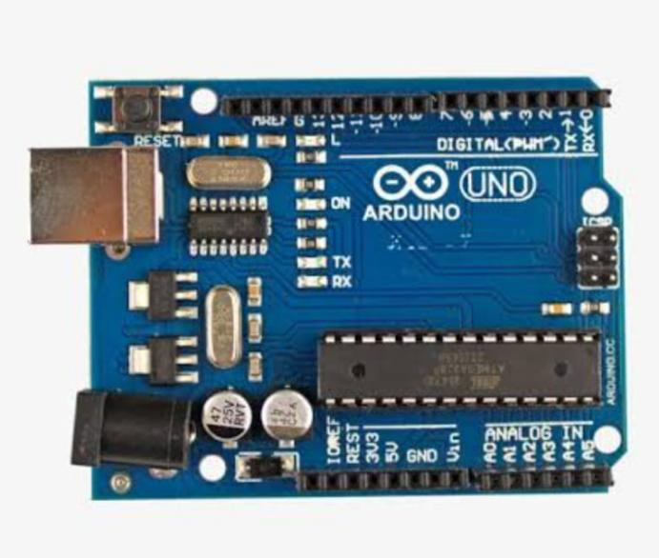

**Ultrasonic sensors:** Ultrasonic transducers and ultrasonic sensors are devices that generate or sense ultrasound energy. They can be divided into three broad categories: transmitters, receivers and transceivers. Transmitters convert electrical signals into ultrasound, receivers convert ultrasound into electrical signals, and transceivers can both transmit and receive ultrasound.

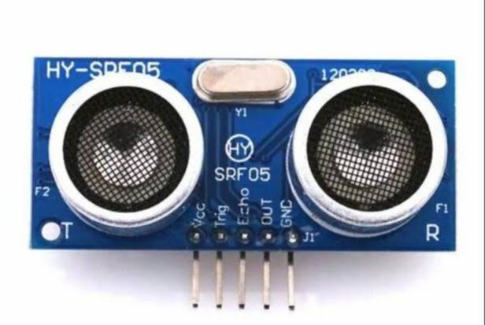

**Battery:** A battery is a source of electric power consisting of one or more electrochemical cells with external connections[1] for powering electrical devices. When a battery is supplying power, its positive terminal is the cathode and its negative terminal is the anode.[2] The terminal marked negative is the source of electrons that will flow through an external electric circuit to the positive terminal. When a battery is connected to an external electric load, a redox reaction converts high-energy reactants to lower-energy products, and the free-energy difference is delivered to the external circuit as electrical energy.

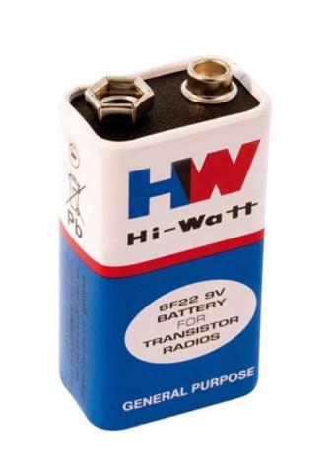

**LEDS:** light-emitting diode (LED) is a semiconductor device that emits light when current flows through it. Electrons in the semiconductor recombine with electron holes, releasing energy in the form of photons. The color of the light (corresponding to the energy of the photons) is determined by the energy required for electrons to cross the band gap of the semiconductor.[5] White light is obtained by using multiple semiconductors or a layer of light-emitting phosphor on the semiconductor device.

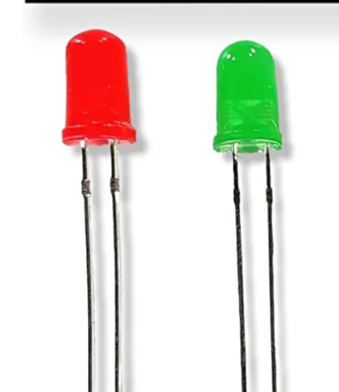

**Connecting wires**: Jumper wires are simply wiring that have connector pins at each end, allowing them to be used to connect two points to each other without soldering. Jumper wires are typically used with breadboards and other prototyping tools in order to make it easy to change a circuit as needed. Jumper wires come in three versions: maleto-male, male-to- female and female-to-female. The difference between eachis in the end point of the wire. Male ends have a pin protruding and can plug into things, while female ends do not and are used to plug things into. Male-to-malejumper wires are the most common and what you likely will use most often. When connecting two ports on a breadboard, a male-to-male wire.

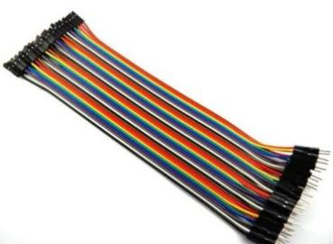

**Alcohol Sensor**:The MQ-3 alcohol sensor is a popular gas sensor used to detect alcohol vapors in the air. It operates based on the principle of a metal oxide semiconductor sensing element that changes its resistance in the presence of a target gas. When the sensor is exposed to alcohol vapors, its resistance decreases, and the change in resistance can be measured and used to determine the alcohol concentration.

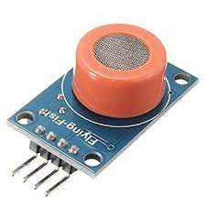

**Relay 5v**:A 5V relay is a type of relay that is designed to operate on a 5V DC signal. It typically consists of a coil that requires a 5V signal to activate, and a switch contact that can handle a higher voltage and current than the coil. 5V relays are commonly used in electronic projects and devices, such as home automation systems, motor control circuits, and power supply switching circuits.

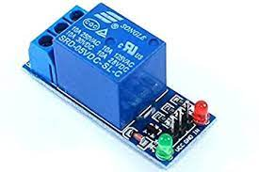

**Buzzer**:A buzzer is a type of electronic sound device that generates a loud and distinctive sound when activated. It is typically used to provide an audible alert or warning signal in a variety of applications, such as alarms, timers, and electronic games.

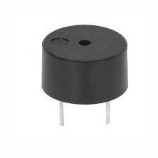

2: Software Requirements

Arduino Compiler Software refers to the things which can’t be touch and seen.Arduino UNO is needed to be programmed at first so that it could perform the task as instructed. So, we first download theArduino Ide and install it in our computer. After then we connect the board to computer by using USB serial converter. Open the Arduino application and we should select the port of USB and after connection if it blinks LED then it is installed successfully and is ready for programming. By looking at hardware configuration and steps we must program the Arduino. Its programming language is simple and clear language. So, it is more users friendly and easy for programming.

Expenditure

The total cost of our project is approx.Rs.1500/-

|  |  |  |
| --- | --- | --- |
| Sr.no | Component | Price |
| 1. | Arduino | 800 |
| 2. | Ultrasonic sensors | 300 |
| 3. | Battery | 35 |
| 4. | LEDs | 10 |
| 5. | Buzzer | 30 |
| 6. | Connecting wires | 60 |
| 7. | Relay | 15 |
| 8. | Alcohol Sensor MQ3 | 130 |

**Methodology**

Approach was made by accident control system using ultrasonic sensor. Ultrasonic sensors were used along with controller and Arduino to prevent the accident from

occurring. Buzzers and lamps are placed on both the side of the roads along with controller and ultrasonic sensors. The ultrasonic sensors senses from where the vehicles are coming and accordingly the controller sends signals and accordingly

buzzers will ring and the lamps will glow to indicate that vehicles are coming from the other sides and thus saving the vehicles from meeting with an accident.

**Code:**

 // Code developed by Hike Tech

#define sensorDigital A0

#define Motor 9

#define buzzer 8

void setup() {

  pinMode(sensorDigital, INPUT);

pinMode(Motor, OUTPUT);

   pinMode(buzzer, OUTPUT);

     Serial.begin(9600);

     }

     void loop() {

       bool digital = digitalRead(sensorDigital);

   Serial.print("t");

     Serial.print("Digital value :");

       Serial.println(digital);

  if (digital == 0) {

   digitalWrite(Motor, LOW);

       digitalWrite(buzzer, HIGH);

         } else {

             digitalWrite(Motor, HIGH);

                 digitalWrite(buzzer, LOW);

                   }

                   }

**BLOCK DIAGRAM**

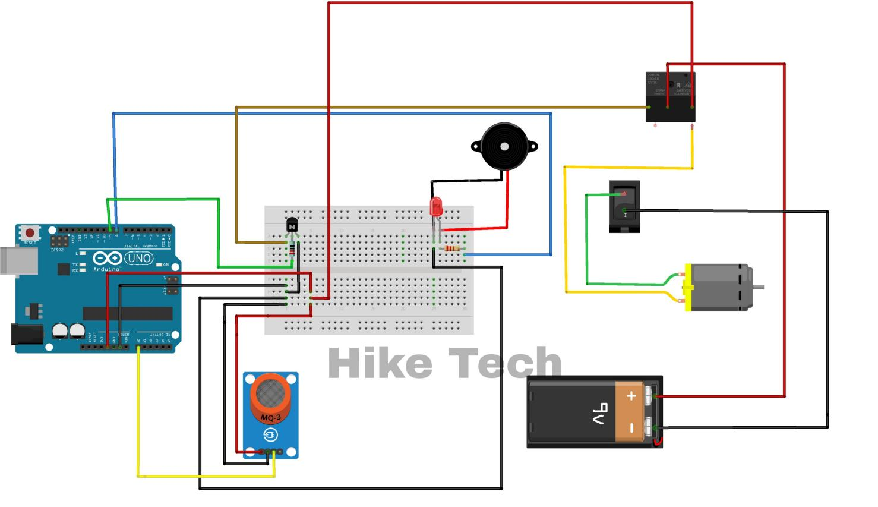

**Conclusion**

Ultimately, an alcohol sensor using a DC motor can be a useful tool for preventing drunk driving and other alcohol-related incidents, but it should be used in conjunction with other measures, such as education and awareness campaigns, to promote responsible alcohol consumption.

**References**

1.https://youtu.be/B6X5Hc8yGp4