🔐 Cybersecurity Home Lab: Active Directory, Firewall Segmentation, Attack Simulation, & SIEM Logging
Author: Kshitiz
Domain: kshitizcyberlab.local
All the lab work is done in VMware Workstation Pro.

📌 Overview
This project is a practical Security Operations Center (SOC) home lab designed to simulate real-world enterprise security monitoring. The Kali Linux machine is placed inside the user network (10.0.0.0/24). This represents a real-world scenario where an attacker has already gained access to the internal network, typically through phishing, malware, or stolen credentials.
The lab demonstrates how logs are generated, collected, and analyzed to detect security events such as:
- User account creation
- Privilege escalation
- SSH brute-force attempts
- Network scanning and enumeration
The environment combines endpoint monitoring, Active Directory logging, firewall inspection, and attack simulation.

🧱 Architecture
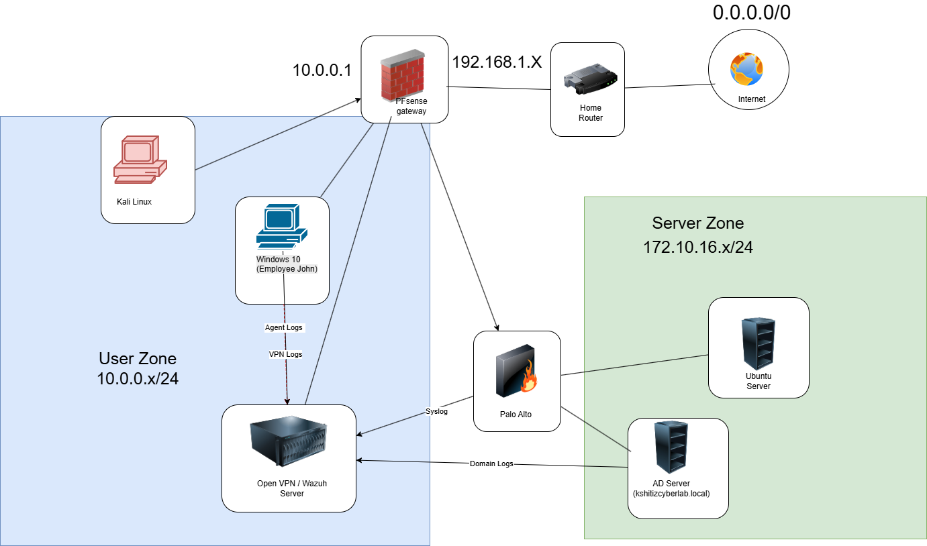

The lab is divided into multiple networks to simulate a real enterprise environment.
- User Network (10.0.0.0/24):
Contains endpoint systems and attacker machine
- Server Network (172.16.10.0/24):
Contains critical infrastructure like Active Directory and internal servers

Core Network Flow
Internet → Home Router → pfSense → Palo Alto Firewall → Server Network
All traffic to the server network must pass through the Palo Alto firewall.

🔧 Infrastructure & IP Configuration

Core Systems
Component | Role | IP Address
pfSense | Gateway | 10.0.0.1
Palo Alto Firewall | Internal segmentation firewall | 10.0.0.2 / 172.16.10.1
Wazuh Server (Ubuntu) | SIEM | 10.0.0.60
Active Directory | Domain Controller | 172.16.10.10
Windows 10 (John VM) | Endpoint | 10.0.0.50
Kali Linux | Attacker | 10.0.0.40
Ubuntu Server | Target (SSH/Web/FTP) | 172.16.10.20

Interface Details
pfSense
- WAN: 192.168.1.x (connected to home router)
- LAN: 10.0.0.1
Palo Alto Firewall
- eth1/1 (Untrust): 10.0.0.2
- eth1/2 (Trust): 172.16.10.1

🛡️ Wazuh SIEM Configuration
The Wazuh SIEM was configured to collect logs from multiple sources.
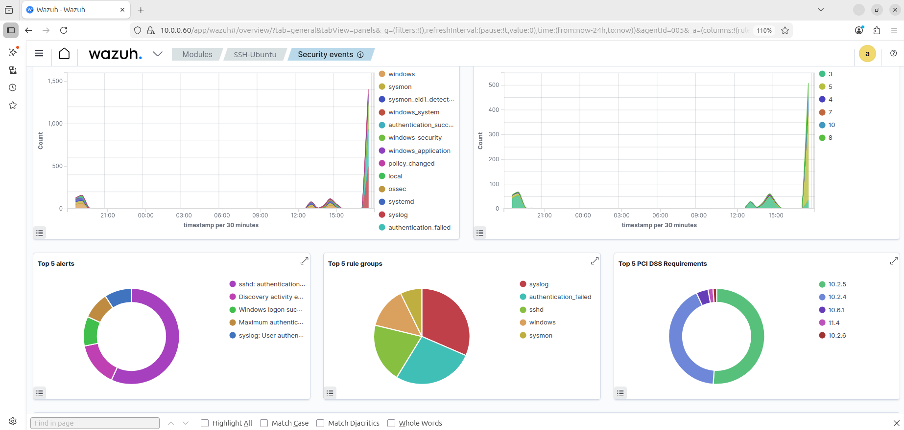

Reliable Log Ingestion
The default UDP communication was replaced with TCP on port 1514.
This ensures that log messages are reliably delivered without packet loss.

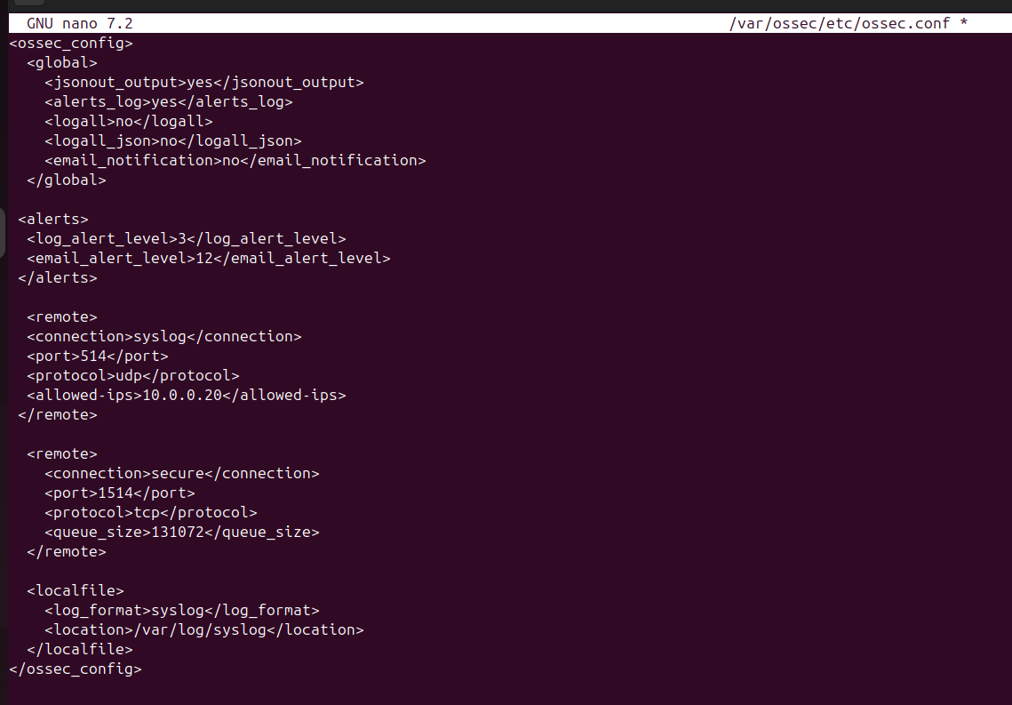Syslog Integration
The Palo Alto firewall was configured to forward syslog to Wazuh
This allows firewall-level visibility inside the SIEM.
⚠️ pfSense is not configured to forward syslog in this setup.

🧠 Active Directory & Auditing
The domain kshitizcyberlab.local was created using Windows Server 2022.

🔥 Firewall & Network Security
The Palo Alto firewall is placed between the user network and the server network.

🌐 Target Server (Ubuntu) – Exposed Services
The Ubuntu server (172.16.10.20) was configured as an attack target.
Running services:
- SSH (22) – remote access
- FTP (21) – file transfer
- HTTP (80) – web server (Apache)
- MySQL (localhost only)
This creates a realistic multi-service attack surface.
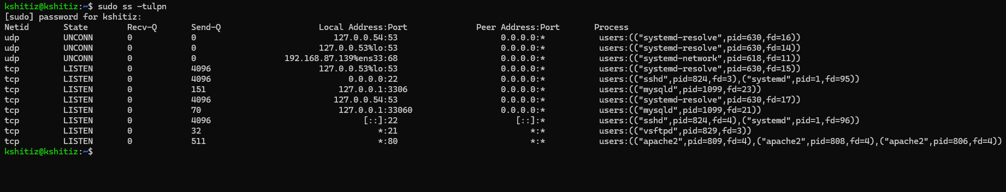

⚔️ Attack Simulation
The goal of this phase was to generate realistic security events and verify that they are correctly detected by the Wazuh SIEM. Attack simulations were performed using Kali Linux (10.0.0.40) and suspicious activity was done manaually using CMD and PowerShell in Windows 10 (John), and AD server.

5.1 Domain-Level Attack Simulation (Active Directory)
The following PowerShell commands were executed on the Domain Controller:
$password = ConvertTo-SecureString "P@ssw0rd123!" -AsPlainText -Force

New-ADUser -Name "SOC_Test_User" `
-SamAccountName "soc_test" `
-UserPrincipalName "soc_test@kshitizcyberlab.local" `
-AccountPassword $password `
-Enabled $true

Add-ADGroupMember -Identity "Domain Admins" -Members "soc_test"
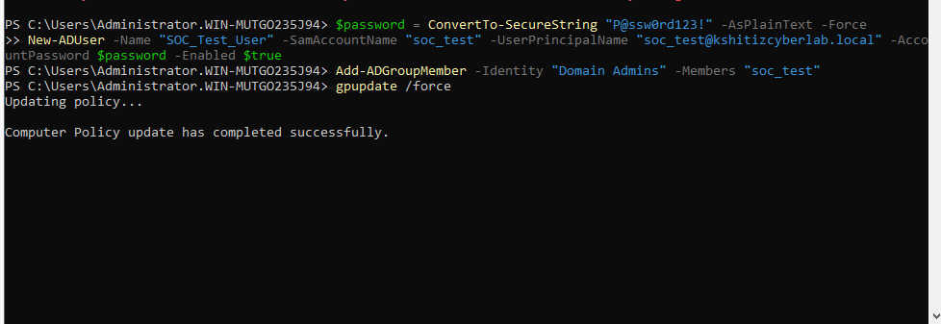
This activity simulates a real attack scenario where:
- A new user account is created inside the domain
- The user is immediately added to the Domain Admins group
This represents a privilege escalation attack, which is a common technique used after initial access.
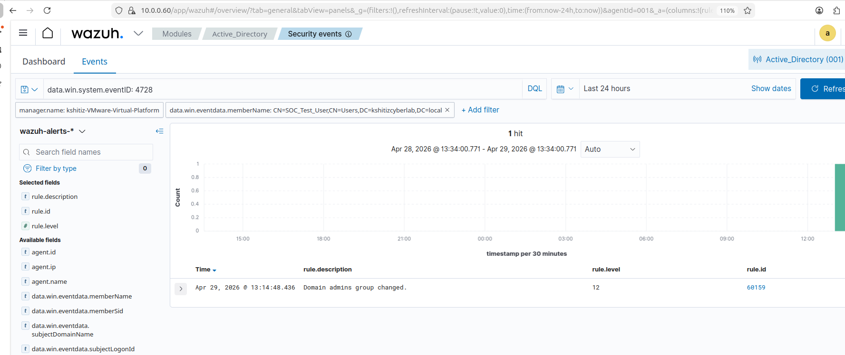
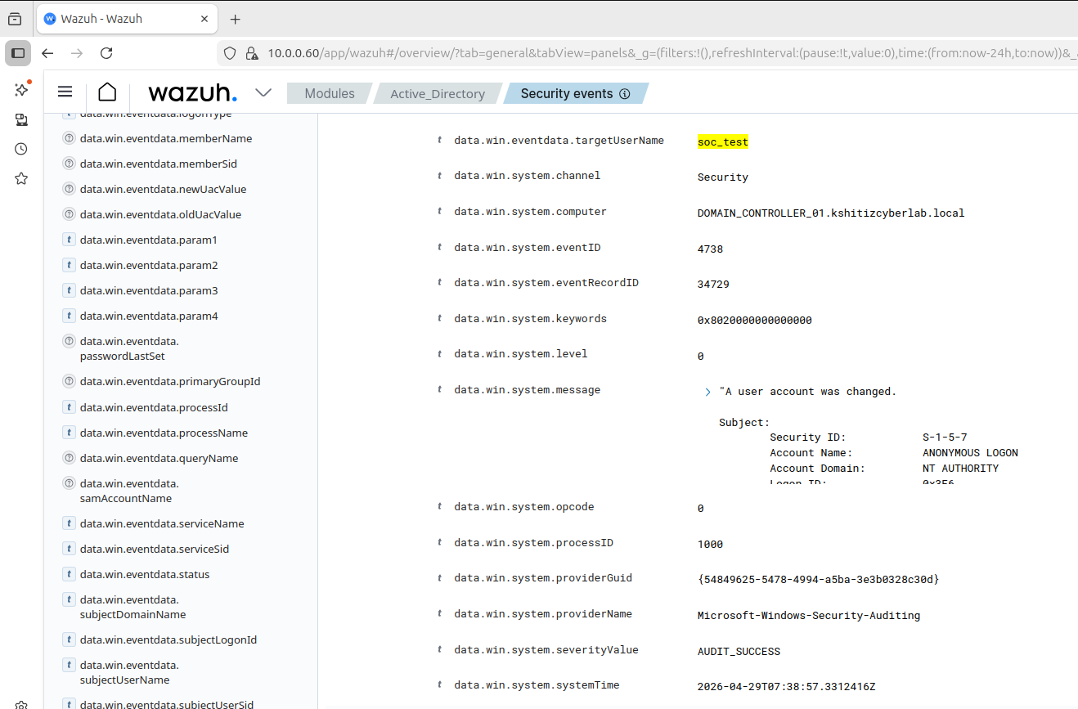

5.2 Endpoint-Level Activity (Windows 10)
The following command was executed on the Windows 10 endpoint:
net user hacker_test Pass123! /add
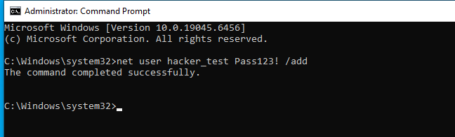
This simulates the creation of a local user account on an endpoint system.
This type of activity is often used by attackers to maintain persistence.
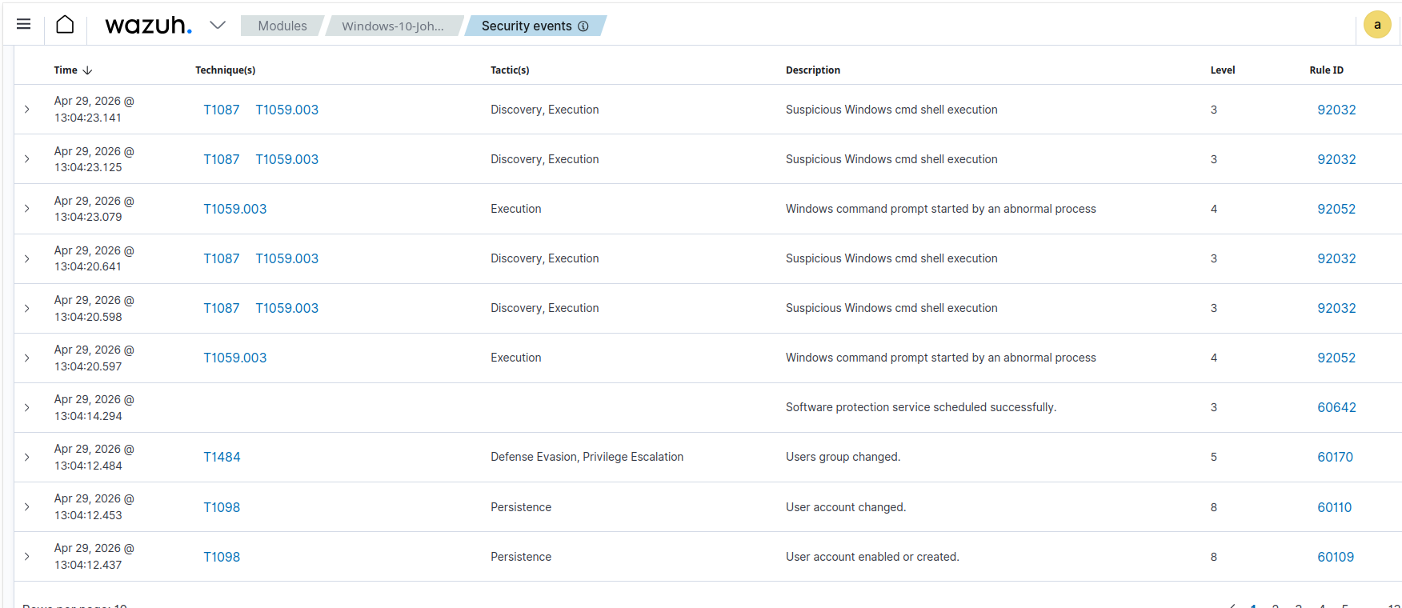

5.3 Attack Simulation (Kali Linux)
Attack simulations were performed from Kali Linux against the Ubuntu server (172.16.10.20).

Web Enumeration
gobuster dir -u http://172.16.10.20 -w /usr/share/wordlists/dirb/common.txt
This command attempts to discover hidden directories on the web server.
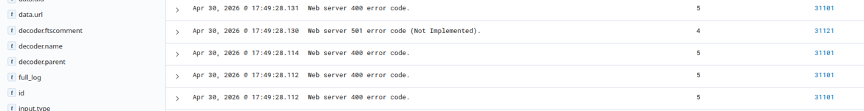

Network Scanning
sudo nmap -sS -A 172.16.10.20
This command performs service detection and port scanning.
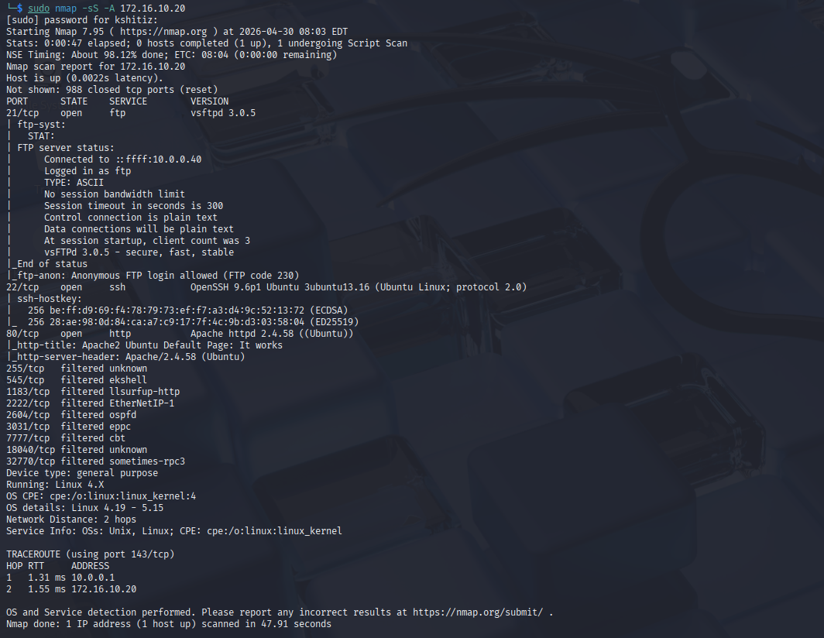
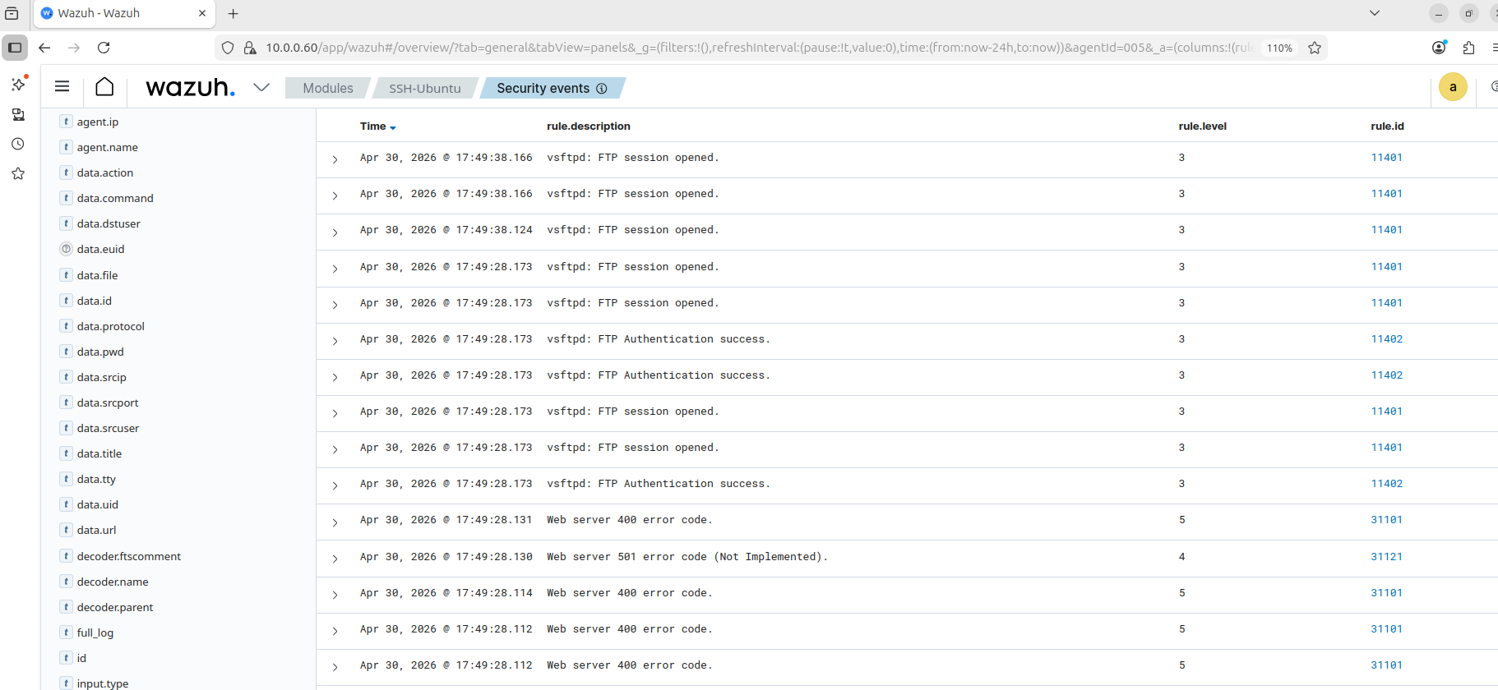

SSH Brute Force Behavior
Multiple login attempts were generated against the SSH service, resulting in authentication failures.
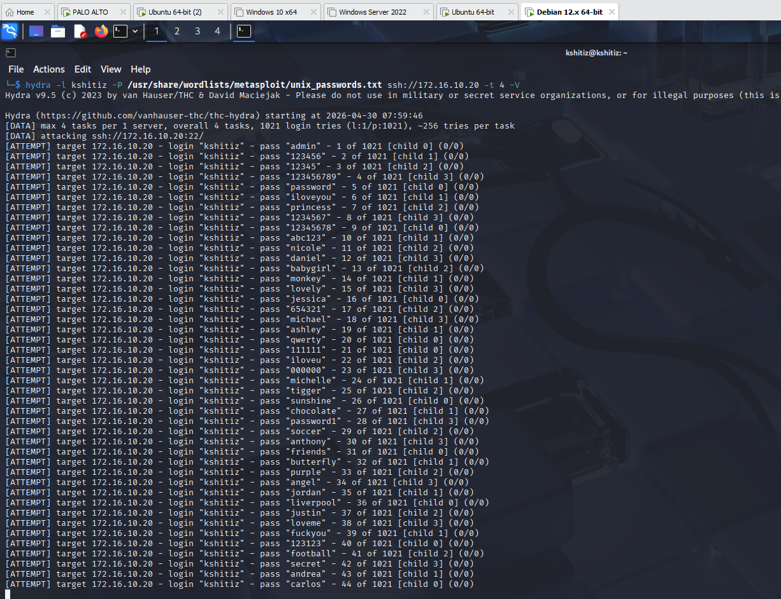
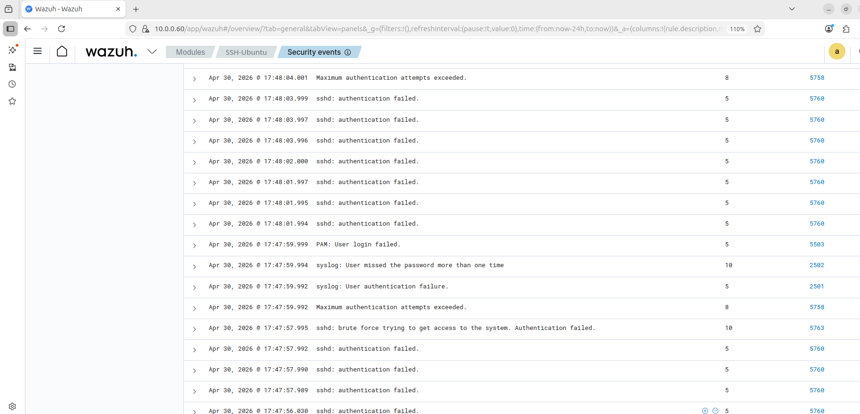

5.4 Detection Results in Wazuh
The Wazuh SIEM successfully detected all simulated activities.
Detection of local user account creation on Windows endpoint

SSH Attack Detection
- Multiple authentication failed logs
- Maximum authentication attempts exceeded
- PAM: User login failed
- Indicators of brute-force attempts

Web Attack Detection
- HTTP 400 and 501 error responses
- Suspicious request patterns from enumeration

FTP Activity Detection
- FTP session creation logs
- Authentication success events

Summary
The SIEM successfully collected and correlated these events, proving that the monitoring setup is functioning correctly.

⚠️ Lab Limitation
Due to hardware limitations (16 GB RAM), all systems could not run simultaneously.

Firewall Policies

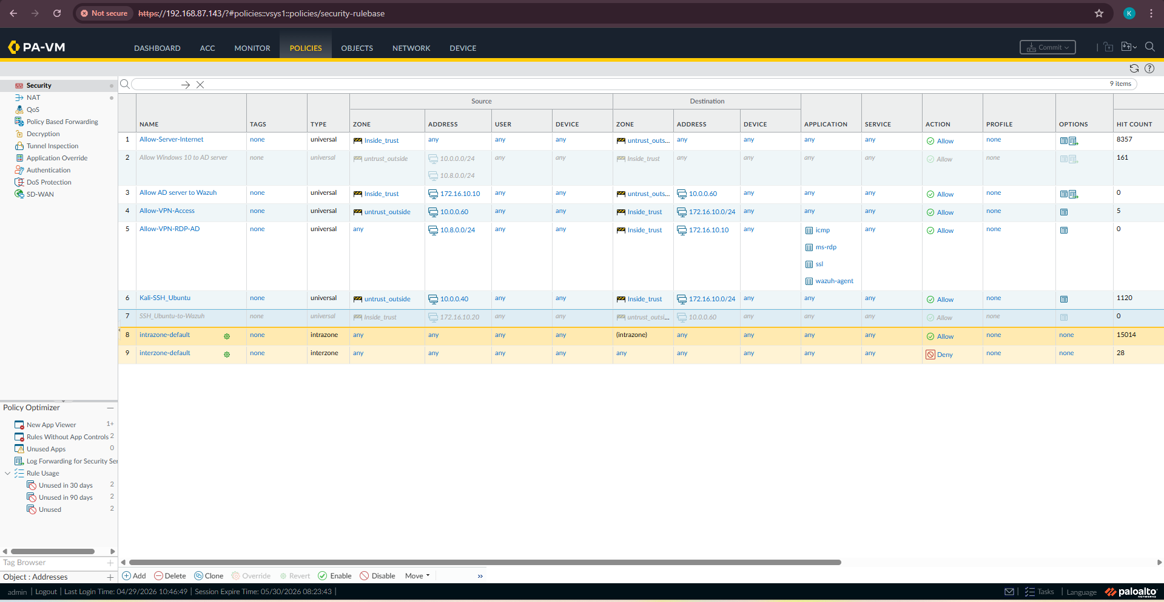

📊 Results
The lab successfully demonstrates:
- Centralized log collection using SIEM
- Detection of identity-based attacks
- Detection of brute-force and scanning activity
- Network segmentation using a firewall
- Visibility across multiple log sources

📂 Hardware Allocation
System | RAM
pfSense | 1 GB
Palo Alto | 5.5 GB
Wazuh (Ubuntu) | 4 GB
Windows 10 | 2.1 GB
Windows Server 2022 | 2.6 GB
Kali Linux | 2 GB
Ubuntu Server | 1 GB

📌 Key Takeaways
This project demonstrates practical understanding of:
- SIEM deployment and log analysis
- Active Directory monitoring
- Firewall-based segmentation
- Attack simulation techniques
- Security event detection

📊 References

Microsoft. (2025, January 15). Active Directory overview – Windows Server.https://learn.microsoft.com/en-us/troubleshoot/windows-server/active-directory/active-directory-overview

Palo Alto Networks. (2026, March 20). Create a security policy rule. https://docs.paloaltonetworks.com/network-security/security-policy/administration/security-rules/create-a-security-policy-rule

Wazuh. (n.d.). Getting started with Wazuh.

https://documentation.wazuh.com/current/getting-started/index.html

👨‍💻 Author
Kshitiz
Cybersecurity Student

