name: - Sujal Singh

Roll No.: - 23020570052

Subject: - Probability for computing

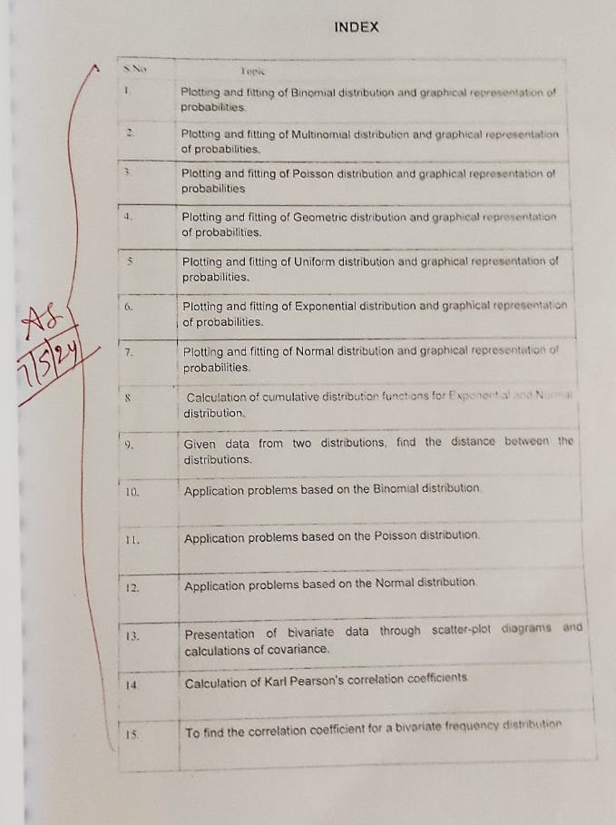

1.Plotting and fitting of Binomial distribution and graphical representation of probabilities.

Introduction:

* The Binomial distribution is used to model the probability of obtaining a certain number of successes in **n independent Bernoulli Trials**.
* It’s PMF, variance & mean are given by:
* 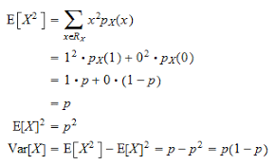
* Graphical representation involves plotting the probability mass function (PMF) to show the probability of each possible outcome.
* A Binomial distribution can be approximated by a normal distribution when the number of trials are large, and by a Poisson distribution when the success probability is very low ( typically <0.2).
* It is used in modelling anything having either a success or a failure, nothing in between, for example: a dice roll.
* In EXCEL, **BINOM.DIST(K,n,p,FALSE) .**

Application:

**Problem statement:**

* Suppose that an xyz electronic company produces both wired and wireless mice. The production output is 50% wired & 50% wireless mice. If we choose 10 mice at random & choosing a wireless mouse is a success, then plot the graph of this distribution with p = 0.5 as the success.

**Answer**:

* Case I: When p = 0.5, the dist is symmetric about the expected value (n*p = 5), where the probability of success below the mean matches that above it.
* Case II: When p <0.5, the distribution is positively skewed, that is the probability of success below the mean is greater than those above it.
* Case III: When p > 0.5, the distribution is negatively skewed, that is the probability of success above the mean is greater than below above it.
* A screenshot of a graph

  Description automatically generated
* A graph with numbers and a bar

  Description automatically generatedA graph with numbers and lines

  Description automatically generated

1. Plotting and fitting of Multinomial distribution and graphical representation of probabilities.

Introduction:

* The Multinomial distribution generalizes the Binomial distribution to more than 2 possible outcomes.
* It can be graphically represented by plotting the PMFs of each possible outcome.
* Its PMF is given by, where p1, p2…pN are the probabilities of kth result & x1, x2…, xk the value of the Random variable which is desired. 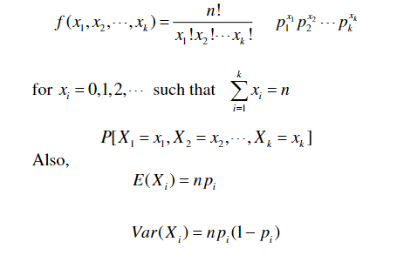
* The mean and variance are given by: E(Xi) = npi, & Var(Xi) = npi(1-pi).
* In EXCEL, **MULTINOMDIST(R1, R2)**

Application:

* Suppose that a bag contains 8 balls, 3 red, 1 green & 4 blue. You reach at the bag and pull out a ball and put it back, and pull out another ball. This experiment is repeated a total of 10 times. What is the probability that the outcome will result in 4 red & 6 blue balls?
* E1 : red ball is drawn, E2: a green ball, E3: blue ball
* P1 : ⅜, P2: ⅛ , P3: 4/8
* A screenshot of a spreadsheet

  Description automatically generated
* A graph with a bar and a number of bars

  Description automatically generated with medium confidence

1. Plotting and fitting of Poisson distribution and graphical representation of probabilities

Introduction:

* The Poisson distribution models the number of events occurring in a fixed interval of time or space, given a constant mean rate.
* Graphical representation involves plotting the probability mass function (PMF) to show the probabilities of different event counts.
* PMF given by:
* A black text on a white background

  Description automatically generated
* Mean = λ, variance = λ
* Where lambda is the mean rate, and x is the number of events occurring in that interval.
* It is used in modelling radioactive decay, network failures, etc.
* EXCEL formula, **POISSON.DIST(K, λ, FALSE)**

Application:

Problem statement:

* An electronic store sells an average of 10 desktops in a week. Assuming that the purchases are as described above, then what is the probability that the store will have turned away potential customers if they stock 2 computers. How many computers should the store stock in order to make sure that it has a 99% probability of meeting a week’s demands?
* A screenshot of a computer

  Description automatically generated
* A graph with blue and white lines

  Description automatically generated

1. Plotting and fitting of Geometric distribution and graphical representation of probabilities.

Introduction:

* The Geometric distribution models the number of trials needed to achieve the first success in a sequence of independent Bernoulli trials.
* Graphical representation includes plotting the probability mass function (PMF) to show the probability of each possible number of trials.
* PMF given by:
* A math equations with black text

  Description automatically generated with medium confidence
* Mean = 1/p, variance = (1-p)/p^2, p: prob of success
* It can be used to model the number of lottery tickets needed before the first win, or can be used in structural analysis, to calculate the number of earthquakes before a building/structure goes down.
* In EXCEL, **NEGBINOM.DIST(x, k, p, FALSE).**

Application:

* Suppose a programmer is waiting outside the PM's office for the PM’s views on AI (whether he supports it or not). If the probability that the PM supports AI is 0.2, what is the probability that 4th PM is the first one to support AI.

* A graph with blue dots

  Description automatically generated

1. Plotting and fitting of Uniform distribution and graphical representation of probabilities.

Introduction

* The Uniform distribution represents outcomes that are equally likely over a specified range.
* Graphical representation involves plotting the probability density function (PDF) to show the uniform distribution over the specified range
* PDF, mean, SD & variance given by:
* A math equations with numbers and symbols

  Description automatically generated with medium confidence
* This is used in PRNGs to generate Random Numbers, and is also used in gaming, and simulations to generate terrains and maps, known as Procedural Random Generation. (PRGs).
* In EXCEL, **UNIFORM_DIST(x, α, β, cum)**

Application:

* A content search on an xyz search engine will show up the results every time in 20 secs. If you search something on xyz, what is the probability that it will show up in 8 seconds?
* A white grid with black numbers and yellow text

  Description automatically generated
* A graph showing the number of students in uniform distribution

  Description automatically generated with medium confidence

1. Plotting and fitting of Exponential distribution and graphical representation of probabilities.

Introduction:

* The Exponential distribution models the time between 2 events in a Poisson process, where events occur **continuously** and independently at a constant mean rate.
* It can be graphically represented by plotting the PDFs and the probability of the time intervals between the events.
* PDF given by:
* 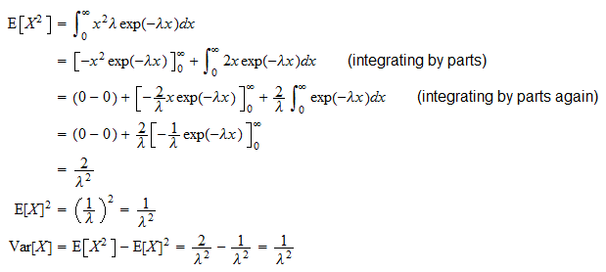
* Here, Lambda is the rate parameter, which is the frequency at which the events occur (basically the time b/w 2 events).
* It is memoryless, i.e.
* 
* Mean = 1/λ, Variance = 1/λ^2.
* In EXCEL, **EXPON.DIST(X, λ, cumulative)**

Application:

1. Suppose a computer goes on an automatic update every 40 weeks on average. After an update occurs, find the probability that it will take more than 50 weeks for the next update to arrive.

λ = 1/mu = 1/40 = 0.025

7. Plotting and fitting of Normal distribution and graphical representation of probabilities.

Introduction:

* The Normal distribution is used to model an event having a large number of identical & independently distributed Random variables added together; this distribution takes the form of a Bell curve (e^(-x^2)).
* It is represented by N(mean,variance), the standard Normal dist. is given by: N(0,1), where the mean is 0 & variance is 1.
* A diagram of a normal distribution with Ryugyong Hotel in the background

  Description automatically generated
* It is the most important distribution, with each natural & social process following it.
* It’s PDF is given by:
* A mathematical equation with numbers and symbols

  Description automatically generated
* Graphical representation involves plotting the probability density function (PDF) to show the bell-shaped curve of the distribution.
* Mean = μ , Variance = σ2
* In Excel, **NORM.DIST(X, μ, σ, cumulative)**.
* Mean = **AVERAGE(C1)**
* STD. dev = **STDDEV(C2)**

Application:

8. Calculation of cumulative distribution functions for Exponential and Normal distribution.

Introduction:

* The cumulative distribution function (CDF) gives the probability that a random variable takes on a value less than or equal to a given value.
* A math equation with black text

  Description automatically generated
* For exponential random var, it is given by: P(X ≤ x) = 1 - e^(-λx)
* For normal dist, it is given by:
* A math equations with numbers and symbols

  Description automatically generated
* In EXCEL, exponential dist CDF = **EXPON.DIST(X, λ, TRUE).**
* Normal, CDF = **NORM.DIST(X, μ, σ, TRUE).**
* **Normal:**
* **A graph with blue dots

  Description automatically generated**
* **Exponential:**
* **A graph with blue dots

  Description automatically generated**

1. Given data from two distributions. Calculate the distance between the 2 distributions.

Introduction:

* We’ll be using **Euclidean Distance** for the distance between 2 real valued vectors. It is calculated as the square root of the sum of the squares of the differences of the vectors’ components.
* A black background with white text and symbols

  Description automatically generated
* In Excel, function: **SQRT(SUMXMY2(array_x,array_y))**

|  |  |
| --- | --- |
| **Binomial** | **Poisson** |
| **X** | **Y** |
| 0.1 | 0.3 |
| 0.3 | 0.5 |
| 0.4 | 0.8 |
| 0.7 | 0.11 |
| 0.8 | 0.14 |
| 0.1 | 0.19 |
| 0.15 | 0.25 |
| 0.28 | 0.27 |
| 0.2 | 0.30 |
| 0.21 | 0.35 |

10. Applications problem based on Binomial distribution.



**Case Study:**

The phe-mycin Case: Drug side effects antibiotics occasionally cause nausea as a side effect and a major drug company has developed a new antibiotic called phemycin. The company claims that at most, 10% of all patients treated with phe-mycin would experience nausea as a side effect of taking the drug. Suppose that we randomly select n = 4 patients and treat them with phemycin. Each patient will either experience nausea(success) or will not experience nausea (Failure). We will assume that p, the true probability that a patient will experience nausea as a side effect is 0.10, the maximum value of p claimed by the drug company. Let x denote the number of patients among the four who will experience nausea as a side effect. It follows that c is a binomial random variable which can take on any of the potential values 0,1,2,3,4.

Suppose that when a sample *n = 4* randomly selected patients is treated with phe-mycin, three of the four will experience nausea *3/4 =0.75* which is far greater than 0.10, we have some evidence contradicting the assumption that p equals 0.10 x = 3 or x=4 are mutually exclusive:

**P(x >= 3) = P(x = 3) + P(x = 4) =0.0036 +0.0001 =0.0037**

For instance, the probability that none of the four randomly selected patients experience nausea is:

**P(0) = P(x = 0) =4!/0!(4-0)!*(0.10)(0.9)^4-0 =(0.9)^4=0.6561**

**P(X=3)=0.0036 says that 3 out of 4 would experience nausea.**

11. Applications problems based on Normal Distribution.

Case Study:

According to the website of the American Association for Justice, Stella Liebeck of Albuquerque, New Mexico, was severely burned by McDonald’s coffee in February 1992. Liebeck, who received third-degree burns over 6 percent of her body, was awarded $160,000 in compensatory damages and $480,000 in punitive damages. A post verdict investigation revealed that the coffee temperature at the local Albuquerque McDonald’s had dropped from about 185°F before the trial to about 158° after the trial.

This case concerns coffee temperatures at a fast-food restaurant. Because of the possibility of future litigation and to possibly improve the coffee’s taste, the restaurant wishes to study the temperature of the coffee it serves. To do this, the restaurant personnel measure the temperature of the coffee being dispensed (in degrees Fahrenheit) at a randomly selected time during each of the 24 half-hour periods from 8 A.M. to 7:30 P.M . on a given day. This is then repeated on a second day, giving the 48 coffee temperatures .

Make a time series plot of the coffee temperatures, and assuming process consistency, estimate limits between which most of the coffee temperatures at the restaurant would fall.

Answer:

One minus the probability would represent the proportion of coffee served by the restaurant that had the temperature outside the range **153 -167**

**It follows that the probability that x will be in between 153 and 167 is the area under the temperature normal curve between 153 and 167**

The area is 0.7223

**P(153<=x<=167)=5.7223**

**In conclusion, we estimate that 72.23% of the coffee served at the restaurant is within the range of temperature that is best and 27.77% of the coffee served is not in this range.**

**If management wishes a very high percentage of the coffee**

**Served to taste best,it must improve the coffee making process by better controlling temperature.**

1. Presentation of bivariate data through scatter-plot diagrams and calculations of covariance.

**Bivariate Analysis:**

The term Bivariate Analysis refers to the analysis of 2 variables. The objective of this is to understand the relationship between 2 variables. There are 3 common ways to perform this:

* Scatter Plots
* Correlation Coefficients
* Simple Linear Regression

Covariance in excel: **COVARIANCE.P(array_1,array_2)**, where arrays are the range of integer values.

Few things to remember about these arguments:

* If the array contains text or logical values, then they are ignored by the COVARIANCE function.
* The data set should have the same number of sample points (same size)
* The dataset should not be empty, nor should the std. dev of its values be equal to 0.
* A black text on a white background

  Description automatically generated
* n : sample size.
* Covariance is a measure to indicate the extent to which 2 random variables change together.
* The sign of covariance shows the linear relation b/w the variables.
* It is a measure of correlation.
* It is affected by change in scale.

**Dataset:**

Perform bivariate analysis in EXCEL using the following dataset, of 2 variables: X : hours spent studying. Y: exam score of 20 students.

In EXCEL, **CORREL(array1,array2) = 0.890 (strong +ve correlation)**

1. Calculation of Karl Pearson’s correlation coefficients.

Introduction:

* Correlation is a measure used to represent how strongly two random variables are related to each other.
* Correlation refers to the scaled form of covariance.
* Correlation can range from -1 to 1.
* Correlation measures both the strength and the direction of linear relationship between the 2 variables.
* It is not affected by changes in the scale.
* **Pearson’s Correlation Coeff.** is given by:
* A diagram of equations and numbers

  Description automatically generated with medium confidence
* A diagram of a graph

  Description automatically generated with medium confidence
* In EXCEL, **PEARSON(array1, array2)**
* A screenshot of a computer

  Description automatically generated
* A graph of a number of people

  Description automatically generated with medium confidence

1. To find the correlation coefficient for a bivariate frequency distribution.

Introduction:

* Bivariate Frequency Distribution: A series of data showing the frequency of 2 variables simultaneously is called bivariate frequency dist. In other words, the frequency distribution of 2 variables is called Bivariate, examples: sales and advertisements, weight & height of an individual, etc.
* Significant in business, reason:
  + Decision Making
  + Market segmentation
  + Risk assessment
  + Resource Allocation

Question:

Prepare frequency distribution for the following data.

Where, X: age in years (interval of 4) and y denotes the corresponding blood pressure.

1. Generating Random numbers from discrete (Bernoulli, Binomial, Poisson) distributions.

Introduction:

* Generating from Binomial:
* In excel, formula = **BINOM.INV(1, p, rand())**, will generate 1 or 0 with a chance of 1 being p.
* A screenshot of a table

  Description automatically generatedA screenshot of a computer

  Description automatically generated
* A white sheet with blue and green lines

  Description automatically generated

1. Generating Random numbers from continuous (Uniform, Normal) distributions.

Introduction:

* Generating from Normal:
* In excel, random numbers can be generated from a given Normal distribution, using the formula, **NORMINV(RAND(),B2,C2)**, where **B2** is the mean, and **C2** is the std. dev.
* Example: If the average weekly sales of an electronic company for laptops is $2000, which fluctuates about $500 up or down, use the random function to establish probability.
* Mean = 2000
* STD. dev = 500
* **NORMINV(RAND(),2000,500)**A screenshot of a cell phone

  Description automatically generatedA screenshot of a data

  Description automatically generated
* **A screenshot of a graph

  Description automatically generated**
* **A screenshot of a data

  Description automatically generated**

17. Find the entropy from the given dataset.

Introduction:

* The entropy of a random variable is the average level of information, uncertainty, surprise, randomness to a variable’s possible outcomes.
* Given a random variable X, which takes values in the alphabet X & distributed as per P : X -> [0,1], the entropy is defined as:

* Where the logarithm’s base can be 2 (shannons/bits), e (nat), or 10 (hartleys).
* An equivalent definition of entropy is the expected value of the self information of a variable.
* In case of 2 fair coin tosses, the information entropy exhibits **Base-2** logarithm of the no. of possible outcomes with 2 coins, these are the possible outcomes with 2 bits of entropy:
  + **HH, HT, TH, TT.**
* Generally, entropy is the average information covered by an event when considering all possible outcomes.
* Entropy, H(X) of a coin flip measured in bits.
* A graph with a blue line

  Description automatically generated
* For a fair coin, the entropy is 1 due to 2 possible outcomes.
* The result of a fair die, having 6 possible outcomes, has entropy calculated as log_base2(6 bits).
* A screenshot of a computer

  Description automatically generated
* Here, the first 3 rows are inputs. 4th row is the sum of (a1:a3)..., 5th row denotes log_base2(sum): calculated by **LOG(number, [base]).**
* **Finally,** the 7th row lists the individual entropies, and the last row is the sum of all the entropies.

Submitted to :- Dr. Aakash