CREATE VIEW MakerCountry AS

SELECT Maker.Maker_Name AS Maker_Name,

Country.Country_Name AS Country_Name

FROM Maker INNER JOIN Country ON Maker.Country_ID = Country.ID_Country

Select * from MakerCountry

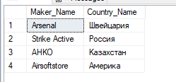

CREATE VIEW WarehouseMakerDelivery AS

SELECT Warehouse.Warehouse_Address AS Warehouse_Address,

Maker.Maker_Name AS Maker_Name,

Delivery.Delivery_Number AS Delivery_Number

FROM Delivery INNER JOIN Warehouse ON Delivery.Warehouse_ID = Warehouse.ID_Warehouse

inner join Maker on Delivery.Maker_ID = Maker.ID_Maker

Select * from WarehouseMakerDelivery

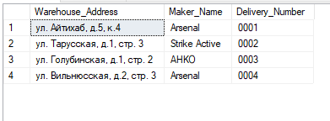

CREATE VIEW Sale_CheckClient_CardClient AS

SELECT Sale_Check.Sale_Check_Number AS Sale_Check_Number,

Client_Card.Card_Number AS Card_Number,

Client.First_Name_Client + ' ' + Client.Second_Name_Client + ' ' + Client.Middle_Name_Client AS FIO

FROM Client_Card INNER JOIN Client ON Client_Card.Client_ID = Client.ID_Client

inner join Sale_Check on Sale_Check.Client_Card_ID = Client_Card.ID_Client_Card

select * from Sale_CheckClient_CardClient

