**Welcome to ATM Java project below are the artifacts for the ATM_project.**

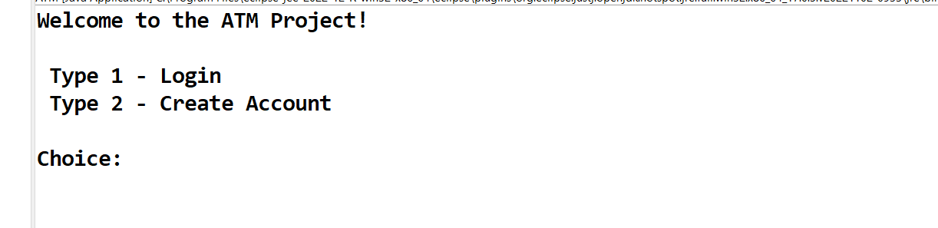

**Case1: Choice 1 for Login**

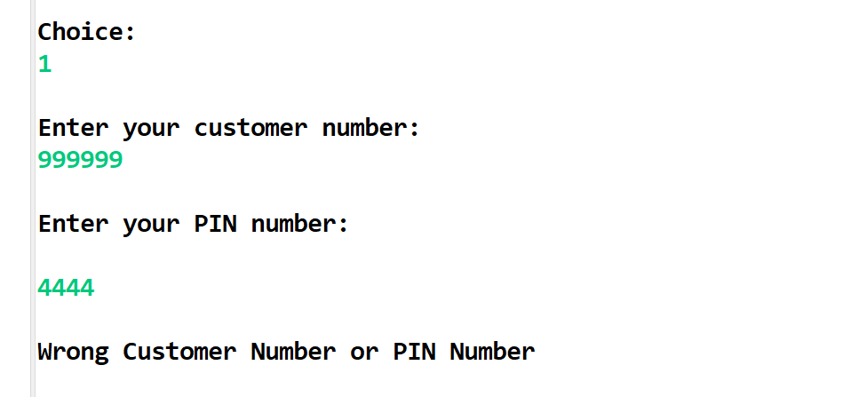

**Because you don’t have account that’s why it is showing wrong customer number or pin.**

**Case 2:Create Account**

**For creating account choose 2:**

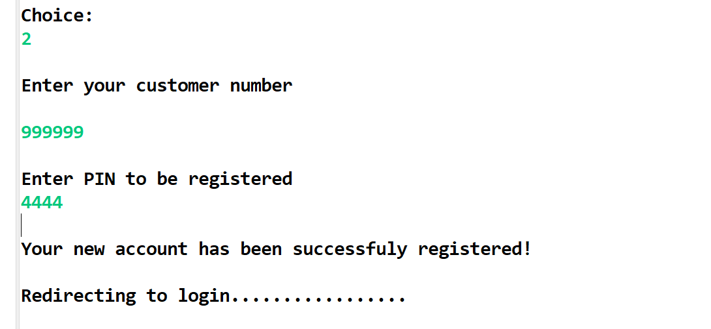

**Case 3: After creating your account Enter your customer number and PIN**

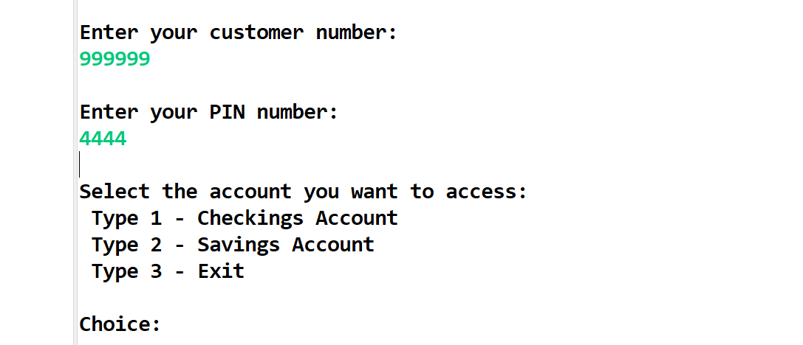

**Case 4: Select Checking account by Type Choice 1**

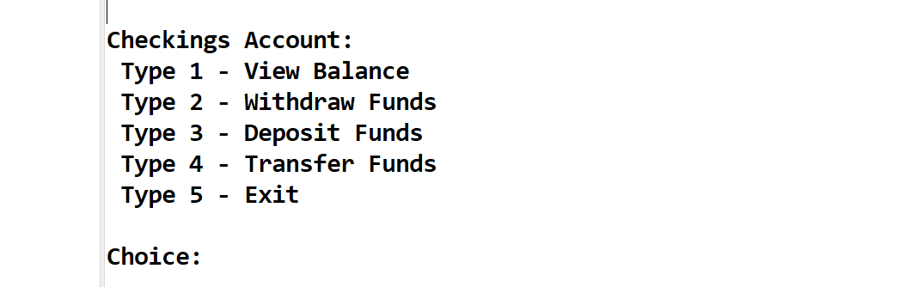

**Case 5: Type 1 for checking balance**

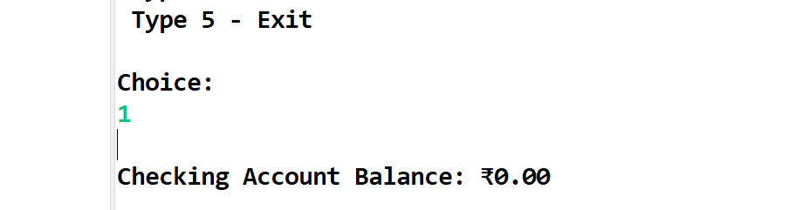

**Case 6:Type 3 for the Deposit Funds in your account**

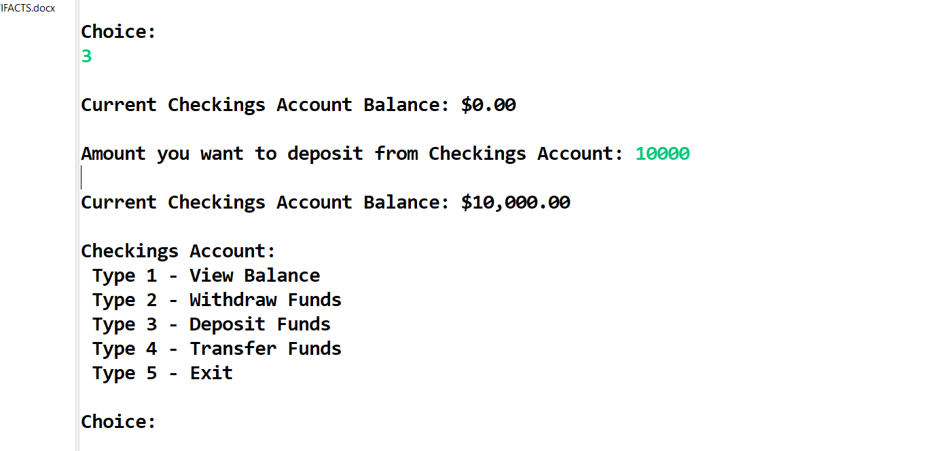

**Case 7: Type 2 for withdraw funds**

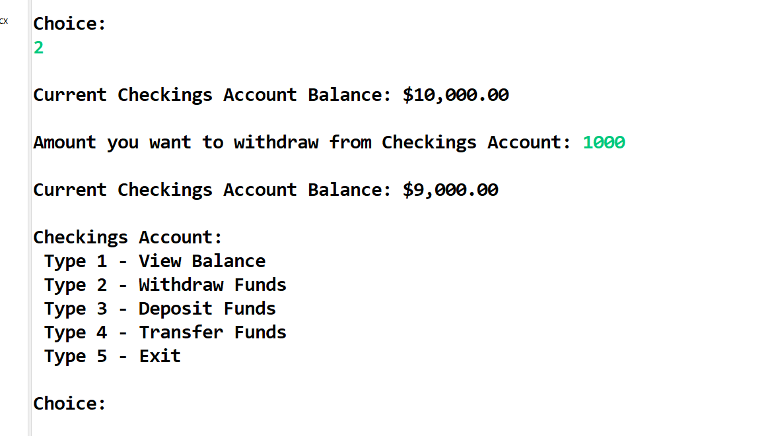

**Case 8:Type 4 for Transfer your funds**

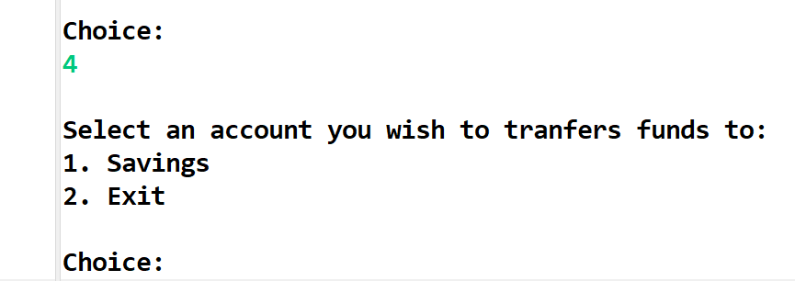

**Case 9: Type 1 for transfer your funds from saving account or type 2 for getting Exit**

**Case:10 Type 1 for transferring funds to saving account**

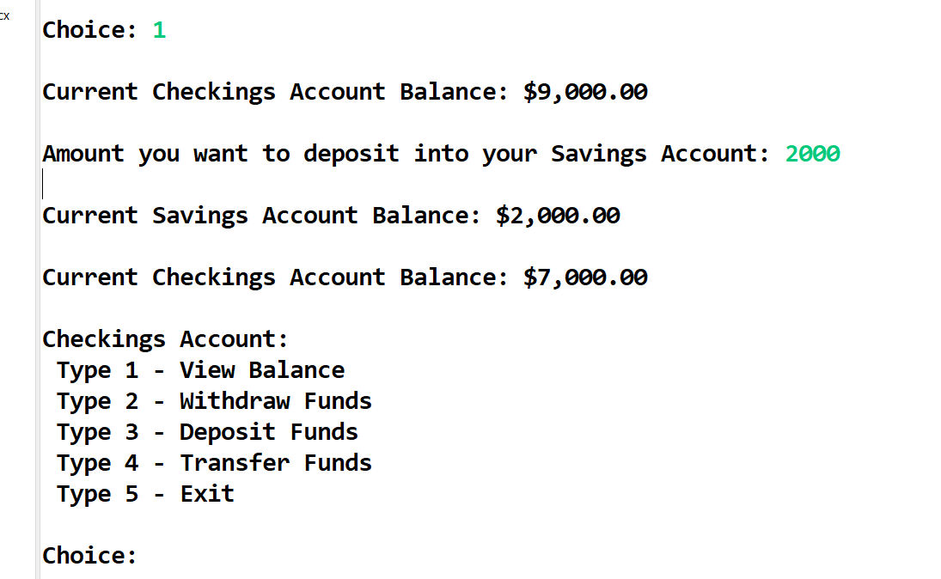

**Your funds has been transferred.**

**Case 11: Type 5 for getting exit.**

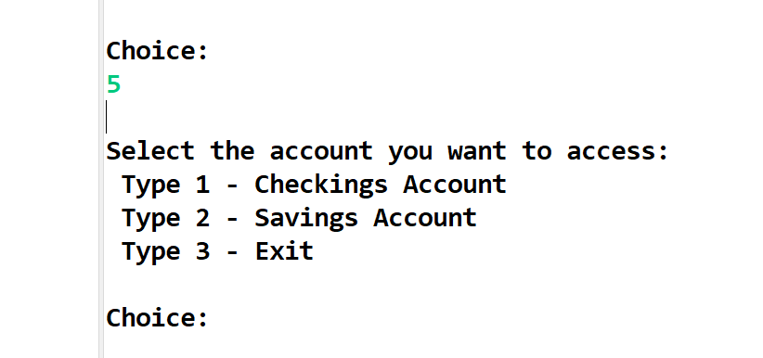

**Case 12: Now choose saving account by typing 2**

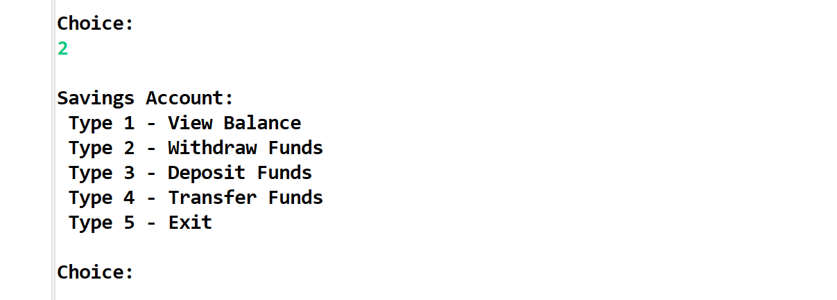

**Case 13:Type 1 for checking balance of your saving account**

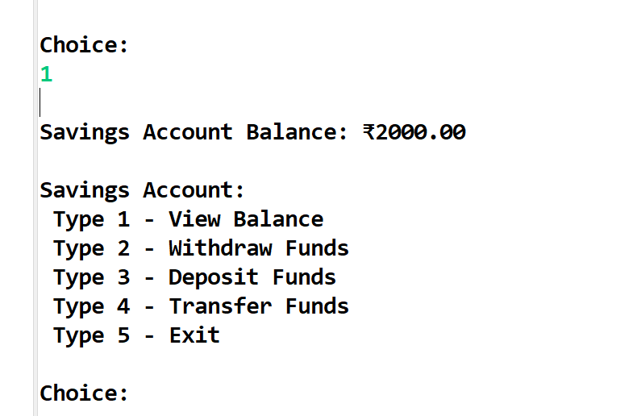

**Case 14: Type 2 for withdraw funds from your saving account**

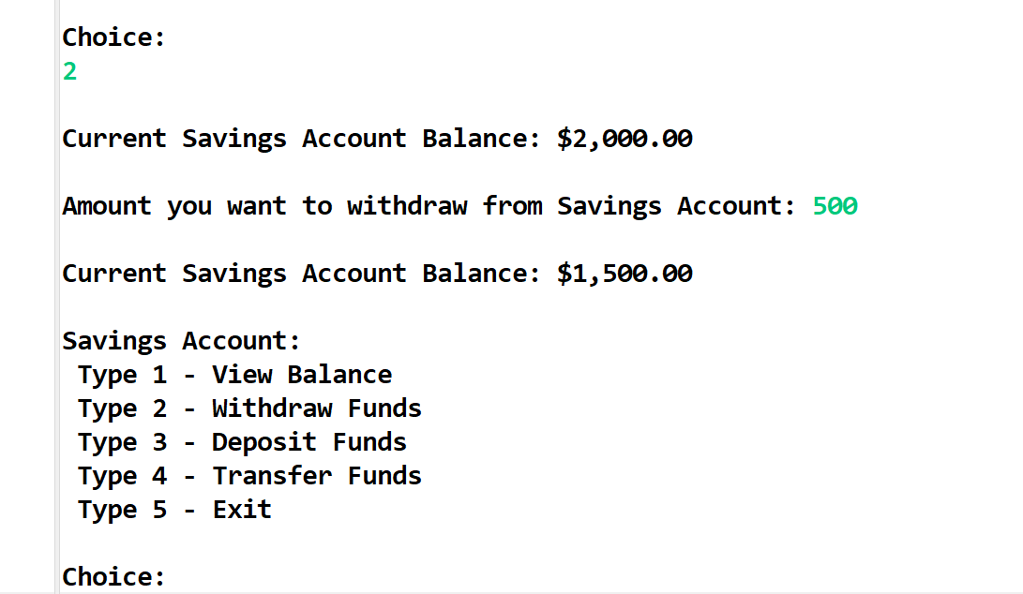

**Case 15: choose 3 for deposit funds in your account**

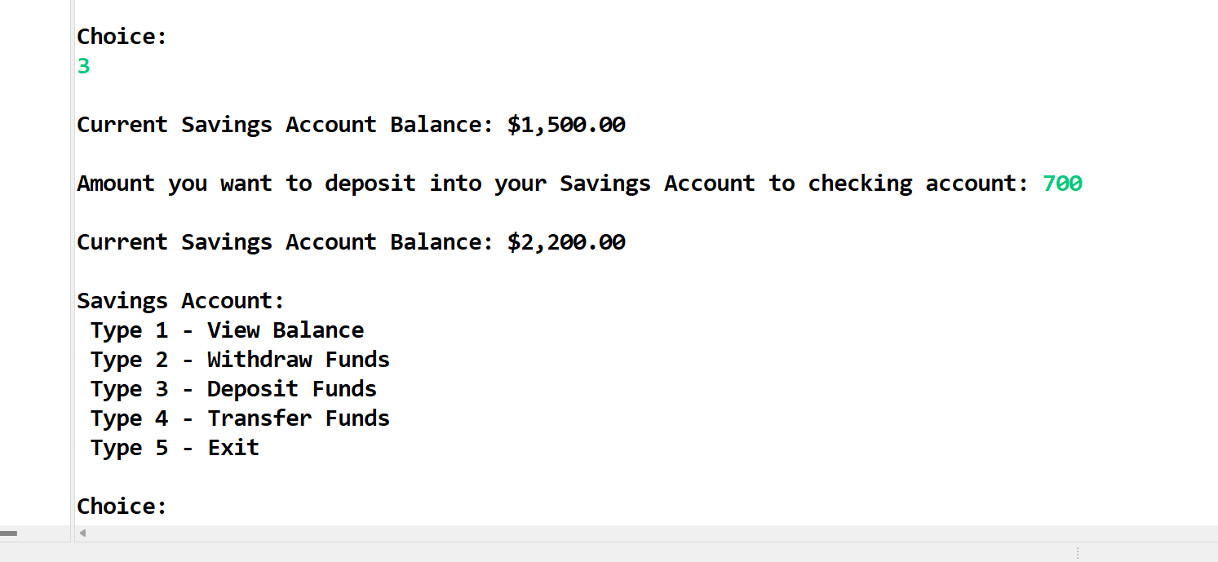

**Case 16: Choose 4 for Transfer your funds and then type 1 for transfer to checking account**

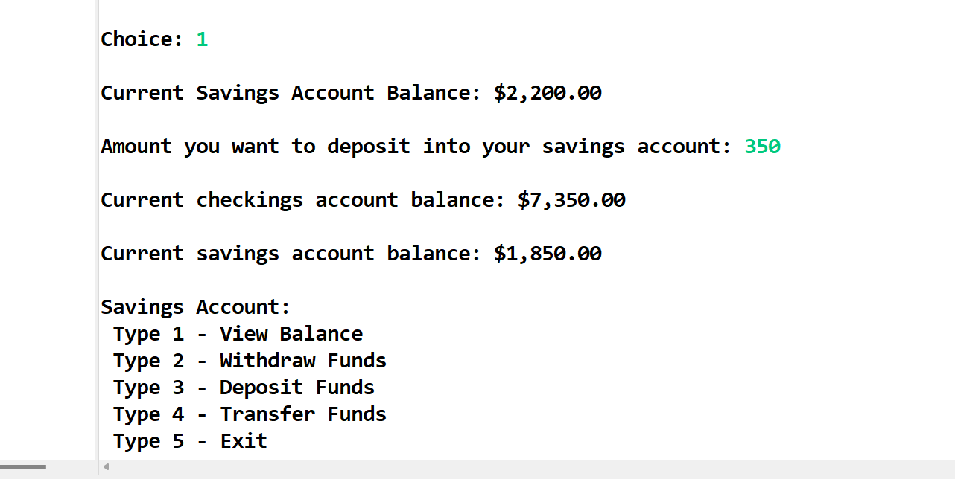

**Case 17: Choose 5 for and 3 for getting exit**

