A MINI PROJECT

ON

ONLINE MUSIC WEBSITE



Submitted By

Ms.kavuru Pravalli Mukulitha

Regd.Number:21B91A05F1

Mr.kavuru Vamsi Satya Hari Krishna

Regd.Number:21B91A05F2

Ms.Kilari Sirisha

Regd.Number:21B91A05F3

COMPUTER SCIENCE AND ENGINEERING

S. R. K. R ENGINEERING COLLEGE (A)

(Affiliated to JNTU, KAKINADA)

BHIMAVARAM-534204

(2022-2023)

COMPUTER SCIENCE AND ENGINEERING

S. R. K. R ENGINEERING COLLEGE

BHIMAVARAM

 CERTIFICATE

This is to certify that this is a bonafide work on “ONLINE MUSIC WEBSITE” for and has been submitted by Ms.Kavuri Pravalli Mukulitha(21B91A05F1) ,Mr.Kavuri Vamsi Satya Hari Krishna(21B91A05F2) and Ms.Kilari Sirisha(21B91A05F3)as a Web Application Development Using Full Stack laboratory report, in partial fulfilment of the requirements for theaward of the Degree of Bachelor of Technology in Computer Science and Engineering, during the academic year 2022-2023. The candidate worked right under my Supervision and guidance.

LECTURERS IN- CHARGE:

Dr.K ARUNA KUMARI

Miss.M JANAKI DEVI

Sri.S HARI KRISHNA HEAD OF THE DEPARTMENT:

Assistant professor Dr.V.CHANDRA SEKHAR

Department of CSE Department of CSE

S.R.K.R Engineering College S.R.K.R.Engineering college

Bhimavaram Bhimavaram.

ACKNOWLEDGEMENT

I take immense pleasure in thanking Dr. M. Jagapathi Raju, beloved principal of S.R.K.R Engineering College, Bhimavaram, and Dr. V. Chandra Shekar, esteemed Head of the Department (C.S.E), for having permitted me to carry out this Web Application Development Using Full Stack mini project work.

I wish to express my deep sense of gratitude especially to my project Guide, Dr.K Aruna Kumari Assistant Professor, Miss.M Janaki Devi, Assistant Professor, Sri S Hari Krishna, Assistant Professor, for their guidance and useful suggestions, which helped me in completing the project work, on time.

Finally, yet importantly, I would like to express my heartful thanks to my beloved parents, faculty, my friends/classmates for their help, and my wishes for the successful completion of this project. Ms.Kavuri Pravalli Mukulitha (20B91A05F1),Mr.kavuri Vamsi Satya Hari Krishna(21B91A05F2) and Ms.Kilari Sirisha(21B91A05F3).

Ms.Kavuri Pravalli Mukulitha

(21B91A05F1)

Mr.kavuri Vamsi Satya Hari Krishna

(21B91A05F2)

Ms.Kilari Sirisha

(21B91A05F3).

TABLE OF CONTENTS

S. No CONTENTS PAGE. No

1. ABSTRACT 5

2. MODULES 5

3. SOFTWARE REQUIREMENTS 5

4. HARDWARE REQUIREMENTS 5

5. TECHNICAL STACK 5

6. SAMPLE CODE 6-11

7. SCREENSHOTS

**TECHNICAL STACK**

**HTML**

Hypertext Markup Language (HTML) is the set of markup symbols or codes inserted into a file intended for display on the Internet. The markup tells web browsers how to display a web page's words and images. Each individual piece markup code (which would fall between "<" and ">" characters) is referred to as an element, though many people also refer to it as a tag. Some elements come in pairs that indicate when some display effect is to begin and when it is to end.

# CSS

# CSS stands for Cascading Style Sheets. It is a style sheet language which is used to describe the look and formatting of a document written in markup language. It provides an additional feature to HTML. It is generally used with HTML to change the style of web pages and user interfaces. It can also be used with any kind of XML documents including plain XML, SVG and XUL. CSS is used along with HTML and JavaScript in most websites to create user interfaces for web applications and user interfaces for many mobile applications.

# JAVA SCRIPT

# JavaScript is a dynamic computer programming language. It is lightweight and most commonly used as a part of web pages, whose implementations allow clientside script to interact with the user and make dynamic pages. It is an interpreted programming language with object-oriented capabilities. JavaScript was first known as LiveScript, but Netscape changed its name to JavaScript, possibly because of the excitement being generated by Java. JavaScript made its first appearance in Netscape 2.0 in 1995 with the name LiveScript. The generalpurpose core of the language has been embedded in Netscape, Internet Explorer, and other web browsers.

SAMPLE CODE

1)Jok.css(login1.css):

img

{

width: 200px; ;

height: 50px;

position: relative;

left: 575px;

top:50px;

}

input

{

width: 268px;

height: 38px;

position:relative;

left: 550px;

right: auto;

top: auto;

bottom: auto;

}

button.a

{

color: black;

font-style: bold;

width:auto ;

height: 38px;

position:relative;

left: 500px;

right: auto;

top: auto;

bottom: auto;

}

button.b

{

height: 38px;

width: 268px;

background-color:#0095F6 ;

color: white;

position: relative;

left: 550px;

right: auto;

top: auto;

bottom: auto;

border-color: #0095F6;

border-radius: 5px;

}

section.a

{

background-color: white;

border: 1px solid black;

width: 350px;

height: 320px;

position: relative;

left: 570px;

top: 50px;

right: auto;

bottom: auto;

}

section.c{

background-color: white;

border: 1px solid black;

width: 350px;

height: 50px;

position: relative;

bottom: 250px;

left: 570px;

right: auto;

top: auto;

}

p

{

padding-left: 75px;

}

p.a

{

position: relative;

bottom: 257px;

left: 665px;

right: auto;

top: auto;

color: white;

}

section.d

{

position:relative;

bottom: 300px;

right: auto;

left: 60px;;

top: auto;

align-self: center;

}

body

{

background-image:url("https://imgur.com/gqJy08u.png");

background-size:cover;

background-repeat: no-repeat;

position: fixed;

width: 100%;

height: 100vh;

}

a

{

color: #0095F6;

}

|  |  |
| --- | --- |
|  | |
| 2)Login.html:   |  | | --- | |  | | |  | | --- | | <html> | |  | <head> | |  | <title>Login</title> | |  | <link rel="stylesheet" href="jok.css"> | |  | <meta id="viewport" name="viewport" content="width=device-width, initial-scale=1, minimum-scale=1, maximum-scale=2, viewport-fit=cover"> | |  | </head> | |  | <body> | |  | <div> | |  | <section class="a"></section> | |  |  | |  | <section class="d"> | |  | <img src="bg8.png"><br><br><br><br><br><br><br> | |  | <input type="text" placeholder="Email"><br><br> | |  | <input type="password" placeholder="password"> | |  | <button class="a">show</button><br><br> | |  | <button onclick="window.location.href='Swaras.html'" class="b">Log in</button> | |  | </section> | |  |  | |  | <p class="a">or</p> | |  | <section class="c"> | |  | <p>Did'nt have account?&ensp;<a href="signup1.html" >register now</a></p> | |  | </section> | |  | </div> | |  | </body> | |  | </html>  3)Jokki.css(signup page)  img  {  width: 200px; ;  height: 50px;  position: relative;  left: 575px;  top:-150px;  }  input  {  width: 268px;  height: 38px;  position:relative;  left: 550px;  right: auto;  top: auto;  bottom: 100px;  }  button.a  {  color: black;  font-style: bold;  width:auto ;  height: 38px;  position:relative;  left: 500px;  right: auto;  top: auto;  bottom: auto;  }  button.b  {  height: 38px;  width: 268px;  background-color:#0095F6 ;  color: white;  position: relative;  left: 550px;  right: auto;  top: auto;  bottom: 100px;  border-color: #0095F6;  border-radius: 5px;  }  section.a  {  background-color: white;  border: 1px solid black;  width: 350px;  height: 550px;  position: relative;  left: 570px;  top: 50px;  right: auto;  bottom: auto;    }  section.c{  background-color: white;  border: 1px solid black;  width: 350px;  height: 50px;  position: relative;  bottom: 250px;  left: 570px;  right: auto;  top: auto;    }  p  {  padding-left: 75px;  }  p.a  {  position: relative;  bottom: 257px;  left: 665px;  right: auto;  top: auto;  color: white;    }  section.d  {  position:relative;  bottom: 300px;  right: auto;  left: 60px;  top: auto;    }  body  {  background-image: url("https://imgur.com/gqJy08u.png");  background-size: cover;  background-repeat: no-repeat;  position: fixed;  width: 100%;  height: 100vh;  }  a  {  color: #0095F6;  }  label  {  color: red;  }  4)Signup.html:   |  | | --- | |  | | <html> | <head> | |  | <title>Sign Up</title> | |  | <link rel="stylesheet" href="jokki.css"> | |  |  | |  | </head> | |  | <body> | |  | <div> | |  | <section class="a"></section> | |  |  | |  | <section class="d"> | |  | <img src="bg8.png"><br> | |  | <input type="text" placeholder="First Name"><br><br> | |  | <input type="text" placeholder="Last Name"><br><br> | |  | <input type="text" placeholder="Email"><br><br> | |  | <input type="password" placeholder="password"><br><br> | |  | <input type="password" placeholder="re-enter password"> | |  | <br><br> | |  | <button onclick="window.location.href='login1.html'" class="b">Sign Up</button> | |  | </section> | |  | </div> | |  | </body> | |  | </html> | | |  | |  |  | |  |  | |  |  | |  |  | |  |  | |  |  | |  |  | |  |  | |  |  | |  |  | |  |  | |  |  | |  |  | |  |  | |  |  | |  |  | |  |  | |  |  | |  |  | |  |  | |  |  | |  |  | |  |  | |  | |
|  |  | |
|  |  | |
|  |  | |
|  |  | |
|  |  | |
|  |  | |
|  |  | |
|  |  | |
|  |  | |
|  |  | |
|  |  | |
|  |  | |
|  |  | |
|  |  | |
|  |  | |
|  |  | |
|  |  | |
|  |  | |
|  |  | |
|  |  | |
|  |  | |
|  |  | |

|  |  |
| --- | --- |
|  |  |

Swaras.html:

<html>

<head>

<meta charset="UTF-8">

<meta http-equiv="X-UA-Compatible" content="IE=edge">

<meta name="viewport" content="width=device-width, initial-scale=1.0">

<style>

body{

background-image:url('bg7.png');

background-repeat:no repeat-y;

background-size:cover;

}

#rcorners {

border-radius: 25px;

border: 2px solid lightgrey;

padding: 20px;

width: 200px;

height: 150px;

}

span.ex1:hover,span.ex1:active {font-size: 105%;}

a{

text-decoration: none;

}

</style> <body><br><br><br><br><br><br><br><br><br><br><br><br><br><br><br><br><br><br><br><br><br>

<h1 align="center">&ensp;&ensp;&ensp; <a href="swaras_main.html"><span id="rcorners" class="ex1" style=" color: #d9d9d9;;font-family:'Trebuchet MS', 'Lucida Sans Unicode', 'Lucida Grande', 'Lucida Sans', Arial, sans-serif">Get Started</span></a></h1>

</body>

</html>

Swaras_main.css:

|  |  |
| --- | --- |
|  | <!DOCTYPE html> |
|  | <head> |
|  | <title>Main page</title> |
|  | <link rel="stylesheet" href="swaras_main.css"> |
|  | </head> |
|  | <body> |
|  | <div class="topnav"><img class="title" src="<https://imgur.com/RAXYYEQ.png>"><span>HOME</span>&ensp;&ensp;&ensp;<span>CONTACT US</span><form action="https://www.google.com/search" method="get"><input type="text" placeholder="search" name="q"><button type="submit"><img src="<https://imgur.com/6iZd3D7.png>"class="img" ></button> </form></div> |
|  | <br> |
|  | <br> |
|  | <br> |
|  | <div class="flex-container"> |
|  | <div><a href="<https://open.spotify.com/artist/4zCH9qm4R2DADamUHMCa6O?si=cvYifvEKQQekNGkreQJUYQ>"><img src="<https://imgur.com/HMn8o1i.png>" width="250" height="219.4"></a></div> |
|  | <div><a href="<https://open.spotify.com/playlist/37i9dQZF1EIWA5Ogme7zvt?si=tDw2D8AsRzuyBO2j6FZmyw>"><img src="<https://imgur.com/wkMVU04.png>" width="250" height="219.4"></a></div> |
|  | <div><a href="<https://open.spotify.com/artist/4YRxDV8wJFPHPTeXepOstw?si=Lz0J7pwSSWeqzWUj9tz-TQ>"><img src="<https://imgur.com/Gd8rOUc.png>" width="250" height="219.4"></a></div> |
|  | <div><a href="<https://open.spotify.com/artist/4IKVDbCSBTxBeAsMKjAuTs?si=71rLazcuSQKyL-Zvhnx4hA>"><img src="<https://imgur.com/WKgsYDL.png>" width="250" height="219.4"></a></div> |
|  | </div> |
|  | <table> |
|  | <tr> |
|  | <td style="padding-left:145px"><a href="<https://www.google.com/url?sa=t&source=web&rct=j&url=https://en.m.wikipedia.org/wiki/Anirudh_(composer)&ved=2ahUKEwif-JOCiaP8AhUkTmwGHcigAvUQFnoECDkQAQ&usg=AOvVaw188MfKXxT98ZpLQ0iuR1Bv>">ANIRUDH</a></td> |
|  | <td style="padding-left:250px"><a href="<https://www.google.com/url?sa=t&source=web&rct=j&url=https://en.m.wikipedia.org/wiki/Anurag_Kulkarni&ved=2ahUKEwjwxoKqiaP8AhWkSWwGHYPNB_UQFnoECDUQAQ&usg=AOvVaw2eAEXQI88EQGzivMnEDhkd>">ANURAG</a></td> |
|  | <td style="padding-left:300px"><a href="<https://www.google.com/url?sa=t&source=web&rct=j&url=https://translate.google.com/translate%3Fu%3Dhttps://en.wikipedia.org/wiki/Arijit_Singh%26hl%3Dhi%26sl%3Den%26tl%3Dhi%26client%3Dsrp%26prev%3Dsearch&ved=2ahUKEwji8NeOiaP8AhWIXWwGHWMUCPUQFnoECGQQAQ&usg=AOvVaw0EkvRKCOySr6DB52bUJ2Qb>">ARJITH</a></td> |
|  | <td style="padding-left:300px"><a href="<https://www.google.com/search?client=ms-android-oppo&sxsrf=ALiCzsZKftdlm9Jvsv8nalP1IsNxJprHzw:1672501619360&q=armaan+malik+dil+mein+ho+tum&stick=H4sIAAAAAAAAAONgFuLSz9U3MCorNypLVuLVT9c3NEy3zLUoyKiq0hL0LS3OTHYsKsksLgnJD87PS1_EKpNYlJuYmKeQm5iTma2QkpmjkJuamaeQka9QUpoLAMRsggNPAAAA&sa=X&ved=2ahUKEwiix6GHmqT8AhWW-TgGHYN5CLYQri56BAgQEAs&biw=360&bih=716&dpr=2>">ARMAAN</a></td> |
|  | </tr> |
|  | </table> |
|  | <div class="flex-container"> |
|  | <div><a href="<https://open.spotify.com/artist/5UJ2sHO2ELrgW6aXeRLTQQ?si=enc4_jV0R4mUzv9LVKD5CA>"><img src="<https://imgur.com/T9qd20g.png>" width="250" height="219.4"></a></div> |
|  | <div><a href="<https://open.spotify.com/artist/7qjJw7ZM2ekDSahLXPjIlN?si=b7gmWlGmQHWBe3P3Pd2vbQ>"><img src="<https://imgur.com/bp4VP42.png>" width="250" height="219.4"></a></div> |
|  | <div><a href="<https://open.spotify.com/artist/5sSzCxHtgL82pYDvx2QyEU?si=wDQRE6FaSZWPuGKdpCyzdw>"><img src="<https://imgur.com/GkcNyOL.png>" width="250" height="219.4"></a></div> |
|  | <div><a href="<https://open.spotify.com/artist/1QvyquqkuuwUzdszyoKIy4?si=ZLhNYASoRUakLsKRJsQLUQ>"><img src="<https://imgur.com/D5REs1C.png>" width="250" height="219.4"></a></div> |
|  | </div> |
|  | <table> |
|  | <tr> |
|  | <td style="padding-left:145px"><a href="<https://www.google.com/url?sa=t&source=web&rct=j&url=https://en.m.wikipedia.org/wiki/Chinmayi&ved=2ahUKEwjQu8vzmaT8AhVl7jgGHVoWCGUQFnoECDUQAQ&usg=AOvVaw2LFmjmNqbu75ipqK3JId96>">CHINMAYI</a></td> |
|  | <td style="padding-left:250px"><a href="<https://www.google.com/url?sa=t&source=web&rct=j&url=https://en.m.wikipedia.org/wiki/Sid_Sriram&ved=2ahUKEwjr8NL2iKP8AhW1XmwGHfWxBvUQFnoECDwQAQ&usg=AOvVaw1HWVmg-eHnXltmLOVLafwg>">SID SRIRAM</a></td> |
|  | <td style="padding-left:300px"><a href="<https://www.google.com/url?sa=t&source=web&rct=j&url=https://en.m.wikipedia.org/wiki/Devi_Sri_Prasad&ved=2ahUKEwiHp4y6iaP8AhVZTWwGHRTuBvUQFnoECDwQAQ&usg=AOvVaw195BRFwEoxkjfiLU6QOqet>">DSP</a></td> |
|  | <td style="padding-left:300px"><a href="<https://www.google.com/url?sa=t&source=web&rct=j&url=https://en.m.wikipedia.org/wiki/Haricharan&ved=2ahUKEwi-kpyciKP8AhV3TWwGHboRDfUQFnoECCgQAQ&usg=AOvVaw2MTcL-sm97meul0p6h4Ndn>">HARI CHARAN</a></td> |
|  | </tr> |
|  | </table> |
|  | <div class="flex-container"> |
|  | <div><a href="<https://open.spotify.com/artist/0LSPREIgGMZXCuKVel7LVD?si=CMnTgzLrSxiMOAOc-TKFjg>"><img src="<https://imgur.com/2PXlQEm.png>" width="250" height="219.4"></a></div> |
|  | <div><a href="<https://open.spotify.com/artist/2IUtwMti1OiT3lkW6RubgH?si=SnNAFQmgRZ2aXPv6OUXFdw>"><img src="<https://imgur.com/DbHFmyA.png>" width="250" height="219.4"></a></div> |
|  | <div><a href="<https://open.spotify.com/artist/5f4QpKfy7ptCHwTqspnSJI?si=KMtbnyaNS8WJ_rMugXT4vQ>"><img src="<https://imgur.com/9SPXNuR.png>" width="250" height="219.4"></a></div> |
|  | <div><a href="<https://open.spotify.com/artist/4svvMm4TQnkphZJfhLCzzv?si=83NDr7biRtuW-t_dLZqdkw>"><img src="<https://imgur.com/jxf9rIo.png>" width="250" height="219.4"></a></div> |
|  | </div> |
|  | <table> |
|  | <tr> |
|  | <td style="padding-left:145px"><a href="<https://www.google.com/url?sa=t&source=web&rct=j&url=https://en.m.wikipedia.org/wiki/Karthik_(singer)&ved=2ahUKEwix5JHJi6P8AhXU9zgGHZ8rCBcQFnoECCsQAQ&usg=AOvVaw3OSwjHdypDT9eY1tfRVeBK>">KARTHIK</a></td> |
|  | <td style="padding-left:250px"><a href="<https://www.google.com/url?sa=t&source=web&rct=j&url=https://en.m.wikipedia.org/wiki/K._S._Chithra&ved=2ahUKEwjkps-diaP8AhXmTWwGHXmTA_UQFnoECDUQAQ&usg=AOvVaw2SuzaW53EqFKWcrQtluCr->">KS CHITRA</a></td> |
|  | <td style="padding-left:300px"><a href="<https://www.google.com/url?sa=t&source=web&rct=j&url=https://en.m.wikipedia.org/wiki/Neha_Kakkar&ved=2ahUKEwi1y_Ooi6P8AhW4R2wGHeyQDfMQFnoECGsQAQ&usg=AOvVaw3B0KA3-M_KL9n-gZ_Q4F3e>">NEHA</a></td> |
|  | <td style="padding-left:300px"><a href="<https://www.google.com/url?sa=t&source=web&rct=j&url=https://en.m.wikipedia.org/wiki/Ramya_Behara&ved=2ahUKEwjwr62IiqP8AhUxSmwGHdPSDfMQFnoECDQQAQ&usg=AOvVaw2EHmyuxZZUPZfkXwDiIuwZ>">RAMYA</a></td> |
|  | </tr> |
|  | </table> |
|  | <div class="flex-container"> |
|  | <div><a href="<https://open.spotify.com/artist/2ae6PxICSOZHvjqiCcgon8?si=-ezP2GlDTueMO8hXylSEKw>"><img src="<https://imgur.com/e3xDMSs.png>" width="250" height="219.4"></a></div> |
|  | <div><a href="<https://open.spotify.com/artist/0w1zspBrCXnMx8CcB1WR31?si=LkLv5m-aRDqKcI5vn_oWNA>"><img src="<https://imgur.com/QzZmEGx.png>" width="250" height="219.4"></a></div> |
|  | <div><a href="<https://open.spotify.com/artist/72AhOfYH44654ISqbuwdEZ?si=ohk7ziWMRx60Jl__FxJW4g>"><img src="<https://imgur.com/TnKLECz.png>" width="250" height="219.4"></a></div> |
|  | <div><a href="<https://open.spotify.com/artist/1rdQOMFFtoskDXXUVjiGo9?si=4cjLws6NRTuorwslomK7Og>"><img src="<https://imgur.com/ZYphDy0.png>" width="250" height="219.4"></a></div> |
|  | </div> |
|  | <table> |
|  | <tr> |
|  | <td style="padding-left:145px"><a href="<https://www.google.com/url?sa=t&source=web&rct=j&url=https://en.m.wikipedia.org/wiki/S._P._Balasubrahmanyam&ved=2ahUKEwjK3KG3i6P8AhUvUGwGHZTzCvUQFnoECDgQAQ&usg=AOvVaw3OnlGFFOFxG31hpwllWjG8>">SP BALU</a></td> |
|  | <td style="padding-left:250px"><a href="<https://www.google.com/url?sa=t&source=web&rct=j&url=https://en.m.wikipedia.org/wiki/S._P._Sailaja&ved=2ahUKEwivo7jIh6P8AhUWTGwGHcVzBvUQFnoECBQQAQ&usg=AOvVaw2cEn2cbmrAoM8KvTMmwuWl>">SP SAILAJA</a></td> |
|  | <td style="padding-left:300px"><a href="<https://www.google.com/url?sa=t&source=web&rct=j&url=https://en.m.wikipedia.org/wiki/Sunitha_(Telugu_singer)&ved=2ahUKEwjYiYe7iKP8AhUlT2wGHdxdC_UQFnoECDQQAQ&usg=AOvVaw0sxYp2VODeaJM8H5Vk1-p1>">SUNEETHA</a></td> |
|  | <td style="padding-left:250px"><a href="<https://www.google.com/url?sa=t&source=web&rct=j&url=https://en.m.wikipedia.org/wiki/Shweta_Mohan&ved=2ahUKEwj40NGOiKP8AhXvW2wGHSMFBPMQFnoECDcQAQ&usg=AOvVaw1cnUEdNlbj0eaPjM0SWAsY>">SWETHA</a></td> |
|  | </tr> |
|  | </table> |
|  | <div class="flex-container"> |
|  | <div><a href="<https://open.spotify.com/artist/1mYsTxnqsietFxj1OgoGbG?si=0ZNWSO5tRb6nLe8t-2Z4YA>"><img src="<https://imgur.com/R1SJDqY.png>" width="250" height="219.4"></a></div> |
|  | <div><a href="<https://open.spotify.com/artist/6AiX12wXdXFoGJ2vk8zBjy?si=SoGEhC-rTtmKIgogYLoPTQ>"><img src="<https://imgur.com/tLcBuxb.png>" width="250" height="219.4"></a></div> |
|  | <div><a href="<https://open.spotify.com/artist/0oOet2f43PA68X5RxKobEy?si=G4E4swHASeOsMxTbglUjJQ>"><img src="<https://imgur.com/P3I6YLm.png>" width="250" height="219.4"></a></div> |
|  | <div><a href="<https://open.spotify.com/artist/00sCATpEvwH48ays7PlQFU?si=OUJnO-g2TMaTu3lvdTfybQ>"><img src="<https://imgur.com/wpmRQVa.png>" width="250" height="219.4"></a></div> |
|  | </div> |
|  | <table> |
|  | <tr> |
|  | <td style="padding-left:145px"><a href="<https://www.google.com/url?sa=t&source=web&rct=j&url=https://en.m.wikipedia.org/wiki/A._R._Rahman&ved=2ahUKEwjEx57LiKP8AhUPTWwGHQoiAfUQFnoECDYQAQ&usg=AOvVaw1PPwnQI3EVInegV2wY05cN>">AR REHMAN</a></td> |
|  | <td style="padding-left:250px"><a href="<https://www.google.com/url?sa=t&source=web&rct=j&url=https://en.m.wikipedia.org/wiki/Yuvan_Shankar_Raja&ved=2ahUKEwigxtStiKP8AhWwS2wGHZlvAfMQFnoECBIQAQ&usg=AOvVaw2GW3hwpgq35OSEz4iDY-JY>">YUVAN</a></td> |
|  | <td style="padding-left:300px"><a href="<https://www.google.com/url?sa=t&source=web&rct=j&url=https://en.m.wikipedia.org/wiki/Shreya_Ghoshal&ved=2ahUKEwjlk87niKP8AhUbTGwGHR9WAfUQFnoECDwQAQ&usg=AOvVaw2vm7YDAvG25R5X93hz3jMb>">SHREYA</a></td> |
|  | <td style="padding-left:300px"><a href="<https://www.google.com/url?sa=t&source=web&rct=j&url=https://en.m.wikipedia.org/wiki/Jonita_Gandhi&ved=2ahUKEwiqtsTdiKP8AhUyU2wGHboIBfUQFnoECCgQAQ&usg=AOvVaw04lOW15bG9P0x-YImeG1tL>">JONITA</a></td> |
|  | </tr> |
|  | </table>  </body> |

|  |  |
| --- | --- |
|  |  |

Swaras_main.html:

|  |
| --- |
| <!DOCTYPE html> |
|  | <head> |
|  | <title>Main page</title> |
|  | <link rel="stylesheet" href="swaras_main.css"> |
|  | </head> |
|  | <body> |
|  | <div class="topnav"><img class="title" src="<https://imgur.com/RAXYYEQ.png>"><span>HOME</span>&ensp;&ensp;&ensp;<span>CONTACT US</span><form action="https://www.google.com/search" method="get"><input type="text" placeholder="search" name="q"><button type="submit"><img src="<https://imgur.com/6iZd3D7.png>"class="img" ></button> </form></div> |
|  | <br> |
|  | <br> |
|  | <br> |
|  | <div class="flex-container"> |
|  | <div><a href="<https://open.spotify.com/artist/4zCH9qm4R2DADamUHMCa6O?si=cvYifvEKQQekNGkreQJUYQ>"><img src="<https://imgur.com/HMn8o1i.png>" width="250" height="219.4"></a></div> |
|  | <div><a href="<https://open.spotify.com/playlist/37i9dQZF1EIWA5Ogme7zvt?si=tDw2D8AsRzuyBO2j6FZmyw>"><img src="<https://imgur.com/wkMVU04.png>" width="250" height="219.4"></a></div> |
|  | <div><a href="<https://open.spotify.com/artist/4YRxDV8wJFPHPTeXepOstw?si=Lz0J7pwSSWeqzWUj9tz-TQ>"><img src="<https://imgur.com/Gd8rOUc.png>" width="250" height="219.4"></a></div> |
|  | <div><a href="<https://open.spotify.com/artist/4IKVDbCSBTxBeAsMKjAuTs?si=71rLazcuSQKyL-Zvhnx4hA>"><img src="<https://imgur.com/WKgsYDL.png>" width="250" height="219.4"></a></div> |
|  | </div> |
|  | <table> |
|  | <tr> |
|  | <td style="padding-left:145px"><a href="<https://www.google.com/url?sa=t&source=web&rct=j&url=https://en.m.wikipedia.org/wiki/Anirudh_(composer)&ved=2ahUKEwif-JOCiaP8AhUkTmwGHcigAvUQFnoECDkQAQ&usg=AOvVaw188MfKXxT98ZpLQ0iuR1Bv>">ANIRUDH</a></td> |
|  | <td style="padding-left:250px"><a href="<https://www.google.com/url?sa=t&source=web&rct=j&url=https://en.m.wikipedia.org/wiki/Anurag_Kulkarni&ved=2ahUKEwjwxoKqiaP8AhWkSWwGHYPNB_UQFnoECDUQAQ&usg=AOvVaw2eAEXQI88EQGzivMnEDhkd>">ANURAG</a></td> |
|  | <td style="padding-left:300px"><a href="<https://www.google.com/url?sa=t&source=web&rct=j&url=https://translate.google.com/translate%3Fu%3Dhttps://en.wikipedia.org/wiki/Arijit_Singh%26hl%3Dhi%26sl%3Den%26tl%3Dhi%26client%3Dsrp%26prev%3Dsearch&ved=2ahUKEwji8NeOiaP8AhWIXWwGHWMUCPUQFnoECGQQAQ&usg=AOvVaw0EkvRKCOySr6DB52bUJ2Qb>">ARJITH</a></td> |
|  | <td style="padding-left:300px"><a href="<https://www.google.com/search?client=ms-android-oppo&sxsrf=ALiCzsZKftdlm9Jvsv8nalP1IsNxJprHzw:1672501619360&q=armaan+malik+dil+mein+ho+tum&stick=H4sIAAAAAAAAAONgFuLSz9U3MCorNypLVuLVT9c3NEy3zLUoyKiq0hL0LS3OTHYsKsksLgnJD87PS1_EKpNYlJuYmKeQm5iTma2QkpmjkJuamaeQka9QUpoLAMRsggNPAAAA&sa=X&ved=2ahUKEwiix6GHmqT8AhWW-TgGHYN5CLYQri56BAgQEAs&biw=360&bih=716&dpr=2>">ARMAAN</a></td> |
|  | </tr> |
|  | </table> |
|  | <div class="flex-container"> |
|  | <div><a href="<https://open.spotify.com/artist/5UJ2sHO2ELrgW6aXeRLTQQ?si=enc4_jV0R4mUzv9LVKD5CA>"><img src="<https://imgur.com/T9qd20g.png>" width="250" height="219.4"></a></div> |
|  | <div><a href="<https://open.spotify.com/artist/7qjJw7ZM2ekDSahLXPjIlN?si=b7gmWlGmQHWBe3P3Pd2vbQ>"><img src="<https://imgur.com/bp4VP42.png>" width="250" height="219.4"></a></div> |
|  | <div><a href="<https://open.spotify.com/artist/5sSzCxHtgL82pYDvx2QyEU?si=wDQRE6FaSZWPuGKdpCyzdw>"><img src="<https://imgur.com/GkcNyOL.png>" width="250" height="219.4"></a></div> |
|  | <div><a href="<https://open.spotify.com/artist/1QvyquqkuuwUzdszyoKIy4?si=ZLhNYASoRUakLsKRJsQLUQ>"><img src="<https://imgur.com/D5REs1C.png>" width="250" height="219.4"></a></div> |
|  | </div> |
|  | <table> |
|  | <tr> |
|  | <td style="padding-left:145px"><a href="<https://www.google.com/url?sa=t&source=web&rct=j&url=https://en.m.wikipedia.org/wiki/Chinmayi&ved=2ahUKEwjQu8vzmaT8AhVl7jgGHVoWCGUQFnoECDUQAQ&usg=AOvVaw2LFmjmNqbu75ipqK3JId96>">CHINMAYI</a></td> |
|  | <td style="padding-left:250px"><a href="<https://www.google.com/url?sa=t&source=web&rct=j&url=https://en.m.wikipedia.org/wiki/Sid_Sriram&ved=2ahUKEwjr8NL2iKP8AhW1XmwGHfWxBvUQFnoECDwQAQ&usg=AOvVaw1HWVmg-eHnXltmLOVLafwg>">SID SRIRAM</a></td> |
|  | <td style="padding-left:300px"><a href="<https://www.google.com/url?sa=t&source=web&rct=j&url=https://en.m.wikipedia.org/wiki/Devi_Sri_Prasad&ved=2ahUKEwiHp4y6iaP8AhVZTWwGHRTuBvUQFnoECDwQAQ&usg=AOvVaw195BRFwEoxkjfiLU6QOqet>">DSP</a></td> |
|  | <td style="padding-left:300px"><a href="<https://www.google.com/url?sa=t&source=web&rct=j&url=https://en.m.wikipedia.org/wiki/Haricharan&ved=2ahUKEwi-kpyciKP8AhV3TWwGHboRDfUQFnoECCgQAQ&usg=AOvVaw2MTcL-sm97meul0p6h4Ndn>">HARI CHARAN</a></td> |
|  | </tr> |
|  | </table> |
|  | <div class="flex-container"> |
|  | <div><a href="<https://open.spotify.com/artist/0LSPREIgGMZXCuKVel7LVD?si=CMnTgzLrSxiMOAOc-TKFjg>"><img src="<https://imgur.com/2PXlQEm.png>" width="250" height="219.4"></a></div> |
|  | <div><a href="<https://open.spotify.com/artist/2IUtwMti1OiT3lkW6RubgH?si=SnNAFQmgRZ2aXPv6OUXFdw>"><img src="<https://imgur.com/DbHFmyA.png>" width="250" height="219.4"></a></div> |
|  | <div><a href="<https://open.spotify.com/artist/5f4QpKfy7ptCHwTqspnSJI?si=KMtbnyaNS8WJ_rMugXT4vQ>"><img src="<https://imgur.com/9SPXNuR.png>" width="250" height="219.4"></a></div> |
|  | <div><a href="<https://open.spotify.com/artist/4svvMm4TQnkphZJfhLCzzv?si=83NDr7biRtuW-t_dLZqdkw>"><img src="<https://imgur.com/jxf9rIo.png>" width="250" height="219.4"></a></div> |
|  | </div> |
|  | <table> |
|  | <tr> |
|  | <td style="padding-left:145px"><a href="<https://www.google.com/url?sa=t&source=web&rct=j&url=https://en.m.wikipedia.org/wiki/Karthik_(singer)&ved=2ahUKEwix5JHJi6P8AhXU9zgGHZ8rCBcQFnoECCsQAQ&usg=AOvVaw3OSwjHdypDT9eY1tfRVeBK>">KARTHIK</a></td> |
|  | <td style="padding-left:250px"><a href="<https://www.google.com/url?sa=t&source=web&rct=j&url=https://en.m.wikipedia.org/wiki/K._S._Chithra&ved=2ahUKEwjkps-diaP8AhXmTWwGHXmTA_UQFnoECDUQAQ&usg=AOvVaw2SuzaW53EqFKWcrQtluCr->">KS CHITRA</a></td> |
|  | <td style="padding-left:300px"><a href="<https://www.google.com/url?sa=t&source=web&rct=j&url=https://en.m.wikipedia.org/wiki/Neha_Kakkar&ved=2ahUKEwi1y_Ooi6P8AhW4R2wGHeyQDfMQFnoECGsQAQ&usg=AOvVaw3B0KA3-M_KL9n-gZ_Q4F3e>">NEHA</a></td> |
|  | <td style="padding-left:300px"><a href="<https://www.google.com/url?sa=t&source=web&rct=j&url=https://en.m.wikipedia.org/wiki/Ramya_Behara&ved=2ahUKEwjwr62IiqP8AhUxSmwGHdPSDfMQFnoECDQQAQ&usg=AOvVaw2EHmyuxZZUPZfkXwDiIuwZ>">RAMYA</a></td> |
|  | </tr> |
|  | </table> |
|  | <div class="flex-container"> |
|  | <div><a href="<https://open.spotify.com/artist/2ae6PxICSOZHvjqiCcgon8?si=-ezP2GlDTueMO8hXylSEKw>"><img src="<https://imgur.com/e3xDMSs.png>" width="250" height="219.4"></a></div> |
|  | <div><a href="<https://open.spotify.com/artist/0w1zspBrCXnMx8CcB1WR31?si=LkLv5m-aRDqKcI5vn_oWNA>"><img src="<https://imgur.com/QzZmEGx.png>" width="250" height="219.4"></a></div> |
|  | <div><a href="<https://open.spotify.com/artist/72AhOfYH44654ISqbuwdEZ?si=ohk7ziWMRx60Jl__FxJW4g>"><img src="<https://imgur.com/TnKLECz.png>" width="250" height="219.4"></a></div> |
|  | <div><a href="<https://open.spotify.com/artist/1rdQOMFFtoskDXXUVjiGo9?si=4cjLws6NRTuorwslomK7Og>"><img src="<https://imgur.com/ZYphDy0.png>" width="250" height="219.4"></a></div> |
|  | </div> |
|  | <table> |
|  | <tr> |
|  | <td style="padding-left:145px"><a href="<https://www.google.com/url?sa=t&source=web&rct=j&url=https://en.m.wikipedia.org/wiki/S._P._Balasubrahmanyam&ved=2ahUKEwjK3KG3i6P8AhUvUGwGHZTzCvUQFnoECDgQAQ&usg=AOvVaw3OnlGFFOFxG31hpwllWjG8>">SP BALU</a></td> |
|  | <td style="padding-left:250px"><a href="<https://www.google.com/url?sa=t&source=web&rct=j&url=https://en.m.wikipedia.org/wiki/S._P._Sailaja&ved=2ahUKEwivo7jIh6P8AhUWTGwGHcVzBvUQFnoECBQQAQ&usg=AOvVaw2cEn2cbmrAoM8KvTMmwuWl>">SP SAILAJA</a></td> |
|  | <td style="padding-left:300px"><a href="<https://www.google.com/url?sa=t&source=web&rct=j&url=https://en.m.wikipedia.org/wiki/Sunitha_(Telugu_singer)&ved=2ahUKEwjYiYe7iKP8AhUlT2wGHdxdC_UQFnoECDQQAQ&usg=AOvVaw0sxYp2VODeaJM8H5Vk1-p1>">SUNEETHA</a></td> |
|  | <td style="padding-left:250px"><a href="<https://www.google.com/url?sa=t&source=web&rct=j&url=https://en.m.wikipedia.org/wiki/Shweta_Mohan&ved=2ahUKEwj40NGOiKP8AhXvW2wGHSMFBPMQFnoECDcQAQ&usg=AOvVaw1cnUEdNlbj0eaPjM0SWAsY>">SWETHA</a></td> |
|  | </tr> |
|  | </table> |
|  | <div class="flex-container"> |
|  | <div><a href="<https://open.spotify.com/artist/1mYsTxnqsietFxj1OgoGbG?si=0ZNWSO5tRb6nLe8t-2Z4YA>"><img src="<https://imgur.com/R1SJDqY.png>" width="250" height="219.4"></a></div> |
|  | <div><a href="<https://open.spotify.com/artist/6AiX12wXdXFoGJ2vk8zBjy?si=SoGEhC-rTtmKIgogYLoPTQ>"><img src="<https://imgur.com/tLcBuxb.png>" width="250" height="219.4"></a></div> |
|  | <div><a href="<https://open.spotify.com/artist/0oOet2f43PA68X5RxKobEy?si=G4E4swHASeOsMxTbglUjJQ>"><img src="<https://imgur.com/P3I6YLm.png>" width="250" height="219.4"></a></div> |
|  | <div><a href="<https://open.spotify.com/artist/00sCATpEvwH48ays7PlQFU?si=OUJnO-g2TMaTu3lvdTfybQ>"><img src="<https://imgur.com/wpmRQVa.png>" width="250" height="219.4"></a></div> |
|  | </div> |
|  | <table> |
|  | <tr> |
|  | <td style="padding-left:145px"><a href="<https://www.google.com/url?sa=t&source=web&rct=j&url=https://en.m.wikipedia.org/wiki/A._R._Rahman&ved=2ahUKEwjEx57LiKP8AhUPTWwGHQoiAfUQFnoECDYQAQ&usg=AOvVaw1PPwnQI3EVInegV2wY05cN>">AR REHMAN</a></td> |
|  | <td style="padding-left:250px"><a href="<https://www.google.com/url?sa=t&source=web&rct=j&url=https://en.m.wikipedia.org/wiki/Yuvan_Shankar_Raja&ved=2ahUKEwigxtStiKP8AhWwS2wGHZlvAfMQFnoECBIQAQ&usg=AOvVaw2GW3hwpgq35OSEz4iDY-JY>">YUVAN</a></td> |
|  | <td style="padding-left:300px"><a href="<https://www.google.com/url?sa=t&source=web&rct=j&url=https://en.m.wikipedia.org/wiki/Shreya_Ghoshal&ved=2ahUKEwjlk87niKP8AhUbTGwGHR9WAfUQFnoECDwQAQ&usg=AOvVaw2vm7YDAvG25R5X93hz3jMb>">SHREYA</a></td> |
|  | <td style="padding-left:300px"><a href="<https://www.google.com/url?sa=t&source=web&rct=j&url=https://en.m.wikipedia.org/wiki/Jonita_Gandhi&ved=2ahUKEwiqtsTdiKP8AhUyU2wGHboIBfUQFnoECCgQAQ&usg=AOvVaw04lOW15bG9P0x-YImeG1tL>">JONITA</a></td> |
|  | </tr> |
|  | </table> |
|  | </body> |

SCREENSHOTS

1)jok.css(login page):

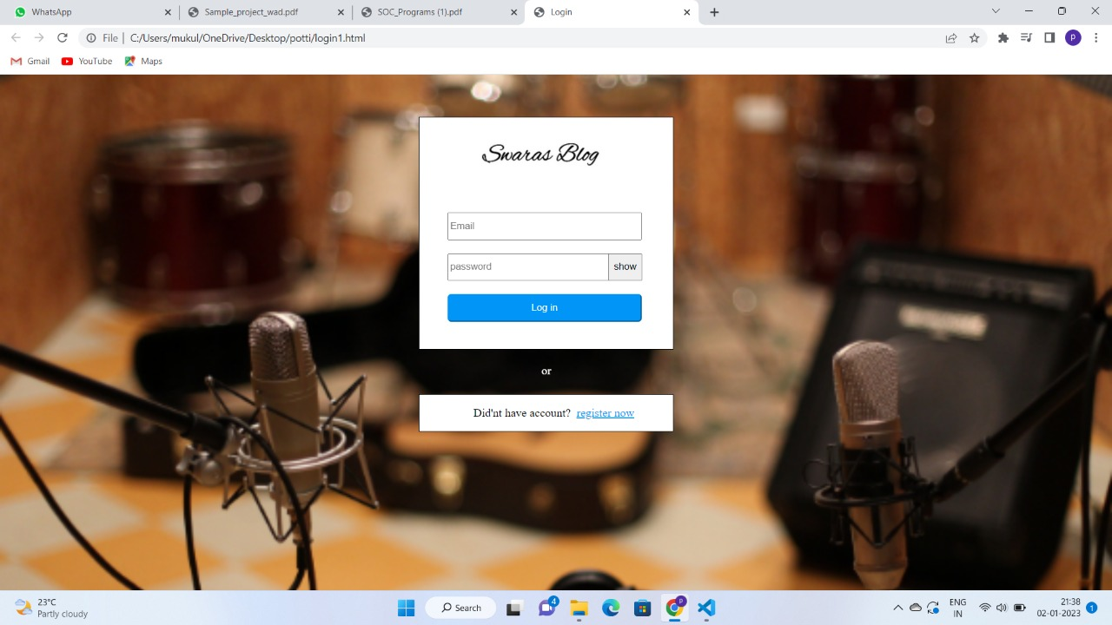

2)jokki.css(signup page):

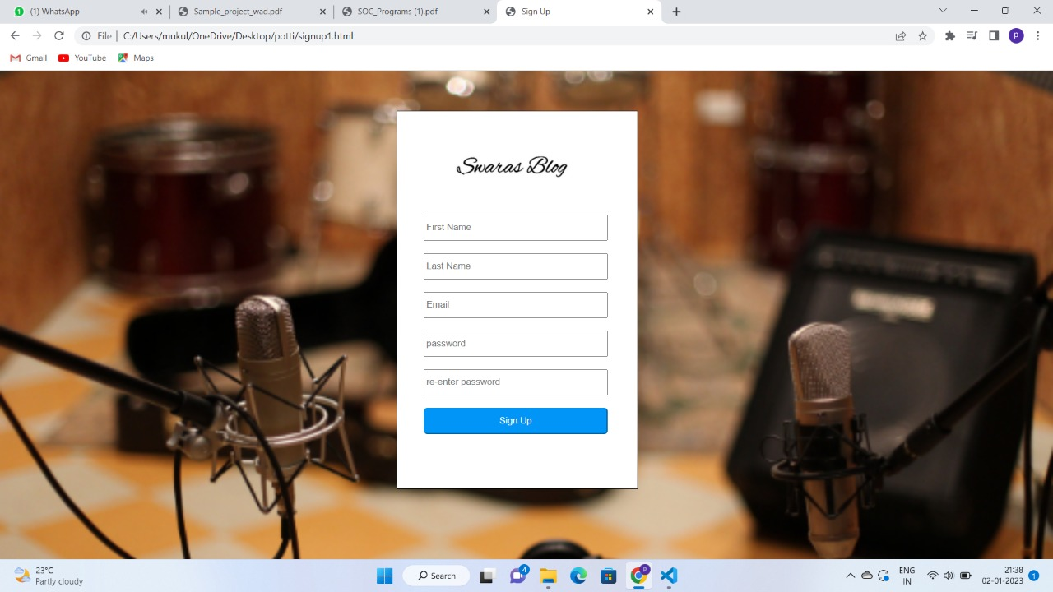

3)Swaras.html:

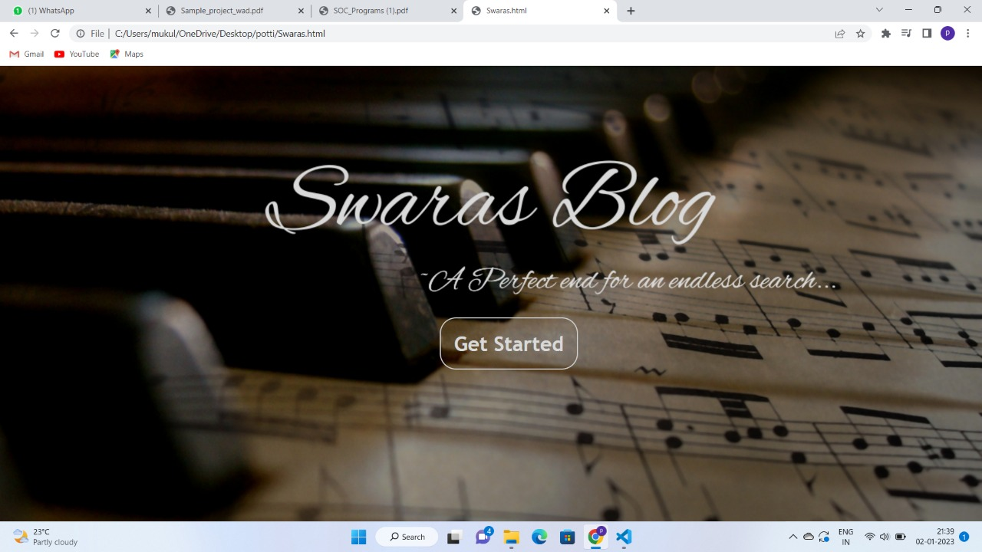

4)Swaras_main.css:

