**DEMAND:** Demand is the “quantity bought by an individual (s) at a given point of time at a given price”.

The three essentials of demand are desire backed by ability to pay and willingness to pay.

In other words, desire + ability to pay + willingness to pay.

**INDIVIDUAL DEMAND:** Individual demand is the quantity bought by one person at a given point of time at a given price.

**MARKET DEMAND:** Market demand is the quantity bought by a group of people at a given point of time at a given price.

**MARKET DEMAND DETERMINANTS**

The main determinants of demand are

1) Price of the product

2) Price of the substitute product

3) Consumer’s expectation’s about the price

4) Advertisement effect

5) Distribution of income &wealth

6) Tastes & preferences of the consumers

7) Climatic conditions

8) Customs & traditions

9) Population growth

10) Number of buyers

11) Age and gender

12) Tax policies

13) Inventions and innovations

14) Fashions

**Price of the product:** The most important factor affecting the quantity demanded is the price of the product. When the price falls the general demand for the good increases and the demand for the good decreases with a rise in the price of the commodity.

eg: At a price of RS.10, the demand is 100 units and at a price of RS.25,the demand is 120 units.

**Price of the substitute product**: In a given market, if the price of one good influences the quantity demanded for other good. These two goods are related to each other they are

1. **Price of substitutes**: When two commodities satisfy almost the same desire they are called as substitutes. In case of substitutes, the rise in price of one commodity will lead to increase in demand for other commodity.

ex: Tea & coffee, groundnut oil & til oil, jowar and bajra

**B) Price of complementary goods**: when both the products are required together, they are called as complementary goods. In case of complementary goods, the rise in price of one commodity will lead to decrease in price of both the commodities.

ex: if price of car increases the demand for petrol decreases.

**Consumers’ expectations about the price**: A Consumers’ expectation about the future change in the prices of a given product may also affect its demand. When the consumers’ expects the prices to fall in the future the current demand for the products will be less whereas if they expect the prices to increase in future, they tends to buy more now.

**Advertisement effect**: In modern times, consumer preferences can be changed by advertisement & sales propaganda. A good advertisement may influence the people to buy the product leading to increase in demand. Demand for many products like tooth paste, soaps, washing powder etc.is partially caused by the advertisement effect.

**Distribution of Income and wealth:** In a society, when income is distributed evenly then the demand for superior goods and comforts will be more. On the other hand, if the income is unevenly distributed in the society, the demand for inferior goods and luxuries will be more. it is obvious that consumer income will influence the amount of goods & services people will purchase at any given price. The idea is that the consumer generally goes in favour of better goods as soon as they can afford. When consumers income increases the demand will increase significantly.

**General tastes and scale of preferences:** The general tastes and preferences will influence the demand for a commodity. A product which is liked by more people will have more demand than others. ex: The demand for goods like chocolates, beverages, ice creams etc depend upon individual taste and preference.

**Climatic conditions**: The climate of an area and the weather prevailing there will also affect consumers’ demand. ex: In cold areas or in winter woolen clothes are demanded. In rainy season umbrellas, rain coats will have more demand whereas ice-creams are not much demanded.

**Customs & traditions**: Customs & traditions followed by people vary from place to place & this will influence the customers demand. Though the product is not the basic need as it is customary to buy that product people buy it.

ex: during Diwali season crackers will have more demand. This is becausen it is customary to burn crackers on Diwali day.

**Population growth**: The most important factor affecting quantity demanded is population growth. If population increases then the demand for the products increase as the consumption of products will be more.

**Number of buyers:** If the number of buyers increases then the demand for different commodities increases.

**Age and gender:** Depending upon the age, different commodities will be demanded. Toys will be in demand when there is more number of children in the population. Gender also influences the demand for commodities

**Tax policies**: If the tax increases on the salary then the demand for products will decrease as the disposable income with the consumer decreases. When the taxes on the income are less, the disposable income increases leading to more demand.

Eg: If the person’s salary is Rs. 5000 and the tax imposed is Rs.3000, then the disposable income is Rs.2000. If the tax increases to rs.4000 then the disposable income decreases to Rs.1000.

**Inventions and innovations:** Invention means producing new items and innovation means making improvement in existing product by using new technology. Whenever a new product comes into the market either in the form of invention or innovation, the demand for the old product decreases and the demand for the new product increases.

Eg: CD’S and DVD’S will have more demand than cassettes.

Fashions: Fashionable goods are mostly used by youth. A product which is out of fashion either due to technology or other reason the demand for the product decreases. This factor is more applicable to textiles.

**LAW OF DEMAND**

Demand is the quantity purchased by an individual or individuals at a given point of time at a given price. Law of demand states that “higher is the price, lower the demand and vice versa, when all other factors except price remain the same.” The price-quantity relationship is shown in the form of table with prices and corresponding quantities. This table is known as law of demand schedule.

**DEMAND SCHEDULE:**

|  |  |
| --- | --- |
| Price per unit  (In Rs.) | Quantity  (in units) |
| 4 | 80 |
| 3 | 100 |
| 2 | 150 |
| 1 | 200 |

**DEMAND CURVE:** 

Qunatity

(in units)

The “law of demand” is also portrayed graphically by representing quantity purchased (in units) on X axis and price (in Rs.) on Y axis. The Law of demand curve slopes downward from left to right indicating that when price increases, less is demanded and when prices falls, more is demanded.

**ASSUMPTIONS:**

* **Inverse relationship:** The relationship between price and quantity demanded is inverse. That is, if the price rises demand falls and vice versa.
* **Price and demand:** Under the law of demand, it is the effect of price on demand which is examined, and not the effect of demand on price. It means, price is regarded as an independent variable and demand a dependent variable.
* **Other things remain the same:** The law of demand assumes that Price of the substitute product, Consumer’s expectation’s about the price, Advertisement effect, Distribution of income &wealth, Tastes & preferences of the consumers, Climatic conditions, Customs & traditions, Population growth , Number of buyers, Age and gender, Tax policies, Inventions and innovations, Fashions remains same and only price is assumed to be changing.

**REASONS UNDERLYING LAW OF DEMAND:**

The inverse relationship price and can be explained in terms of two reasons, Income effect and substitution effect.

* Income effect: When the income remains constant, the fall in price of commodity leads to an increase in the purchasing power of the consumer because less has to be spent to purchase the same product. When price increases, the purchasing power reduces as expenditure on all commodities has to be reduced.
* Substitution effect: When the price of the commodity falls, the consumer tends to substitute that commodity with other commodities which have not become relatively dearer.

**EXCEPTIONS FOR LAW OF DEMAND:**

**Giften case:** Giften found that in 19th century, people of Ireland who were so poor spent a major part of their income on potatoes and a small part of their income on meat. When the price of potatoes increased, they have to economize on meat to maintain the same consumption of potatoes. Further to fill up the loss of calories, more potatoes have to be purchased as potatoes were still the cheapest food. Thus the rise in price led to increase in sale of potatoes.

**Snob appeal:** There are some goods which are purchased mainly for their snob appeal. When prices of such goods rise, their snob appeal increases and they are purchased in large quantities. Eg: high end cars.

**Spectulative goods:** In the speculative market, a rise in price is frequently followed by larger purchases like when share prices rise; people expect further rise and rush to buy. Fall in prices lead to smaller purchases, i.e., when prices fall, they wait for further fall and stop buying. This is especially applicable to purchases of industrial materials.

**Fear of scarcity:** If a commodity is expected to be scarce in near future then price of it increases but purchases also increase in the fear of scarcity.

**Impulse buying:** Some of the commodities will be purchased instantaneously without any plan even though the price of commodity is high. In exhibitions, though the prices are more, more people buy leading to more demand.

**Basic needs:** If the price of basic needs will increase the demand won’t change because they are essential commodities and have to be purchased.

**Wrong notion of people:** Generally, people expect that commodities with higher price have a good quality and purchase more. It may not be so all the time but it is the wrong notion of people.

Inexceptional cases the law of demand curve will be an upward rising curve.

Quantity demanded (in units)

P

R

I

C

E

(in

Rs.)

# ELASTICITY OF DEMAND

Elasticity of demand can be defined as "the degree of responsiveness of quantity demanded to a change in the variables namely, price of the commodity, income of the consumer, price of the substitute products and advertisement expenditure”.

# Elasticity of demand, therefore, can be studied under four types namely, price elasticity of demand, income elasticity of demand, cross elasticity of demand and advertising elasticity of demand.

# PRICE ELASTICITY

Price elasticity of demand is the measure of responsiveness of quantity demanded of a commodity to a given change in the price of a commodity. Price elasticity of demand can be defined as "the degree of responsiveness of quantity demanded to a change in the price. It represents the rate of change in the quantity demanded due to a change in price. It is also defined as a ratio of relative change in demand and price variables. It is measured by using the following formula:

ep = Proportionate change in the quantity demanded of a commodity / proportionate change in the price of the commodity.

Where

ep = price elasticity of demand .

Q1 = quantity demanded before any change in price.

Q2 = quantity demanded after price change.

P1 = initial/original price.

P2 = New price.

Mathematically, it can be represented as

ep = [(Q2 - Q1) / Q1] / [(P2 - P1 )/ P1]

OR

= [(Q2 - Q1) / (Q2 + Q1] / [(P2 - P1 )/ (P2 + P1]

**TYPES OF PRICE ELASTICITY**

1. Perfectly elastic demand

2. Perfectly inelastic demand

3. Unity elasticity

4. Relatively elastic demand

5. Relatively in elastic demand

**PERFECTLY ELASTIC DEMAND:**

In this case, the company can sell infinite quantity at ta prevailing price. No reduction in price in needed to cause an increase in demand. Once small increase in price is observed the demand falls to zero. The value of price elasticity of demand in this case will be infinity.

**SCHEDULE:**

|  |  |
| --- | --- |
| Price per unit  (in Rs.) | Quantity  (in units) |
| 2.5 | 2 |
| 2.5(P1) | 4(Q1) |
| 2.5(P2) | 6 (Q2) |
| 2.5 | 8 |
| 2.5 | 10 |

**CALCULATION:**

ep = [(Q2 - Q1) / Q1] / [(P2 - P1 )/ P1] = = [(6 - 4) / 4 ]/ [(2.5 - 2.5) / 2.5] = ∞

OR

= [(Q2 - Q1) / (Q2 + Q1] / [(P2 - P1 )/ (P2 + P1] = [(6 - 4) / (6 + 4)] / [(2.5 - 2.5) /

(2.5 + 2.5)] =  ∞

**DIAGRAM:**

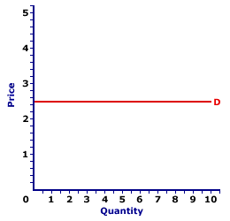

The above figure is plotted by taking quantity in units on X-axis and price per unit in Rs. on Y-axis. Also from the above figure we notice that the price being constant at Rs.2.5 and the quantity is going on increasing the curve is a straight line parallel to X axis.

**Perfectly inelastic demand:**

In this case, a change in price causes no change in quantity demanded. Here the shape of the curve is vertical. The value of ep in this case is equal to zero.

|  |  |
| --- | --- |
| Price per unit  (in Rs.) | Quantity  (in units) |
| 10 | 2 |
| 20(P1) | 4(Q1) |
| 30(P2) | 6 (Q2) |
| 40 | 8 |
| 50 | 10 |

**SCHEDULE:**

**CALCULATION:**

ep = [(Q2 - Q1) / Q1] / [(P2 - P1 )/ P1] = = [(6 - 4) / 4 ]/ [(30 - 20) / 20] = 0

OR

= [(Q2 - Q1) / (Q2 + Q1] / [(P2 - P1)/ (P2 + P1] = [(6 - 4) / (6 + 4)] / [(30 - 20) /

(30 + 20)] = 0

**DIAGRAM:**

Elasticity = 0

Quantity demanded (in units)

P

R

I

C

E

(in

Rs.)

**Unitary elastic demand:** Where a proportionate change in price causes a proportionate change in the quantity demanded. Here the shape of the demand curve is that of a rectangular hyperbola. The value of ep in this case is equal to one.

**SCHEDULE:**

|  |  |
| --- | --- |
| Price per unit  (in Rs.) | Quantity  (in units) |
| P1 30  P2  50 | 50 Q1  30 Q2 |

**CALCULATION:**

ep = [(Q2 - Q1) / Q1] / [(P2 - P1 )/ P1] = (30 - 50) ÷ 50 /(50 - 30) ÷ 30 = - 0.6

OR

= [(Q2 - Q1) / (Q2 + Q1] / [(P2 - P1 )/ (P2 + P1] = **(**30 - 50) ÷ (30 + 50) /(50 -

30) ÷ (50 + 30) = -1

**Graph: (Rectangular Hyperbola)**

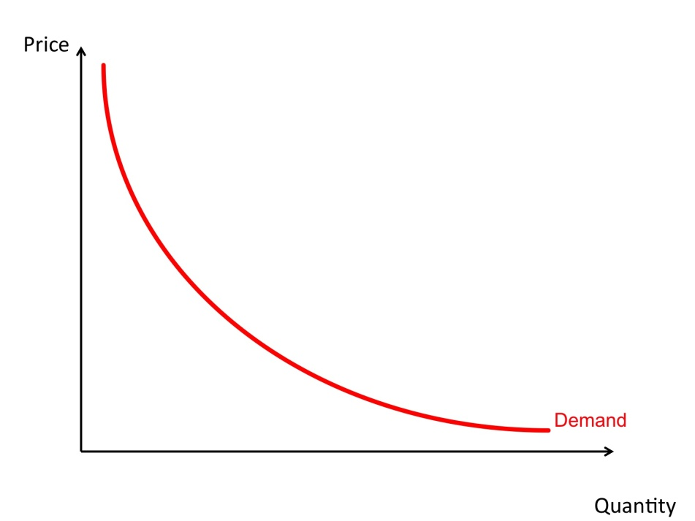

**Relatively elastic demand:**

It is a case in which change in price leads to more than proportionate change in demand. Hence the shape of the demand curve is downward sloping. The value of ep in this case is greater than 1.

|  |  |
| --- | --- |
| Price of commodity (in Rs.) | Quantity of demand (in units) |
| 10 (P1) | 4 (Q1) |
| 12 (P2) | 3 (Q2) |

**SCHEDULE:**

As we can observe from the table, that a small variation in price is leading to a great variation in demand. By substituting the values of P1 , P2 , Q1 , Q2 in the ep formula we get the value of ep always greater than 1.

**CALCULATION:**

ep = [(Q2 - Q1) / Q1] / [(P2 - P1 )/ P1] = [(3 - 4) / 4] / [(12 – 10 )/ 10] = -1.25

[(Q2 - Q1) / (Q2 + Q1] / [(P2 - P1 )/ (P2 + P1] =

(3 – 4) /( 3 + 4) / (12 – 10) / (12 + 10) = 1.5

**DIAGRAM:**

Elasticity more than one

Quantity demanded (in units)

P

R

I

C

E

(in

Rs.)

In the above diagram quantity in units is represented on X axis and price in Rs is represented on Y axis. The more elastic demand curve is downward sloping but a flatter curve as the price variation is less and quantity variation is more.

**Relatively inelastic demand:** Where a decline in price leads to less than proportionate increase in demand it is relatively inelastic or less elastic demand. The value of ep in this case is less than 1. Here the shape of the curve is downward sloping but steep.

|  |  |
| --- | --- |
| Price of commodity (in Rs.) | Quantity of demand (in units) |
| 10 (P1) | 4 (Q1) |
| 20 (P2) | 3 (Q2) |

**SCHEDULE:**

**CALCULATION:**

ep = [(Q2 - Q1) / Q1] / [(P2 - P1 )/ P1] = [(3 - 4) / 4] / [(20 – 10 )/ 10] = -0.25

[(Q2 - Q1) / (Q2 + Q1] / [(P2 - P1 )/ (P2 + P1] = (3 – 4) /( 3 + 4) / (20 – 10) / (20

+ 10) = -0.42

**DIAGRAM:**

Elasticity less than one

Quantity demanded (in units)

P

R

I

C

E

(in

Rs.)