### Low Power Wide Area Networking Technologies

* are used extensively for communication in the IoT ecosystem.
* LPWAN technologies are superior to Bluetooth for M2M communication because of their cost effectiveness and low-power consumption.
* LPWAN technology is ideal for connecting devices that send small amounts of data over a long range with battery efficiency.
* Eg: sensors, which are used for transmitting data within smart homes, buildings, parking systems, and so on.

**Low power wide area networking technologies (LPWAN)**

|  |  |  |
| --- | --- | --- |
| *Mobile Use Cases for IoT* | *Challenge* | *Mobile-Based Solution* |
| Intelligent energy conservation | * Access to electricity for development of cities * High leveIs of electricity theft * Inefficiencies of traditional grid * High leveIs of electric vehicle charging * Inability to track energy consumption and usage in real time | A mobile-based energy management service that helps consumers track and manage energy consumption in real time, pay bills using mobile devices, track energy theft, and identify energy leakage |
| Wireless fleet management | * Inefficiencies in supply chains | A mobile-based intelligent fleet management solution for mobile tracking of fleet and routing using embedded telematics |
| Remote health care monitoring | * Reliance on costly health care models * Aging infrastructure and outdated technology * Limited real-time data about patient’s body parameters | Remote patient monitoring and health care solutions using mobile devices |
| Mobile payments and ticketing | * Cost of maintaining muItichannel ticketing systems * Inconvenience for the consumers | A mobile ticketing platform that uses the NFC technology to provide end-to-end ticketing solutions for the customer |
| Analytics and commercial insights | * Disconnected data sets in silos * Inability to track and derive useful insights about various aspects pertaining to citizens in diverse city domains | Mobile business intelligence platforms that provide real-time insight for the city government |

The key features of LPWAN that make it suitable for IoT ecosystem are the following:

* *Long-range communication*: Ability to support nodes that are greater than or equal to 10 km distance from the gateway. However, the correct distance is based on the LPWAN technol- ogy that is used.
* *Low transmission data rate*: Less than 5000 bits of data are sent per second. Often only 20–256 bytes per message sent several times a day.
* *Low-power consumption*: This provides very long battery life for the devices. Many times, the battery life may last up to 10 years.

LPWAN technology is ideally suited for the following two types of applications:

1. *Fixed, medium-to-high density connections*: This is mainly used in cities and for buildings as an alternative option for cellular communications. Some common examples are smart grids, GPS-based asset tracking systems, and smart lighting systems.
2. *Long life, battery powered applications*: For applications that need a long range. Some exam- ples are water meters, gas detectors, smart agriculture systems, and so on.

The bandwidth and the range requirements of various wireless networking technologies are sum- marized in Figure 2.10.

The needs of IoT and M2M applications have given rise to some specific requirements on LPWAN technologies as compared with other wireless technologies. This is depicted in Figure 2.11.

For LPWAN technology, a star-topology network is preferred instead of a mesh-topology network. The endpoints of star networks are connected directly to access points. Repeaters can be used to fill in gaps in coverage areas so that there is no drop in transmission power. LPWAN technologies operate with 140–160 decibels that can provide several miles of range. In order to accomplish high miles, highly sensitive receivers are employed in LPWAN

Range capability

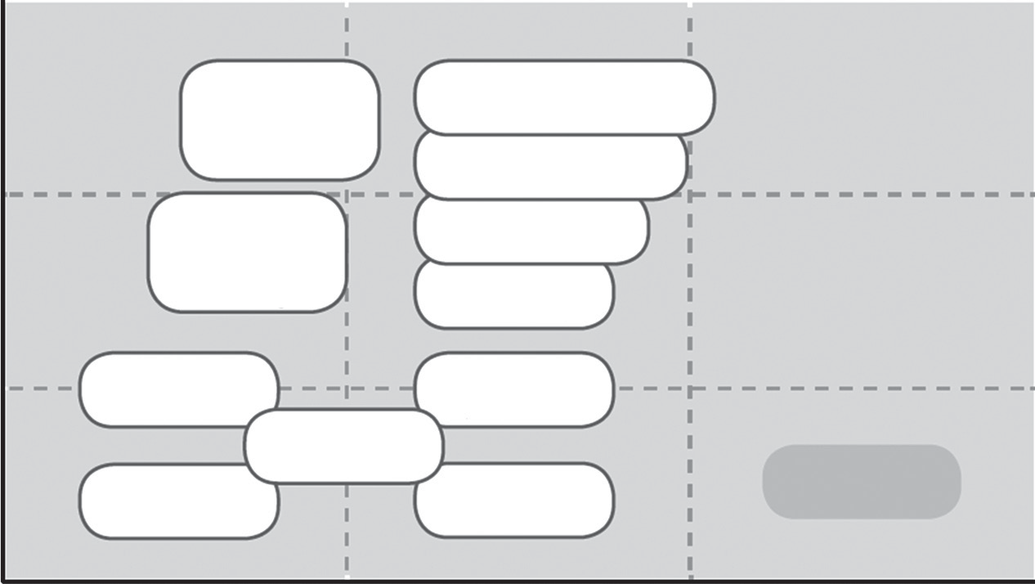

802.11ac

802.11ad

802.11n

802.11a

802.11b

802.11g

5G

4G

3G

2G

Bluetooth BLE

WBAN 802.15.6

RFID/NFC

ZigBee 802.15.4

WPAN 802.15.4

LPWAN

Bandwidth required

**Figure 2.10 Bandwidth requirements of LPWAN technologies.**

Geographical coverage, penetration

Transmission latency

LPWAN

Range

ZigBee 802.15.4

Power consumption

Bandwidth

Number of base stations

3G/4G/5G

Radio subscription costs

Radio chipset costs

**Figure 2.11 Requirements of LPWAN technologies.**

technologies. The following are the most important parameters to be considered while choos- ing a LPWAN technology:

* Capacity
* Quality of service
* Range
* Reliability
* Battery life
* Security
* Cost
* Proprietary versus standard

#### LPWAN Network Topologies

LPWAN has two network topologies:

* Direct device connectivity (base station)
* Indirect device connectivity through an LPWAN gateway

###### Direct Device Connectivity Topology of LPWAN

This topology is depicted in Figure 2.12.

* The base station that is present in the network provides connectivity to a large number of devices.
* The traffic is sent to servers (cloud) through TCP or IP-based networks (Internet).
* The base station is responsible for translation of protocol from IoT protocols such as MQTT or CoAP to specific device application protocols.

LPWAN connectivity

Access network

Cloud and servers

Applications

Base station

Star topology for long-range radio connectivity

Wired backhaul, TCP/IP-based (e.g., MQTT)

**Figure 2.12 Direct device connectivity topology of LPWAN.**

###### Indirect Device Connectivity through an LPWAN Gateway

This topology is depicted in Figure 2.13.

In certain networks where it is not possible to connect devices directly to LPWAN, a local gateway is used to bridge LPWAN connectivity to some short-range radio (SRD) technology like ZigBee or BLE. This gateway generally runs on mains power as it has to support a large number of devices. The gateway should also have the capability to perform protocol conversion from SRD radio technologies to LPWAN technology. Gateways also provide more security to IoT ecosystem as they offer options to implement powerful security algorithms.

#### Sigfox

Sigfox is very popular in the LPWAN industry. It has partnership with a lot of vendors in the radio space such as Texas Instruments, Silicon Labs, and Axom. Sigfox does not support bidirectional networks and offers support for uplink only sensor applications. This imposes a restriction on the end user to transfer only 15 bytes of traffic at a time with an average of only 10 messages per day. This limits the usability of this technology only for very simple devices.

Sigfox uses antennas that are set up on towers in order to receive data from devices such as parking sensors and water sensors. Data transmissions using Sigfox technology happen in 868 or 915 MHz frequency bands.

Short-range communication

Gateway

LPWAN

connectivity

Base station

Access network

Cloud and servers

Applications

Short range local connectivity

Star topology for long range radio connectivity

Wired backhaul,

TCP/IP (e.g., MQTT)

**Figure 2.13 Indirect device connectivity through an LPWAN gateway.**

Sigfox’s wireless systems send data in very small quantities very slowly using a mobile technol- ogy called binary phase shift keying (BPSK). Data transmissions for long ranges are done with the help of long and short messages.

###### Binary Phase Shift Keying

Phase-shift keying (PSK) is a modulation technique that transmits data by changing the phase of the reference signal, which is called carrier wave. This technique is widely used for data transmis- sion RFIDs, wireless LANs, and Bluetooth. Binary phase shift keying (BPSK) is the simplest form of PSK. It uses two phases that are separated by an angle of 180°. Since there are two phases, this technique is also called 2-PSK.

Sigfox is widely used for applications that send small, infrequent bursts of data. Some examples of application domains are alarm systems, location monitoring systems, and simple metering sys- tems. In these systems, signal data are sent few times to ensure that the data gets transmitted. The downside of this approach is shorter battery life for battery powered applications.

#### Weightless

*Weightless* is an open LPWAN standard. It operates in sub-1 GHz unlicensed spectrum. Weightless has three open standards:

* Weightless-P
* Weightless-N
* Weightless-W

###### Weightless-P

This standard offers bidirectional communication. It uses a narrow band modulation scheme in order to provide bidirectional communications capability. This standard provides very high qual- ity of service (QoS) parameter that is the best in class offered in the IoT sector.

Weightless-P will offer the committed performance rate, network reliability, and security parameters that are given by 3GPP carrier grade solutions. This standard also provides substantially lower costs when compared to other LPWAN technologies. This standard has less than 100 uW power consumption in an idle state. This power consumption rate is low when compared to 3 mW, which is used by other best cellular technologies that are available in the market.

###### Weightless-N

This standard offers one-way communication. They have a long battery life of about 10 years and have a low network cost. The Weightless-N standard uses star network architecture. It works in sub-GHz spectrum using ultra narrow band (UNB) technology. This standard offers a range of several kilometers even in urban environments. This standard offers very low power consumption, which in turn provides a long battery life for devices. This standard requires small conventional cells, minimal hardware, and incurs less network costs. This standard uses differential binary phase shift keying (DBPSK) digital modulation scheme to transmit using narrow frequency bands. This standard uses a frequency hopping algorithm in order to reduce interference.

This standard provides support for encryption and implicit authentication using a shared secret key regime in order to encode transmitted information via a 128-bit AES algorithm. This standard offers support for mobility as the network can automatically route terminal messages to the correct destination. Using this standard, multiple networks that are operated by different companies are enabled and can be colocated as well. Each base station that operates using this standard queries a central database in order to determine which network the terminal is registered to in order to decode and route data correctly.

###### Weightless-W

This standard is the most extensively used option as it runs in the unused TV spectrum. Data rates from 1 Kbit/s to 10 Mbit/s are possible based on the link budget with the size of data packets starting from 10 bytes. There is no upper bound on packet size. The overhead is extremely low, for example, 50 byte packets have less than 20% overhead. Both acknowledged and unacknowledged

message transmission modes are supported. The multicast call feature allows messages to be sent to

multiple devices. Interrupt feature supported by this standard allows devices to raise alarms in order to notify specific events that need attention such as power outage.

Service provision layering features provide worldwide contracts and automated change of net- work provider capabilities. Terminals can run multiple applications at the same time, and the mobility is fully supported. This standard provides an ultra secure 128-bit encryption and authen- tication model, which is based on a shared secret key. This standard has an extremely low com- plexity architecture. This type of architecture facilitates low-cost implementation using minimal memory and processor power in order to further extend battery life.

At the network level, careful scheduling features enable transmissions to be planned well ahead of time. The capability to plan ahead of time provides very high loading efficiency. The frequency hopping and intelligent frequency planning features help to maximize throughput on congested networks.

This standard offers wide range of modulation schemes and spreading factors, which in turn offers flexibility in network design. The range is about 5 km in indoor terminals. The entire core network runs as a software service that enables cloud hosting of this service.

#### NWave

NWave operates in UNB radio spectrum, which runs in sub-1 GHz ISM bands. They use a star networking topology for their operation. This allows direct communication with base stations. NWave uses advance demodulation techniques that help this standard to coexist with other radio technologies without causing any additional noise or distortion in transmission.

#### Ingenu

Ingenu uses a technology called random phase multiple access (RPMA).

###### Random Phase Multiple Access

Random phase multiple access (RPMA) technology is a combination of technologies that are designed exclusively for wireless M2M communication. RPMA supports large coverage area due to the high sensitivity levels of its receivers. High levels of receiver sensitivity provide good

levels of signal power while maintaining significant capacity levels. RPMA also operates in

2.4 GHz band that provides greater transmission power for this technology. All these factors are responsible for the great signal strength and more coverage area offered by this technology. An RPMA access point can also support hundreds and thousands of endpoint devices with various data rates.

Access points and endpoints of RPMA are synchronized in such a way that endpoints send signals that fall inside predefined frame sizes. Endpoints transmit their signals with a delay in such a way that it does not exceed the frame size. The access point despreads the signal and checks it for errors using cyclic redundancy check. Endpoints send their signals with a delay that is planned in such a way that it does not exceed the frame size. While receiving a signal, RPMA endpoints are aware of the conditions that exist in the channel and also about the local interference levels of signals. A combination of all these techniques combined in a specific and unique way gives RPMA the capability to support simultaneous demodulation of up to 1200 fully overlapping signals.

#### LoRa

LoRa Alliance12 promotes use of an open standard for LoRa-based networks called LoRaWAN. This standard was developed by Semtech, IBM research, and Actility. Following are the main features of LoRaWAN:

* They have three open standards that provide various types of options for end users.
* Since it is an open ecosystem, there are a lot of software and vendors that are available in the market for supporting this standard.
* This standard lacks many features like support for roaming, packetization, firmware upgrades over air, and so on.
* In order to use this standard, the network server software should be run in the cloud that mandates subscription from a network server vendor.
* Semtech is the only vendor that manufactures the chips that may impact the scale of produc- tion and adoption of this standard.