**WEEK - 01 Program to operate RGB LED’s using push buttons**

**PRELAB QUESTIONS - 01**

1. Draw the high level architecture of IoT.

Ans:

5 Layer Architecture

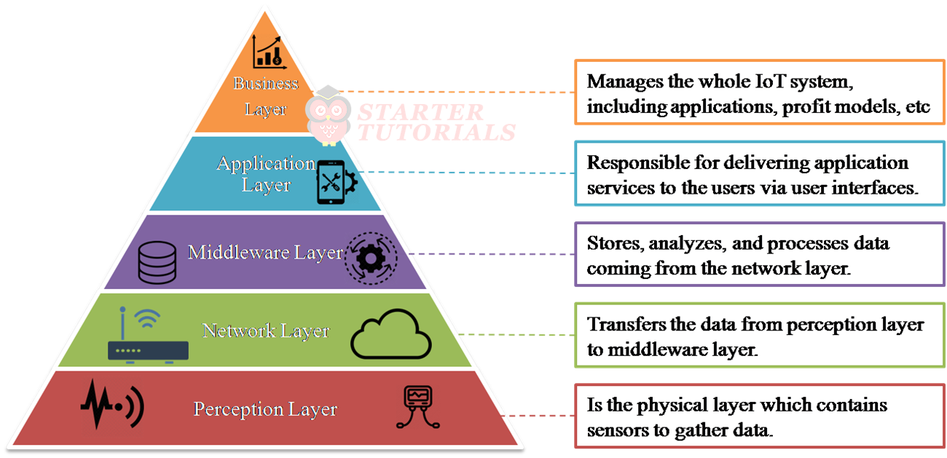

2.Draw the architecture of Raspberry PI3.

Ans:

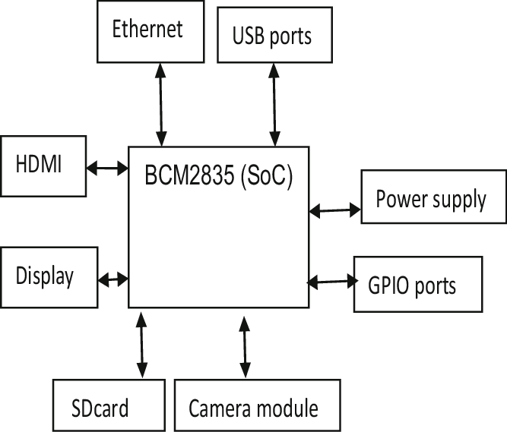

3.Write about I2C and SPI protocol.

Ans:

**I2C Protocol**: I2C (Inter-Integrated Circuit) is a serial communication protocol that uses two wires (SDA for data, SCL for clock) to connect multiple slave devices to one or more master devices, supporting multiple masters and slaves on the same bus.

**SPI Protocol**: SPI (Serial Peripheral Interface) is a serial communication protocol that uses four wires (MISO, MOSI, SCK, and SS) for full-duplex communication between a single master and a single slave or multiple slaves, but only one slave can be addressed at a time.

4.What is the difference between a push button and a key on a keyboard?

Ans:

A push button is a simple switch that controls a single action or input, whereas a key on a keyboard is designed to input characters or commands into a device, often with the ability to register multiple simultaneous presses.

1. What is the significance of Board mode and BCM mode in Raspberry PI?

Ans:

Board mode refers to pin numbering based on the physical pin layout, while BCM mode uses the Broadcom chip-specific pin numbers, offering two ways to identify GPIO pins for programming.

1. What is the role of MCP3008?

Ans:

The MCP3008 is an analog-to-digital converter (ADC) used with microcontrollers like the Raspberry Pi to read analog signals, enabling the Pi to interact with analog sensors or devices.

LAB PROGRAM - 01

1. Write a program to operate RGB LED’s using push buttons.

Code:

import sys

import time

sys.path.append("/home/pi/1602-21-733/Adafruit_MCP230xx")

from Adafruit_MCP230xx import Adafruit_MCP230XX

mcp=Adafruit_MCP230XX(busnum=1, address=0x20,num_gpios=16)

mcp.config(1,mcp.OUTPUT)

mcp.config(2,mcp.OUTPUT)

mcp.config(3,mcp.OUTPUT)

mcp.config(4,mcp.OUTPUT)

mcp.config(5,mcp.OUTPUT)

mcp.config(6,mcp.OUTPUT)

mcp.config(7,mcp.OUTPUT)

mcp.config(8,mcp.OUTPUT)

mcp.config(9,mcp.INPUT)

mcp.config(10,mcp.INPUT)

while True:

mcp.output(2,0)

if mcp.input(9) == 512 :

mcp.output(2,1)

if mcp.input(10) == 0:

mcp.output(2,0)

mcp.output(3,1)

time.sleep(5)

**Output:**

