**WEEK - 02Buzzer and BME280 onboard sensor on Raspberry PI**

**PRELAB QUESTIONS - 02**

1.**What is a sensor? List different types of Analog and Digital sensors.**

Ans:

A sensor is a device that detects and responds to inputs from the physical environment, such as light, heat, motion, or pressure.

Types of Sensors:

**1.Analog Sensors**: Thermistors (Temperature), Photocells (Light), Potentiometers (Position).

**2.Digital Sensors**: Digital Temperature Sensors, Infrared Motion Sensors, Ultrasonic Range Finders.

2**.Give the details of BME280 sensor. What are the ranges supported by this sensor?**

Ans:

The BME280 is an integrated environmental sensor developed by Bosch, capable of measuring temperature, humidity, and pressure.

Ranges Supported:

1.**Temperature**: -40°C to +85°C

2.**Humidity**: 0% to 100% relative humidity

3.**Pressure**: 300 to1100 hPa (hectopascals)

3.**What is an IO expander?**

Ans:

An IO expander is a hardware device used to increase the number of input/output (I/O) pins available on a microcontroller or microprocessor, allowing it to control more devices or read more sensors. It typically communicates with the main processor via serial interfaces like I2C or SPI

4.**What are the power modes supported by BME280?**

Ans:

Power Modes Supported by BME280:

1.**Sleep Mode**: Minimal power, functions halted except serial interface.

2.**Forced Mode**: Single measurement on demand, then returns to sleep.

3.**Normal Mode**: Cycles between measurement and standby for regular updates.

5**.Write the applications of BME280.**

Ans:

Applications of BME280:

1.Weather monitoring.

2.Indoor climate control.

3.Health and wellness monitoring.

4.Environmental sensing for IoT.

5.Altitude and pressure measurements.

6.**What are the applications of buzzer & push buttons?**

Ans:

Applications of Buzzer:

1.Alarm systems (e.g., smoke alarms).

2.User feedback for electronic devices.

3.Timers and clocks alerts.

Applications of Push Buttons:

4.User input for electronic projects.

5.Starting/stopping machinery.

6.Interface controls for devices.

1. Write a program to Control buzzer using push down buttons

Code:

import sys

sys.path.append('/home/pi/Adafruit-Raspberry-Pi-Python-Code- legacy/Adafruit_MCP230xx')

from Adafruit_MCP230XX import Adafruit_MCP230XX

import time

mcp Adafruit_MCP230XX(busnum = 1, address = 0x20, num gpios = 16)

mcp.config(4, mcp.OUTPUT)

mcp.config(9, mcp.INPUT)

mcp.config(11, mcp.OUTPUT)

while True:

mcp.output(4,0)

if mcp.input(9)==0:

mcp.output(11,1)

mcp.output(4,1)

else:

mcp.output(11,0)

mcp.output(4,0)

OUTPUT:

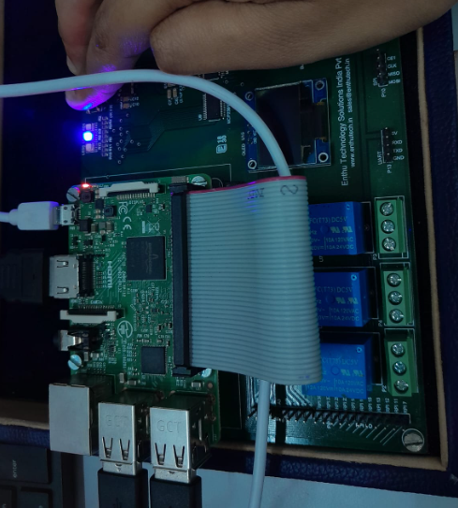

1. **Write a program toread data from BME280 onboard sensor on Raspberry PI development kit**

Code:

import sys

import time

sys.path.append('/home/pi/ETS_IOT KIT demo/DemoCode/BME280')

import BME280lib as BME

while True:

temperature, pressure, humidity=BME.readBME280A11()

print ("Temperature:", temperature, "C")

print ("Pressure :", pressure ,"hPa")

print ("Humidity :", humidity, "%")

time.sleep(3)

OUTPUT:

