**WEEK - 05 PIR sensor data to control servo motor and LED’s:**

**PRELAB QUESTIONS - 05**

1. Draw the connection diagram to interconnect the components of servo motor

A:

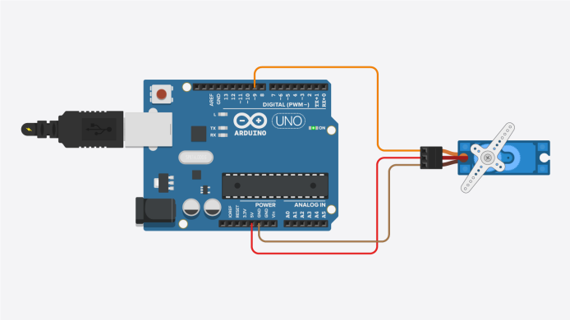

1. List the application areas of servo motors.

Ans: **Robotics Precision**: Servo motors ensure precise movement in robotic arms and hands, allowing them to perform delicate tasks with accuracy.

**Manufacturing Precision**: They are integral to CNC machines, enabling precise carving and shaping of materials for manufacturing processes, such as making car parts or intricate designs.

**Industrial Automation**: Servo motors facilitate the smooth movement of products along assembly lines and assist in packing items into boxes with precision in factory settings.

**Aerospace Applications**: These motors control movements in aircraft and drones, aiding in flight control and stabilization for safe and accurate maneuvers.

**Automotive Functionality**: In automobiles, servo motors contribute to steering systems for smooth handling and assist in brake control, ensuring vehicles operate safely and effectively.

Top of Form

1. Differentiate between servo motor and a DC motor.

Ans: **Servo Motor:**

- Utilizes a closed-loop control system for precise motion control.

- Offers high precision, accuracy, and controlled speed/torque.

- Incorporates feedback devices for real-time position, velocity, and/or torque information.

- Ideal for applications requiring exact positioning, such as robotics and CNC machines.

**DC Motor:**

- Typically operates in an open-loop system without feedback control.

- Provides high torque but may lack precision in speed control.

- Commonly used in simpler applications such as fans, pumps, and conveyors.

- Can be equipped with external sensors for specific feedback control if needed.

1. Classify different motors available?

Ans: Electric Motors: AC Motors, Induction Motors, Synchronous Motors, DC Motors, Brushed DC Motors, Brushless DC Motors

Hydraulic Motors, Pneumatic Motors, Brushed Motors, Brushless Motors, Stepper Motors, Servo Motors, Linear Motors

Top of Form

Lab programs:

1. Program to control Servo motor in different directions:

Code:

Import RPi

Import RPi.GPIO as GPIO

Import time

GPIO.setmode(GPIO.BOARD)

GPIO.setup(22, GPIO.OUT)

pwm=GPIO.PWM(22,100)

pwm.start(5)

angle1=1

duty1=float(angle1)/10+2.5

angle2=160

duty2= float(angle2)/10+2.5

ck=0

while ck<=5:

pwm.ChangeDutyCycle(duty1)

time.sleep(0.8)

pwm.ChangeDutyCycle(duty2)

time.sleep(0.8)

ck=ck+1

time.sleep(1)

GPIO.cleanup()

OUTPUT:

