**WEEK - 08ZigBee and ThingsSpeak**

**PRELAB QUESTIONS - 08**

1. What is the range supported by ZigBee?

Ans: ZigBee typically supports a range of about 10 to 100 meters, depending on environmental conditions such as physical obstructions and radio interference. The range can be extended through the use of mesh networking.

1. Compare ZigBee and Bluetooth.

Ans:ZigBee is optimized for low-power, low-data rate, and long battery life applications, supporting a large network with many nodes via mesh networking. Bluetooth, particularly Bluetooth Low Energy (BLE), is optimized for short-range, high-data rate applications and is generally used for point-to-point communications rather than large networks.

1. What is mesh networking? How is this helpful?

Ans:Mesh networking is a network topology where each node relays data for the network. All mesh nodes cooperate in the distribution of data in the network. This helps in extending the wireless range and providing multiple pathways for the data to reach its destination, enhancing reliability and coverage.

1. How do we configure the ZigBee node as coordinator?

Ans:

* To configure a ZigBee node as a coordinator using XCTU:
* Connect the ZigBee module to your computer via a USB adapter.
* Launch XCTU, select the device in the list, and connect to it.
* Configure the module’s settings to operate in Coordinator (CE = 1) mode.
* Write the settings to the module to save them.

1. Write a few applications where Zigbee can be used?

Ans:

* Home automation for controlling lighting, heating, air conditioning, and security devices.
* Industrial automation for machine-to-machine communication and sensor networks.
* Smart energy management systems for monitoring and controlling energy usage.
* Personal health care monitoring systems.

Lab programs:

1. Write a program to sense the weather and upload the weather information on to the public Cloud ThingSpeak.

Code :

import sys

sys.path.append('/home/pi/Desktop/New2')

import BME280lib as bme

import urllib.request as ur

import time

while True:

t, p, h = bme.readBME280All()

print("Temperature:", t, "C")

print("Pressure:", p, "hPa")

print("Humidity:", h, "%")

st=f'https://api.thingspeak.com/update?api_key=JXHSGARY1MYEDBEN&field1={t}

&field2={p}&field3={h}'

# Sending the data to ThingSpeak

f = ur.urlopen(st)

time.sleep(2)

Output:

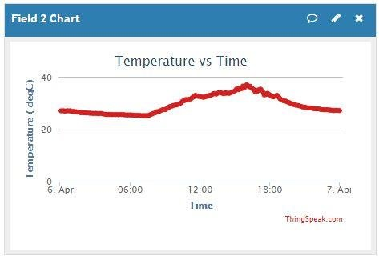 etc..

1. Write a program to Implement Zigbee

Code:

import time

import serial

ser = serial.Serial(port='/dev/ttyUSB0', baudrate=9600,

parity=serial.PARITY_NONE,

stopbits=serial.STOPBITS_ONE,

bytesize=serial.EIGHTBITS, timeout=1)

while True:

x = 'blank'

x = ser.readline()

print('message from EN:', x)

ser.write(('message from R: %s' % x).encode())

time.sleep(1)

OUTPUT:

