VASAVI COLLEGE OF ENGINEERING (AUTONOMOUS)
IBRAHIMBAGH, HYDERABAD-31
Department of Computer Science and Engineering

Name of the Course: Database Management Systems
Assignment – 1

Name of the Faculty: R.Sateesh Kuma Date of submission: 17/04/2023
Class: B.E 2/4 A Sem: IV

Set-1 (1602-21-733-012, 013, 015, 020, 026, 029, 032, 036, 037, 069)

Q. No. | Description of the question | Marks | BTL  (1/2/3/4/5/6) | Mapped
 |  |  |  | CO | PO
 | List six major steps that you would take in setting up a database for a particular enterprise.  Give one example | 2 | 3 | 1 | 1,2
 | Draw an E-R diagram for a university database, containing information about professors (identified by social security number, or SSN) and courses (identified by courseid). Professors teach courses; For each situation, draw an ER diagram that describes it  1. Professors can teach the same course in several semesters, and each offering must be recorded.  2. Professors can teach the same course in several semesters,  3. Every professor must teach some course.  4. Every professor teaches exactly one course (no more, no less).  5. Every professor teaches exactly one course (no more, no less), and every course must be taught by some professor. | 1 | 3 | 1 | 1,2,3
 | Consider the bank database .  branch(branch_name, branch city, assets)  customer (customer_ name, customer street, customer city)  loan (loan _number, branch name, amount)  borrower (customer_name, loan number)  account (account_number, branch name, balance)  depositor (custome_ name, account number)  a. What are the appropriate primary keys?  b. Given your choice of primary keys, identify appropriate foreign keys. | 2 | 3 | 1 | 1,2,3

Set-2 (1602-21-733-001, 002,003,004,005,006,007,008)

Q.No. | Description of the question | Marks | BTL  (1/2/3/4/5/6) | Mapped
 |  |  |  | CO | PO
 | List two reasons why null values might be introduced into the database. Give an Example. | 2 | 3 | 1 | 1,2
 | Construct an Entity-Relationship diagram for a online shopping systems such as Jabong/Flipcart. Quote your assumptions and list the requirements considered by you for conceptual database design for the above system. | 2 | 3 | 1 | 1,2,3
 | Consider the following schema write SQL queries :  Sailor(sid, sname, age, rating)  Boats(bid, bname, bcolor)  Reserves(sid,bid,day)  a) Find the boats reserved by sailor with id 567. b) Find the names of the sailors who reserved ‘red’ boats.  c) Find the boats which have at least two reservations by different sailors. | 1 | 3 | 2 | 1,2,3

Set-3 (1602-21-733-009, 010,011,014,016,017,018,019)

Q.No. | Description of the question | Marks | BTL  (1/2/3/4/5/6) | Mapped
 |  |  |  | CO | PO
 | Construct the table for the relationship mentioned in the diagram  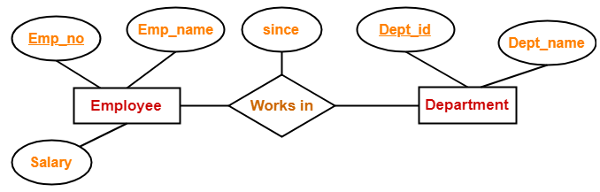 | 1 | 3 | 1 | 1,2
 | Construct an ER-Diagram for a hospital with a set of patients and set of medical doctors. Associated with each patient a log of the various tests and examinations conducted. | 2 | 3 | 1 | 1,2,3
 | Consider the following table:  Part(Partno, Supplierno, contract, partcost)  Supplier(Supplierno, Sname, Partno, detail)  Customer(C_id, C_city, Partno)  Write SQL queries for getting:  - Name of the city with maximum number of customer.  - List the city of the customer who has been supplied with maximum number of parts.  - List the name of Supplier who has been Supplies part with maximum cost. | 2 | 3 | 1 | 1,2,3

Set-4 (1602-21-733-020,021,022,023,024,025,027,028)

Q.No. | Description of the question | Marks | BTL  (1/2/3/4/5/6) | Mapped
 |  |  |  | CO | PO
 | Draw an E-R diagram for a university database, contains information about professors (identified by social security number, or SSN) and courses (identified by courseid). Professors teach courses; For each situation, draw an ER diagram that describes it  1. Professors can teach the same course in several semesters, and each offering must be recorded.  2. Professors can teach the same course in several semesters,  3. Every professor must teach some course.  4. Every professor teaches exactly one course (no more, no less).  5. Every professor teaches exactly one course (no more, no less), and every course must be taught by some professor. | 1 | 3 | 1 | 1,2
 | Find the key attributes in the diagram and create the tables with DDL statements.  INCLUDEPICTURE "https://lbsitbytes2010.files.wordpress.com/2013/09/p3.jpg" \* MERGEFORMATINET INCLUDEPICTURE "https://lbsitbytes2010.files.wordpress.com/2013/09/p3.jpg" \* MERGEFORMATINET 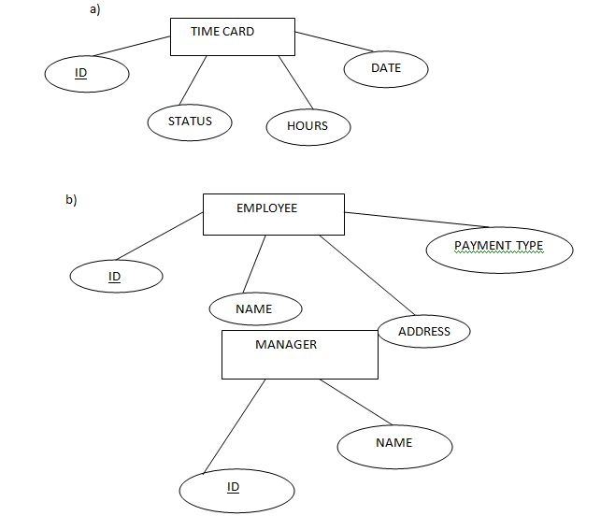 | 2 | 3 | 1 | 1,2,3
 | Consider the following table:  Part(Partno, Supplierno, contract, partcost)  Supplier(Supplierno, Sname, Partno, detail)  Customer(C_id, C_city, Partno)  Write SQL queries for getting:  - Name of the city with maximum number of customer.  - List the city of the customer who has been supplied with maximum number of parts.  - List the name of Supplier who has been Supplies part with maximum cost. | 2 | 3 | 1 | 1,2,3

Set-5 (1602-21-733-030,031,032,033,034,035,038,039)

Q.No. | Description of the question | Marks | BTL  (1/2/3/4/5/6) | Mapped
 |  |  |  | CO | PO
 | Construct the table for the relationship mentioned in the diagram  INCLUDEPICTURE "https://4.bp.blogspot.com/-MmgB0J3yHI4/VyTXUNwHNCI/AAAAAAAABaA/V6KdKMRsZo8ymHLQJohB8yC6BA5tYH49gCLcB/s1600/Basic_ERD.JPG" \* MERGEFORMATINET INCLUDEPICTURE "https://4.bp.blogspot.com/-MmgB0J3yHI4/VyTXUNwHNCI/AAAAAAAABaA/V6KdKMRsZo8ymHLQJohB8yC6BA5tYH49gCLcB/s1600/Basic_ERD.JPG" \* MERGEFORMATINET 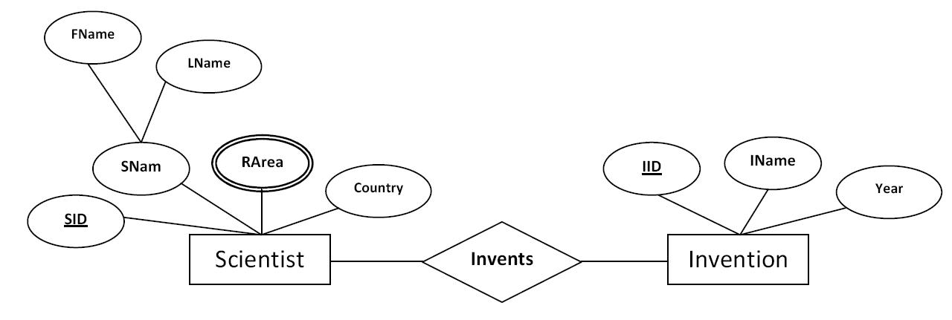 | 1 | 3 | 1 | 1,2
 | Construct an E-R diagram for a hospital with a set of patients and a set of medical doctors. Associate with each patient a log of various tests and examinations conducted. | 2 | 3 | 1 | 1,2,3
 | Consider the given schema and Write the following SQL queries  - To find all customers of the bank who have an account but not a loan  - To find all customers of the bank who have both an account and a loan  - To find all customers of the bank who have either an account or a loan  Customer(Customer_name, Customer_city)  Borrower(Customer_name, Loan_number)  Depositor(Customer_name, account_number) | 2 | 3 | 1 | 1,2,3

Set-6 (1602-21-733-040 to 047)

Q.No. | Description of the question | Marks | BTL  (1/2/3/4/5/6) | Mapped
 |  |  |  | CO | PO
 | Create a table with the following schema:  Account(Account_number,Branch_name,Balance)  The types of the attributes should be the following:  - Account_number: varchar of size 30  - Branch_name: varchar of size 15  - Balance: varchar of size 25 | 2 | 3 | 1 | 1,2
 | Define ER model and explain the following kinds of constraints that can be specified in the ER diagram and give an example of each: i) key constraint ii)participation constraint | 1 | 3 | 1 | 1,2,3
 | Consider the following table:  Part(Partno, Supplierno, contract, partcost)  Supplier(Supplierno, Sname, Partno, detail)  Customer(C_id, C_city, Partno)  Write SQL queries for getting:  - Name of the city with maximum number of customer.  - List the city of the customer who has been supplied with maximum number of parts.  - List the name of Supplier who has been Supplies part with maximum cost. | 2 | 3 | 1 | 1,2,3

Set-7 (1602-21-733-048 to 055)

Q.No. | Description of the question | Marks | BTL  (1/2/3/4/5/6) | Mapped
 |  |  |  | CO | PO
 | How Referential Integrity is different from primary key? Explain with an Employee and Department table by considering required attributes. | 2 | 3 | 1 | 1,2
 | Draw ER diagram for railway reservation consisting of fares, reservation, staff, passengers, etc. Clearly highlight entities, relationship, primary key and foreign key. | 1 | 3 | 1 | 1,2,3
 | Write SQL Queries for the given Schemas  Employee: (Emp_id, Ename, office, Age)  Books: (isbn, title, author, publisher)  Loan : (Emp_id, isbn, date)  - Print the names of employees who have borrowed any book published by Pearson publisher.  - Print the names of employees who have borrowed all books published by Pearson publisher.  - For each publisher, print the names of employees who have borrowed more than five books of that publisher. | 2 | 3 | 1 | 1,2,3

Set-8 (1602-21-733-056 to 062,064)

Q.No. | Description of the question | Marks | BTL  (1/2/3/4/5/6) | Mapped
 |  |  |  | CO | PO
 | Construct a weak entity diagram for the following relation  Loan (Loan_no,type _of_loan,amount)  Payment(Loan_no,date_of_payment) | 2 | 3 | 1 | 1,2,3
 | Draw an ER model of the Banking database application considering the following constraints −  - A bank has many entities.  - Each customer has multiple accounts.  - Multiple customers belong to a single branch.  - Single customer can borrow multiple loans.  - A branch has multiple employees. | 1 | 3 | 1 | 1,2
 | Consider the given schema and Write the following SQL queries  - To find all customers of the bank who have an account but not a loan  - To find all customers of the bank who have both an account and a loan  - To find all customers of the bank who have either an account or a loan  Customer(Customer_name, Customer_city)  Borrower(Customer_name, Loan_number)  Depositor(Customer_name, account_number) | 2 | 3 | 1 | 1,2

Set-9 (1602-21-733-065,066,067,135,136 ,301)

Q.No. | Description of the question | Marks | BTL  (1/2/3/4/5/6) | Mapped
 |  |  |  | CO | PO
 | Find the key attributes in the diagram and create the tables with DDL statements.  INCLUDEPICTURE "https://lbsitbytes2010.files.wordpress.com/2013/09/p3.jpg" \* MERGEFORMATINET INCLUDEPICTURE "https://lbsitbytes2010.files.wordpress.com/2013/09/p3.jpg" \* MERGEFORMATINET | 2 | 3 | 1 | 1,2,3
 | Design an E-R diagram for keeping track of the exploits of your favorite sports team. You should store the matches played, the scores in each match, the players in each match and individual player statistics for each match. Summary statistics should be modeled as derived attributes. | 1 | 3 | 1 | 1,2
 | Consider the following table:  Part(Partno, Supplierno, contract, partcost)  Supplier(Supplierno, Sname, Partno, detail)  Customer(C_id, C_city, Partno)  Write SQL queries for getting:  - Name of the city with maximum number of customer.  - List the city of the customer who has been supplied with maximum number of parts.  - List the name of Supplier who has been Supplies part with maximum cost. | 2 | 3 | 1 | 1,2

Set-10 (1602-21-733-302 to 307)

Q.No. | Description of the question | Marks | BTL  (1/2/3/4/5/6) | Mapped
 |  |  |  | CO | PO
 | How Referential Integrity is different from primary key? Explain with an Employee and Department table by considering required attributes. | 2 | 3 | 1 | 1,2,3
 | Construct the table for the relationship mentioned in the diagram  INCLUDEPICTURE "https://4.bp.blogspot.com/-MmgB0J3yHI4/VyTXUNwHNCI/AAAAAAAABaA/V6KdKMRsZo8ymHLQJohB8yC6BA5tYH49gCLcB/s1600/Basic_ERD.JPG" \* MERGEFORMATINET INCLUDEPICTURE "https://4.bp.blogspot.com/-MmgB0J3yHI4/VyTXUNwHNCI/AAAAAAAABaA/V6KdKMRsZo8ymHLQJohB8yC6BA5tYH49gCLcB/s1600/Basic_ERD.JPG" \* MERGEFORMATINET | 1 | 3 | 1 | 1,2
 | Consider the given schema and Write the following SQL queries  - To find all customers of the bank who have an account but not a loan  - To find all customers of the bank who have both an account and a loan  - To find all customers of the bank who have either an account or a loan  Customer(Customer_name, Customer_city)  Borrower(Customer_name, Loan_number)  Depositor(Customer_name, account_number) | 2 | 3 | 1 | 1,2,3

