**Asia**

**When o Travel** There are a number of different climates across the Far East to match the many varied landscapes, from mountains to beaches. Weather can also vary dramatically in one country, for instance in Thailand it can be the hottest month in Phuket while in Chiang Mai it’s rainy season. Typically high season is classed as January to August and December with dry, cool weather. March and November are the shoulder seasons where the hottest weather begins and the low season falls between September and October as the wet weather descends

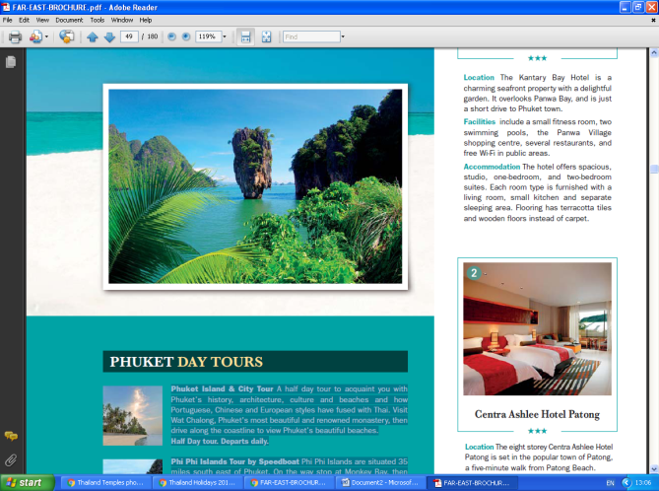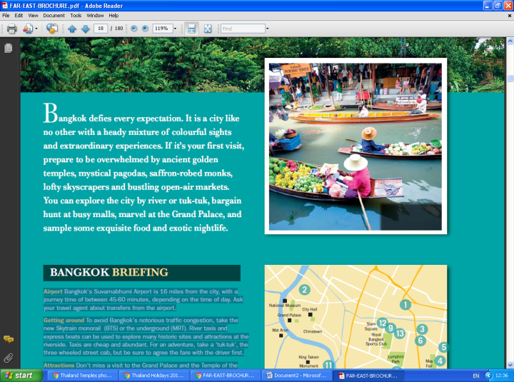**Thailand** every shade of the spectrum is represented from golden temples and emerald paddy fields to sapphire seas and saffron robes worn by the Buddhist monks. The beauty of Thailand is that it’s a country of sharp contrasts; tranquil beaches, buzzing cities, cultural highs and fascinating history. Your first impression of Bangkok is likely to be a sense-assaulting barrage of noise, colour, activity and traffic. But away from the frenetic streets and bustling markets lie calm temples, still and peaceful and magnificently decorated. Bangkok is an ideal starting point to enjoy a city break before heading to the beautiful beaches and serene islands in the south of the country. City, beach, both? Thailand has it all.

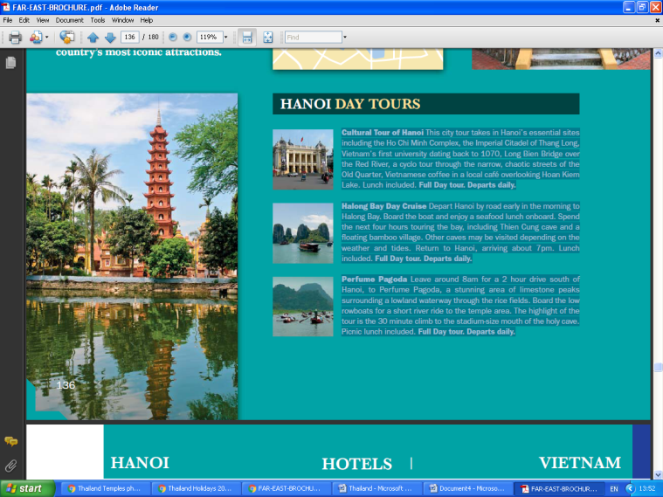Comprising **Cambodia, Vietnam and Laos**; Indochina is a region with a deep and intriguing history, blended with eastern culture and a vibrant, welcoming atmosphere. In Cambodia discover beautiful stretches of untouched coastline combined with huge lakes with floating villages and mangrove swamps. The highlight of this fascinating country is the UNESCO World Heritage Listed Angkor Wat – a collection of vast thousand-year old temples hidden in the depths of jungles. In Vietnam take a cultural journey in the cities of Ho Chi Minh and Hanoi and delve into the rich heritage of times gone by. Then make your way to the contrasting rural areas of terraced slopes, beautiful beaches and traditional villages.

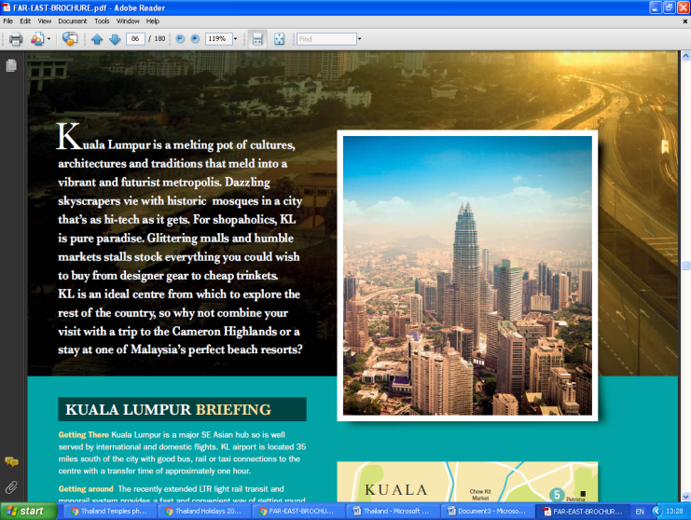Magical **Malaysia** If you’re looking to combine adventure with relaxation, ancient architecture with a modern metropolis and city streets with sandy beaches, then look no further than Malaysia. Kuala Lumpur boasts some of the tallest skyscrapers in South East Asia which sit proudly next to historic temples and sites of cultural significance. While the islands of Penang and Langkawi offer vast stretches of white sandy beaches and unspoilt paradise. Over in Borneo the landscapes and wildlife will take your breath away. Famous for its endangered orang-utans a visit here is rarely complete without time spent with these fascinating mammals.

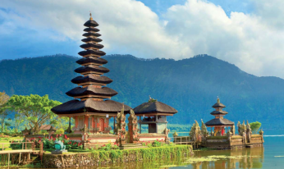**Incredible Indonesia** If you’re in search of endless blue skies, golden sands as far as the eye can see, with some rainforests and volcanoes thrown in for good measure, look no further than Bali. It’s worth taking the time to explore the city’s historical, multi-cultural, traditional, and religious gems. Swim in the clear waters of the area’s beautiful waterfalls, visit the Turtle Conservation and Education Centre, choose one of the remarkable temples to explore or for a literal taste of Bali, book an Indonesian cooking class. The spectacular islands of the Gili Isles offer a slice of picture perfect paradise. Snorkel the stunning coral reefs by day and watch the sunset with a cocktail by night.