1.

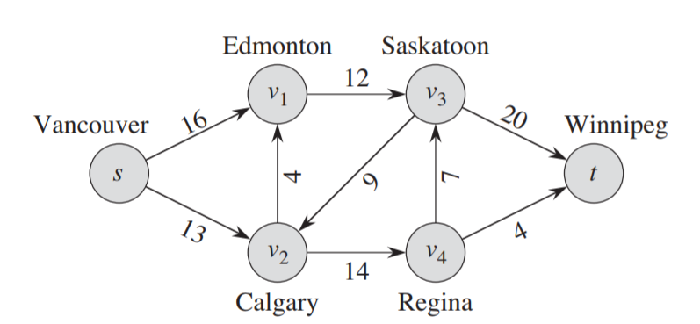

Show the execution of the Edmonds-Karp algorithm on the flow network of above Figure.(with calculation process)

2. State the maximum-flow problem as a linear-programming problem.

3. Convert the following linear program into standard form:

$$\min{2x_{1}}+7x_{2}+x_{3}$$

subject to

4. Solve the following linear program using SIMPLEX: (with calculation process)

$$\min{x_{1}+x_{2}+x_{3}}$$

subject to

$$2x_{1}+7.5x_{2}+3x_{3}≥10000$$

$$20x_{1}+5x_{2}+10x_{3}≥30000$$

$$x_{1},x_{2},x_{3},≥0$$