**Machine Learning HW 4 Report**

0516215林亮穎

1. **Forward-propagate code**

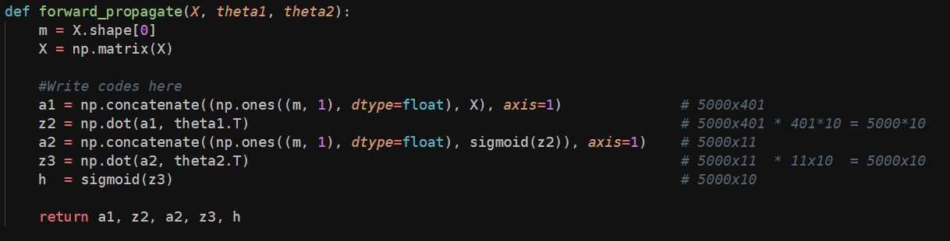

1. **Back-propagate code**

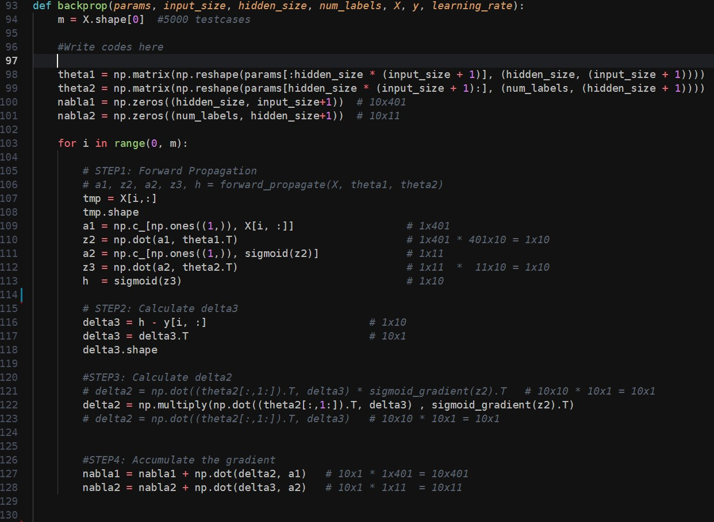

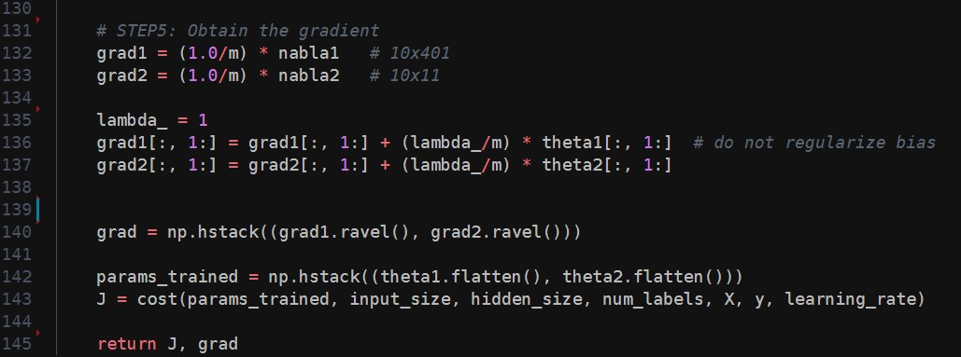

1. **Result accuracy**

