GUIDE FOR OBTAINING OPENEULER DATA – POWER BI
Power BI is a data analysis and visualization tool from Microsoft that allows you to connect, transform, and present information in interactive dashboards and reports. It also integrates with IoT solutions to analyze real-time data from sensors and devices, facilitating monitoring and data-driven decision-making.
Step 1: Access the POWER BI desktop application
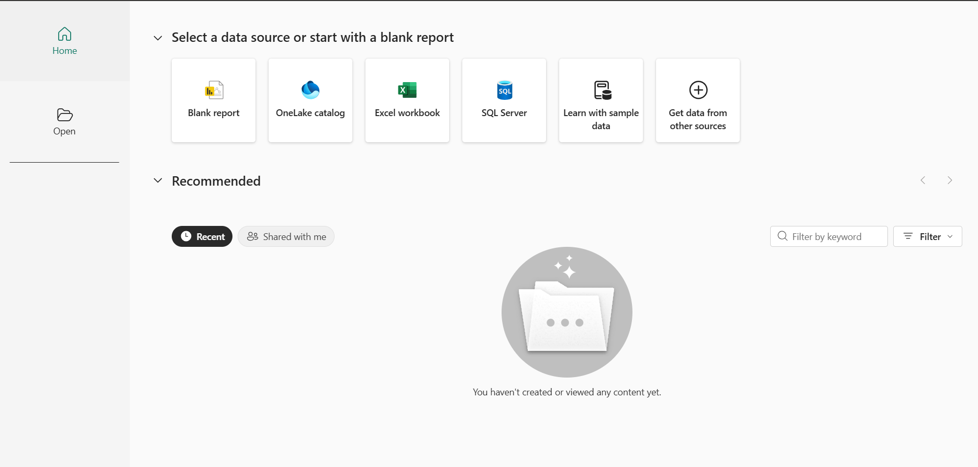
Step 2: We select get data, then we go to other and select web

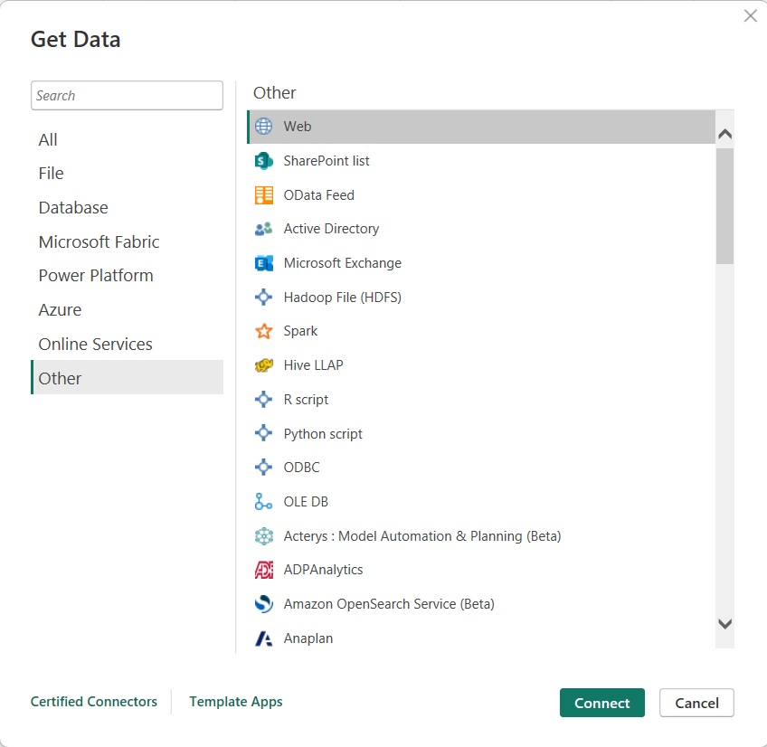

Step 3: We enter the URL where we have our service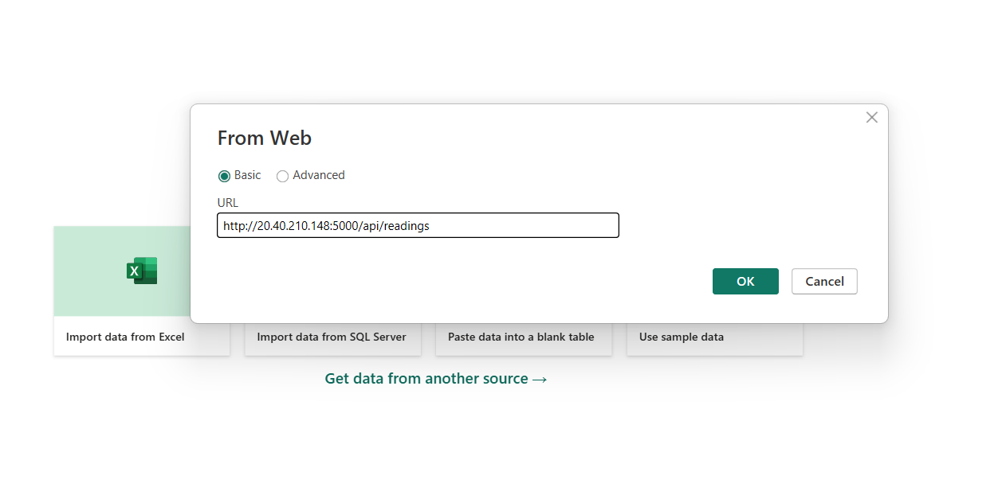
Once inside, we can view all the records.
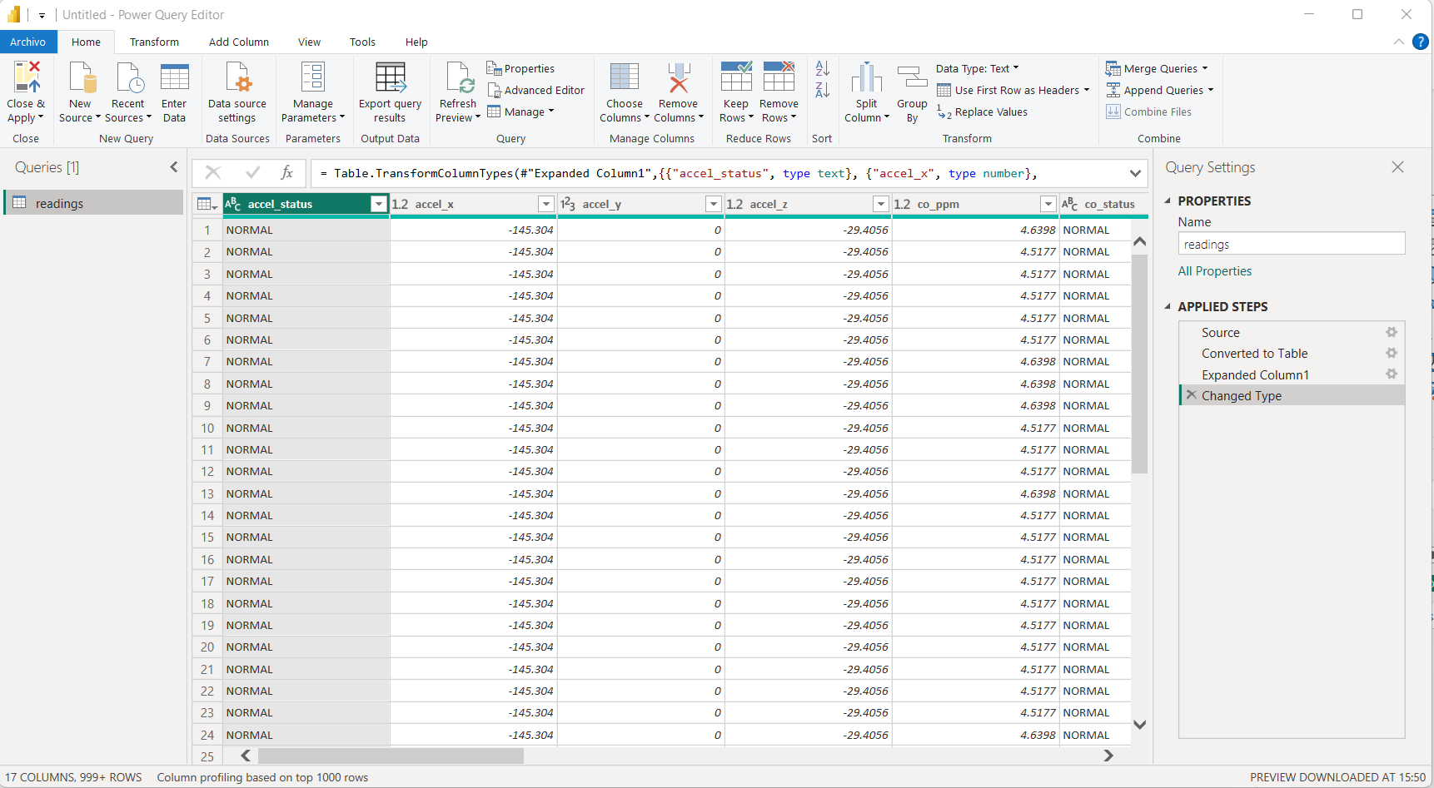
Then we put it away
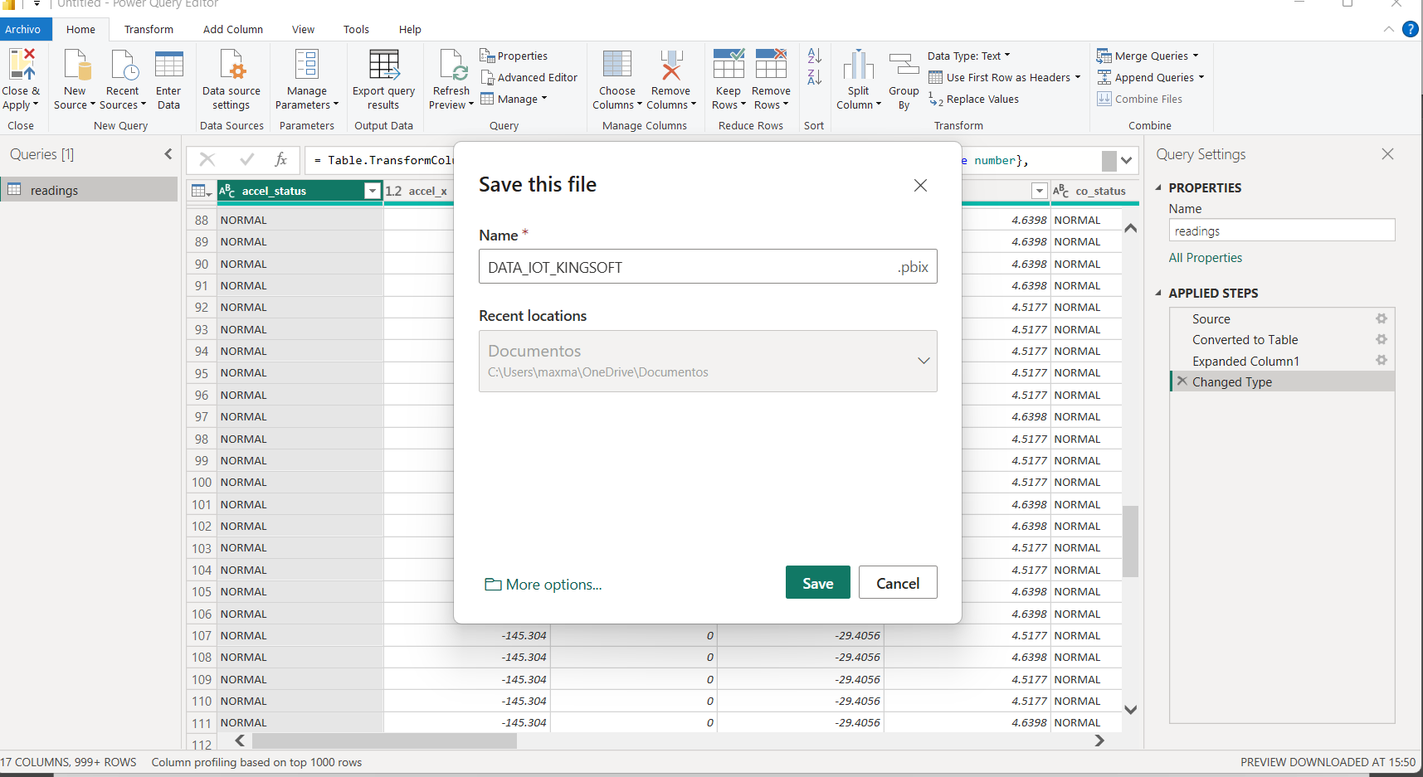

Step 4: Next, the report will load in blank form, then we add the charts and data we want to visualize.
