GUIDE FOR CONNECTING TO IOTDA
This guide describes the process for connecting a microcontroller with ARM Cortex architecture to a minicomputer with the openEuler operating system .
From this minicomputer, a secure connection will be established to a high-availability cloud service, specifically Huawei Cloud IoTDA , which will allow the robust and scalable management, communication, and monitoring of IoT devices.
This architecture's approach allows the microcontroller to be decoupled from the direct connection to the cloud, using the minicomputer as a secure intermediary for sending and receiving data.
IoTDA service
Log in to the Huawei Cloud console and search for the IoTDA service ( IoT Device Access).
By selecting this service, you will access the main menu, from where you will proceed to create or acquire a standard IoTDA instance , necessary to enable secure communication with IoT devices .
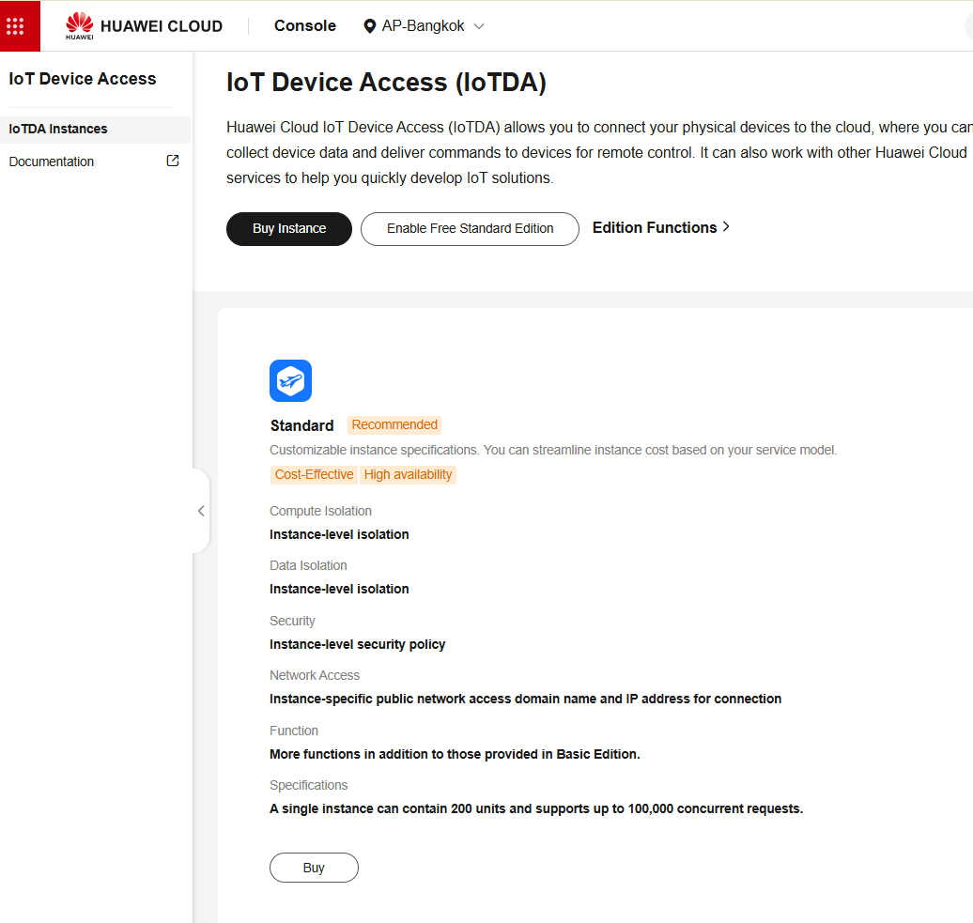
Step 2. Selecting the instance dimension
Once inside the IoTDA service , you will select the instance size you will use. For this test scenario, you will choose the pay-as-you-go model, which optimizes costs during the validation and experimentation phase.
It is recommended to start with the lowest capacity instance available, as it will only be used for testing and learning purposes, and is sufficient to validate connectivity, data transmission, and the overall functioning of the platform.

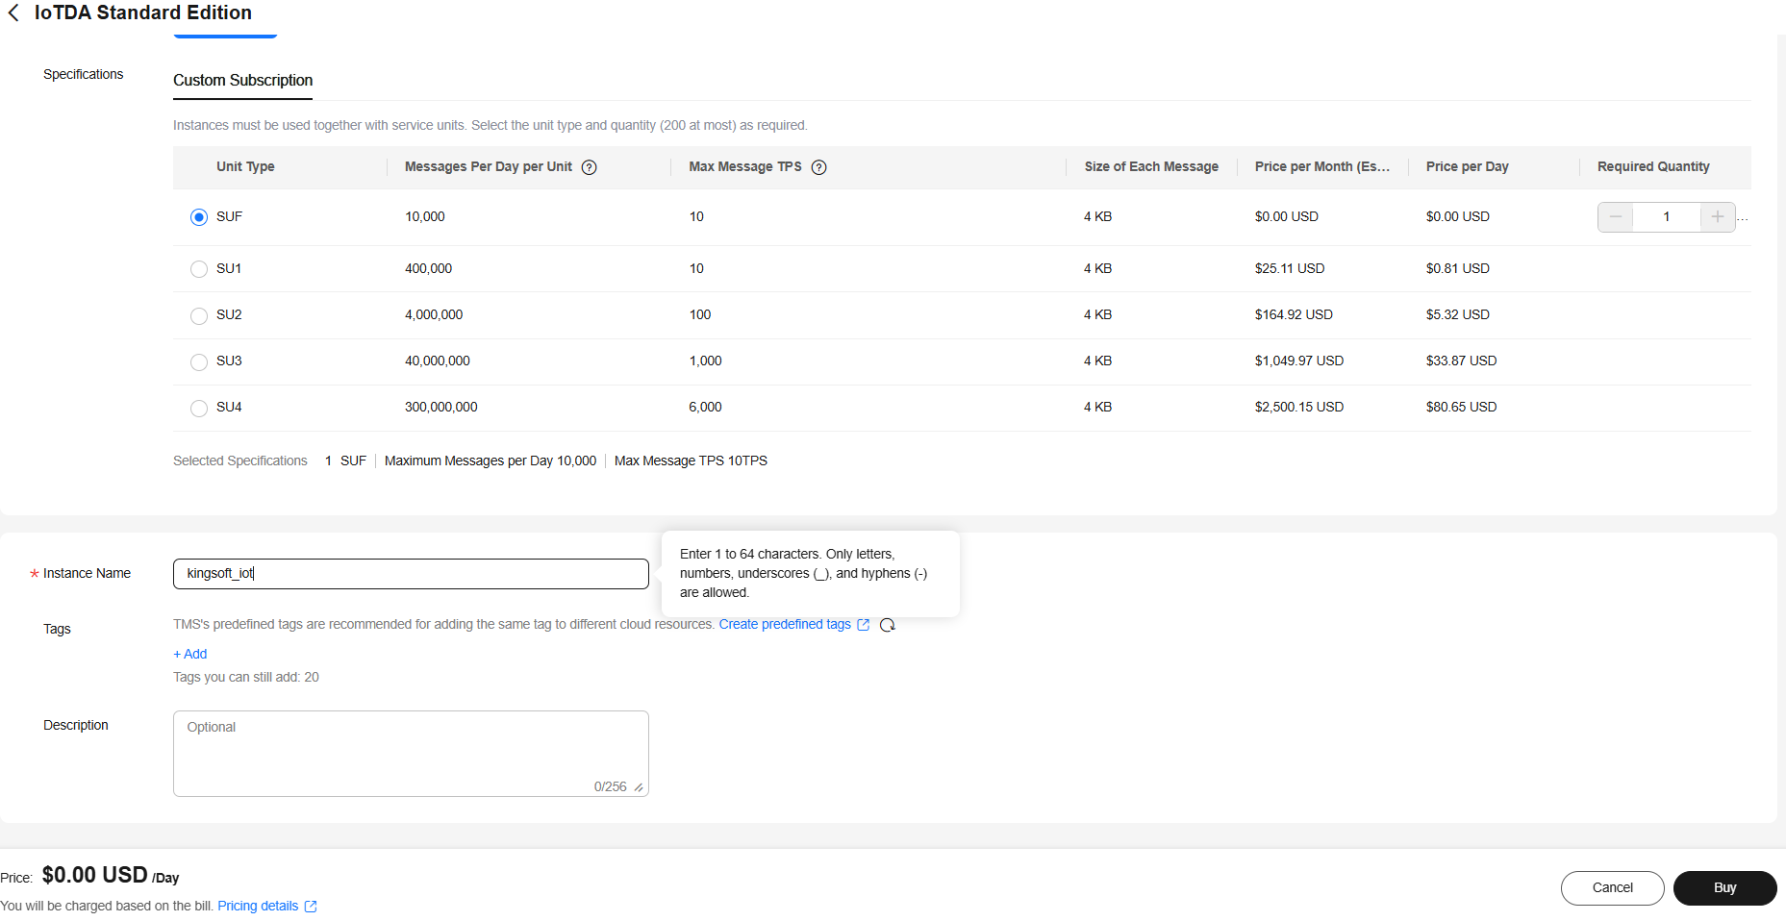

Finally, the Submit button will be pressed to confirm the creation and acquisition of the IoTDA instance .

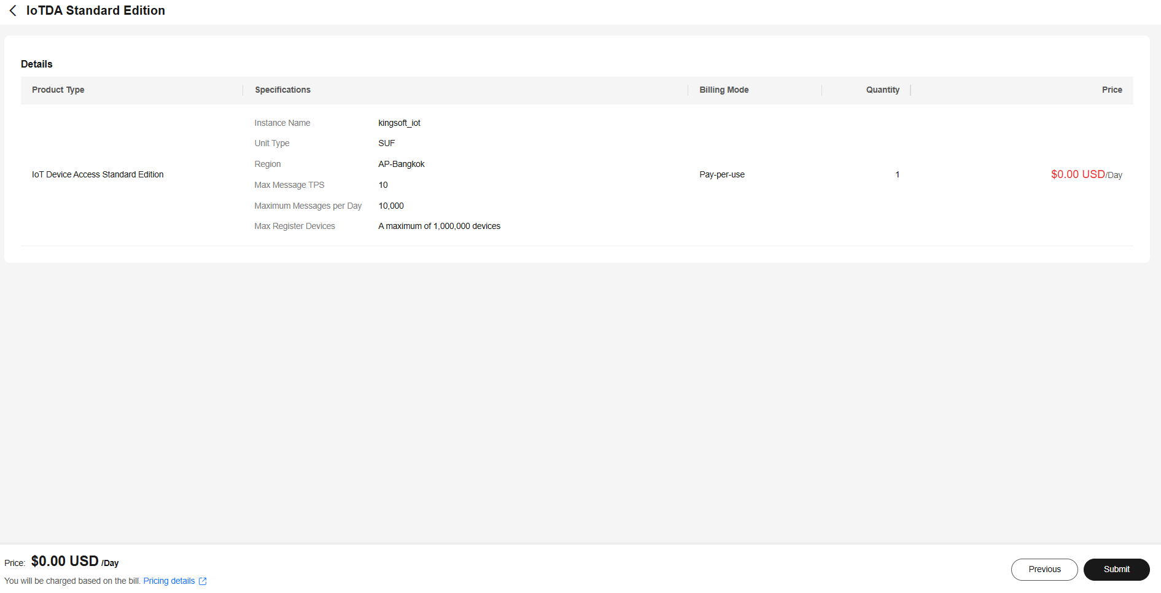
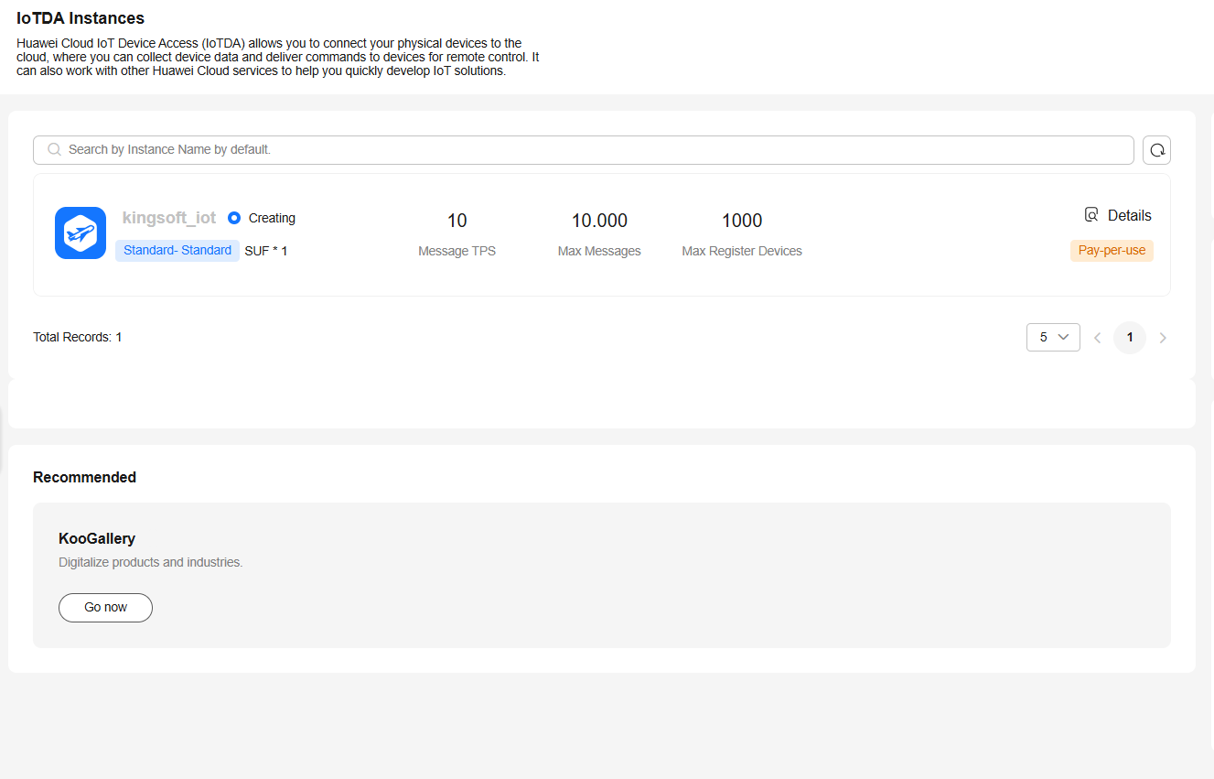
Step 3. Product creation
As a first step in setting up IoTDA , you will create a product. To do this, you will need to enter basic information such as the product name, connection type, industry, and other general definitions requested by the platform.
A product in IoTDA defines the characteristics, capabilities, and behavior of a family of devices, and must be created before registering the actual devices.
This step allows establishing a common model that will be inherited by all devices associated with that product.
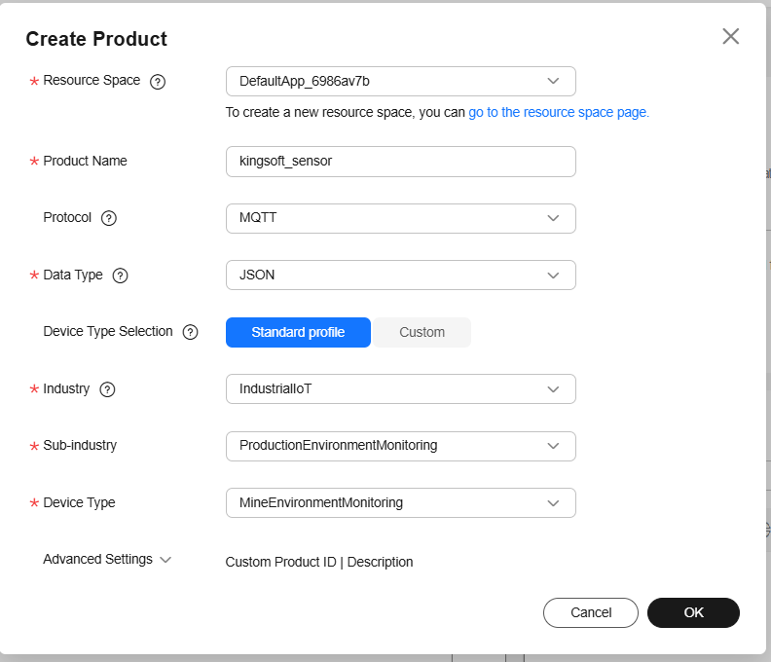

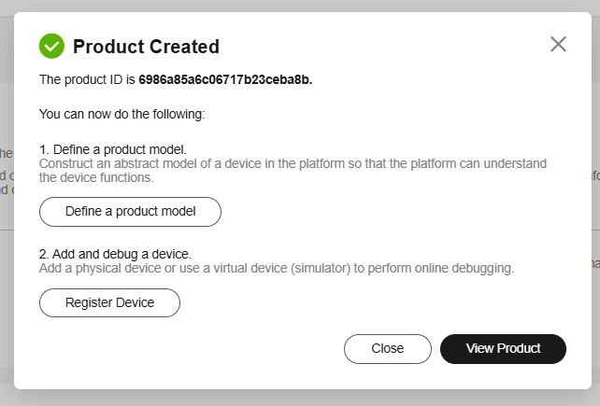
Product Model Definition . Once the product has been created, you will access its configuration and go to the Model Design section .
In this window, you will add a service, which represents a logical grouping of functions and capabilities within the product.
The service allows you to organize and structure the data that the device will send or receive, facilitating the definition of properties, events, and commands associated with the device's behavior.

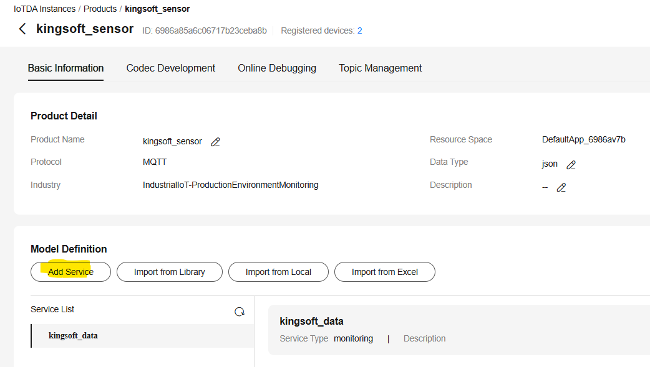
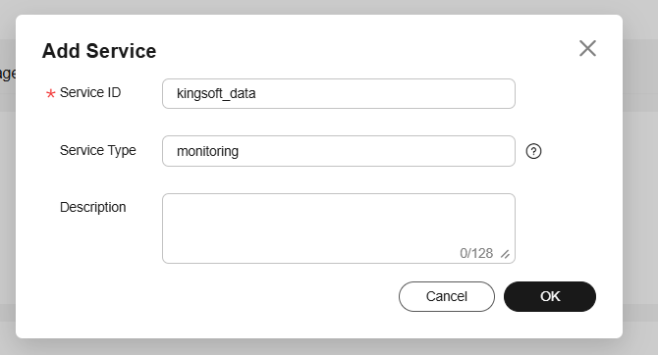
Step 5. Defining Service Properties . Once the service is created, the option to add properties will be enabled at the bottom of the interface.
A property represents a data variable that describes the state, condition, or measurement of a device and is reported periodically to the platform. It will be necessary to define as many properties as there are variables you wish to monitor on the device.

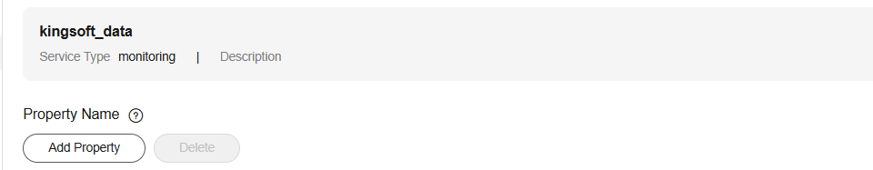

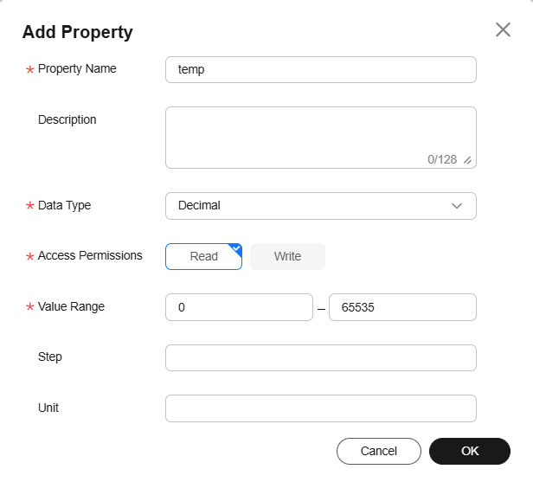
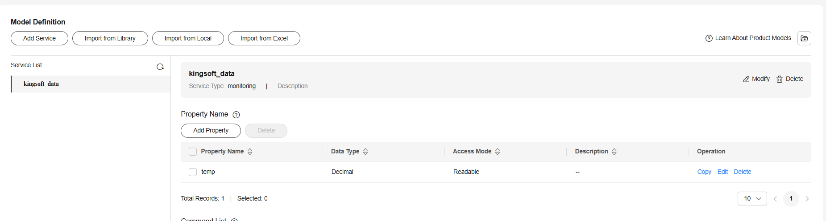
Step 6. Device Registration. Next, you will access the Devices section , where you will define and register the devices that will connect to the platform. Within this section, select the Register Device option , which will create an individual device associated with the previously defined product. During the registration process, the platform will provide key information such as the Device ID, the authentication method, and other parameters necessary for the secure connection of the device with IoTDA .

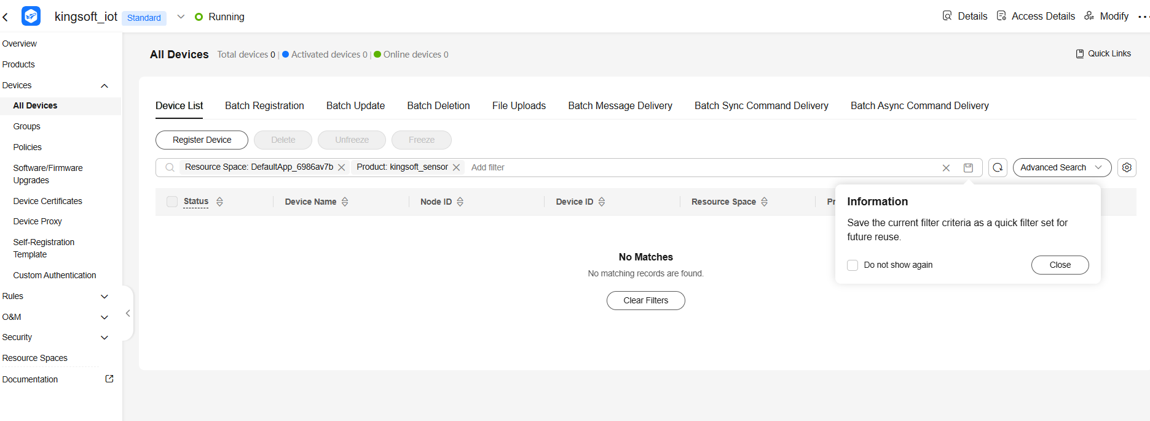

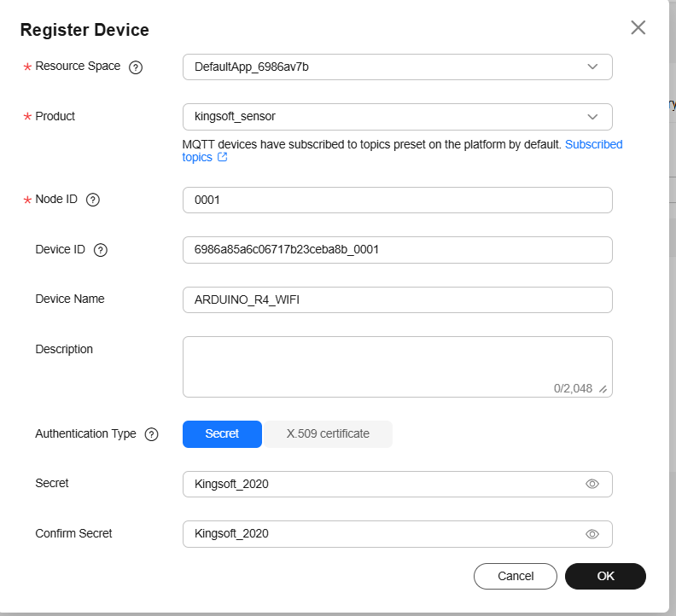
Step 7. Verifying Connection Parameters . Similarly, by returning to the Devices section , you will be able to view the device's access parameters.
To do this, you must select the Check Connection option. Parameters , where the platform will display the information necessary to establish the connection
