GUIDE FOR RDS CONFIGURATION - Relational Database Service
This guide describes the process of creating and configuring a Relational instance Database Service (RDS) on Huawei Cloud.
The RDS service allows the deployment of high-availability managed databases, reducing operational complexity and facilitating work in business environments, with greater security, scalability, and reliability.
Step 1. Accessing the RDS service on Huawei Cloud
In the Huawei Cloud main console, locate and select the Relational service Database Service (RDS).
This option will take us to the main panel where database instances are managed.
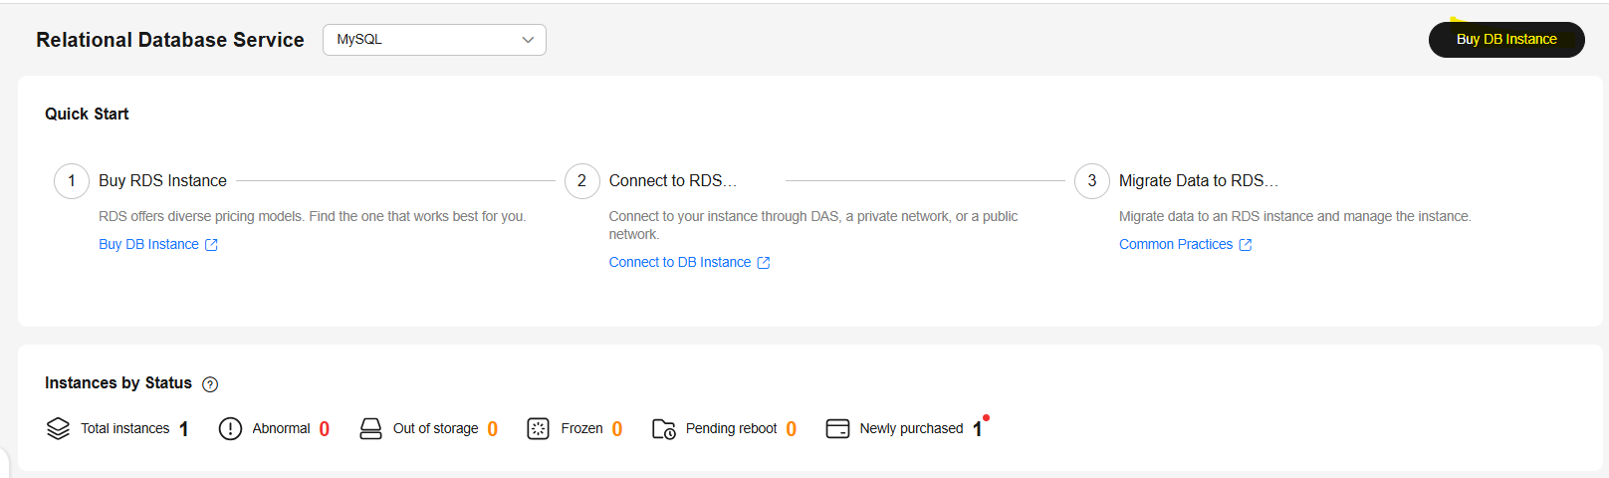
Step 2. Creating a new RDS instance
Within the RDS panel, select the Create DB Instance option to start the database creation wizard.

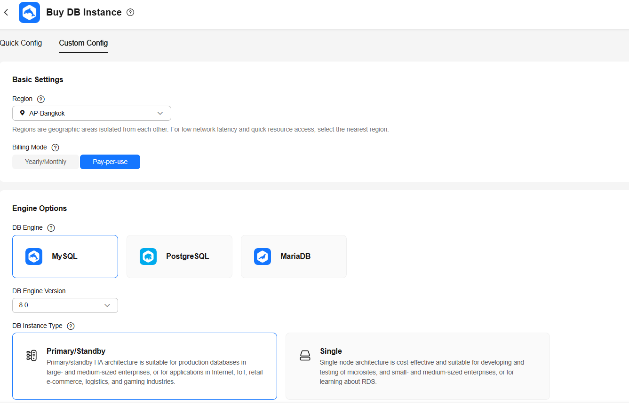
Step 4. Deployment model definition
The deployment model is selected, opting for a high-availability configuration. In this section, the database resources are defined, such as: Number of vCPUs , RAM, and storage capacity. The choice will depend on the expected workload and the test or production environment.

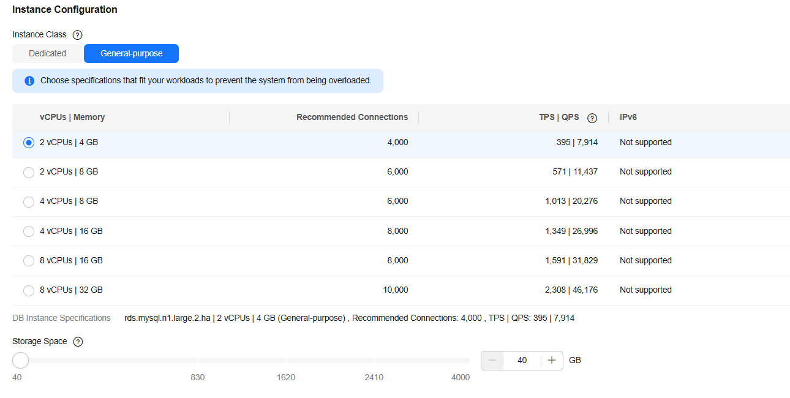
Step 5. Network and security configuration
The VPC, subnet, and security group are defined, allowing control over which servers or IP addresses can access the database, thus ensuring secure access.

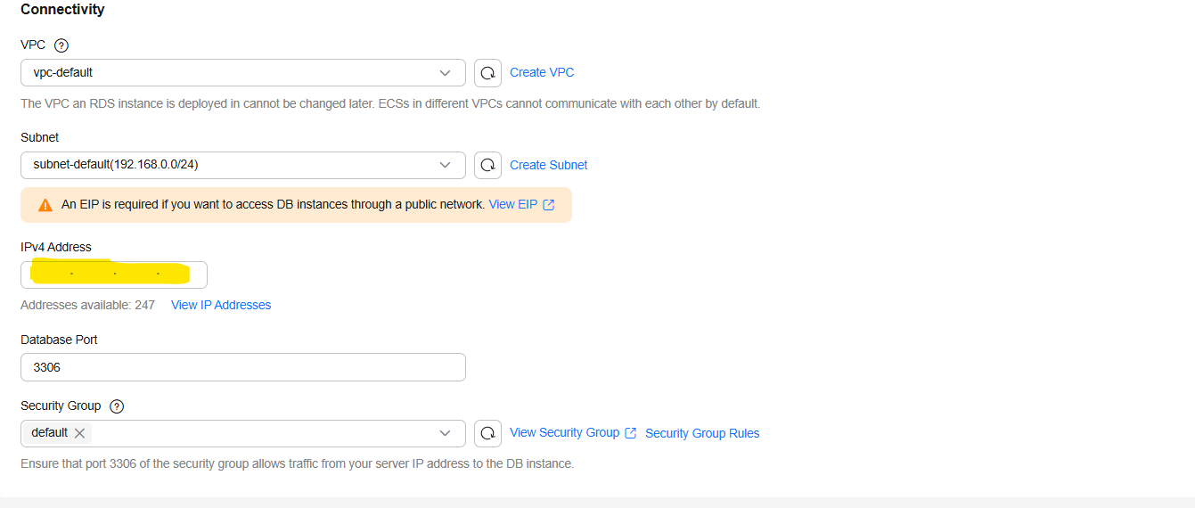

Step 6. Review and creation of the instance
Finally, the entire configuration is reviewed. Once validated, the instance creation is confirmed.

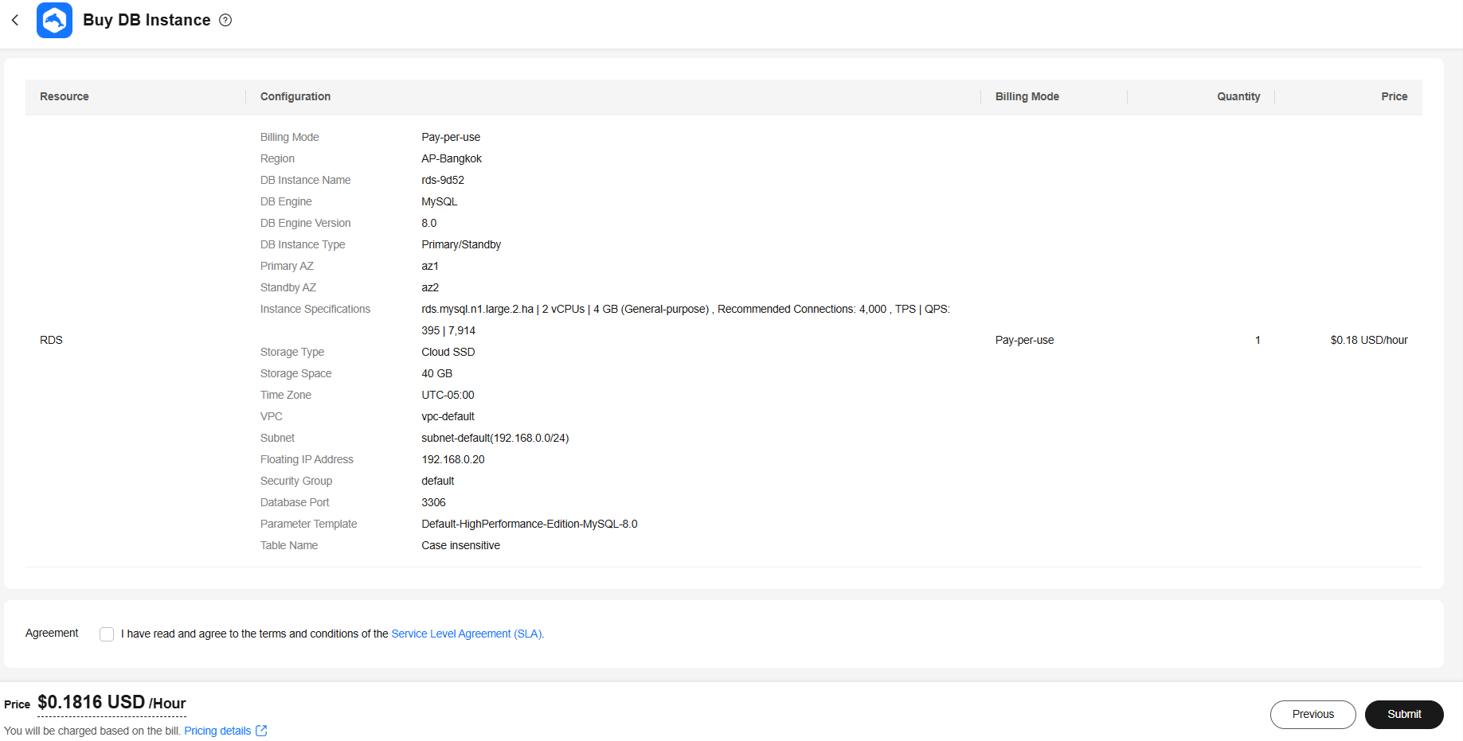

Step 7. Defining the database password
In this step, the password for the database administrator user is defined, which will allow access to and configuration of the RDS instance.
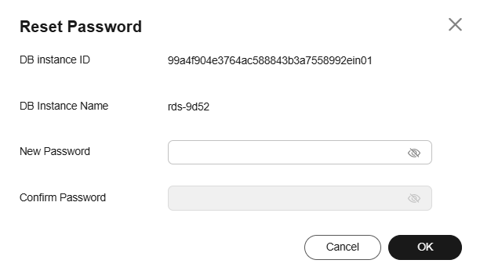
Step 8. Accessing the database instance
Once the instance is created, we log in using the Login option.
We enter the corresponding credentials, using the administrator user ( root ) and the previously defined password.
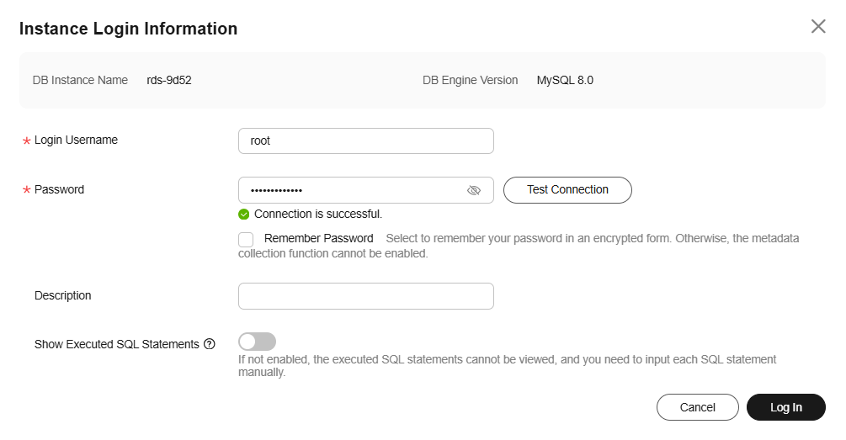
Step 9. Viewing the administration panel
After successfully logging in, the database administration panel is displayed.
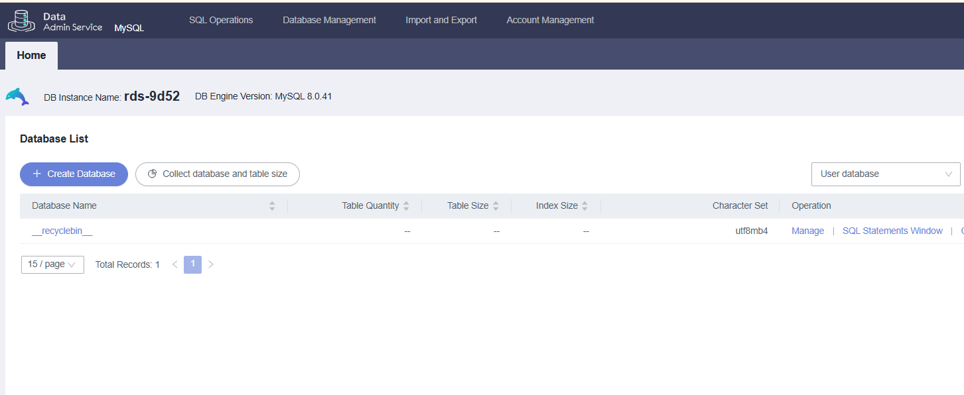
Step 10. Creating a new database
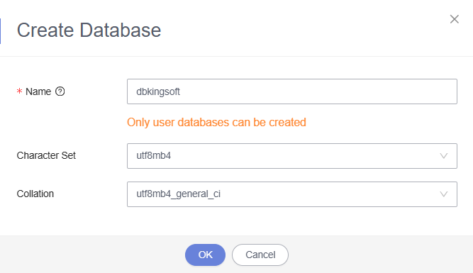
Step 11. Access the database panel and SQL option
Upon logging into the created database, you can view its management panel.
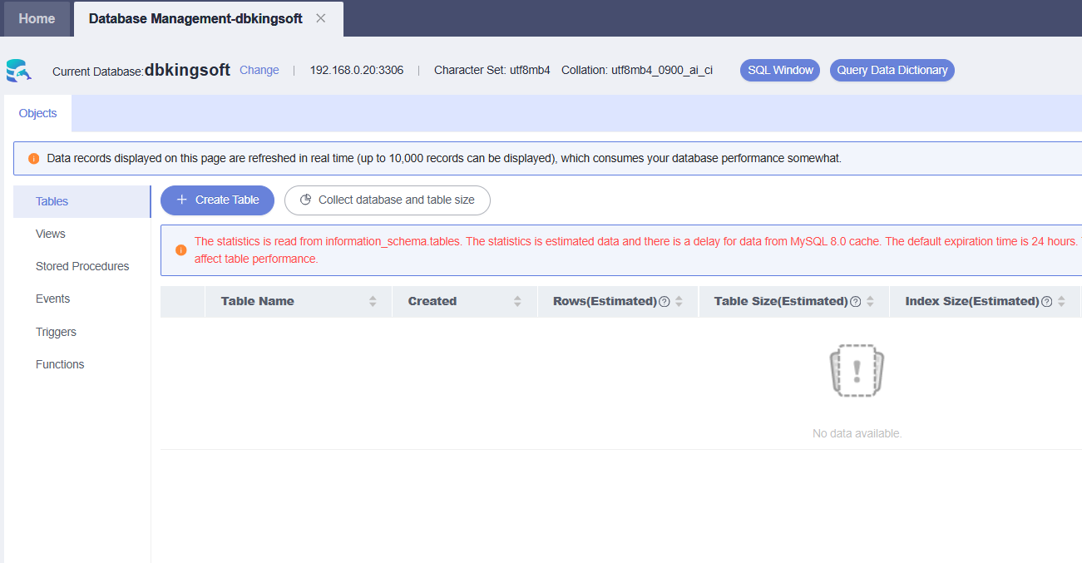

Step 12. Creating an IoT table using SQL
IoT data .
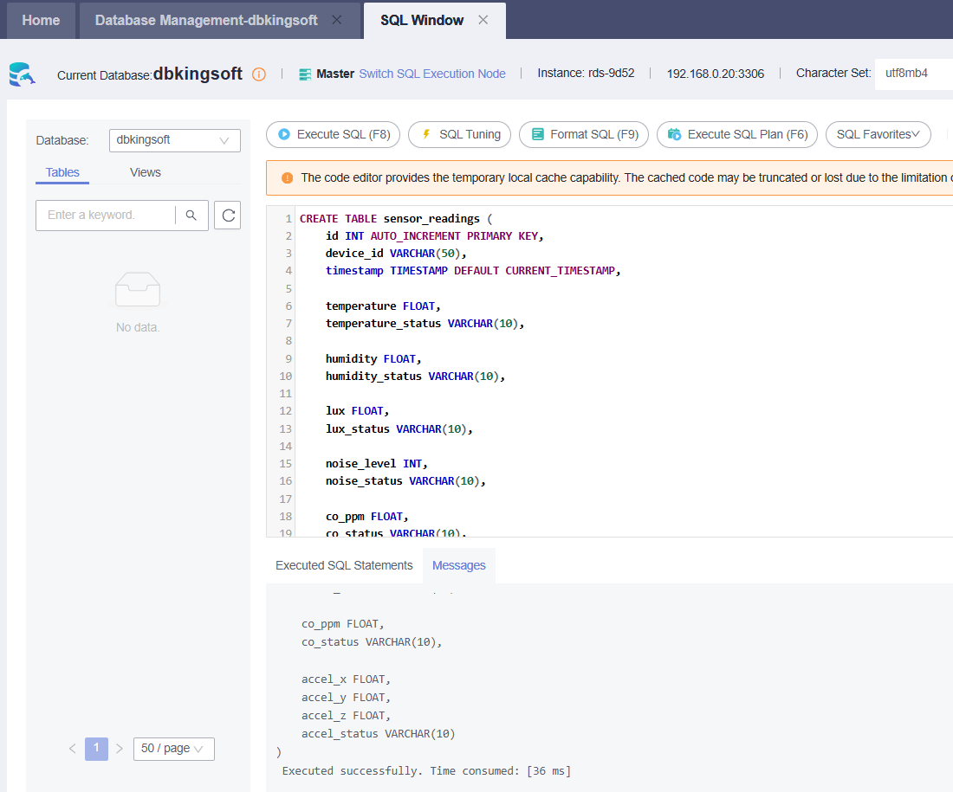

Step 13. User management, parameters and access control
Additionally, from the database administration panel, you can manage users, configure operating parameters, and define the access levels that each user will have.
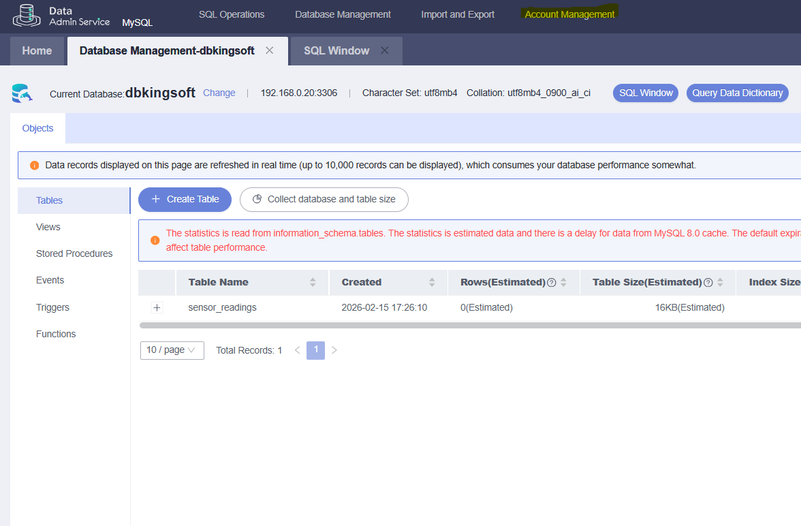

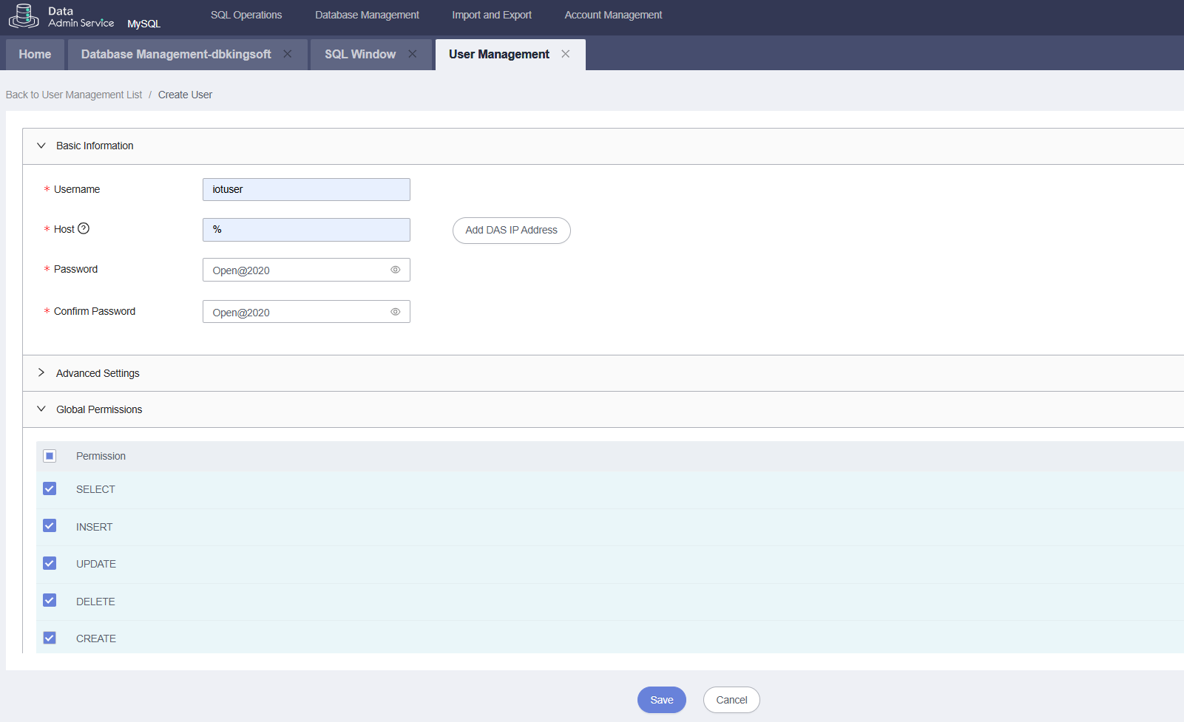
Step 14. Configuring public connectivity for the RDS instance
From the administration panel, we select the option Modify parameters from the RDS instance and then access the Connectivity & Security section.
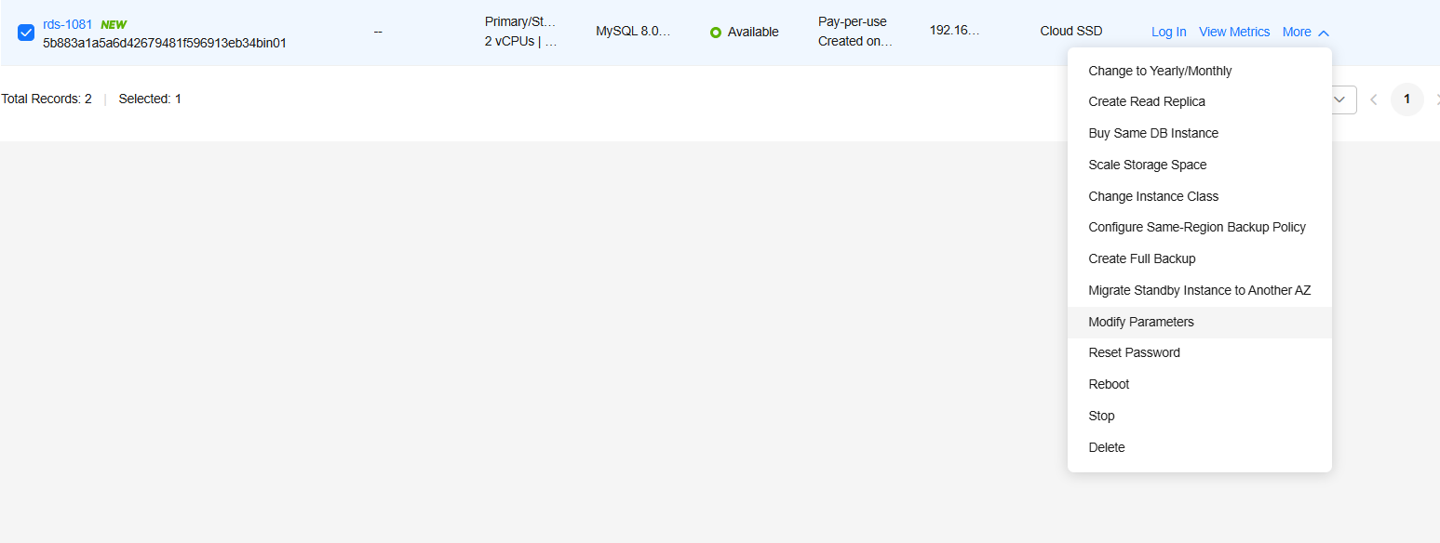
In this section, we will assign an available Elastic IP (EIP) to the RDS instance. Then, we will select the Public Connection option , which will associate the database with a public IP address.
This configuration is mandatory to enable access to the database from other Huawei Cloud services or products, such as IoTDA .

