GUIDE FOR SETTING UP FORWARDING FROM IOTDA TO RDS
The importance of this configuration lies in the ability to capture and store data from IoT devices in a pre-built relational database engine (RDS), which offers high availability, greater reliability, security, and scalability.
The use of IoTDA in conjunction with RDS allows the development of industrial and business solutions capable of handling large volumes of information in real time, facilitating analysis, data persistence, and integration with external applications.
This guide describes the steps necessary to forward the data reported by IoTDA to an existing RDS database.
Step 1. Accessing the IoTDA service
From the Huawei Cloud console, you can access the IoT Device Access (IoTDA) service.
Once inside, you will see the main service administration panel.
Step 2. Access to Data Forwarding
In the IoTDA side menu, select the Rules option and then Data Forwarding. This section allows you to configure rules for forwarding data from IoT devices to other Huawei Cloud services.
Step 3. Creating a new forwarding rule
Within Data Forwarding , select the Create Rule option to create a new data forwarding rule.
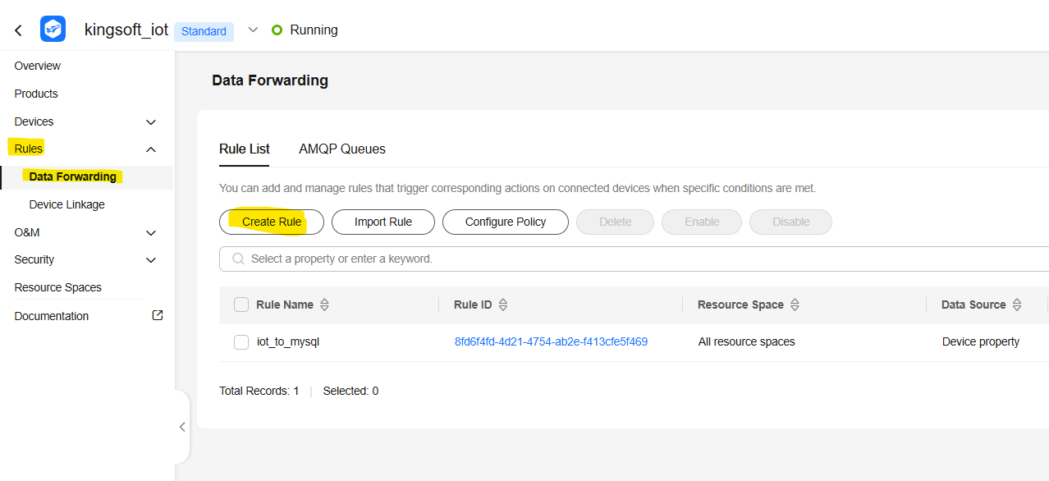

Step 4. Forwarding rule configuration
In this step, you enter the rule name; optionally, you can add a description to make it easier to identify. Next, select Device Property as the data type and define Device Property Reported as the trigger. This option allows you to capture the values that devices send to the IoTDA server. Finally, click Create Rule to create the forwarding rule.
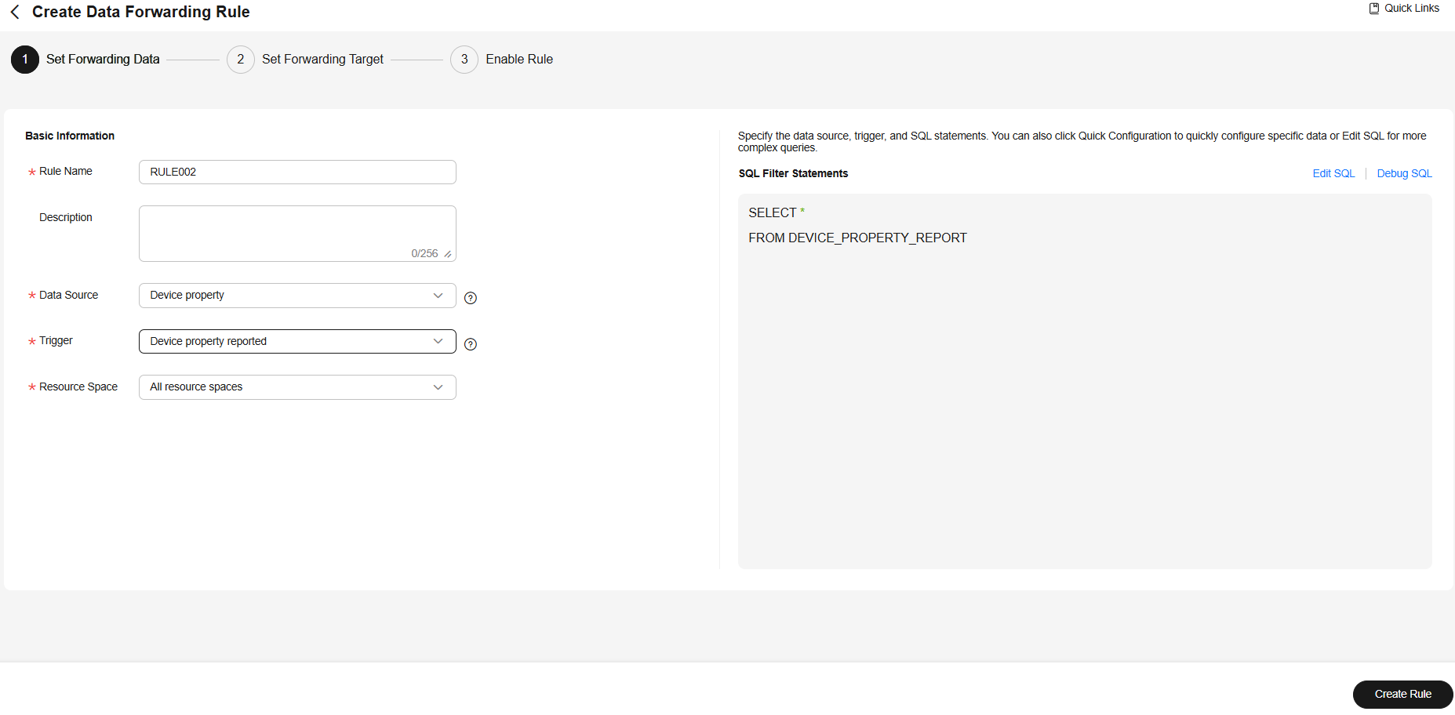
Step 5. Forwarding Destination (RDS) Configuration
Next, the system will ask you to add the forwarding target, where you select the RDS option as the destination. At this point, you must enter the public IP address of the RDS, for which it is necessary that the instance has an Elastic IP (EIP) previously configured.
Finally, the connection details are specified, including the database name, username, and password, which will allow IoTDA to connect correctly to the RDS engine.
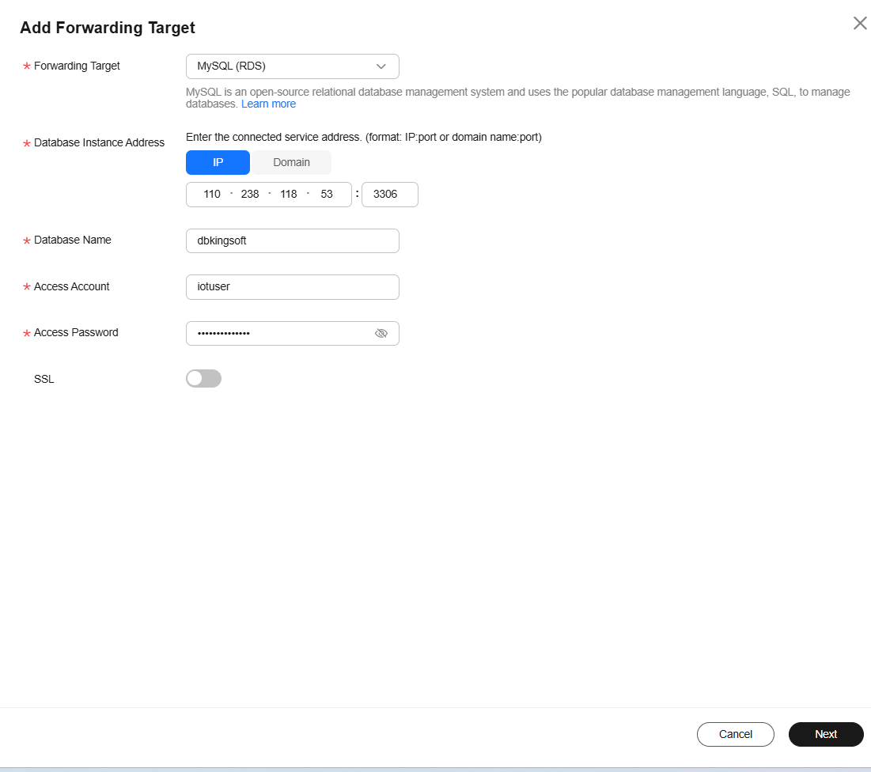
Step 6. Configuring the data content
This step defines which message data will be used.
To access the properties reported by the device, the following structure is used:
notify_data.body.services[0].properties.<property_name>
Example:
notify_data.body.services[0].properties.temp
⚠️ The property name must exactly match the property defined in the product's Model Design .

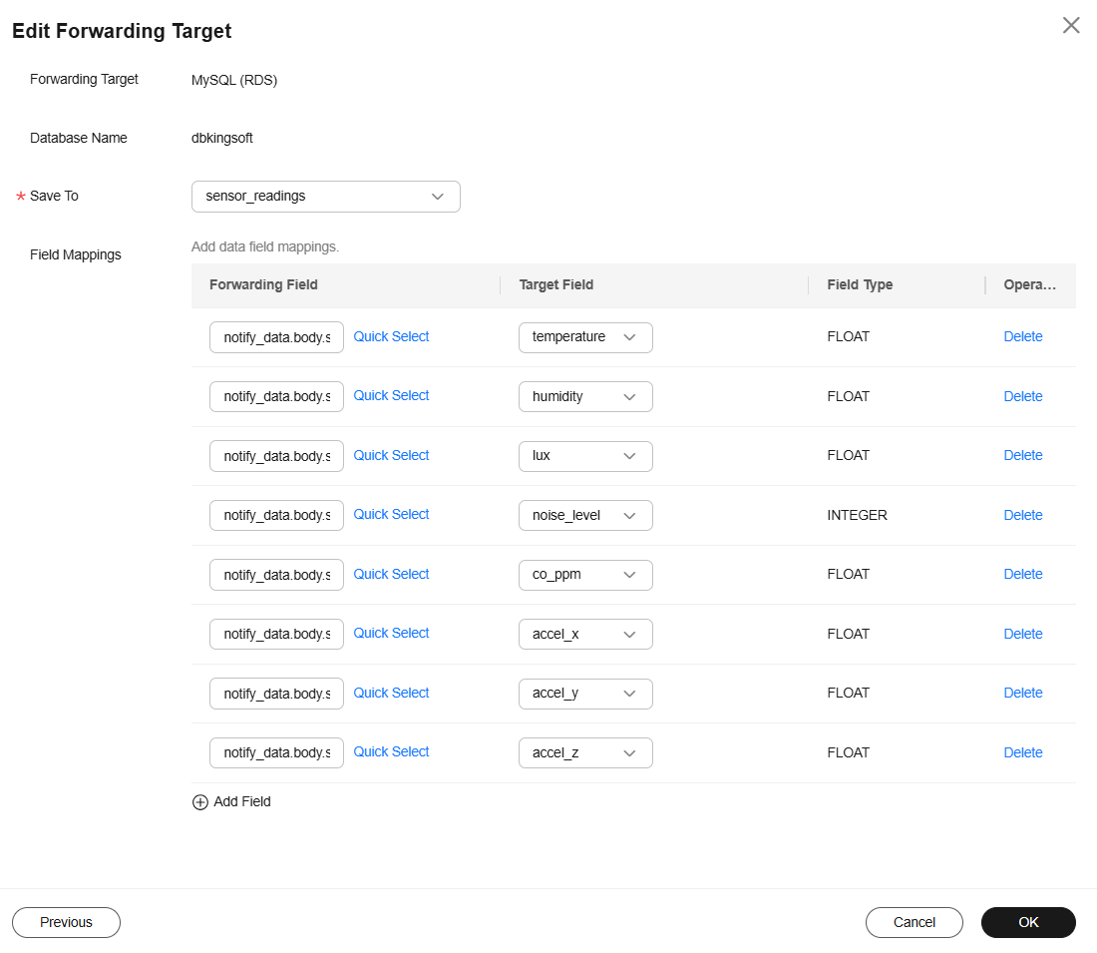

Step 7. Activation of the forwarding rule
The rule remains in the Enabled state, which indicates that it is active and ready to process incoming data.
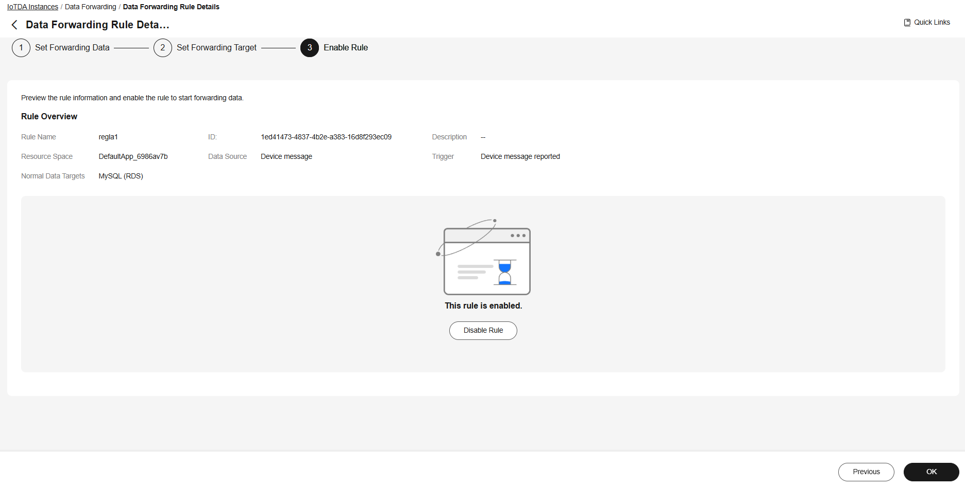
Step 8. Verification of data storage in RDS
Finally, the RDS database panel is accessed to verify that the data is being inserted correctly into the configured table, thus confirming the correct integration between IoTDA and RDS .
