MQTT INSTALLATION GUIDE IN OPENEULER
MQTT is a lightweight messaging protocol for IoT . On our server running OpenEuler , we will install the broker . Mosquitto .
You can find more information at https://mosquitto.org/
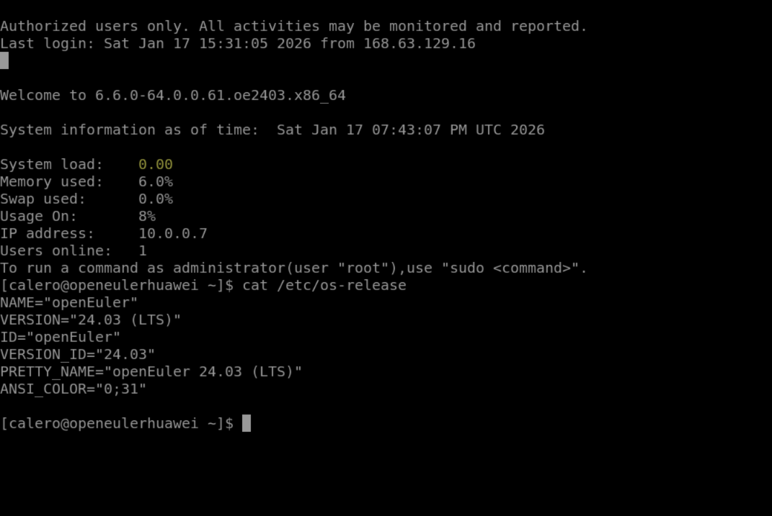
Step 1: Check if it is up to date, sudo dnf update
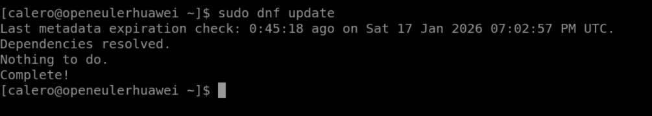
Step 2: Install Mosquito using the following command:
sudo dnf install -y mosquitto
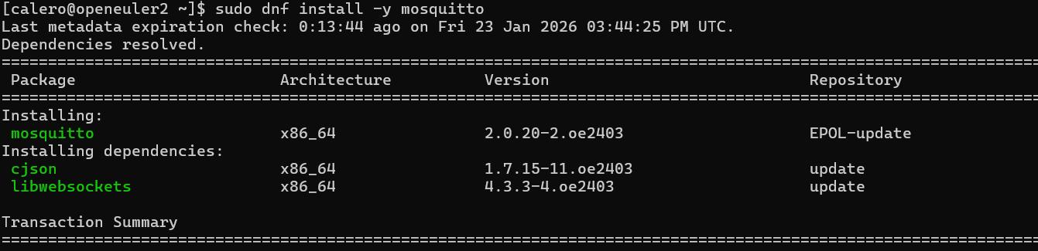
In the end, it should look like this:
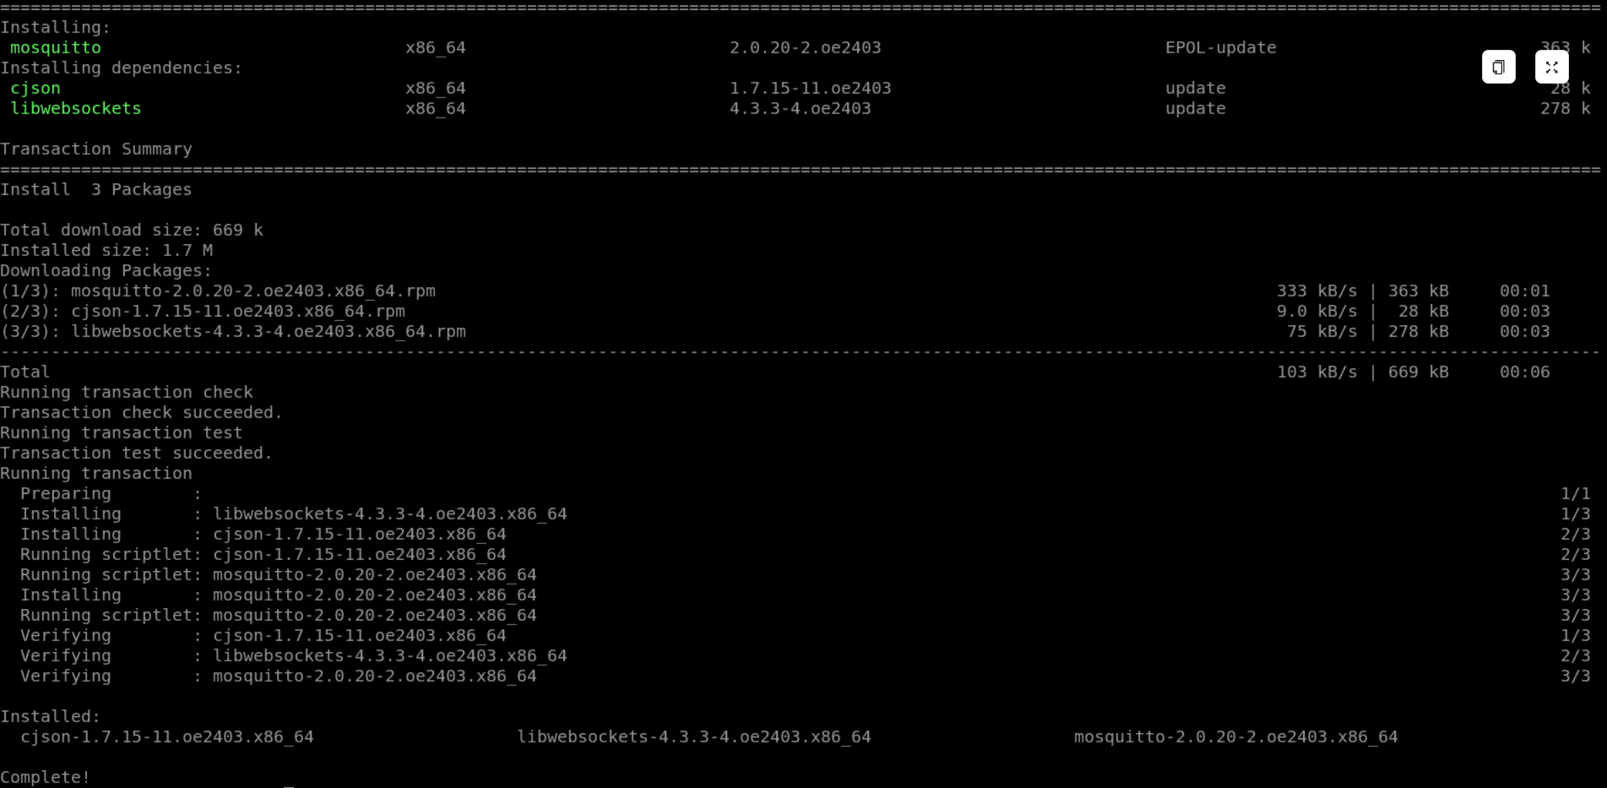
Step 3: Verify that it is installed correctly
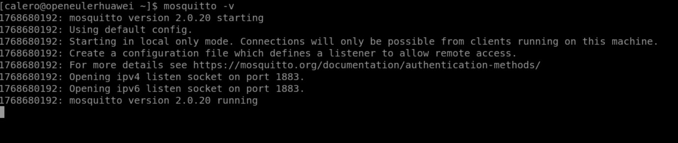
Step 4: Configure the username and password. For this, we will create the user: adminmqtt with the following command :
sweat mosquitto_passwd -c / etc / mosquitto /passwd adminmqtt
Then it will ask for the password; when prompted, we will enter our credentials:
Password : calero2020
Reenter Password : calero2020
(When typing the password, it will not be visible; just press Enter when finished).
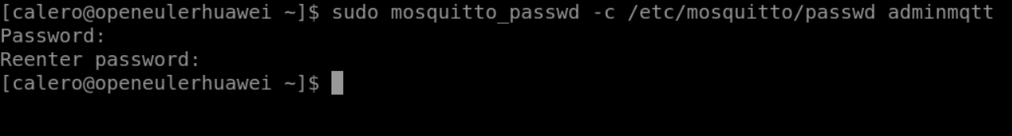
Step 5: Configure the program to allow connections.
nano text editor . Since it's a very versatile text editor, we'll use the following command:
sudo dnf install -y nano
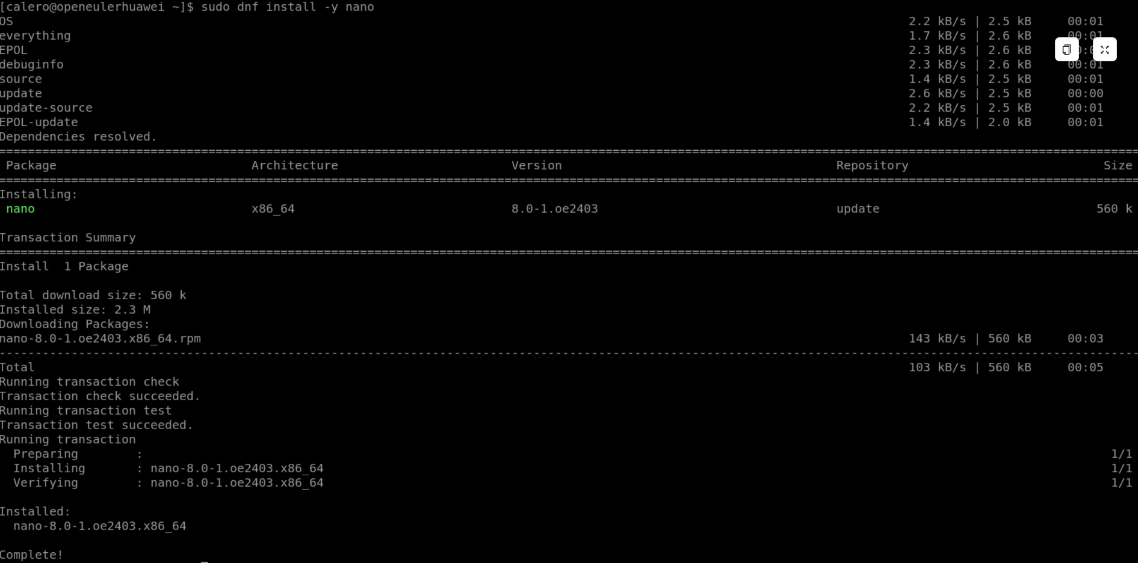
Now we will use the following command to open the configuration file
sudo nano /etc/mosquitto/mosquitto.conf​​​
After running it, a text editor will open with instructions and comments. Once the file is open, add the following text to the end:

# MQTT Port
listener 1883
# Disable anonymous access
allow_anonymous false
# User file​
password_file / etc / mosquitto /passwd
# Persistence
persistence true
persistence_location /var/lib/ mosquitto /
# Logs
log_dest file /var/log/ mosquitto /mosquitto.log
log_type all
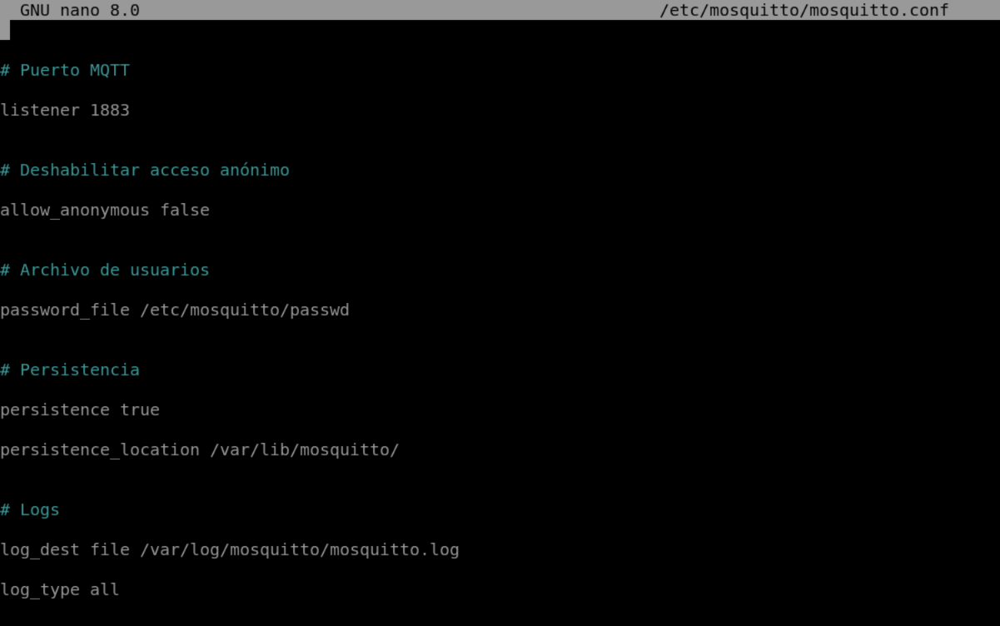
Then we save the changes and confirm
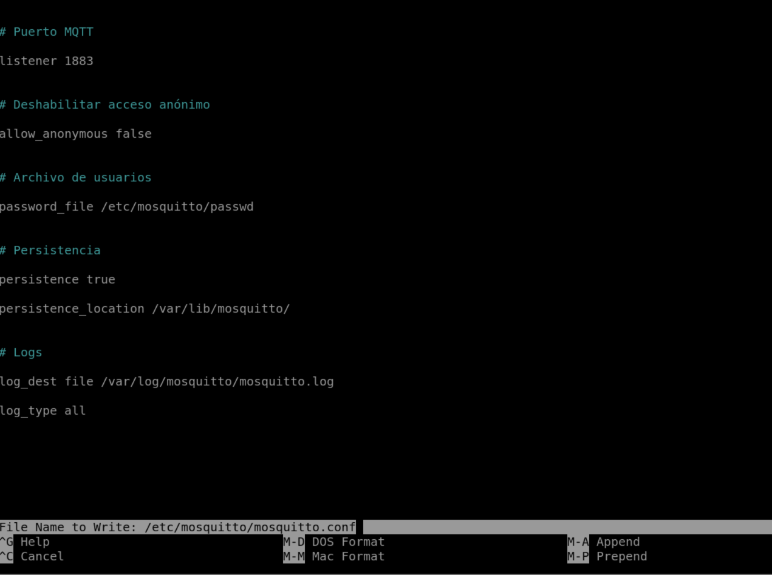
Step 6: The next step will be to grant the necessary permissions to the folder
sweat chown mosquitto:mosquitto / etc / mosquitto /passwd
sudo chmod 600 / etc / mosquitto / passwd
Step 7: Now we run the service and show the status and see that it is active, with this we can now use the broker.
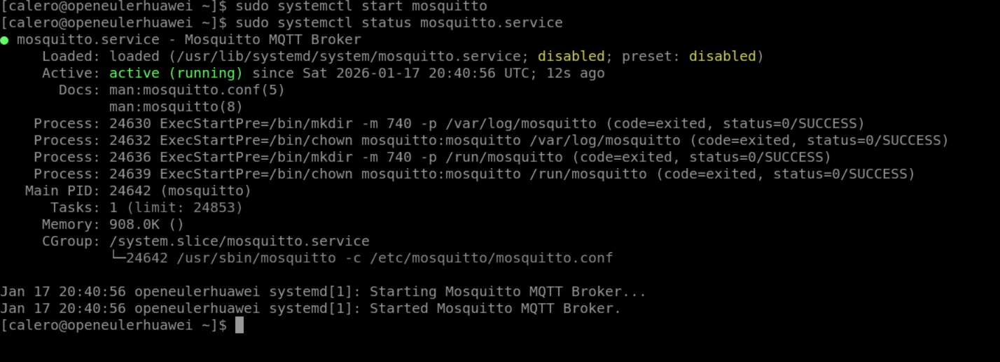
sweat systemctl enable mosquitto
sweat systemctl start mosquitto
sweat systemctl status mosquitto.service
Step 8: Additionally, in order to capture messages on the server, we will install the library version paho Python to be able to work.
pip3 install paho-mqtt
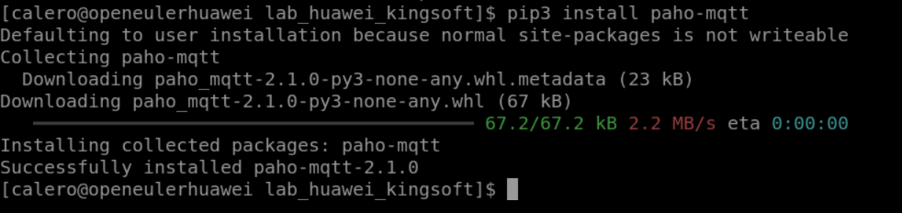
Step 9: You need to enable port 1883 in the firewall settings to gain access.
Azure Servers: Go to the network security group and add a security rule, enter port 1883 and add
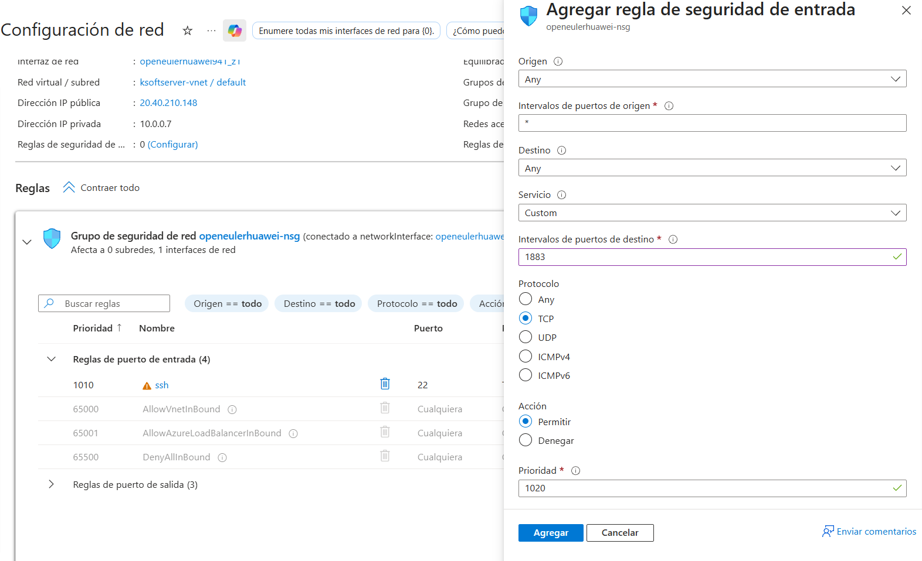
Then we will be able to see which port is active.
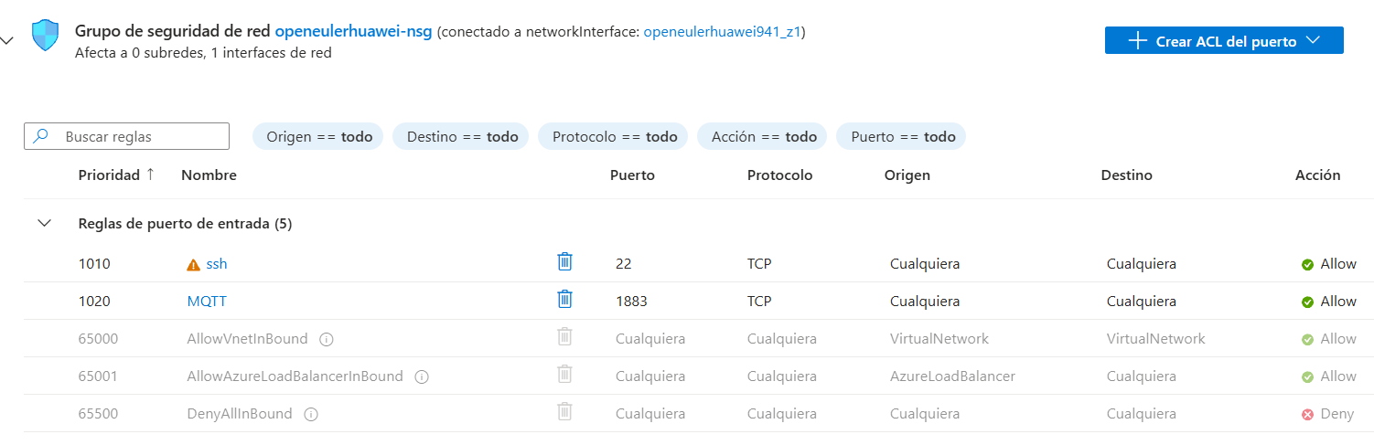
At Huawei's ECS
