- MARIADB INSTALLATION GUIDE IN OPENEULER
MariaDB is an open-source relational database management system developed as a compatible and improved alternative to MySQL. It is characterized by its high performance, stability, and security, and is widely used in web applications, IoT systems , and enterprise environments.
For more information visit https://mariadb.org/
Step 1: We performed a review of pending updates
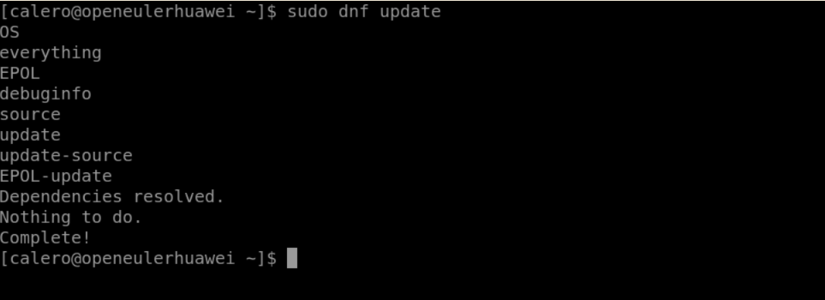
Step 2: We begin installing MariaDB Server using the following command
sudo dnf install mariadb -server mariadb -y
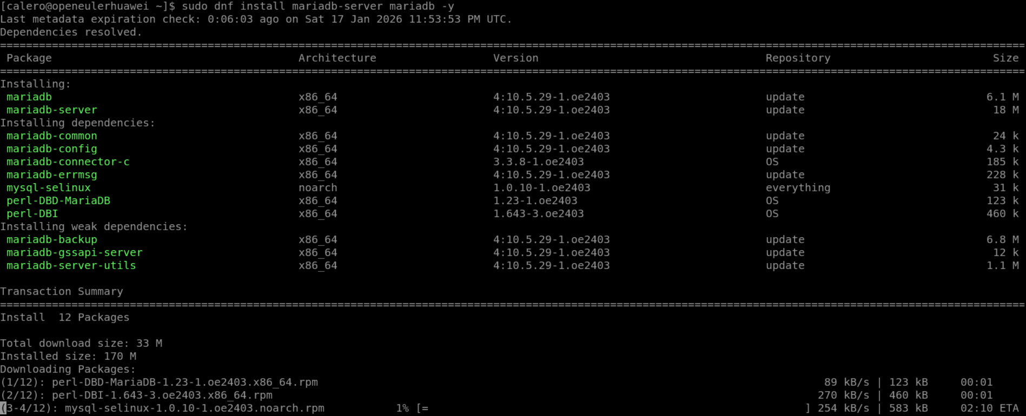
Step 3: Now it will be necessary to start and enable the service using the following commands
sweat systemctl start mariadb
sweat systemctl enable mariadb
also observe the status through the command
sudo systemctl status mariadb
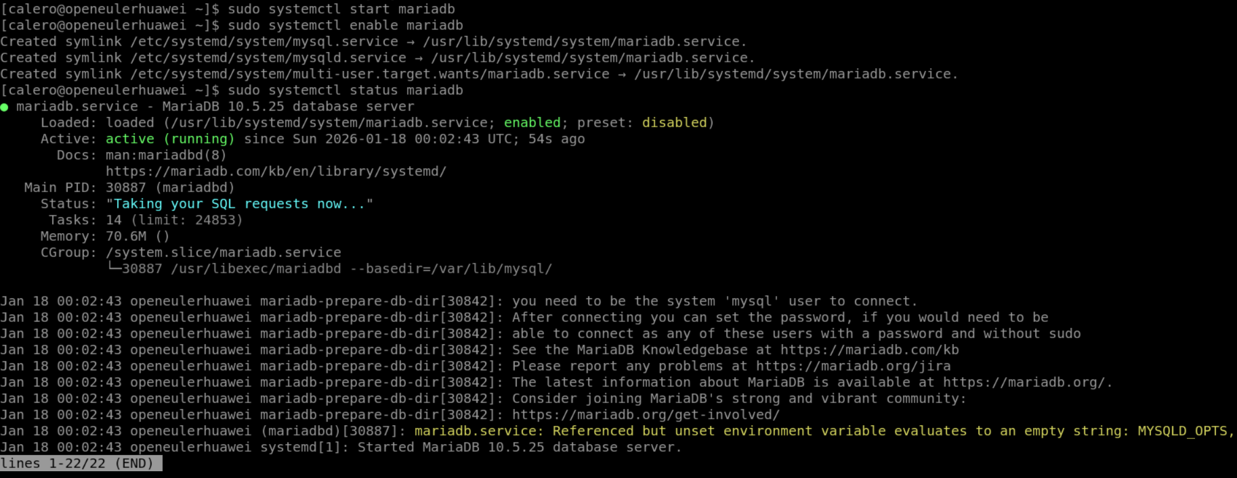
Step 4: Now we will enter the engine through the command
sudo mysql -u root -p
It will ask for a password, but since it's not configured, we'll just press Enter.
If we agreed correctly, he will welcome us.
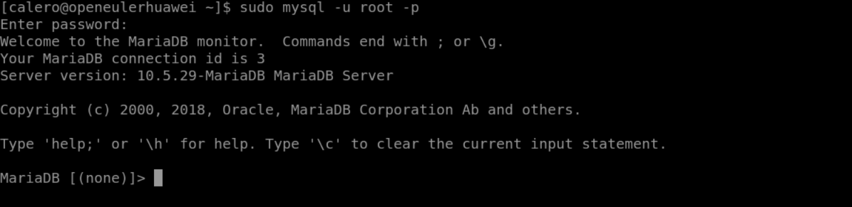
Step 5: Now we will secure our root user , the user who controls the entire engine. To do this, we will assign a password using the command
ALTER USER ' root '@'localhost ' IDENTIFIED BY 'Kingsoft@2026 ' ;
FLUSH PRIVILEGES;
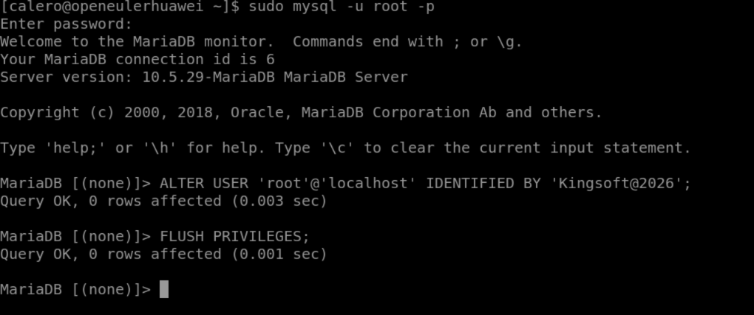

Step 6: We will also use the security script to improve the security of our database since it will be exposed via the public IP address; this will be done directly in the terminal.
sudo mariadb-secure-installation
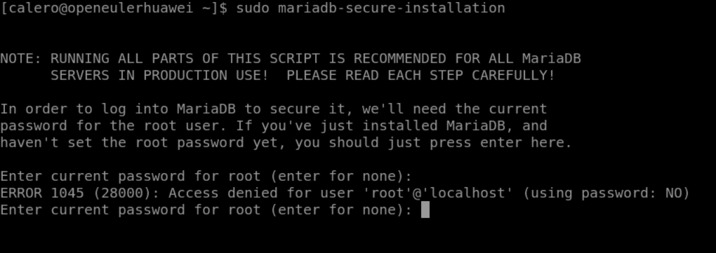
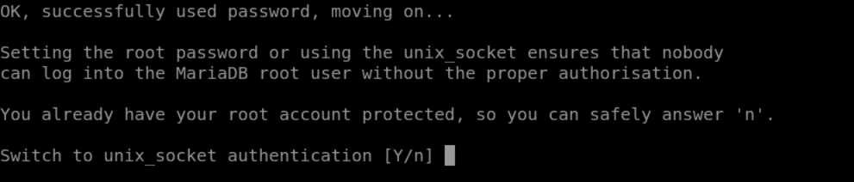
We put Y, so that the root only enters with sudo mariadb
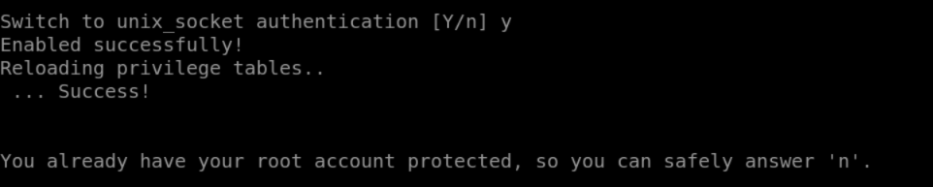
Then we can change the root password but we've already done that, it also asks us to delete anonymous users.
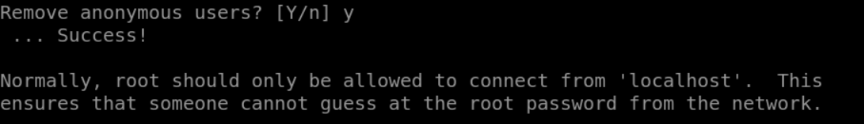
root remote access
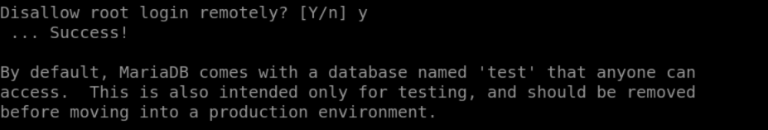
We removed the test tables, as they can be used maliciously, and finally reloaded the privileges.
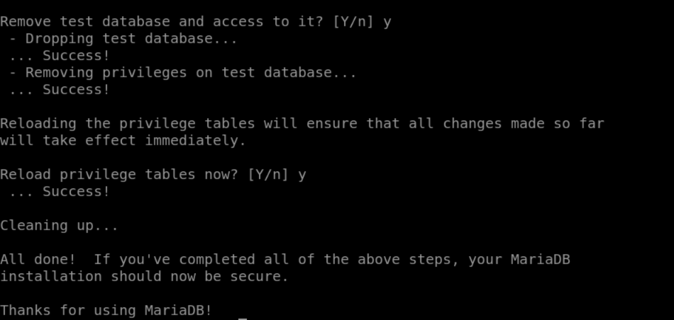

- LABORATORY CONFIGURATION GUIDE USING IOT DATABASE
Step 1: For our lab we will create the database that we will use in the applications.
db_iot_kingsoft database
CREATE DATABASE db_iot_kingsoft CHARACTER SET utf8mb4 COLLATE utf8mb4_general_ ci;
Step 2: We create the kingsoft user and their password, the one who will interact with the database and will have access through the applications
CREATE USER ' kingsoft '@'localhost' IDENTIFIED BY 'Open@2026 ';
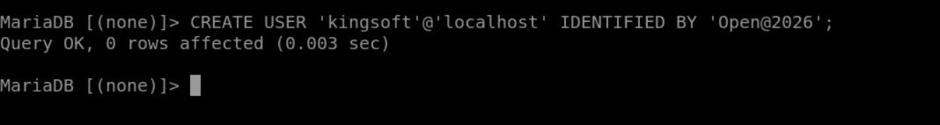
Step 3: We assign basic permissions to the user Kingsoft
GRANT CREATE, SELECT, INSERT, UPDATE, DELETE ON db_iot_ kingsoft.* TO ' kingsoft '@'localhost ';
FLUSH PRIVILEGES;
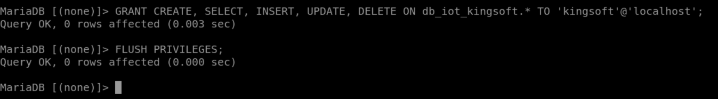
This way, if an attacker obtains our data, they will not be able to cause significant damage to the database. To view the permissions granted to a user, we will use:
SHOW GRANTS FOR ' kingsoft '@'localhost ';
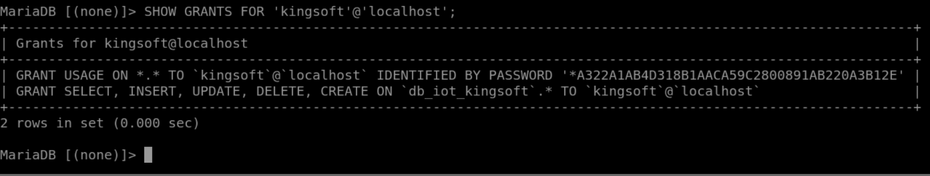
Step 4: Now, to load the database structure we'll use for our system, we'll upload the SQL file containing the basic structure for storing and manipulating our data. The code we'll use to upload the SQL file to the engine is as follows:
mysql -u kingsoft -p db_iot_kingsoft < 1.7_bd.sql
* Note: The 1.7_bd.sql file is downloaded using the command:
git clone https://github.com/Ksoft24/lab_huawei_kingsoft.git
If you do not have git installed : sudo dnf install git -y
Step 5: To communicate with the database using Python, we will use a powerful library created by MySQL, which allows us to perform various operations . To install it, we will use the following code:
pip install mysql -connector-python
