[PM2.5 sensor - G3 PMS3003](http://njiot.blogspot.tw/2016/01/pm25-sensor-g3-pms3003.html)

Ref: <http://www.icshop.com.tw/product_info.php/products_id/20460>  
  
我在 ICShopping 買了一個 G3 PMS3003.

[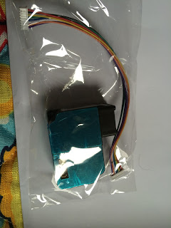](http://3.bp.blogspot.com/-4JeP9V0UbPs/VpY34PyRUNI/AAAAAAAAEr8/qdVu1QvWEEQ/s1600/IMG_9270.JPG)

他是透過 uart 溝通, 我們可以將 RXD/TXD 與 Ameba 的 D0/D1 對接.  
Serial1 (D0/D1) 使用可參考 :  
<http://njiot.blogspot.tw/2015/08/arduino-ameba-uart-serial.html>

[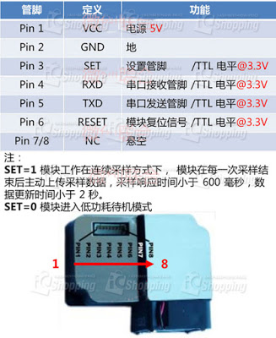](http://4.bp.blogspot.com/-S55hnMJunh4/VpYqtL54T5I/AAAAAAAAErE/e1R_4dzXDEw/s1600/pms3003.jpg)

比較麻煩的是接線, 他的頭是 Molex 1.25mm 間距.

所以首先我去買了一條 1.25mm 端子線.

[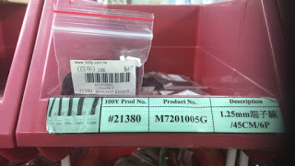](http://4.bp.blogspot.com/-NMaGBBp9Ehk/VpY4WpUfQxI/AAAAAAAAEsE/cZzMYrD1Irs/s1600/molex.jpg)

接下來因為 1.25mm 比較細, 所以另外又加工把 2.54 的排插焊上去.

[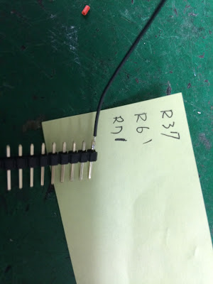](http://1.bp.blogspot.com/-cFkUPBhAcSQ/VpY6BMNsJfI/AAAAAAAAEsQ/dXqndJgKFKA/s1600/IMG_9295.JPG)

斜口鉗剪斷, 並用膠帶貼好,

我買的這條線, 紅色位置和實際 VCC 位置不同, 只好自行在膠帶上做記號.

[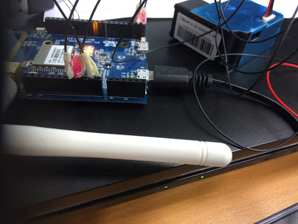](http://3.bp.blogspot.com/-U1ov5qD0KN0/VpY61gclNrI/AAAAAAAAEsg/yGFMkwTcOzI/s1600/IMG_9298.JPG)

pin1 VCC - 接 5V

pin2 GND - 接 GND

pin3 SET - 接 3.3V

pin4 RX - 接 D1

pin5 TX - 接 D0

他傳輸的格式 :

[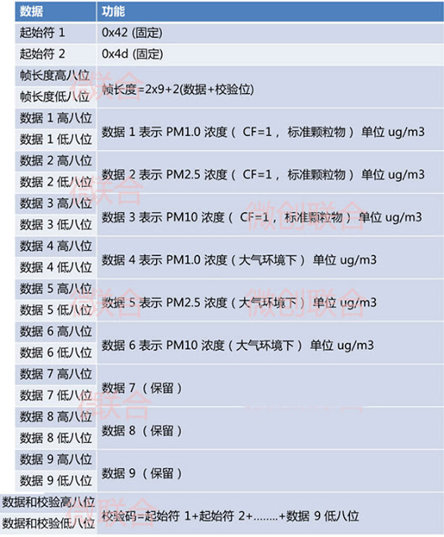](http://4.bp.blogspot.com/-IONqD_oXoQ4/VpY130Zb14I/AAAAAAAAEro/3WAapBtF_54/s1600/pms3003-2.jpg)

測試程式 :  
  
<https://github.com/neojou/arduino-ameba/blob/master/example/pms3003-test/pms3003-test.ino>

|  |
| --- |
|  |
| long pmcf10=0; |
|  | long pmcf25=0; |
|  | long pmcf100=0; |
|  | long pmat10=0; |
|  | long pmat25=0; |
|  | long pmat100=0; |
|  |  |
|  | char buf[50]; |
|  |  |
|  | void setup() { |
|  | // put your setup code here, to run once: |
|  | Serial.begin(9600); |
|  | Serial1.begin(9600); |
|  | } |
|  |  |
|  | void loop() { |
|  | // put your main code here, to run repeatedly: |
|  | int count = 0; |
|  | unsigned char c; |
|  | unsigned char high; |
|  |  |
|  | while (Serial1.available()) { |
|  | c = Serial1.read(); |
|  | if((count==0 && c!=0x42) || (count==1 && c!=0x4d)){ |
|  | Serial.println("check failed"); |
|  | break; |
|  | } |
|  | if(count > 15){ |
|  | Serial.println("complete"); |
|  | break; |
|  | } |
|  | else if(count == 4 || count == 6 || count == 8 || count == 10 || count == 12 || count == 14) { |
|  | high = c; |
|  | } |
|  | else if(count == 5){ |
|  | pmcf10 = 256*high + c; |
|  | Serial.print("CF=1, PM1.0="); |
|  | Serial.print(pmcf10); |
|  | Serial.println(" ug/m3"); |
|  | } |
|  | else if(count == 7){ |
|  | pmcf25 = 256*high + c; |
|  | Serial.print("CF=1, PM2.5="); |
|  | Serial.print(pmcf25); |
|  | Serial.println(" ug/m3"); |
|  | } |
|  | else if(count == 9){ |
|  | pmcf100 = 256*high + c; |
|  | Serial.print("CF=1, PM10="); |
|  | Serial.print(pmcf100); |
|  | Serial.println(" ug/m3"); |
|  | } |
|  | else if(count == 11){ |
|  | pmat10 = 256*high + c; |
|  | Serial.print("atmosphere, PM1.0="); |
|  | Serial.print(pmat10); |
|  | Serial.println(" ug/m3"); |
|  | } |
|  | else if(count == 13){ |
|  | pmat25 = 256*high + c; |
|  | Serial.print("atmosphere, PM2.5="); |
|  | Serial.print(pmat25); |
|  | Serial.println(" ug/m3"); |
|  | } |
|  | else if(count == 15){ |
|  | pmat100 = 256*high + c; |
|  | Serial.print("atmosphere, PM10="); |
|  | Serial.print(pmat100); |
|  | Serial.println(" ug/m3"); |
|  | } |
|  | count++; |
|  | } |
|  | while(Serial1.available()) Serial1.read(); |
|  | Serial.println(); |
|  | delay(5000); |
|  | } |
|  |  |

測試結果  
  
     在我新竹座位量 PM2.5 < 10 ug/m3 , 應該還可以..

[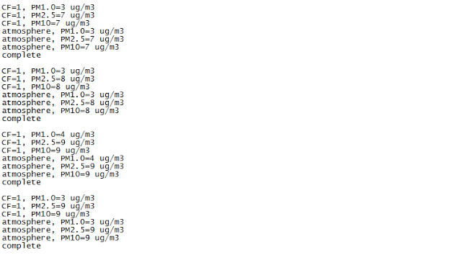](http://2.bp.blogspot.com/-YI8fzpDIuIU/VpY2_S_IUmI/AAAAAAAAEr0/R7n4_Lgm3K8/s1600/pms3003-result.png)

在我台北座位, 看來指數高很多... 台北空氣真的不大好...

[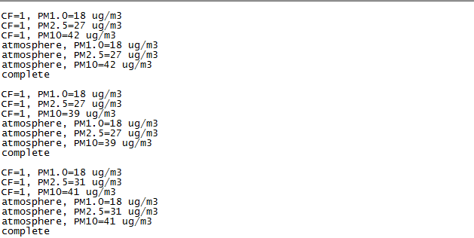](http://4.bp.blogspot.com/-SpzUxLfSUKo/Vpi9JmfYEII/AAAAAAAAEtQ/3KubistOyPM/s1600/pm2.5-1.png)