**ENA Storage and Production Process:**

For your best understanding the flow diagram is pasted below:

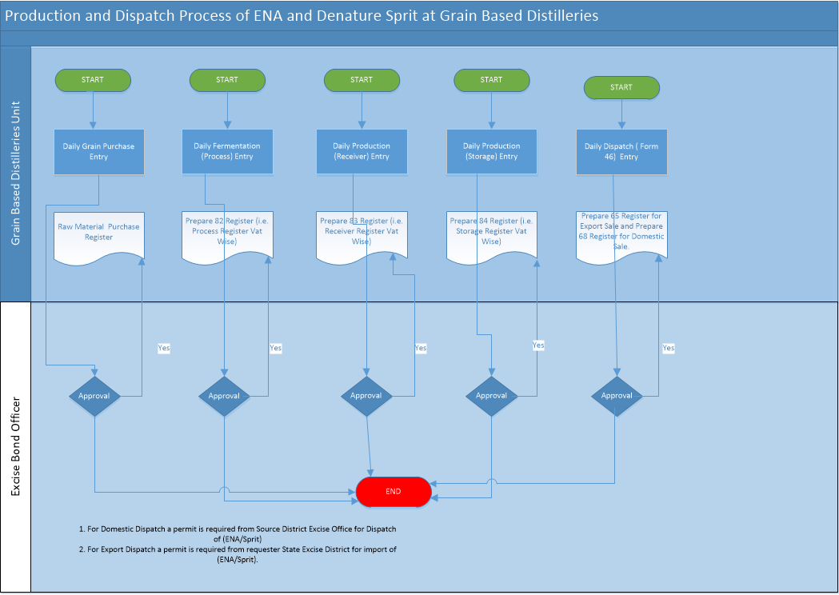

**Grain Purchase Document**

**This document is used for grain purchase the detail required for the document is below:**

1. **Financial Year – Drop Down of year (User Selection)**
2. **Receipt No – Not editable text box – Auto generated in corresponding to the Physical year.**
3. **Date of Receipt – Calendar Control – User Input. User not able to select the date greater than the current date.**
4. **Party Name – Text Box – User Input, Would accept the Alpha Numeric.**
5. **Bill No - Text Box – User Input, Would accept the Alpha Numeric.**
6. **Unit of Measurement – Drop Down (Get the Unit of Measurement from UOM table)**
7. **Receipt Qty – User Input, Would accept Number with decimal value.**
8. **Remarks – Text Box – User Input.**

**Save as Draft and Submit functionality would have.**

**After Submit, the document would not able to change or modify.**

**Receipt & Issue Register of Grain Purchase and Issue**

**The format of Receipt & Issue Register would be as below:**

Filter would be:

Organization Name : Drop Down (If Login form the Distillery Unit only specific Unit Name would be shown, If Login Form Excise District Officer all the Distillery would be shown in the Drop down list persist in their district, If the login from Deputy Commissioner (HO), Commissioner or Admin all the Distilleries would be shown in the List)

From Date : User is able to select the start date to view the report

To Date – User is able to select the end date to view the report

|  |  |  |  |  |  |  |  |  |
| --- | --- | --- | --- | --- | --- | --- | --- | --- |
| Date | Opening Balance | Party Name | Receipt No | Party Bill No | Receipt Qty | Issue Qty | Wastage Qty | Closing Balance  (Opening Balance +Receipt)-Issue |
| 01/04/2020 | 10000 | Ram Naresh | 00001 | R/101 | 2200 | 2000 | 0 | 10200 |
| 02/04/2020 | 10200 |  |  |  |  | 1200 |  | 9000 |
| 03/04/2020 | 9000 | Umesh Singh | 00002 | U/105 | 1500 | 1000 |  | 9500 |
| 04/04/2020 | 9500 | Ram Naresh | 00003 | R/108 | 1200 | 1000 |  | 9700 |
| Total |  |  |  |  | 5900 | 5200 |  |  |

Please Note the Issue Qty would get reflected from From 82 Register document Entry.

**Export Sale of ENA/Impure Sprit (i.e. Out State Sale)**

1. NOC is required (Process of NOC is below)
2. Distilleries have to make a request for Sale of ENA/Impure Sprit to sale in out of state Bihar (i.e. NOC request) with all the details required.
3. The request raised by Distilleries traversed to Excise District Officer Desk for review and recommendation.
4. District Excise Officer will verify all the required document, based on the document District Excise officer will approve or reject the request.
5. If Approve from District Excise Officer then the document will traversed to concerned officer desk (i.e. HO Deputy Commissioner (hodyco) for approval.
6. HO Deputy Commissioner will also verify all the related document and found ok then give his consent to Commissioner for approval else Refer back to District Officer if any clarification is required.
7. If commissioner found all are ok then approve else refer back to HO Deputy Commissioner if any clarification is required.
8. If the NOC request is approved from Commissioner Desk then HO Deputy Commissioner will issue and print the NOC for to requester. The same information shown to District Excise Officer and requester.

For best understanding the Flow diagram is pasted below:

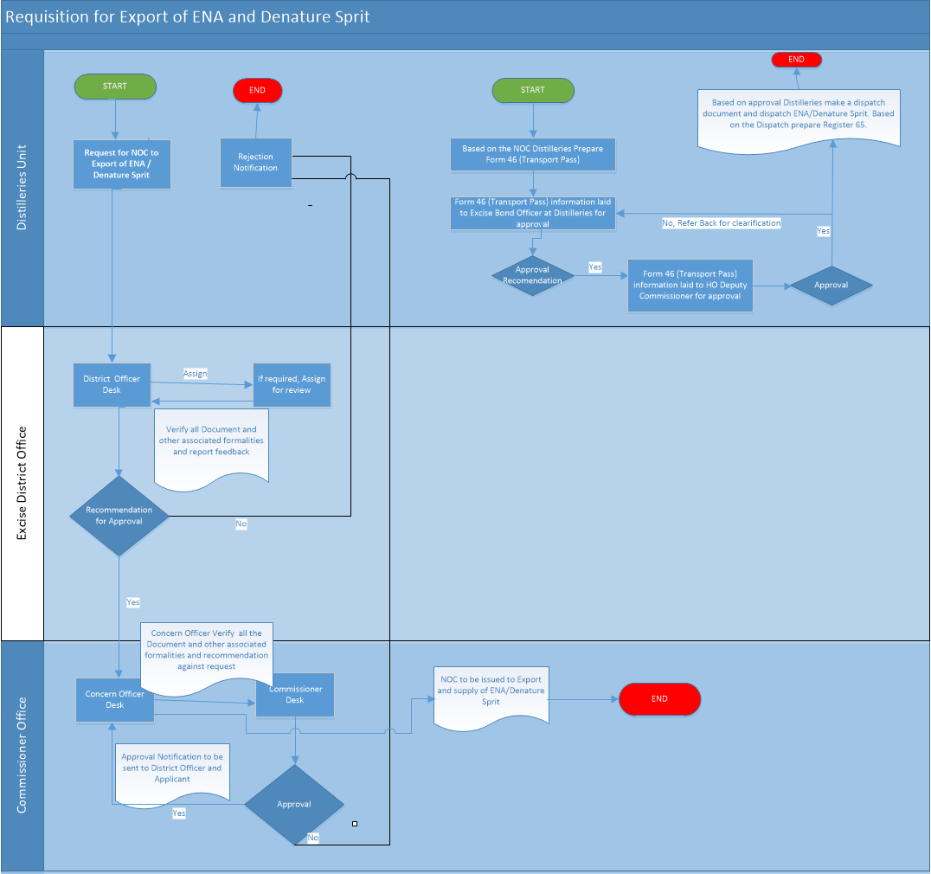

The NOC Form need to be designed as below:

1. Financial Year – Current NOC design as Ethanol
2. NOC No - Current NOC design as Ethanol
3. NOC Date - Current NOC design as Ethanol
4. Name of Applicant – Current NOC design as Ethanol
5. Customer Name - Current NOC design as Ethanol
6. Customer Address - Current NOC design as Ethanol
7. Email Id - Current NOC design as Ethanol
8. Mobile No - Current NOC design as Ethanol
9. Tender No/PO Number/Permit No - Current NOC design as Ethanol
10. Export Order No - User Input (Accept the values as Alpha Numeric)
11. User Input (Accept the values as Alpha Numeric)
12. NOC For - Current NOC design as Ethanol
13. For Detail window (Same as current NOC design but need changes as below).
14. Product Name – Text Box (User Input) – Mandatory
15. Qty (BL) – Text Box (User Input) - Mandatory

The Status of request need to be shown at Requester and all the stakeholder as well.

The NOC approval process screen is almost same but there may be some changes required in the field Level as such as Depot Name as Product Name. You have to take care for the same.

NOC print format is same as current Print Format but taken consideration of product name etc.

1. Transport Pass (Form 46 Entry document)
2. New document need to be make the details of document what we need to capture. Detailed design document is below:
3. Transport pass used for both domestic and export sale. Detailed design document is below:

**Design Document of Transport (Form 46) for Export**

1. Financial Year – Drop Down of year (User Selection)
2. Transport Pass No – Not Editable Text Box – Auto generated No (Document No generation would be as District Code +Distilleries Unit Code+ Financial Year Wise (e.g. Bhojpur/Bihar Distilleries/2020-2021/E00001…..so on)
3. Transport Pass Date – Calendar Control – User Input (Accept the date not greater than the current date)
4. Dispatcher Unit Name & Address – Not Editable Text Box (Hold the logged unit Name & Address)
5. NOC No – Dropdown (Hold all the approved NOC and whose quantity is pending for dispatch)
6. Receiver Unit Name – Not editable Text Box (hold the customer name of selected NOC)
7. Receiver Unit Address – Not editable Text Box (hold the customer Address of selected NOC)
8. Receiver Unit district – Text Box - User Input (Accept the values as Alpha Numeric)
9. Receiver Unit State - User Input (Accept the values as Alpha Numeric)
10. Import Permit No - Not editable Text Box (hold the customer name of selected NOC)
11. Transport route - User Input (Accept the values as Alpha Numeric with special character)
12. Days of Pass Valid up to – User Input (Accept the values as Alpha Numeric)
13. Product Name - Not editable Text Box (hold the value of NOC for of selected NOC)
14. NOC Balance Qty - Not editable Text Box (hold the balance qty of selected NOC)
15. Tanker No - User Input (Accept the values as Alpha Numeric with special character)
16. Digital Lock No - User Input (Accept the values as Alpha Numeric with special character)
17. Temperature - User Input (Accept the values as Alpha Numeric with special character)
18. Indication - User Input (Accept the values as Alpha Numeric with special character)
19. Strength - User Input (Accept the values as Alpha Numeric with special character)
20. Quantity (BL) – User Input (Accept the values as Numeric with decimal)
21. Quantity (LPL) – Text Box Not editable (hold the value as Quantity (BL)*(100+Strength)/100)

Please Note – After approval the document from Distilleries Bond Officer document would not get change.

**Design Document of Transport (Form 46) for Domestic Sale**

1. Financial Year – Drop Down of year (User Selection)
2. Transport Pass No – Not Editable Text Box – Auto generated No (Document No generation would be as District Code +Distilleries Unit Code+ Financial Year Wise (e.g. Bhojpur/Bihar Distilleries/2020-2021/D00001…..so on)
3. Transport Pass Date – Calendar Control – User Input (Accept the date not greater than the current date)
4. Dispatcher Unit Name & Address – Not Editable Text Box (Hold the logged unit Name & Address)
5. Receiver Unit Name – Drop Down (hold the customer name of requester whose request is approved and pending for dispatch)
6. Receiver Unit Address – Not editable Text Box (hold the customer Address of selected Receiver Unit Name)
7. Receiver Unit district – Text Box - User Input (Accept the values as Alpha Numeric)
8. Receiver Unit State - User Input (Accept the values as Alpha Numeric)
9. Request No – Dropdown (Hold all Request No whose quantity is pending for dispatch corresponding the selected Receiver Unit to )
10. Allotment No – Not Editable Text Box (Show the Allotment No on the selected request No)
11. Permit No - Not editable Text Box (should be the tender no field)
12. Transport route - User Input (Accept the values as Alpha Numeric with special character)
13. Days of Pass Valid up to – User Input (Accept the values as Alpha Numeric)
14. Product Name - Not editable Text Box (hold the value of product asked for of selected request no)
15. Balance Qty - Not editable Text Box (hold the balance qty of selected NOC)
16. Tanker No - User Input (Accept the values as Alpha Numeric with special character)
17. Digital Lock No - User Input (Accept the values as Alpha Numeric with special character)
18. Temperature - User Input (Accept the values as Alpha Numeric with special character)
19. Indication - User Input (Accept the values as Alpha Numeric with special character)
20. Strength - User Input (Accept the values as Alpha Numeric with special character)
21. Quantity (BL) – User Input (Accept the values as Numeric with decimal)
22. Quantity (LPL) – Text Box Not editable (hold the value as Quantity (BL)*(100+Strength)/100)

Please Note – After approval the document from Distilleries Bond Officer document would not get change.

The flow of transport pass is mentioned in the above flow diagram. Flow of Transport pass is also mentioned below:

1. Transport pass request is made by Distilleries unit as per NOC or Requested by M&TP Unit.
2. Requested Transport pass traversed at Distilleries Bond Officer for verification and approval recommendation.
3. After verification and approval recommendation the transport pass from Distilleries Bond Officer traversed at HO Deputy Commissioner (i.e. HO Controlling authority).
4. HO Deputy Commissioner (i.e. HO controlling authority) may ask for clarification (i.e. Refer Back) to Distilleries Bond Officer or Approve.
5. After Approval from HO Deputy Commissioner (i.e. HO Controlling authority) Bond officer will able to issue and print the transport pass (i.e. Form 46).

1. Dispatch Entry document for Export / Domestic Sale
2. Financial Year - Drop Down of year (User Selection)
3. Dispatch Based on – Drop Down –User Input (Hold the static value as Export / Domestic Sale)
4. Dispatch No – Auto Generated – Auto generated No (Document No generation For domestic sale would be as District Code +Distilleries Unit Code+ Financial Year Wise (e.g. Bhojpur/Bihar Distilleries/2020-2021/D00001…..so on and For domestic sale would be as District Code +Distilleries Unit Code+ Financial Year Wise (e.g. Bhojpur/Bihar Distilleries/2020-2021/E00001…..so on)
5. Date of Dispatch – Calendar Control to select date (Condition would be not greater than today date and less than the NOC date.
6. Transport Pass No – Drop Down (Show the value based on selection of Export / Domestic sale)
7. Customer Name – Text Box (Not Editable) – Show customer name of selected Transport Pass No.
8. Permit No – Text Box – Not Editable (show the Permit No or Tender No of selected Transport No)
9. NOC No / Allotment No – Not Editable Text Box (Show the NOC No/Allotment No)
10. Quantity – Text Box (Not Editable) – Show the Qty as per Transport Pass
11. Dispatch Under – Drop down (Hold Static Value of 1. Under Bond, 2. On Payment Duty)
12. Dispatch Vat – Drop Down (Show only Denatured VAT (i.e. Dispatch VAT))
13. Available Qty – Text Box (Not Editable) – Show the available balance of selected VAT
14. Dispatch Qty – Text Box (User input – Dispatch Qty would not be greater than Quantity and available Qty.
15. Tax Invoice No – Text Box (User Input)
16. Challan No - Text Box (User Input)
17. Challan Date - Text Box (User Input)
18. Deposited Amount - Text Box (User Input)
19. Vehicle Type – Text Box (User Input)
20. Vehicle No - Text Box (User Input)
21. Transporter Name - Text Box (User Input)
22. Transporter Challan / Bilty No - Text Box (User Input)
23. Driver Name - Text Box (User Input)
24. Digital Lock No - Text Box (User Input)

Please Note – All the user input filed would be Mandatory.

Document would be prepared at Distilleries login and approved by Distillery Bond Officer login (i.e. At distilleries end document would be save as draft mode only and actual document would get save at Bond Officer login after bond officer submit the document).

Document will be editable at Distilleries end till the document did not get approved from Bond Officer. After Bond Officer Approval document not able to edit or modify by distilleries login.

**Approval of Dispatch from Distilleries Bond Officer**

The Approval of Dispatch form would be as below:

All the pending approval of dispatch at bond officer is login would be shown as:

|  |  |  |  |  |  |  |
| --- | --- | --- | --- | --- | --- | --- |
| Transport Pass No | Transport Pass Date | Customer Name | Dispatch No | Dispatch Date | Dispatch Qty |  |
| P001 | 10-04-2020 | HPCL | D001 | 14-04-2020 | 500 | **View** |
| P002 | 10-04-2020 | BPCL | D002 | 14-04-2020 | 400 | **View** |

On View Click the Bond officer may view all the details field in the Dispatch Form below:

1. Transport Pass No – Text Box (Not Editable) – Show the NOC No
2. Dispatch No – Text Box (Not Editable) – Show the NOC No
3. Date of Dispatch - Calendar Control to select date (Condition would be not greater than today date and less than the NOC date.
4. Customer Name – Text Box (Not Editable) – Show customer name
5. Customer Address – Text Box (Not Editable) – Show customer Address
6. NOC No / Allotment No – Not Editable Text Box (Show the NOC No/Allotment No)
7. Tender No / Permit No – Text Box (Not Editable) - show the Permit No or Tender No
8. Dispatch Under – Drop down (Hold the selected Value i.e. 1. Under Bond, 2. On Payment Duty)
9. Dispatch Vat – Text Box (Not Editable) – Show the Vat no
10. Dispatch Qty – Text Box (Not Editable) – Show the Dispatch Qty
11. Tax Invoice No – Text Box (Not Editable) – Show the Invoice No
12. Challan No - Text Box (User Input)
13. Challan Date - Text Box (User Input)
14. Deposited Amount - Text Box (User Input)
15. Vehicle Type – Text Box (Not Editable) – Show the Vehicle Type
16. Vehicle No - Text Box (Not Editable) – Show the Vehicle No
17. Transporter Name - Text Box (Not Editable) – Show the Transporter Name
18. Transporter Challan / Bilty No - Text Box (Not Editable) – Show the Transporter Challan / Bilty No
19. Driver Name - Text Box (Not Editable) – Show the Driver Name
20. Digital Lock No - Text Box (Not Editable) – Show the Digital Lock No
21. Remarks – User Input

Please Note – After submit the document from Bond Officer document would get saved and would not be shown in the grid.

After Bond Officer Approval document not able to edit or modify by distilleries login.

Based on Dispatch made Form No 68 register for Domestic and Form No 65 register for Export Sale would be generated. The format of Form 68 & 65 Register is below:

Form 68 Register (Domestic Sale)

Organization Name : Drop Down (If Login form the Distilleries Unit only specific Unit Name would be shown, If Login Form Excise District Officer Incharge all the Distilleries Unit would be shown in the Drop down list persist in their district, If the login from Deputy Commissioner (HO), Commissioner or Admin all the Distilleries Unit would be shown in the List)

From Date – Calendar Control

To Date – Calendar Control

Register Print would be as

Name & Address – Name and Address of Distilleries Unit

From Date : 01/01/2020 To Date : 15/01/2020

|  |  |  |  |  |  |  |  |  |  |  |  |  |  |  |  |  |  |
| --- | --- | --- | --- | --- | --- | --- | --- | --- | --- | --- | --- | --- | --- | --- | --- | --- | --- |
| Issue No | Issue Date | Party Name and Address | Excisable Articles IMFL/Spirit | Description of Excisable Articles | Bulk Liters | Temperature | Indication | Strength | LP Liters | Duty paid/Under Bond | Transport Pass No & Date | Import Permit No & Date | Export No (NOC No) & Date | Challan No & Date | Deposited Amount | Remarks | Officer’s Initiala |
|  |  |  |  |  |  |  |  |  |  |  |  |  |  |  |  |  |  |
|  |  |  |  |  |  |  |  |  |  |  |  |  |  |  |  |  |  |
|  |  |  |  |  |  |  |  |  |  |  |  |  |  |  |  |  |  |

Form 65 Register (Export Sale)

Organization Name : Drop Down (If Login form the Distilleries Unit only specific Unit Name would be shown, If Login Form Excise District Officer In charge all the Distilleries Unit would be shown in the Drop down list persist in their district, If the login from Deputy Commissioner (HO), Commissioner or Admin all the Distilleries Unit would be shown in the List)

From Date – Calendar Control

To Date – Calendar Control

Register Print would be as

Name & Address – Name and Address of Distilleries Unit

From Date : 01/01/2020 To Date : 15/01/2020

|  |  |  |  |  |  |  |  |  |  |  |  |  |  |  |  |  |  |
| --- | --- | --- | --- | --- | --- | --- | --- | --- | --- | --- | --- | --- | --- | --- | --- | --- | --- |
| Issue No | Issue Date | Party Name and Address | Excisable Articles IMFL/Spirit | Description of Excisable Articles | Bulk Liters | Temperature | Indication | Strength | LP Liters | Duty paid/Under Bond | Transport Pass No & Date | Permit No & Date | Allotment No & Date | Challan No & Date | Deposited Amount | Remarks | Officer’s Initiala |
|  |  |  |  |  |  |  |  |  |  |  |  |  |  |  |  |  |  |
|  |  |  |  |  |  |  |  |  |  |  |  |  |  |  |  |  |  |
|  |  |  |  |  |  |  |  |  |  |  |  |  |  |  |  |  |  |

**Dispatch Register (i.e. ENA/Impure Sprit)**

Organization Name : Drop Down (If Login form the Distilleries Unit only specific Unit Name would be shown, If Login Form Excise District Officer In charge all the Distilleries Unit would be shown in the Drop down list persist in their district, If the login from Deputy Commissioner (HO), Commissioner or Admin all the Distilleries Unit would be shown in the List)

From Date – Calendar Control

To Date – Calendar Control

Sale Type – Drop Down (Hold static value as Export / Domestic Sale)

Register Print would be as

Name & Address – Name and Address of Distilleries Unit

From Date : 01/01/2020 To Date : 15/01/2020

|  |  |  |  |  |  |  |  |  |  |  |  |
| --- | --- | --- | --- | --- | --- | --- | --- | --- | --- | --- | --- |
| Date | Vat Name | Dispatch Qty | Customer Name | Depot Name | NOC No | Permit / Tender No | Tax Invoice No | Vehicle type | Vehicle No | TansporterChallan / Bilty No | Digital Lock No |
| 14-04-2020 | D1 | 300 | HPCL | Patna | N001 | T0001 | I0001 | Tanker | BR-01P-2401 | T00021 | Digi-2151 |
| 14-04-2020 | D2 | 200 | HPCL | Bihta | N001 | T0001 | I0001 | Tanker | BR-01P-2402 | T00022 | Digi-2145 |
| 14-04-2020 | D2 | 200 | BPCL | Bihta | N002 | T0002 | I0002 | Tanker | BR-01P-2852 | T00035 | Digi-3525 |
| 14-04-2020 | D1 | 200 | BPCL | Patna | N002 | T0002 | I0002 | Tanker | BR-01P-2855 | T00035 | Digi-3545 |

1. The follow of dispatch process is below and also mentioned in the flow diagram pasted above i.e. “ENA Manufacturing and Storage Process”.
2. Dispatch request entry made by Distilleries User.
3. Requested dispatch entry traversed to Distilleries Bond Officer for approval.
4. After Approval from Bond officer no edition to be made in the document.
5. Based on dispatch the register 65(Export Sale) and register report 68 (Domestic Sale) need to get generated. The Register format is already given to offshore team Raghvendra at the time of requirement collection.
6. Stock Register (ENA/Impure Sprit)

Filter would be:

Organization Name : Drop Down (If Login form the Distillery Unit only specific Unit Name would be shown, If Login Form Excise District Officer all the Distillery would be shown in the Drop down list persist in their district, If the login from Deputy Commissioner (HO), Commissioner or Admin all the Distilleries would be shown in the List)

From Date : User is able to select the start date to view the report

To Data – User is able to select the end date to view the report

Product – User is able to select the type of product (i.e ENA/Impure Sprit)

VAT – Show the Vat corresponding vat as per product and user is able to select any vat to generate report.

|  |  |  |  |  |  |
| --- | --- | --- | --- | --- | --- |
| Date | Vat Name | Opening Balance (Qtls) | Production (Qtls) | Consumption (Qtls) | Closing Balance (Qtls)  (Opening Balance +Production)-Consumptions |
| 01/04/2020 | SVat 1 | 1000 | 1500 | 500 | 2000 |
| 01/01/2020 | SVat 2 | 1600 | 1000 | 1000 | 1600 |
| Total |  | 2600 | 2500 | 1500 | 3600 |

Please Note – Form 82 Register, Form 83 Register, Form 84 Register and From 84 Register for Dispatch is same as Molasses based distilleries.