For SCM - (Sugar Mill)

|  |
| --- |
| Login: newswadeshi_sgr  SCM Dash Board In Sugarcane stock Report and Graph sugar cane purchase vs consumption Purchase value is mismatch |

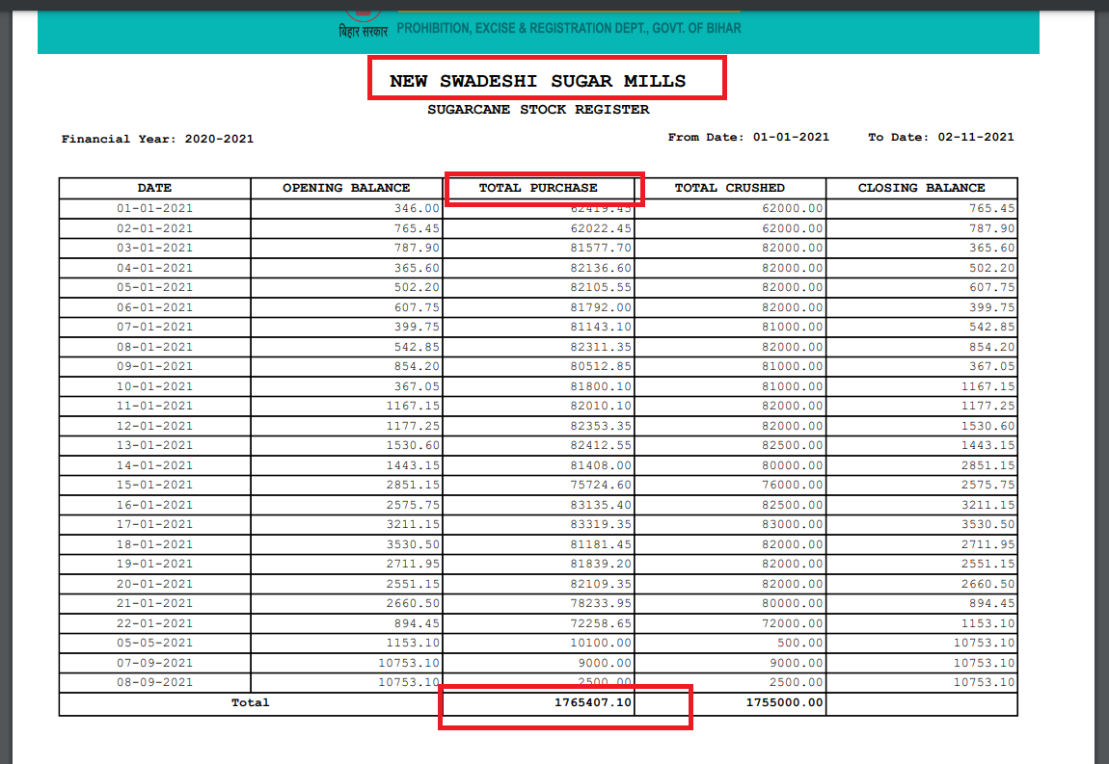

|  |
| --- |
|  |

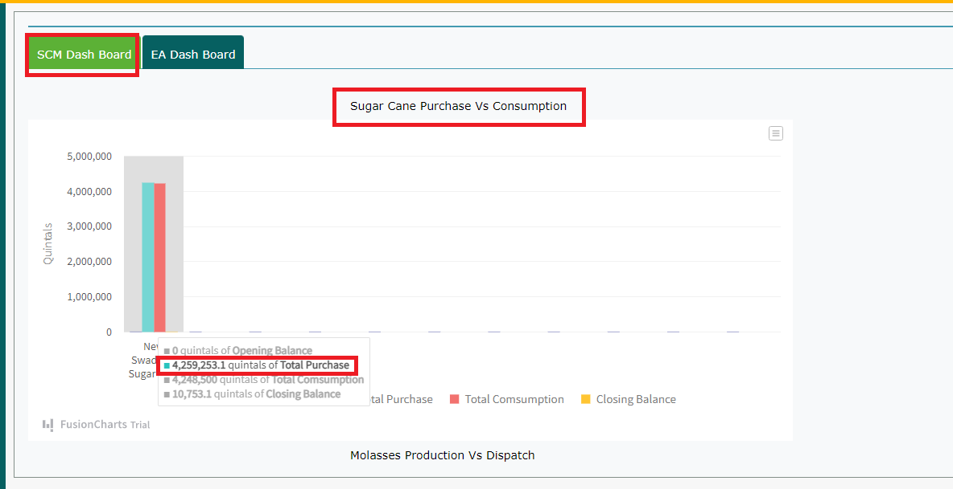

|  |
| --- |
| Login: newswadeshi_sgr  Sugar Cane Purchase Vs Consumption closing Balance of Graph value is matched with SUGARCANE STOCK REGISTER Value |

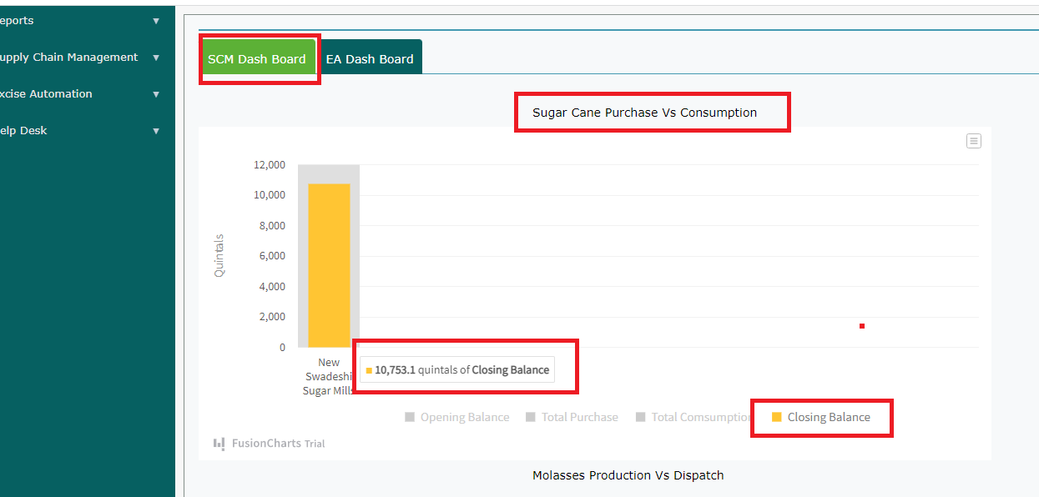

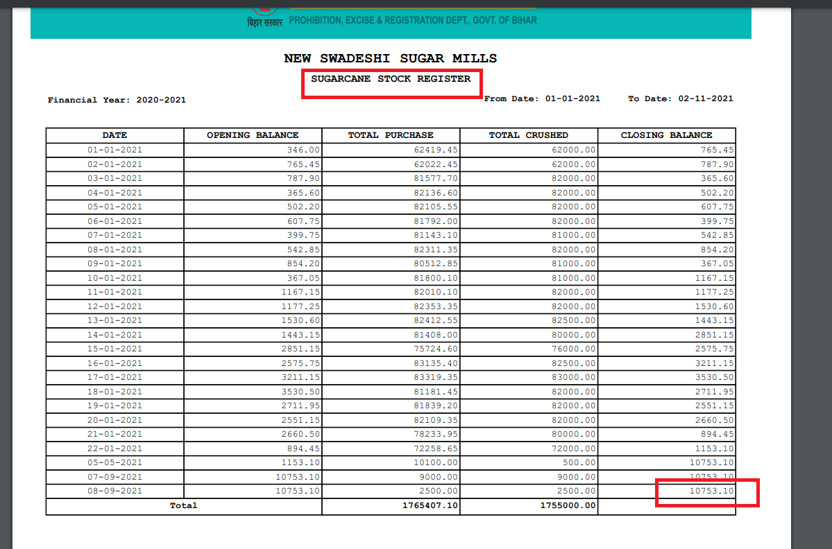

|  |
| --- |
| Login: newswadeshi_sgr  Molasses Production vs Dispatch graph is not there |

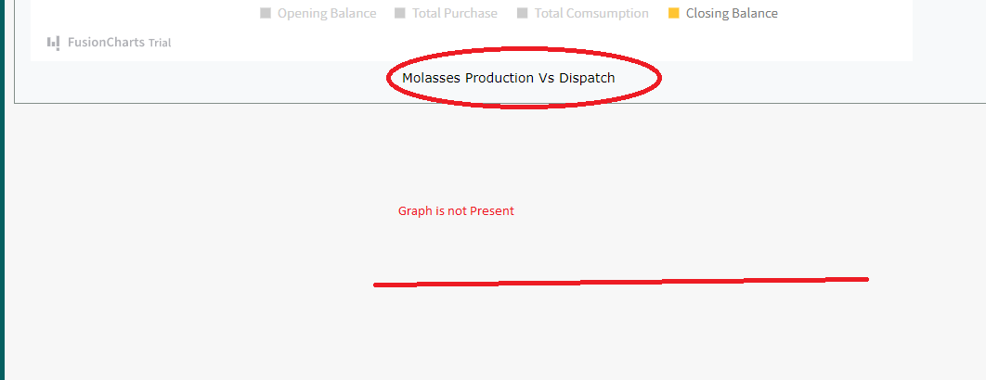

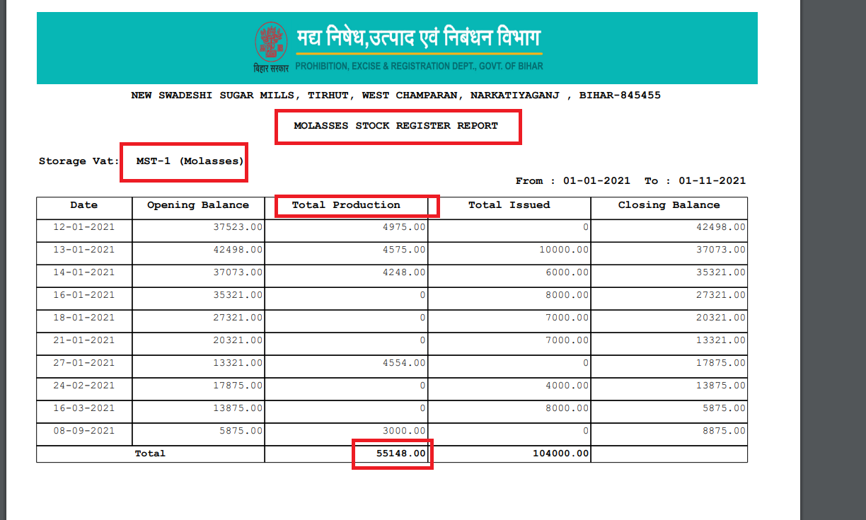

Distillery Unit

|  |
| --- |
| Login: majhaulia_dis Molasses Purchase Vs Consumption graph Graph Consumption value is mismatched with Molasses stock report consumption value |

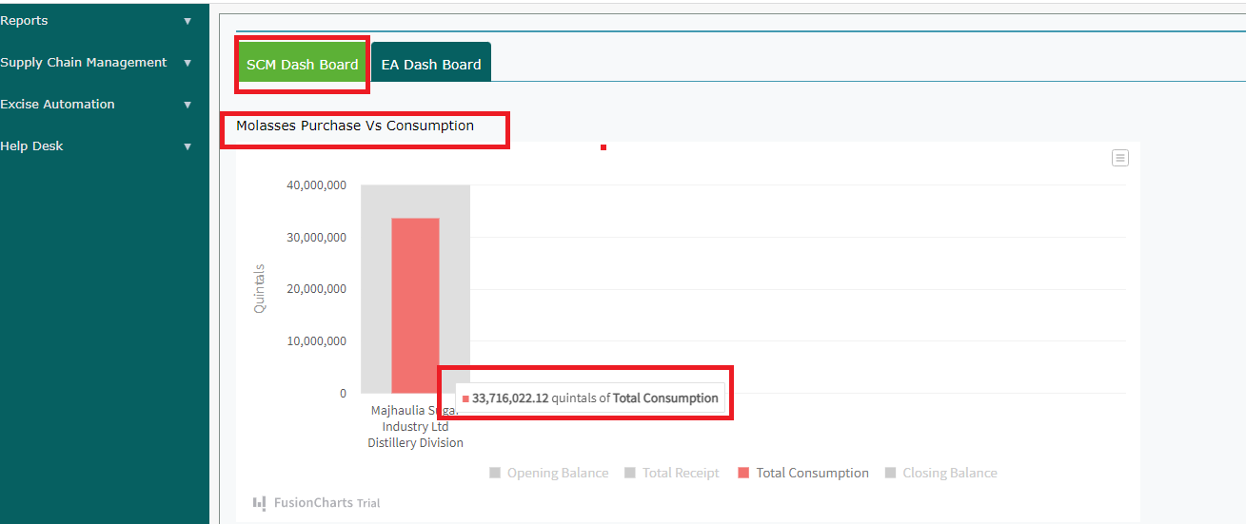

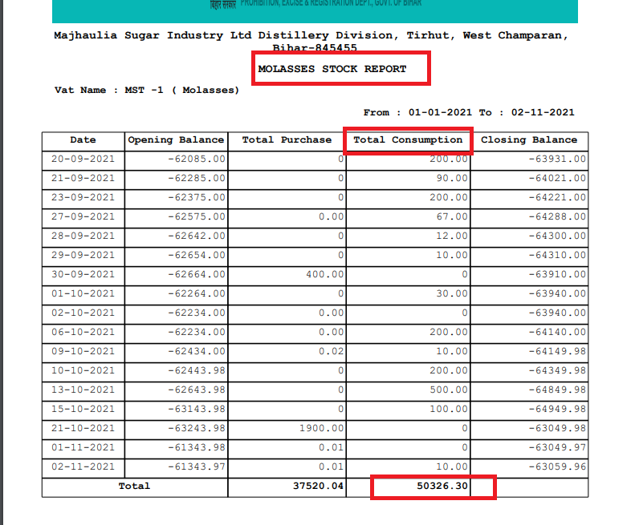

|  |
| --- |
| Login: majhaulia_dis Molasses Purchase Vs Consumption graph Graph Purchase value is mismatched with Molasses stock report Purchase value |

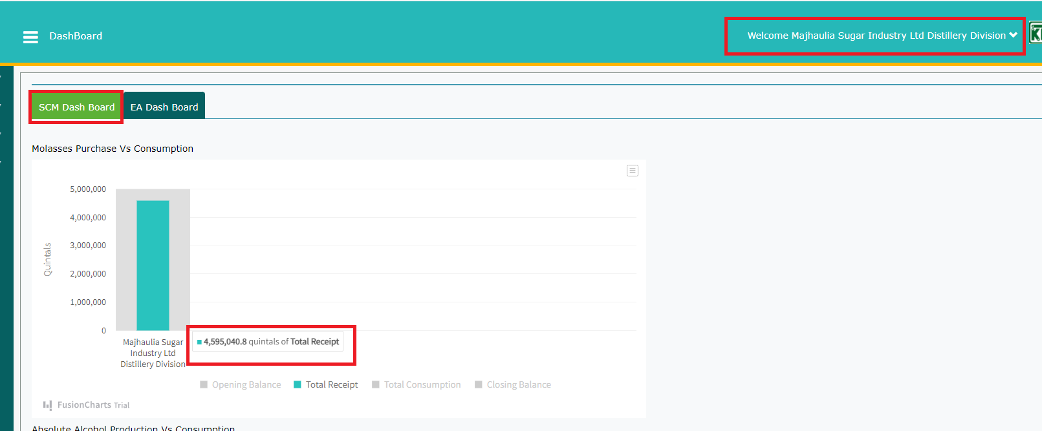

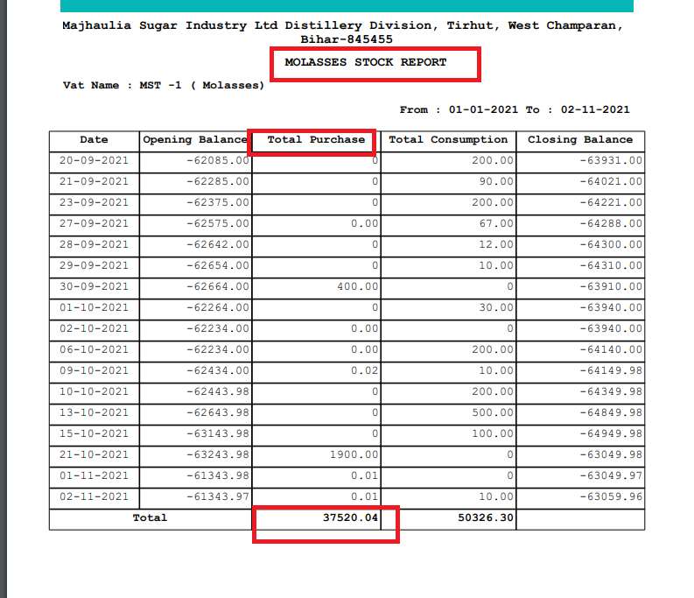

|  |
| --- |
| Login: majhaulia_dis  Absolute Alcohol Production Vs Consumption  Graph Production value is mismatched with ABSOLUTE ALCOHOL STOCK REGISTER REPORT Production value |

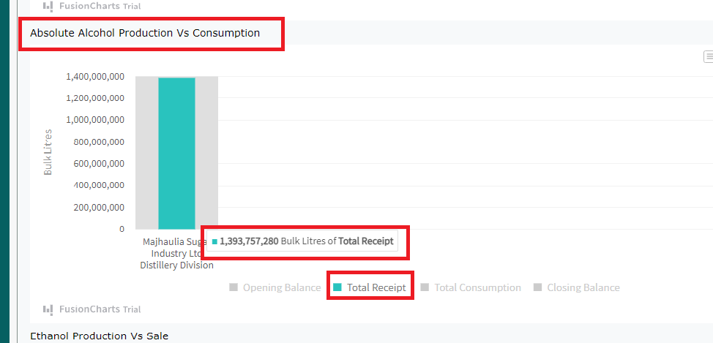

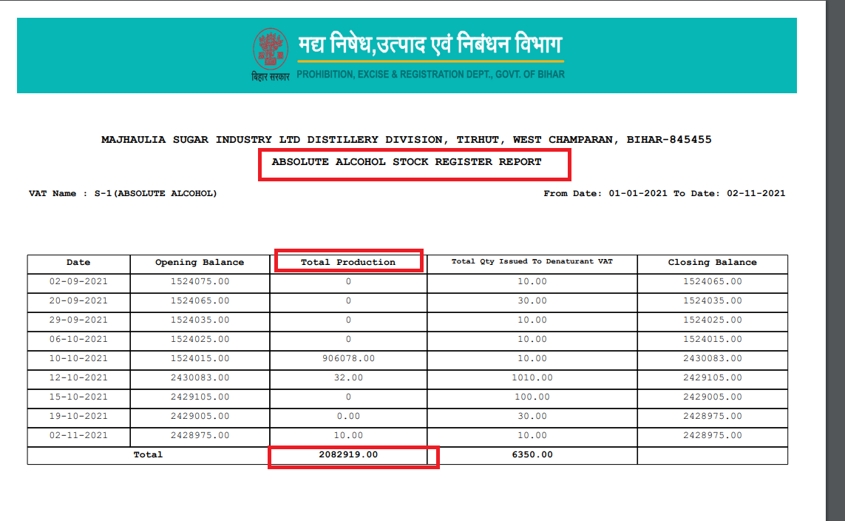

|  |
| --- |
| Login: majhaulia_dis  Absolute Alcohol Production Vs Consumption  Graph closing Balance value is mismatched with ABSOLUTE ALCOHOL STOCK REGISTER REPORT closing Balance value |

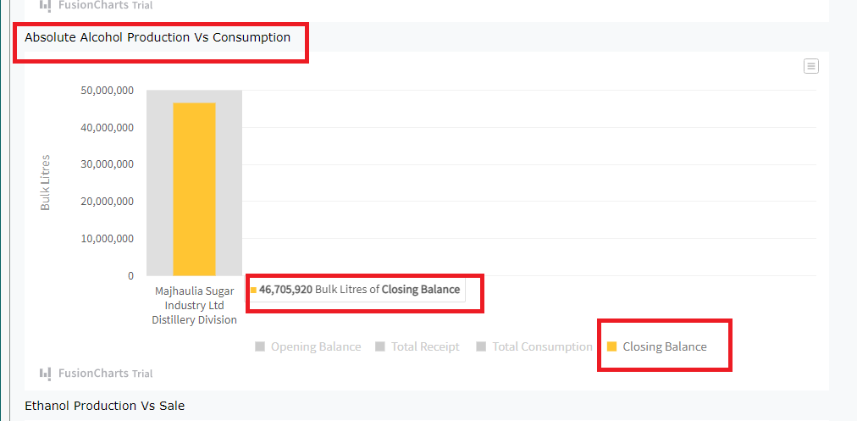

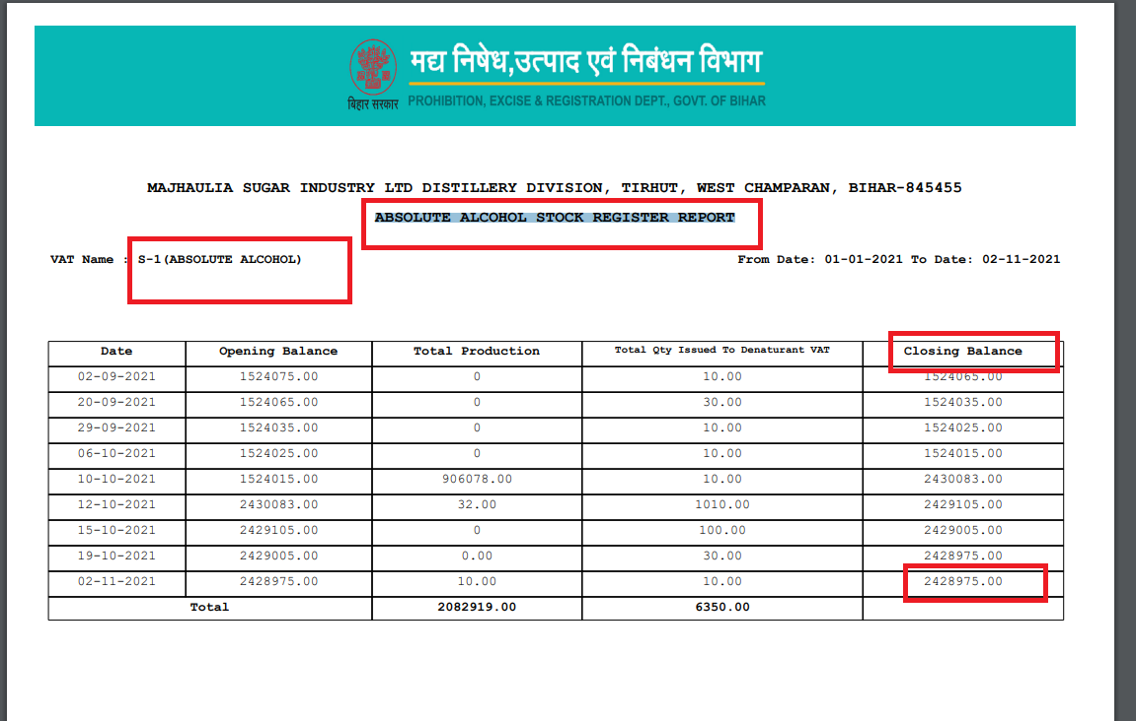

|  |
| --- |
| Login: majhaulia_dis  Ethanol Production Vs Sale  Graph closing Balance value is mismatched with ETHANOL STOCK REGISTER REPORT closing Balance value |

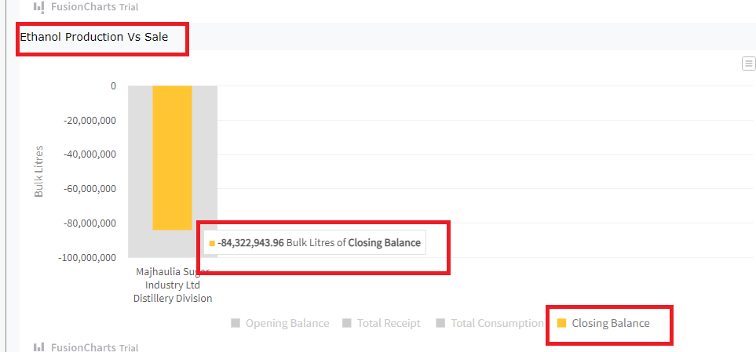

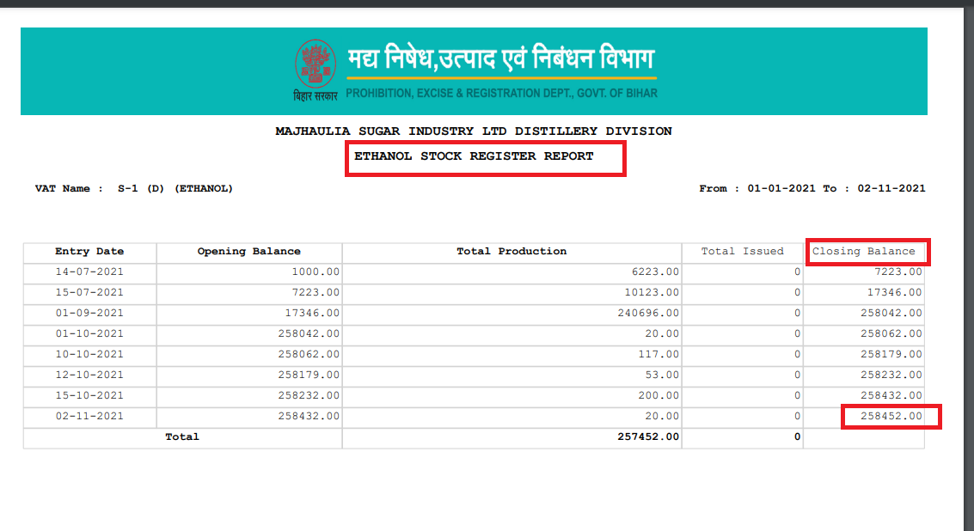

|  |
| --- |
| Login: majhaulia_dis  Ethanol Production Vs Sale  Graph Production value is mismatched with ETHANOL STOCK REGISTER all VATS Production value |

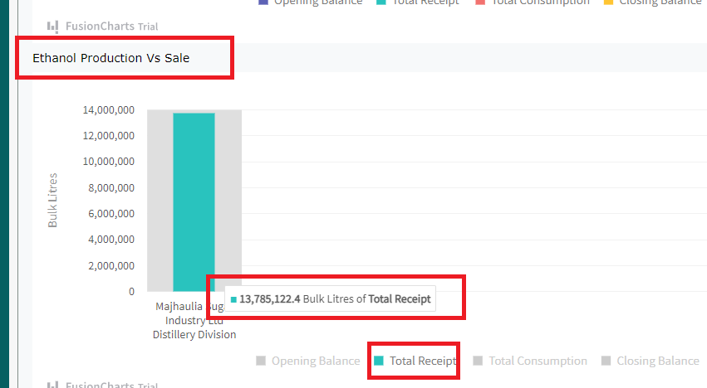

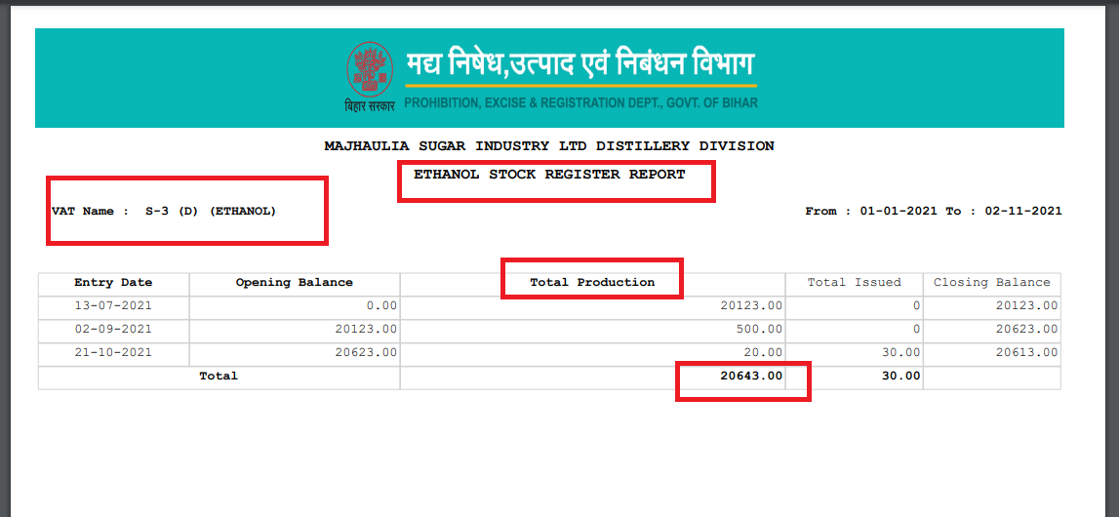

For EA - (Sugar Mill)

|  |
| --- |
| Login: newswadeshi_sgr NOC Approval Status For Export Of Molasses(Sugar Mills) Graph values mismatch with all counting records in NOC |

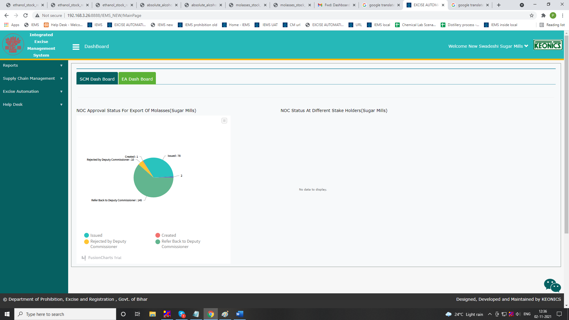

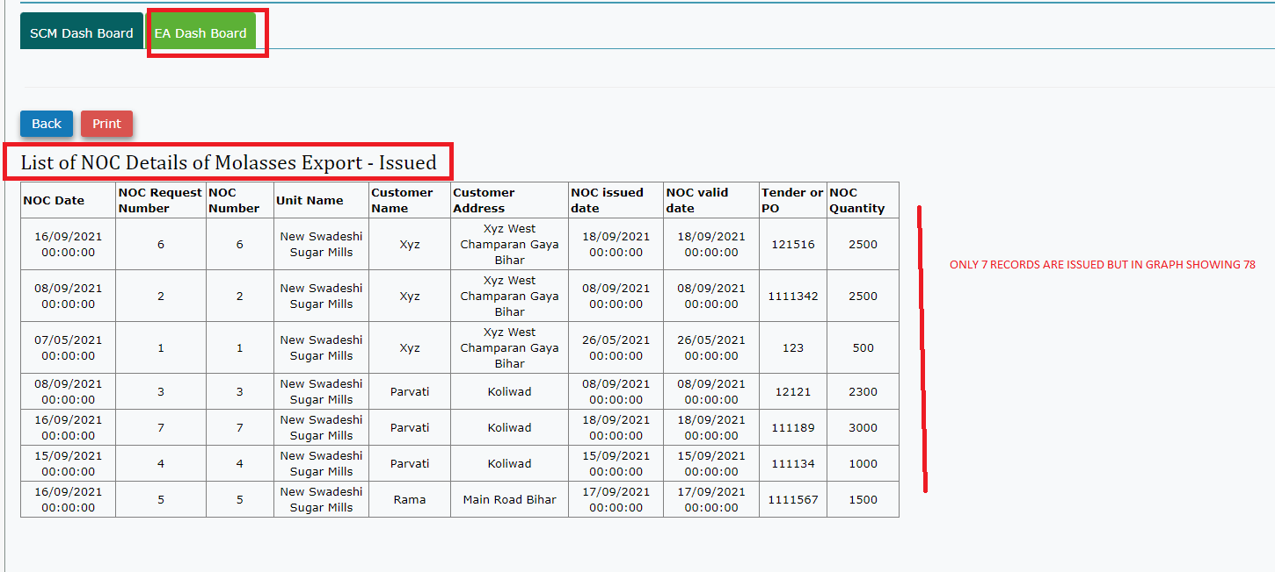

|  |
| --- |
| Login: newswadeshi_sgr  NOC Status at different stakeholders NO Data avialable |

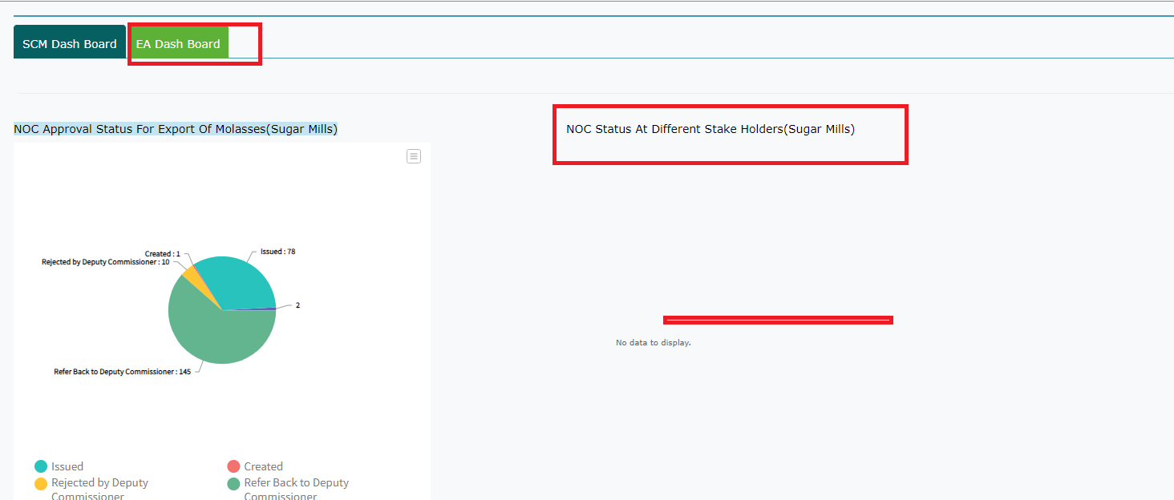

Distillery Unit

|  |
| --- |
| Login: majhaulia_dis  Molasses Allocation Status match the graph value and counting values |

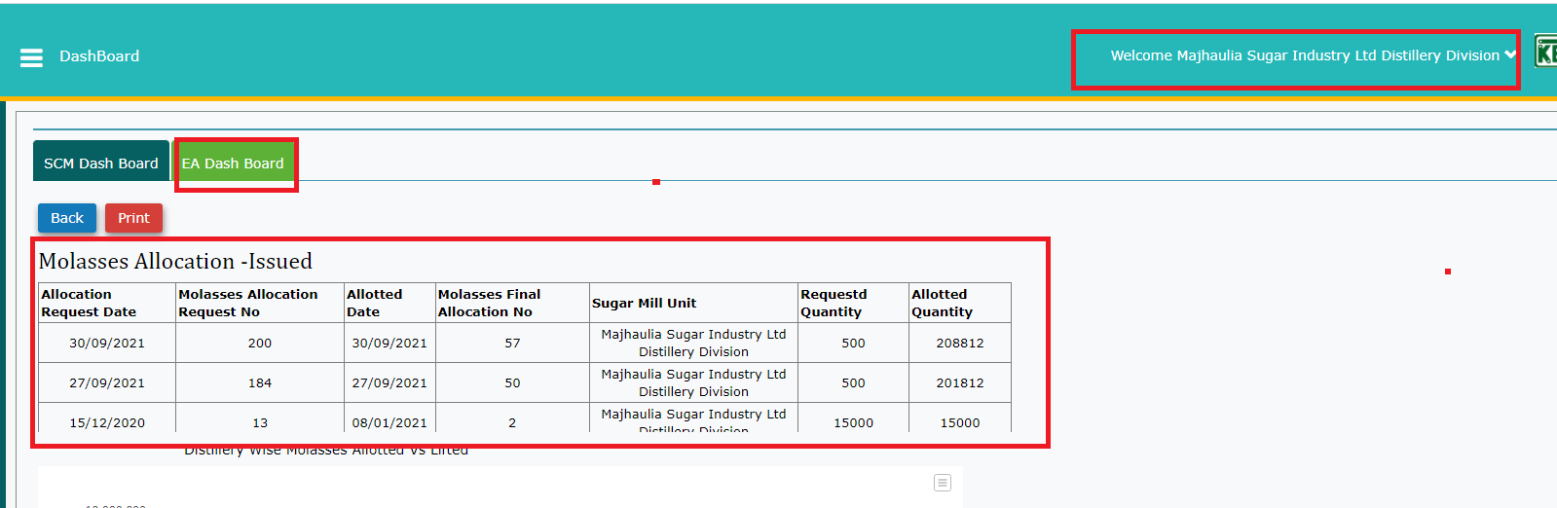

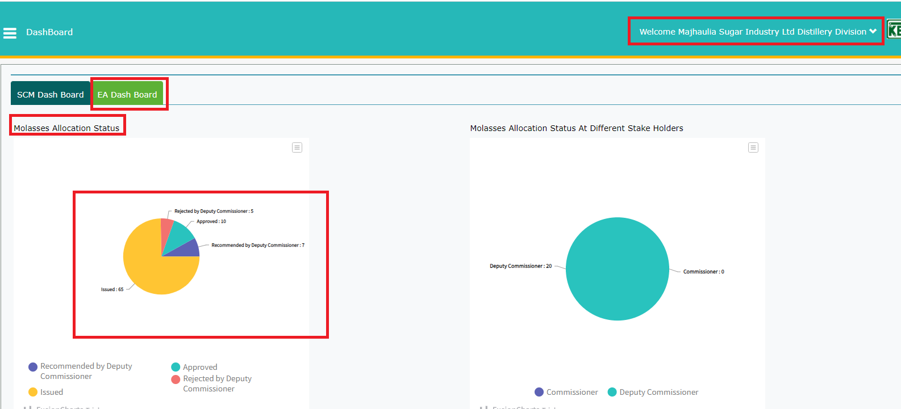

|  |
| --- |
| Login: majhaulia_dis  Molasses Allocation Status at different stakeholders  Counting records and graph values are mismatching |

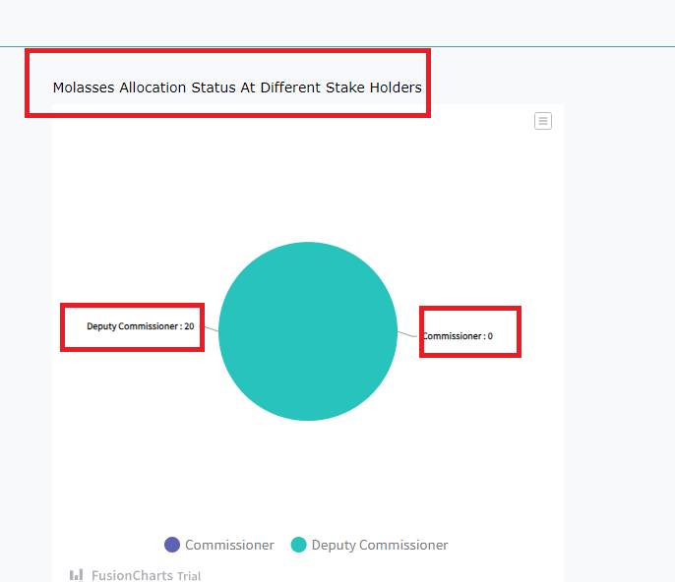

|  |
| --- |
| Distilleries wise molasses allotted vs lifted graps values are mismatch with records value |

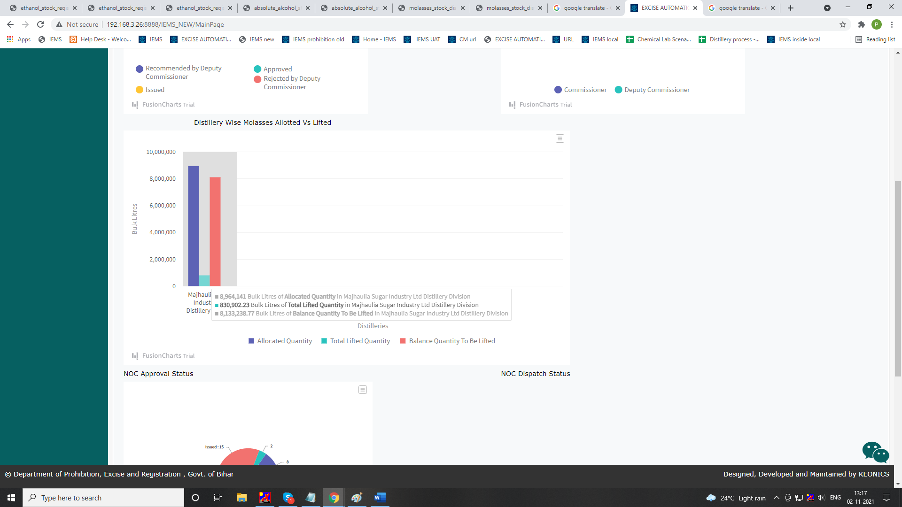

|  |
| --- |
| NOC approval status only issued value is matched rest all mismatched with counting records |

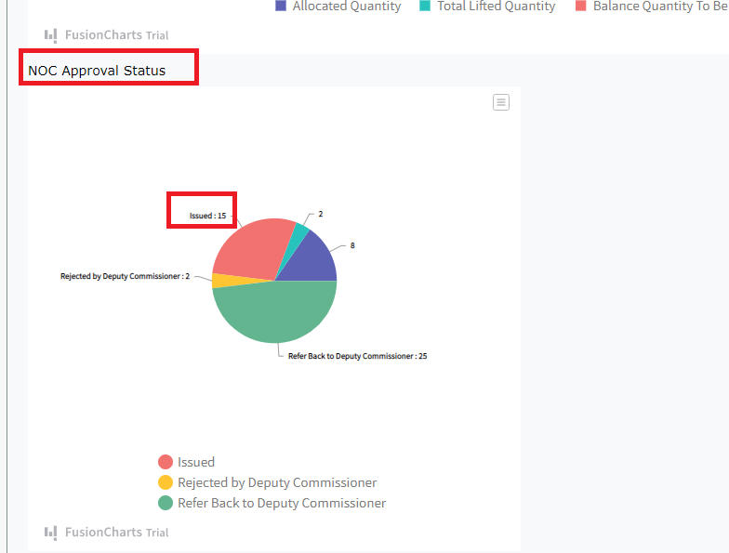

|  |
| --- |
| NOC dispatch status showing data is not available |

