Allocation Request Form

Login : M&TP

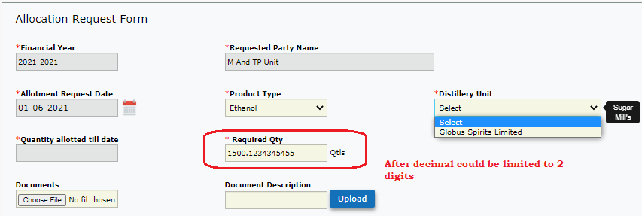

|  |
| --- |
| When Product Type is selected as “Ethanol” – Only Globus spirits Ltd Is listed.  Clarification : Should it fetch all the distilleries who supply “Ethanol” .  Based on the product Type – Units /dispatch unit to be listed? |
| **Allotment Print Letter** |
| **Alert Messages: If mandatory field is not filled**  **For product–“Select Molasses Type** could be changed to **(Select Product Type)**  **Distillery Unit – “Select Sugarmill” –** could be changed to **(Select Distillery Unit)**  **Required Qty – “Enter Molasses Required Qty” –** could be changed to **(Enter Required Qty)** |
|  |

Login Admin

License Type Form

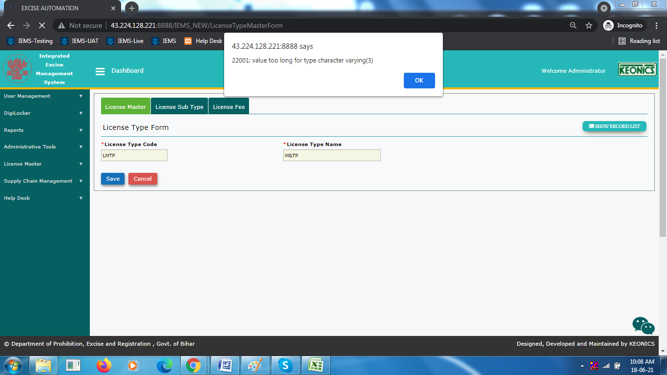

License Sub Type

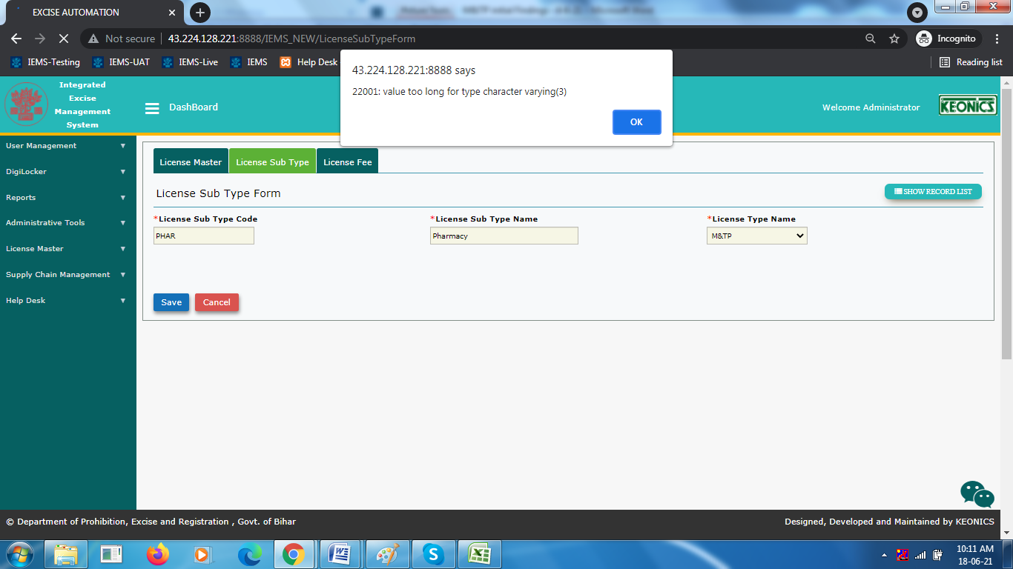

License Fee

Appropriate alert messages to be displayed

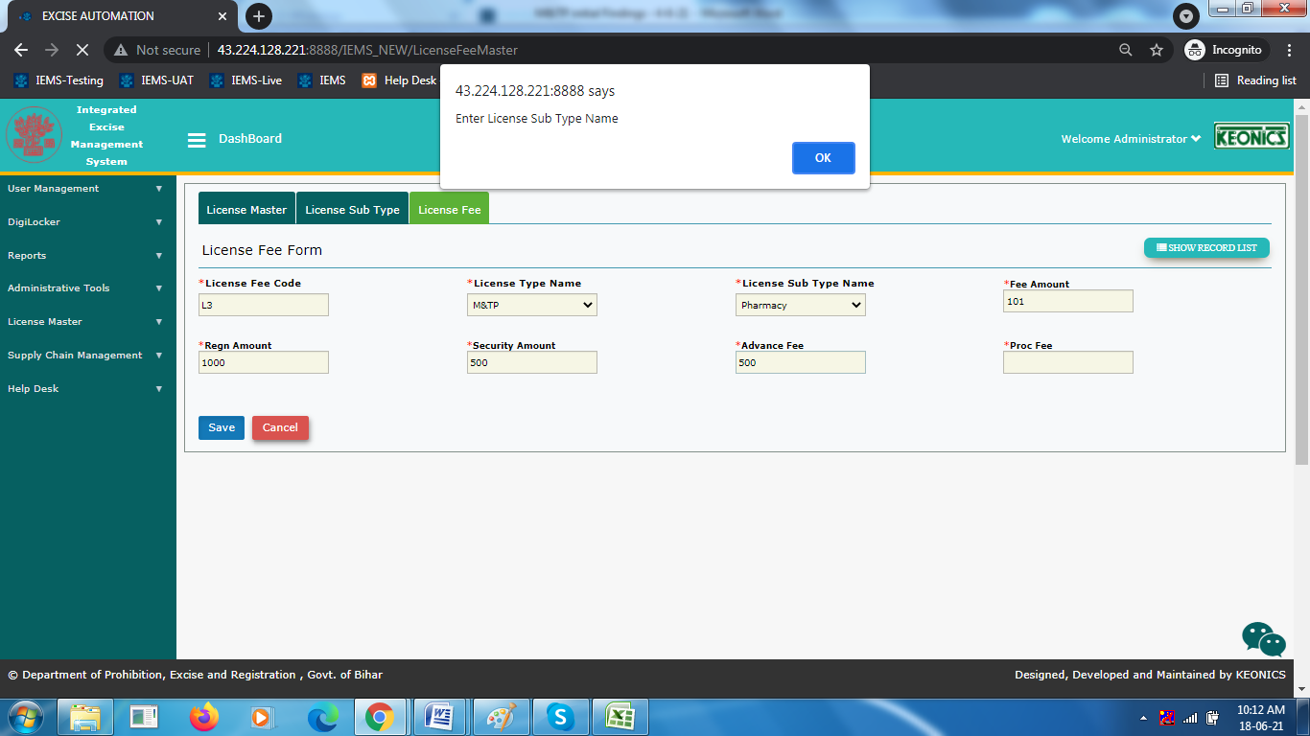

**Login :M&TP**

Allocation Request

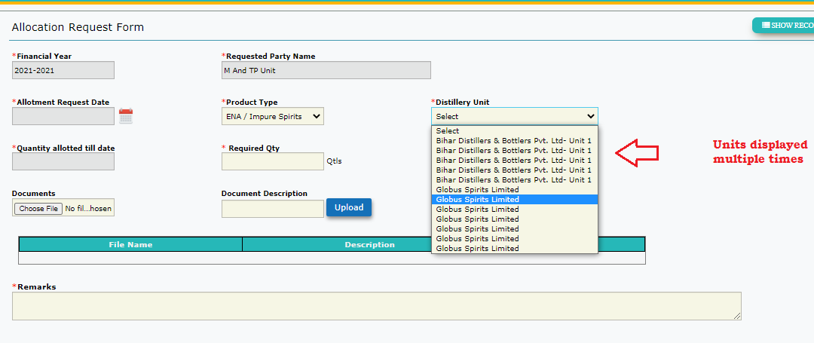

**Com Login**- When clicked on Approve-> getting “ Balance not available with ..still want to continue “Yes or NO” .

Clarification : should Com get this alert message

Issue/Print Form

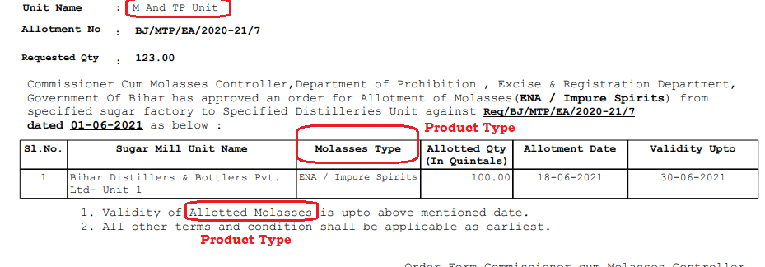

**License Form**

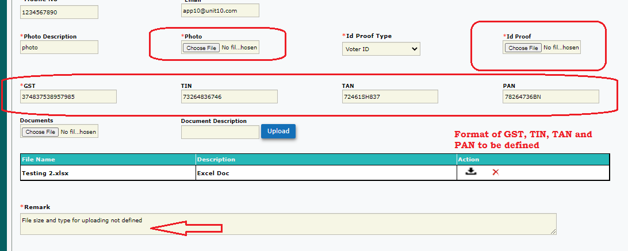

1: File type and size not – allowing all formats and Size of the file exceeding 2mb

2: Format for GST, TIN, TAN and PAN to be defined.

3: On click on “Save as draft” – getting - BLOCKER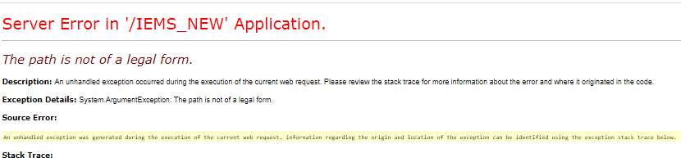

4 : Cancel Button should lead to list screen

**Permit**

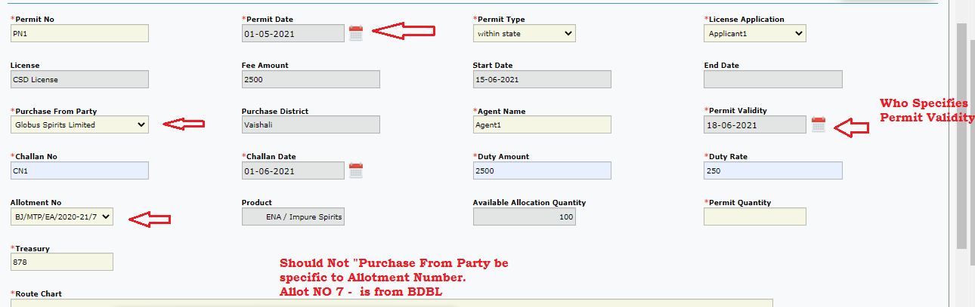

1. Permit date should allow only future dates
2. “Purchase From Party” should be based on Allotment Number (For allotment no7 : party was bdbl).
3. Permit Validity should not be editable.

=====================================================================================Login : Globus/BDBL

EA- Transport Pass- Add new Record – Select Permit Number

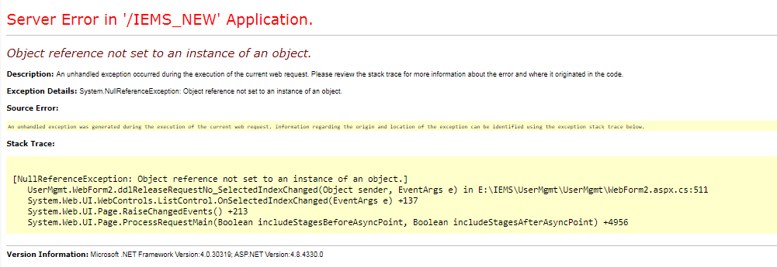

Based on existing Pass

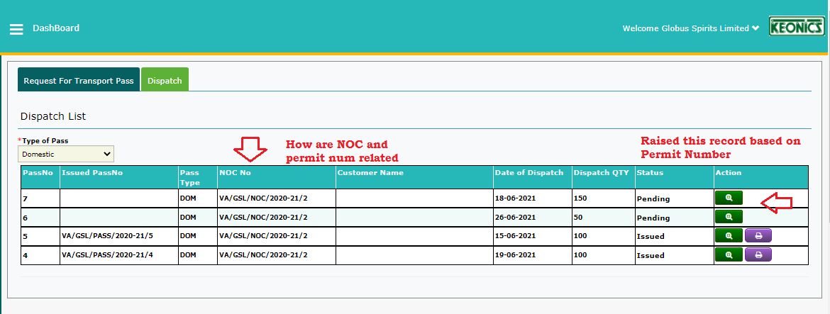

Print

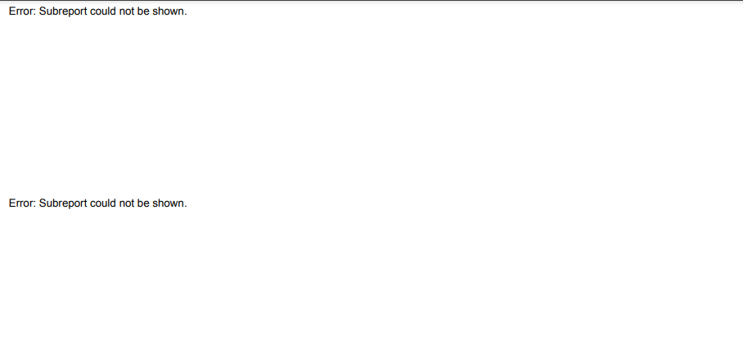

Available Balance in Vat not matching and data not fetched in report

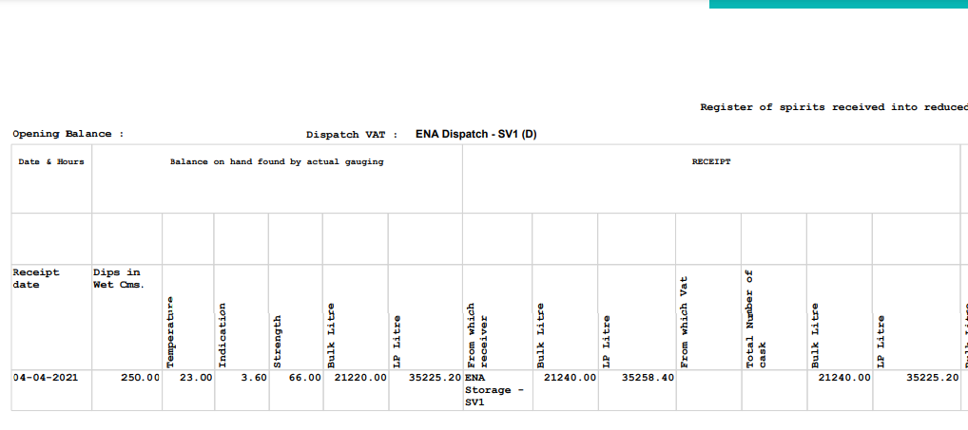

IN pass form on selection of Dvat

D1- 3396, d2-18878, d3 – 5174, D4-156886..etc

