**Opening Balance**

SM Login - Working

SM BO Login - Working

**RG4**

Form

**Tool Tips:**

* Date : Tool tip to be changed from DOB To “Sugar Cane purchase/crush date”
* Today’s Total Purchase : “Today’s Cane Purchased total”
* Total Sugarcane available: “ Total Cane purchase Stock-Crushed”
* 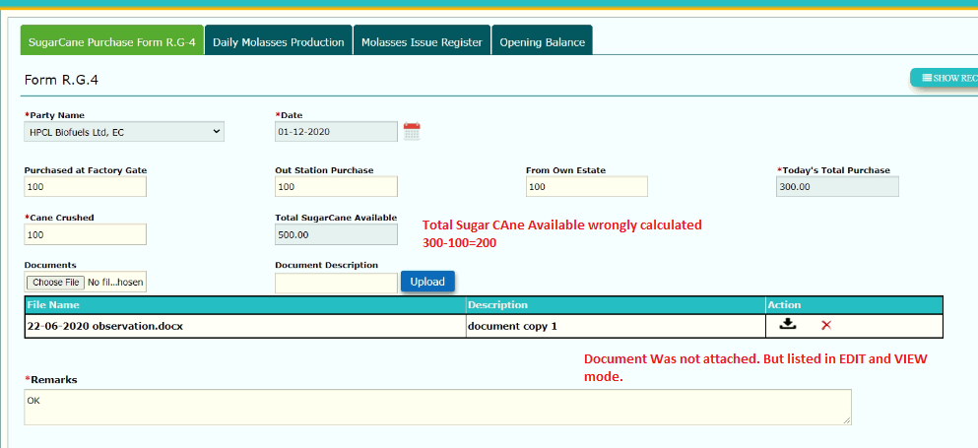Document Description: “ Name of the Document”

1. Cane Crushed : To make it Non mandatory
2. Records gets saved only when at least “ 0” is entered in “Purchase Details” otherwise displays

“Input String not in correct format”

1. If we enter only “Crush Value “ then its displaying “ Zero values not allowed” – Inconsistent
2. Document was not attached still some document is listed in Edit and view mode

(Document listed was attached for Harinagar Sugar Mill)

1. Spelling : If document Description is not entered spelling to be changed in pop up message “Enter Document Description”

Note : List view displaying Correctly

1. RG4-- > In edit mode--> Purchased was 300 and edited crushed to 150 from 100, the alert pop up was displayed. (Edited after 2 records were added)

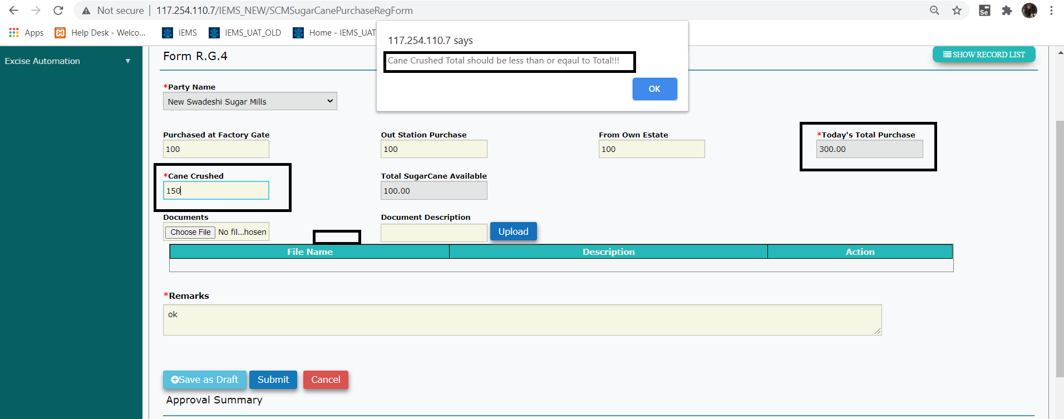

1. 7 Edit mode – User unable to select date as calendar control does not display any dates for selection
2. RG4 List : Change the caption “Total Purchase” To “Total cane purchased”

**RG4 – BO**

1. SM’s Remarks should be non editable.
2. If BO Rejects/Approve then these buttons should be made invisible/disabled.

Note : IF rejects- Reject button should not be enabled till SM again submit the record.

1. IN view Mode after approval: Document Download option is required.